**Project 4- Database CRUD**

Group Members:

Julia Murphy - **JM**

Brooke Eden - **BE**

Hongda Zheng - **HZ**

Nathan Snodgrass - **NS**

1. CSS:
   1. Created Stylesheet - **HZ**
2. Efficient PHP file organization:
   1. Organized everything in GitHub in order to share documents before submission - **JM BE HZ NS**
3. A database and *at least* three tables:
   1. Creation of Database, account table, reviews table and comments table - **JM**
   2. Changing SQL names in existing PHP files to correlate with new tables - **BE JM**
4. Sign up, log in, log out, and delete their accounts AND have the ability to add, change, or remove data from the two other tables:
   1. Created functions in start.php to edit/delete account and reviews - **NS**
   2. Creation of login, sign up and log out page - **HZ**
   3. Review Page has the ability to add and change elements to the tables
   4. Altered Survey.php to write to Reviews data table and upload images to public/img/ for further use - **NS**
   5. Re-organization and styling of object oriented PHP for final site - **HZ**
5. Two original PHP elements:
   1. While loop + $row to display review and comment content from database - **NS**
      1. Would’ve added multiple reviews, but would’ve need comment table for each one
      2. To test posting a review and view it on the “Browse Reviews” page, make sure there is only one review in the table. Any more and the page may break
   2. $_FILES/move_uploaded_file() [in survey.php] - Post file upload from form and upload it to chosen directory. - **NS**
6. Content
   1. Created this document - **BE**
   2. Created accounts, username, and passwords - **BE**
   3. Create reviews with images and posts for the website - **BE**
   4. Create comments for the reviews - **BE**
   5. Update the Document - **NS BE HZ JM**
   6. Code to display reviews in database - **NS**
   7. Code to display comments from database under reviews - **NS JM**

# Accounts and Reviews

**Brooke Eden** Brooke_Eden Password: be123

May 25, 2019

This past week, I traveled to Santorini Greece. It exceeded far past my expectations and I want to go back again. The views were breath-taking and the food was out of this world. I really recommend for anyone to go to Greece



**Julia Murphy** Jmmurphy; Password: jm123

September 1, 2019

I finally made it to New Zealand to see the hobbit holes from Lord of the Rings. This trip has been on my bucket list since I first saw the movies. I officially want to move there and live in them forever.

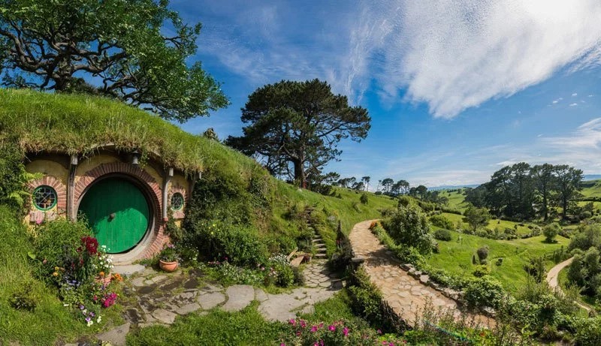

**Nathan Snodgrass** N68grass Password: ns123

January 30, 2015

If you haven’t been to Japan, well pack your bags because you NEED to go. The food was the best I’ve ever had and just being submerged in the culture was an experience I'll never forget.



Comments:

Jmmurphy March 2, 2017 Wow, that sounds amazing! I am going next year and you

just got me so hyped up and ready to go! Post more pictures, please.

**Hongda Zheng** Honhd567 Password: hz123

April 4, 2018

It’s official, I’m moving to Germany. The architecture is something I’ve never seen before. I explored the Neuschwanstein Castle-and yes the one that was used to build the Disney Castle. This trip was by far my favorite trip yet.



Comments:

Brooke_Eden May 4, 2018 I am so jealous that you went to the castle! That’s on my bucket list-I’m a Disney super fan >.<

Id names and attributes for website:

* cid = the text of the comment (comment id variable)
* $conn = connection
* Css class for comments = “comment-box”
  + Edit button class = “edit-form”
  + Delete button class = “delete-form”