Conception Java : TP6
Antoine Gicquel

Le diagramme de classe final de l'exercice 2 :

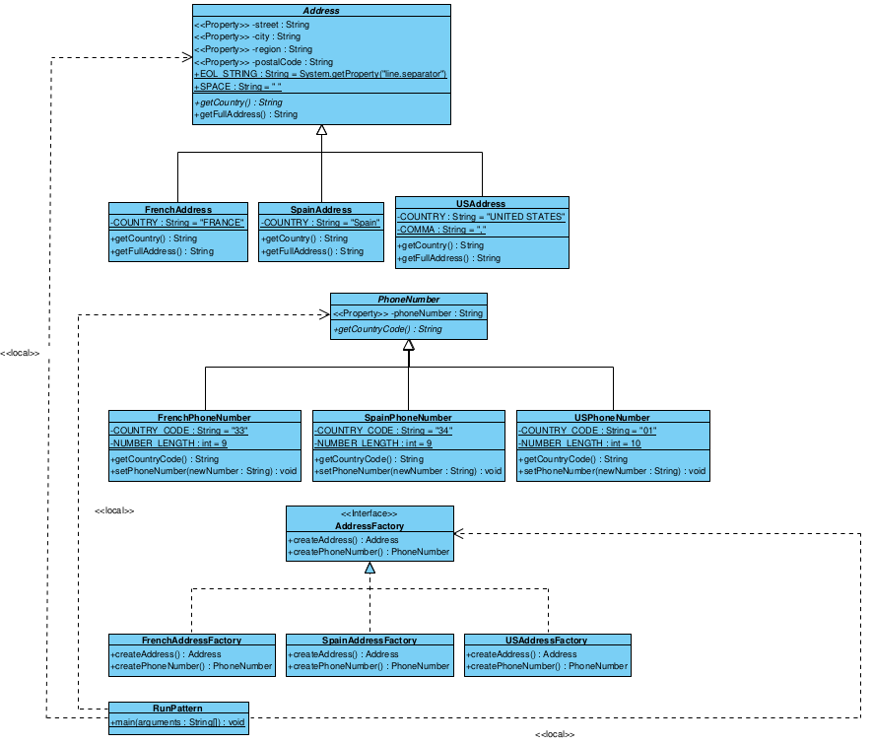

Le diagramme de classes de l'exercice 3 intégrant le pattern Observer :
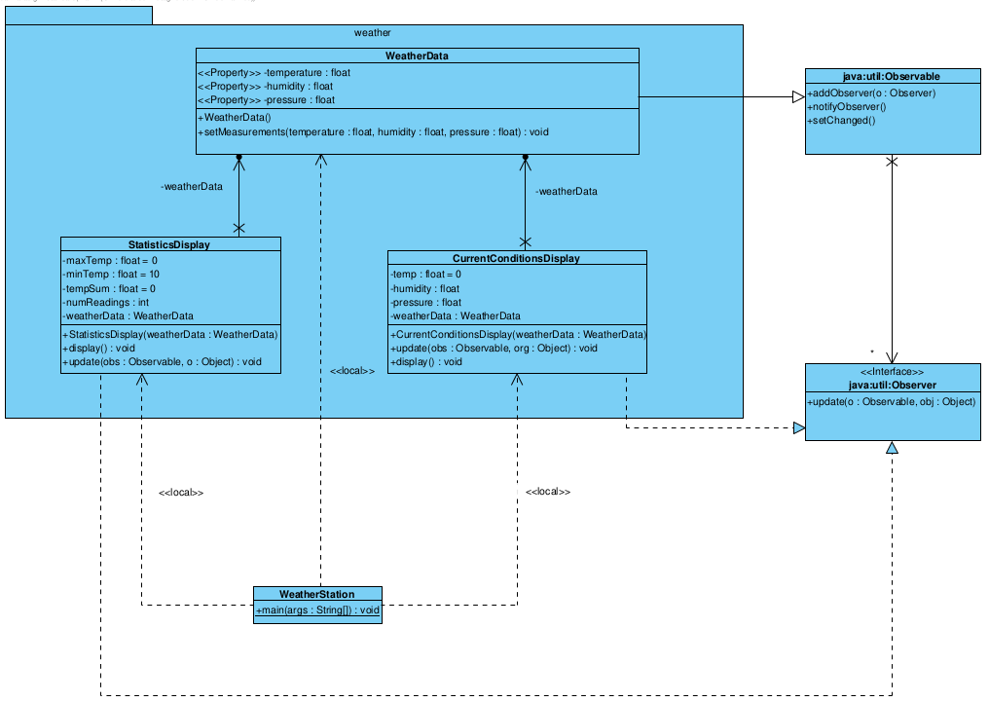

Le code complet de l'exercice 3 :

package weather;

public class WeatherStation {
public static void main(String[] args) {
WeatherData weatherData = new WeatherData();
CurrentConditionsDisplay currentDisplay = new CurrentConditionsDisplay(weatherData);
StatisticsDisplay sd = new StatisticsDisplay(weatherData);
weatherData.setMeasurements(12, 65, 1040);
currentDisplay.update();
}
}

package weather;

public class CurrentConditionsDisplay implements java.util.Observer {
private float temp = 0;
private float humidity;
private float pressure;
private WeatherData weatherData;

public CurrentConditionsDisplay(WeatherData weatherData) {
this.weatherData = weatherData;
weatherData.addObserver(this);
}

public void update(java.util.Observable obs, Object org) {
temp = weatherData.getTemperature();
humidity = weatherData.getHumidity();
pressure = weatherData.getPressure();
this.display();
}

public void display() {
System.out.println("Current conditions : ");
System.out.println("* temperature : " + temp);
System.out.println("humidity : "+ humidity);
System.out.println("pressure : "+ pressure);
}
}

package weather;

import java.util.*;

public class WeatherData extends java.util.Observable {
private float temperature;
private float humidity;
private float pressure;

public void setMeasurements(float temperature, float humidity, float pressure) {
this.temperature = temperature;
this.humidity = humidity;
this.pressure = pressure;
this.setChanged();
this.notifyObservers();
}

public float getTemperature() {
return temperature;
}

public float getHumidity() {
return humidity;
}

public float getPressure() {
return pressure;
}
}

package weather;

public class StatisticsDisplay implements java.util.Observer {
private float maxTemp = 0;
private float minTemp = 10;
private float tempSum= 0;
private int numReadings;
private WeatherData weatherData;

public StatisticsDisplay(WeatherData weatherData) {
this.maxTemp = 0;
this.minTemp = 10;
this.tempSum= 0;
this.weatherData = weatherData;
this.weatherData.addObserver(this);
}

public void update(java.util.Observable obs, Object o) {
float temp = weatherData.getTemperature() ;
tempSum += temp;
numReadings++;
if (temp > maxTemp)
maxTemp = temp;
else if (temp < minTemp)
minTemp = temp;
this.display();
}

public void display() {
System.out.println("Avg/Max/Min temperature = "+ (tempSum / numReadings) + "/" + maxTemp + "/" + minTemp);
}
}

Le diagramme de classes détaillé de l'exercice 4 :
