M3105 : TP5
Antoine Gicquel

Le diagramme :
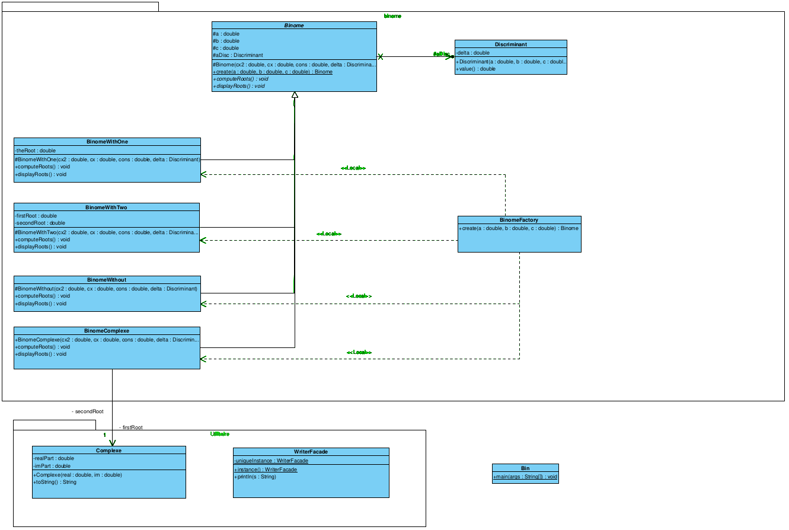

Le code :
package binome;

public class BinomeFactory {

public Binome create(double a, double b, double c) {
Discriminant d = new Discriminant(a, b, c);
double delta = d.value();
Binome aBin;

if ( delta == 0.0 ) {
aBin = new BinomeWithOne (a, b, c, d);
} else if ( delta > 0.0 ) {
aBin = new BinomeWithTwo (a, b, c, d);
} else {
aBin = new BinomeComplexe (a, b, c, d);
}
return aBin;
}
}

import binome.*;
public class Bin {
public static void main(String args[]) {

BinomeFactory b = new BinomeFactory();
Binome bin;

bin = b.create (1.0, 0.0, 1.0);
bin.computeRoots();
bin.displayRoots();
bin = b.create (1.0, 0.0, -1.0);
bin.computeRoots();
bin.displayRoots();
bin = b.create (1.0, 2.0, 1.0);
bin.computeRoots();
bin.displayRoots();
}
}

package Utilitaires;

public class WriterFacade {
private static WriterFacade uniqueInstance;

public static WriterFacade instance() {
if(uniqueInstance == null) {
uniqueInstance = new WriterFacade();
}

return uniqueInstance;
}

public void println(String s) { System.out.println(s); }
}
package binome;
import Utilitaires.*;

class BinomeWithOne extends Binome {

[...]

public void displayRoots() {
WriterFacade.instance().println("Une racine double : " + theRoot);
}

}

package binome;
import Utilitaires.*;

class BinomeWithTwo extends Binome {

[...]

public void displayRoots() {
WriterFacade.instance().println("Deux racines distinctes : \n\tx1 = " +
firstRoot);
WriterFacade.instance().println("\tx2 = " + secondRoot);
}

}

package binome;
import Utilitaires.*;

class BinomeComplexe extends Binome {

[...]

public void displayRoots() {
WriterFacade.instance().println("Deux racines distinctes : \n\tx1 = " + firstRoot.getReal() + " + " + firstRoot.getIm() + "i");
WriterFacade.instance().println(" \n\tx2 = " + secondRoot.getReal() + " + " + secondRoot.getIm() + "i");
}

}

