# TCGA Plotter

*PI: Nathan Siemers*

*Contributors: Nathan Siemers*

*2016-06-13*

### Summary

Comparison of: CDKN2A.cnv with FAP

TCGA Cohort: all

### Analysis Summary

## Data from UCSC Pan-Cancer data feeds, November 2015 release.

# Plots

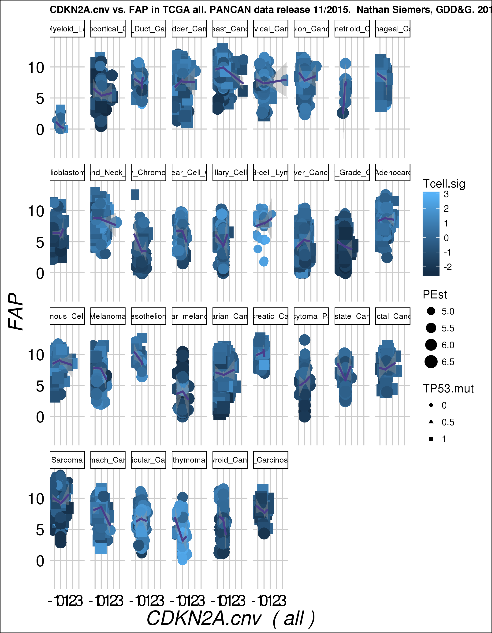

# Parameter details

l.input

$cohort [1] "all"

$mysmooth [1] "TRUE"

$mysize [1] "PEst"

$text1 [1] "foo"

$gene1 [1] "CDKN2A.cnv"

$gene2 [1] "FAP"

$mycolor [1] "Tcell.sig"

$myshape [1] "TP53.mut"