## Table of Contents

Expression survey of LILRB4 across Oncology, Tissue Atlas, and Immunology Sources 1

Project: Human Immune Cell RNA-seq (BMS) 1

Project: Combined Imm Decon with Activated Cells 2

Project: Hallstrom Body Map (gene level) 3

Crown PDX Models 4

Gene Expression Dossier

# Expression survey of LILRB4 across Oncology, Tissue Atlas, and Immunology Sources

*Nathan Siemers*

*Genetically Defined Diseases and Genomics*

*Date: Wed May 27 16:41:58 2015*

# Project: Human Immune Cell RNA-seq (BMS)

dfplot(df, gene, fac)

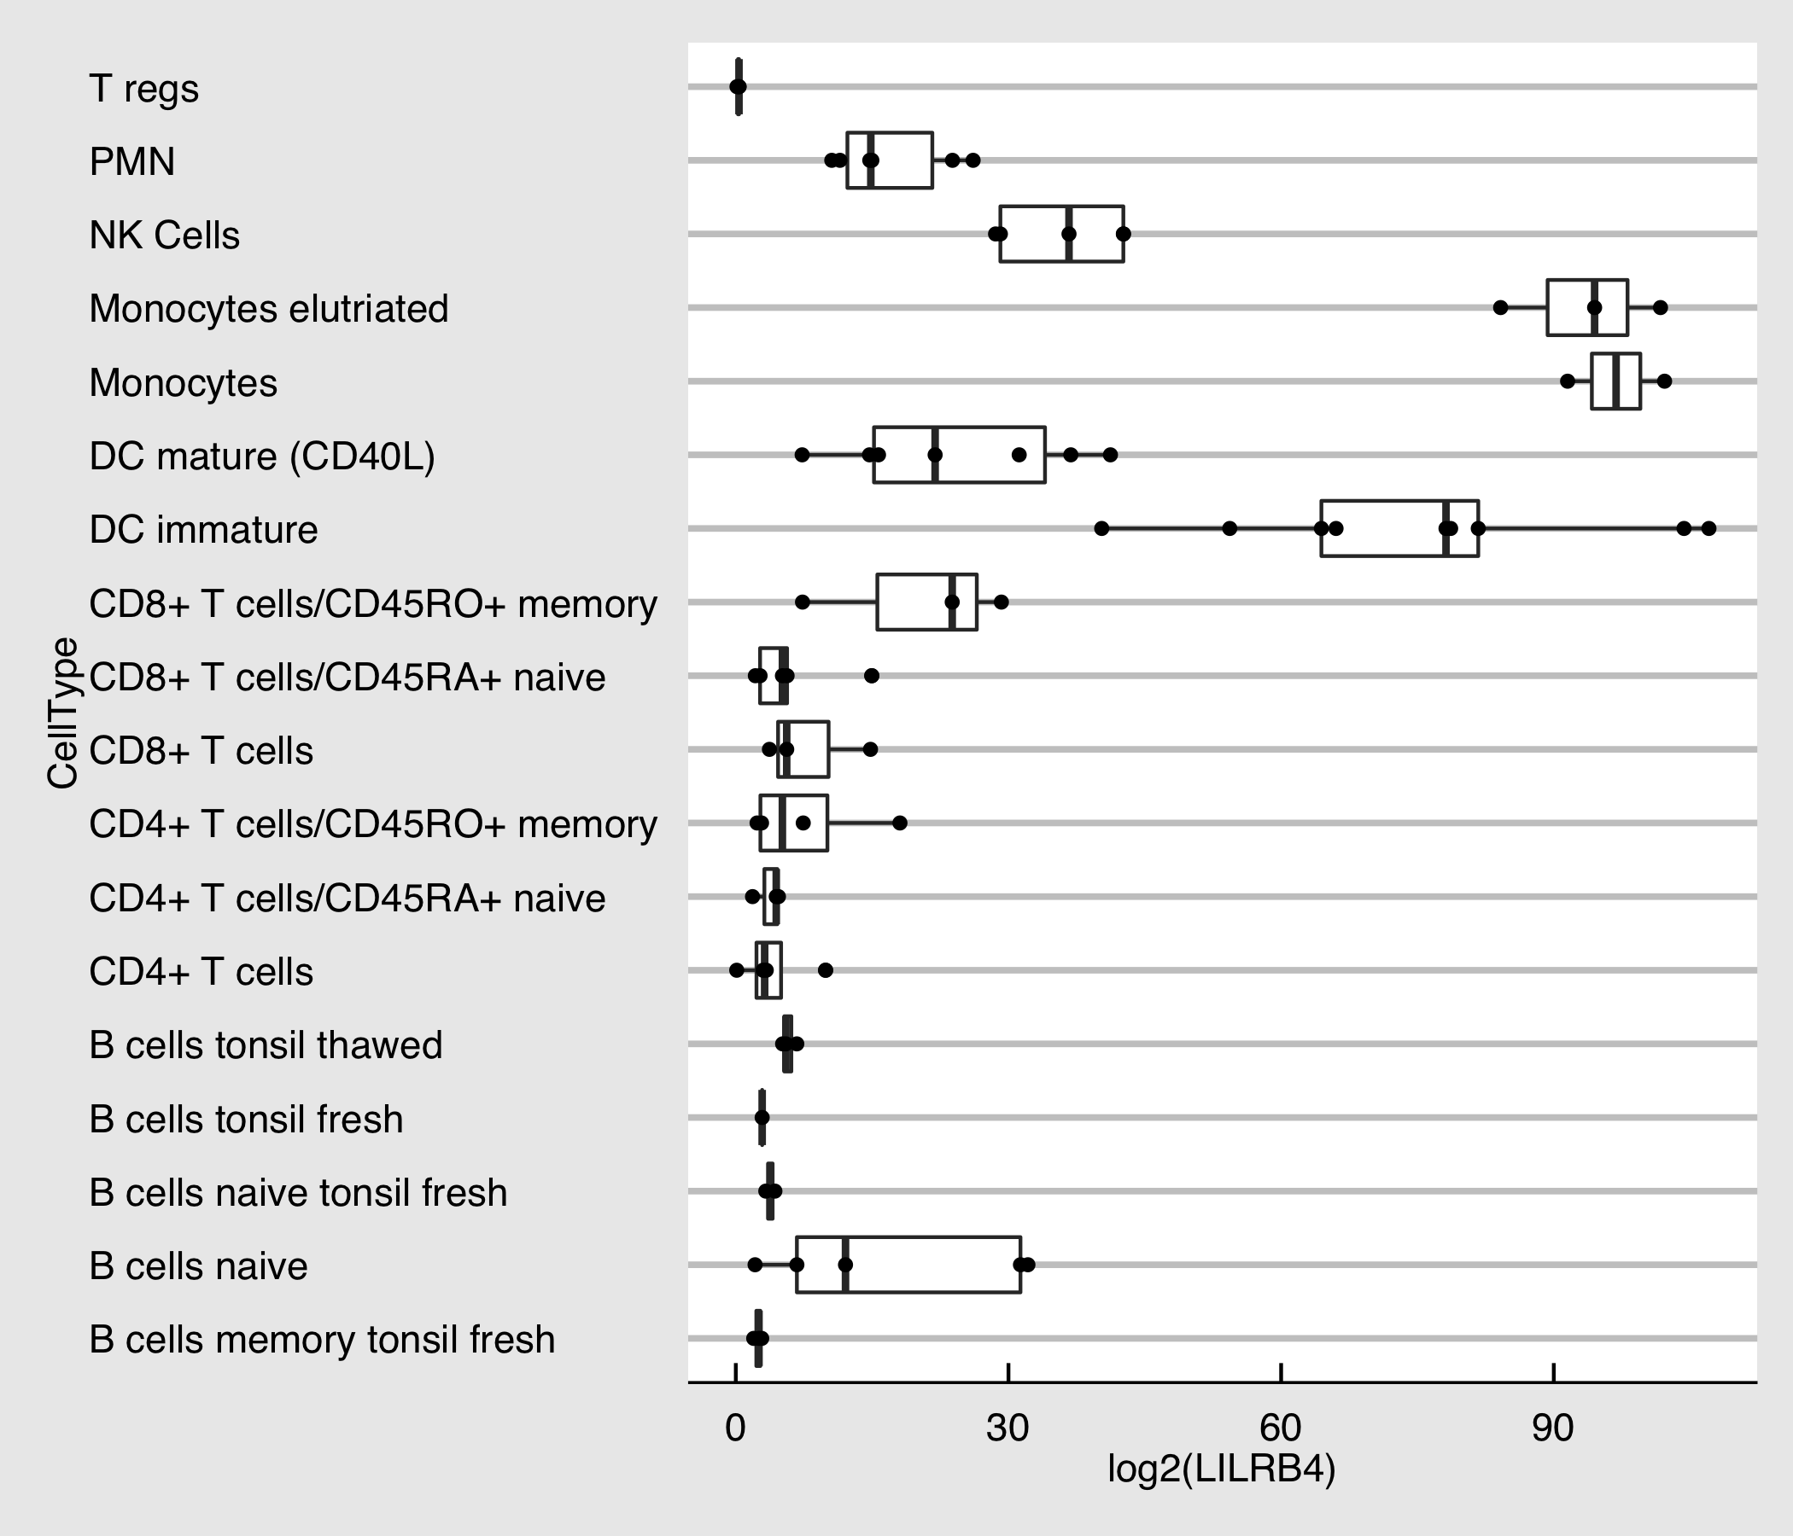

plot of chunk human.immune.cell.rna.seq.plot

### Project: Combined Imm Decon with Activated Cells

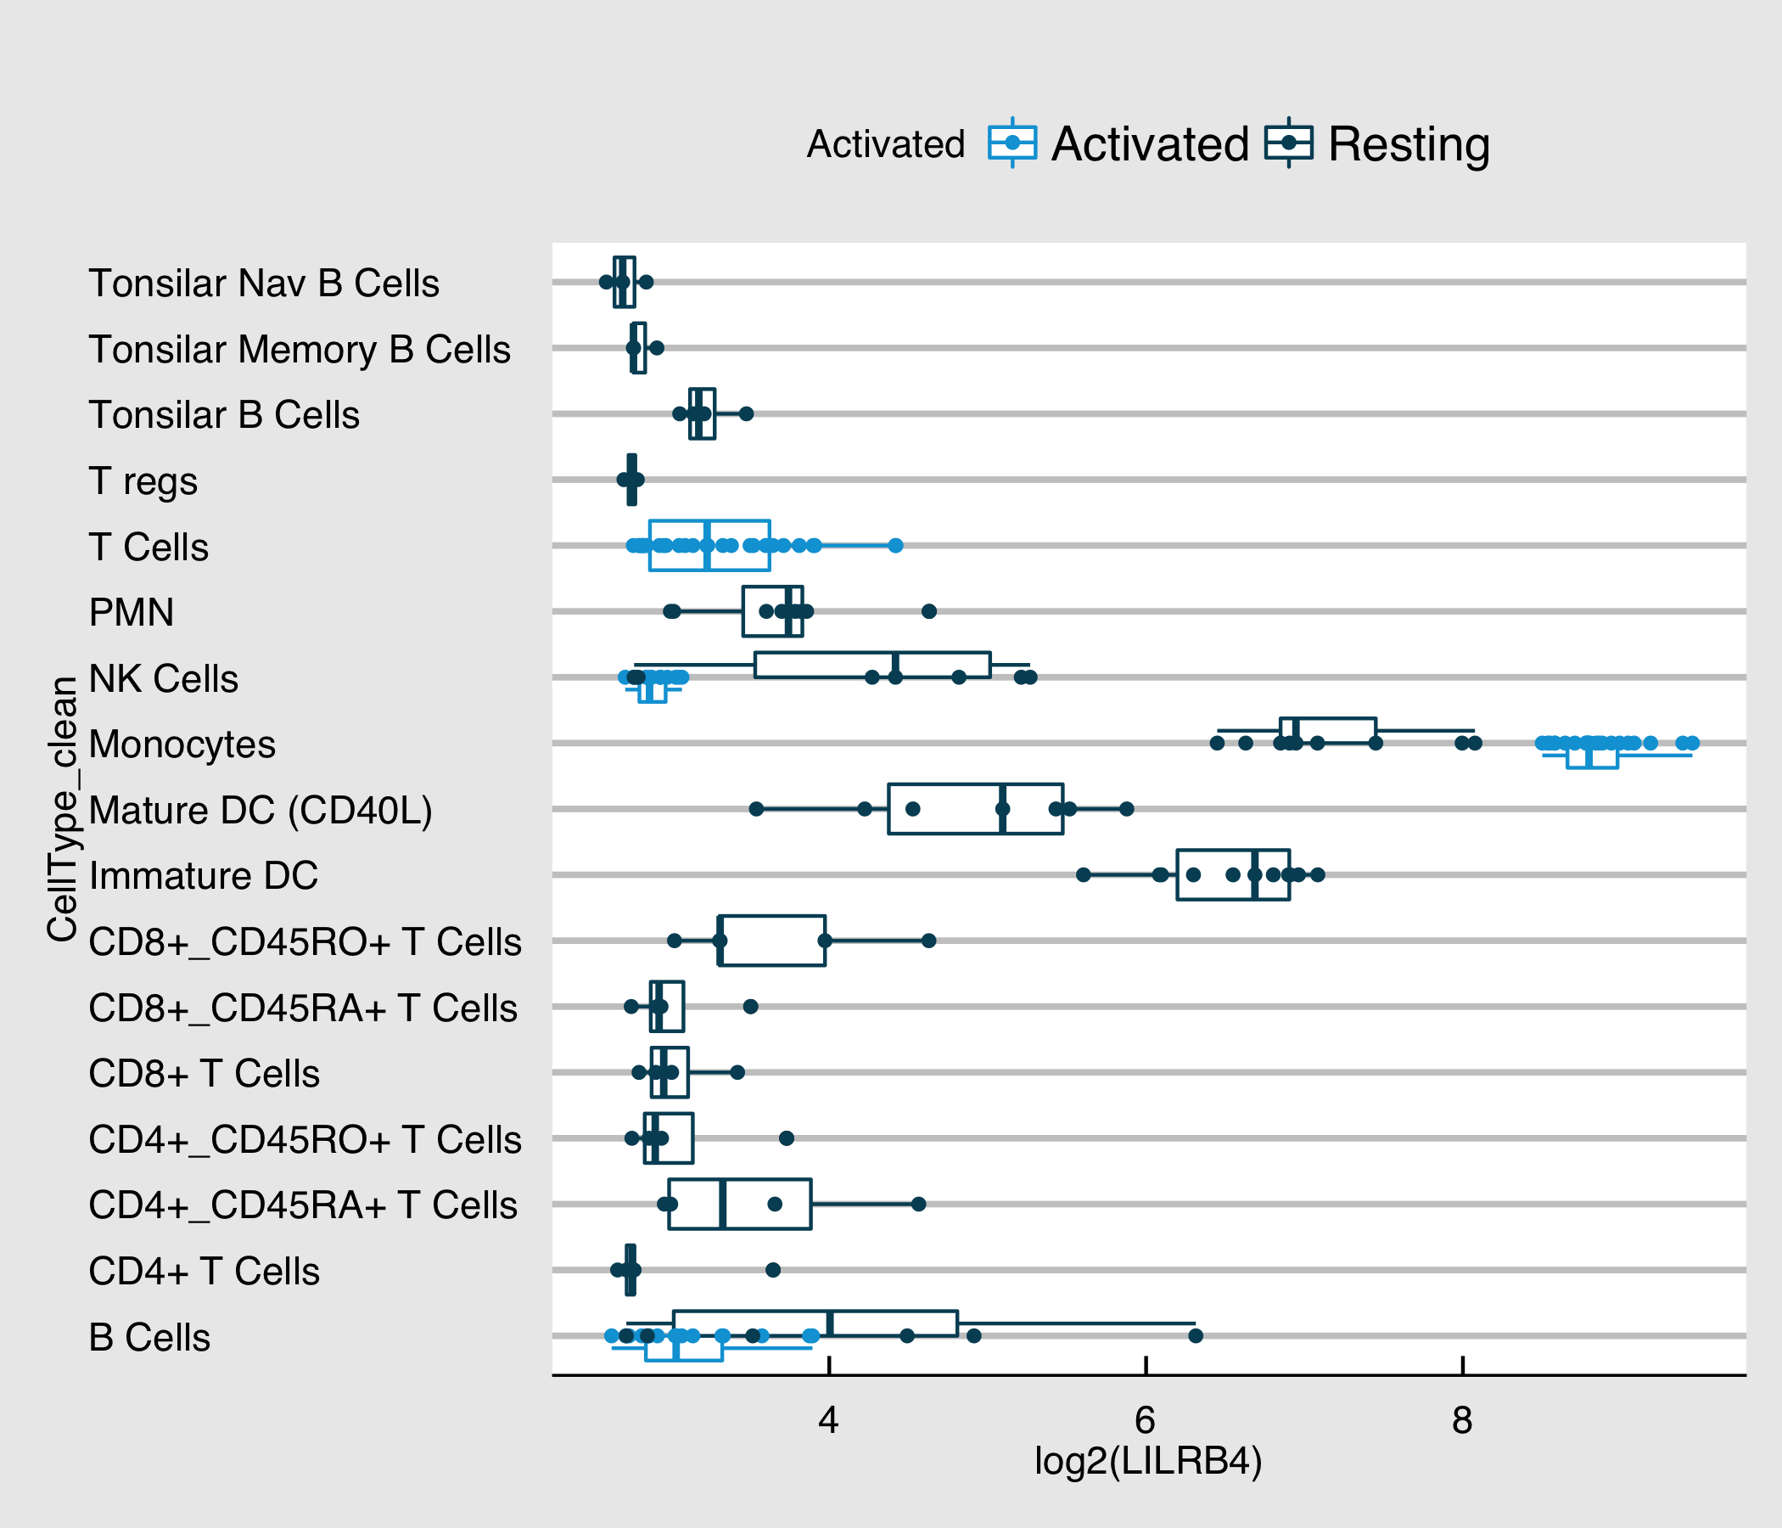

plot of chunk combined.imm.decon

### Project: Hallstrom Body Map (gene level)

Caution - right now these absolute numbers cannot be compared to the TCGA values

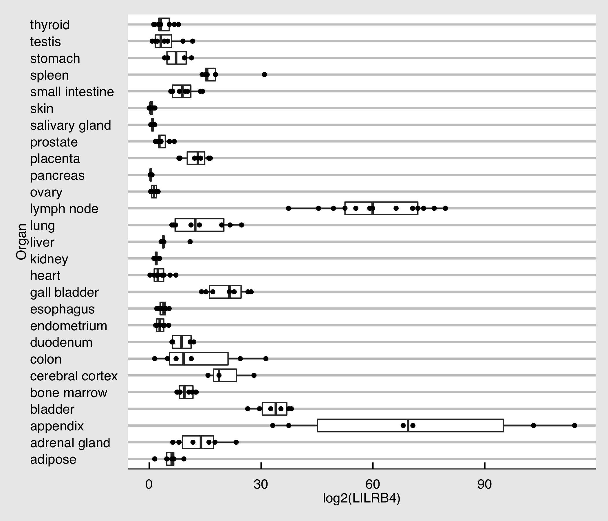

plot of chunk hallstrom

### Crown PDX Models

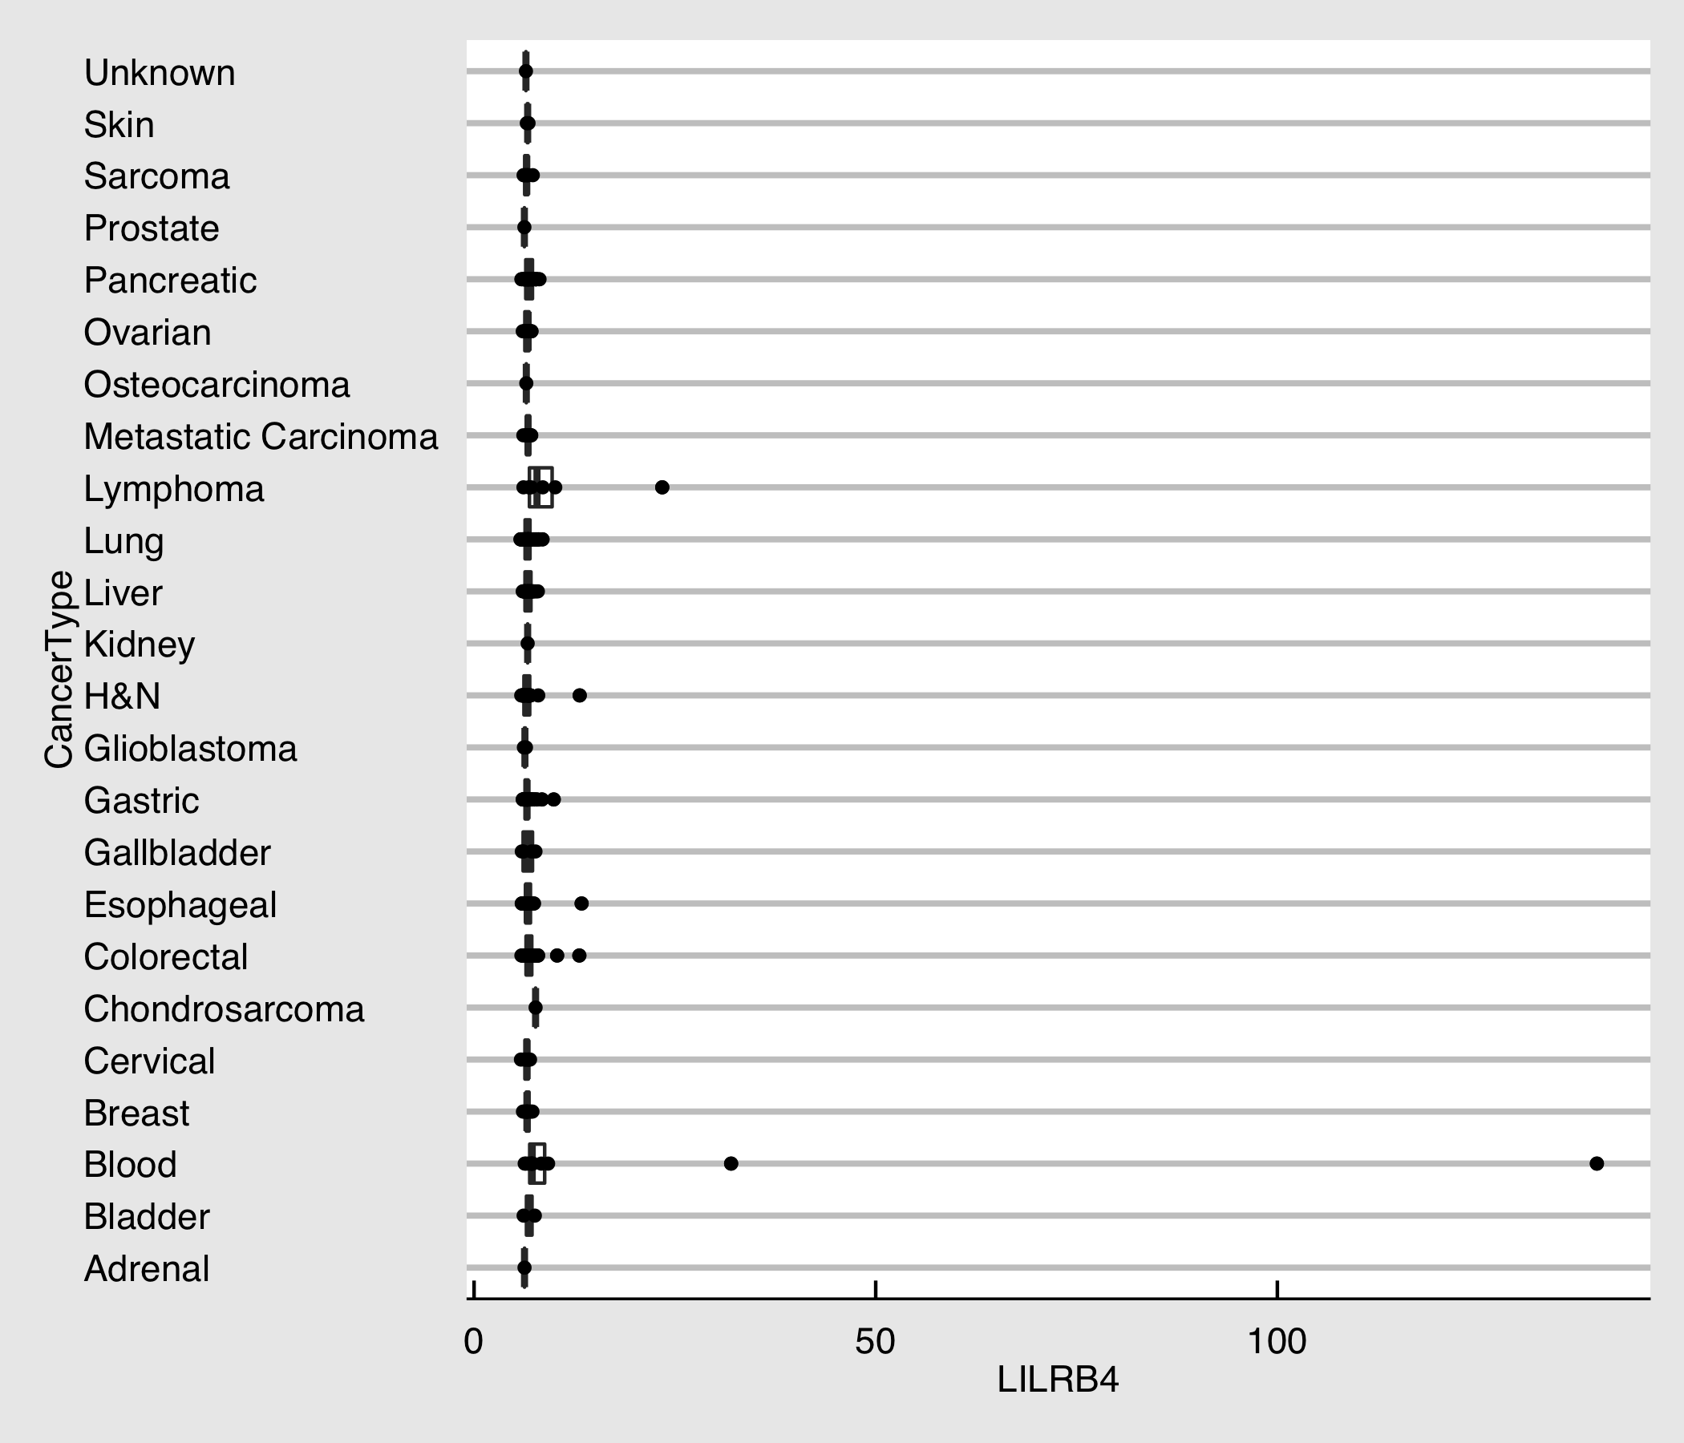

plot of chunk crown