Nathan Sirere

**Cybersecurity** (Online) 2:00PM-4:00PM

WHOIS.COM

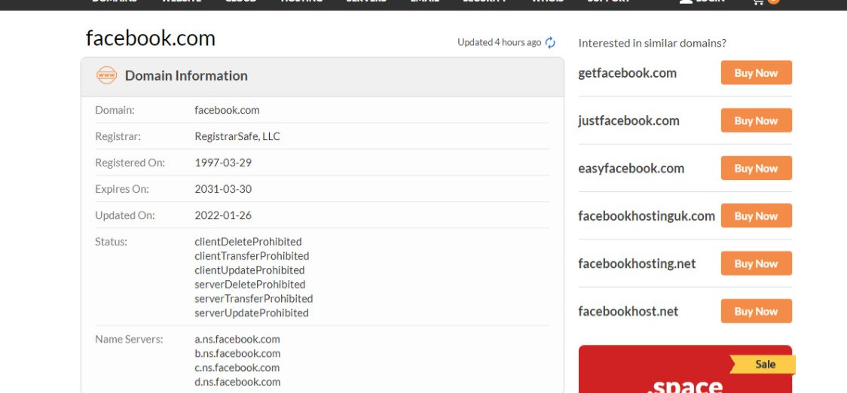

Domain information for Facebook.com

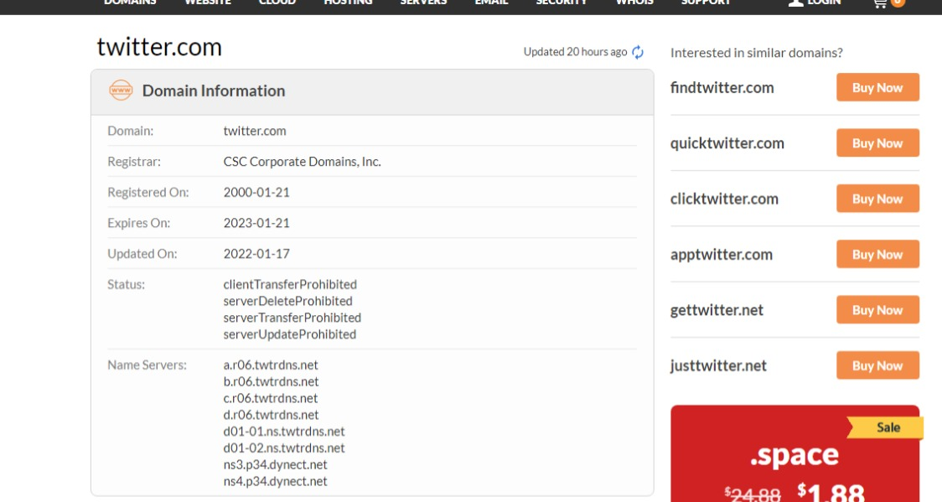

Domain information for Twitter.com