Nathan Spasaro
CSD 325
Module 9.2
11/6/2026

Astronaut request code:
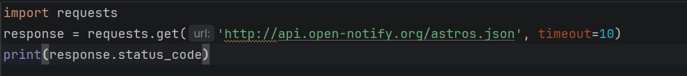
Astronaut request result:
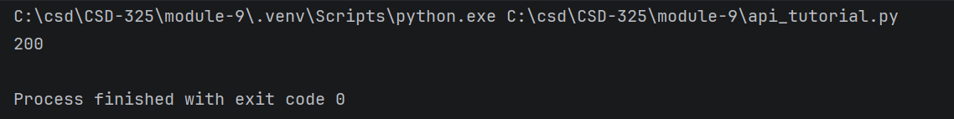
Astronaut call and print code:
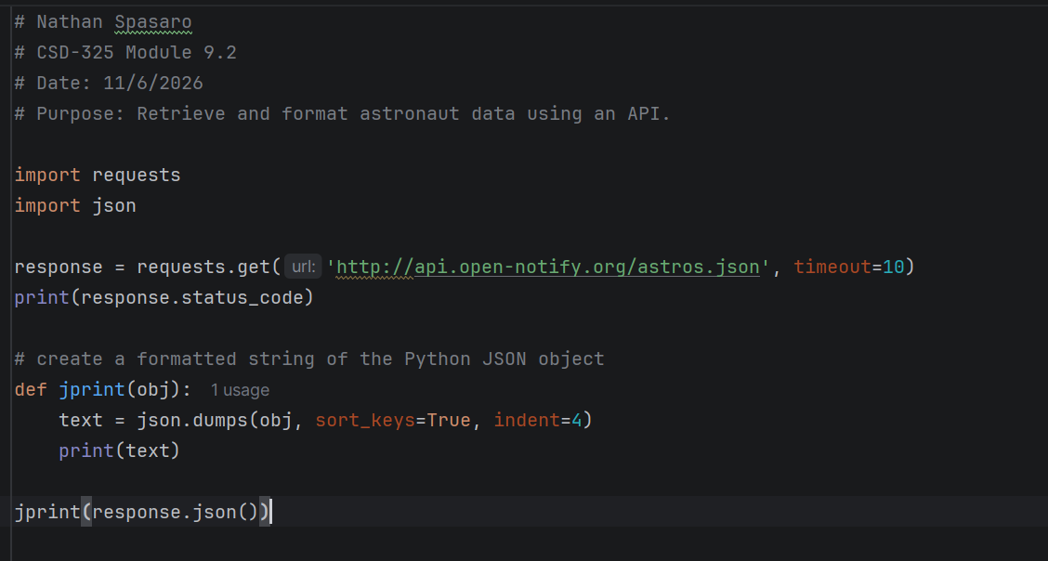
Astronaut call and print result:
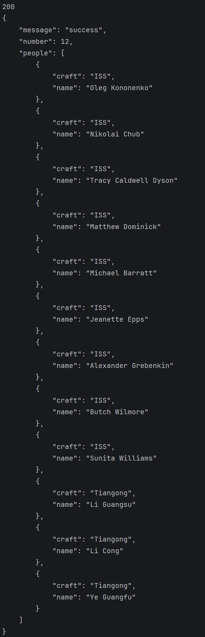
Poke API code:
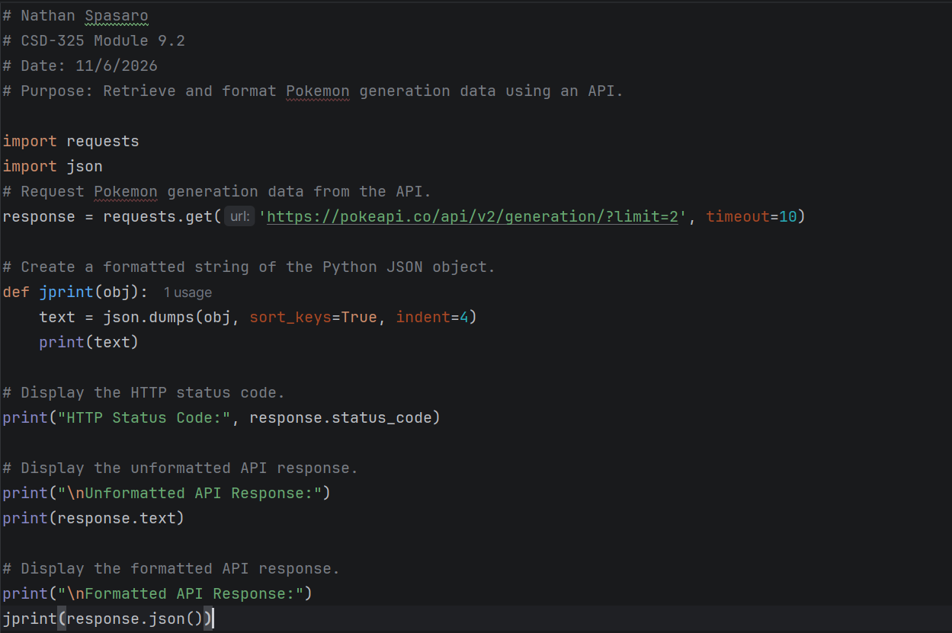
Poke API result:

