Nathan Spasaro
October 26, 2026
CSD-325 Module 8 Assignment

Flow Chart:
- 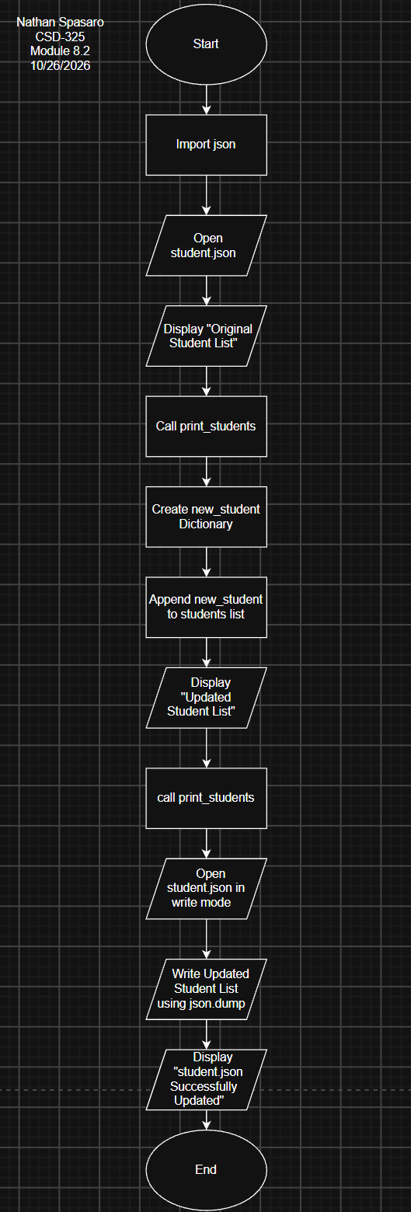
- 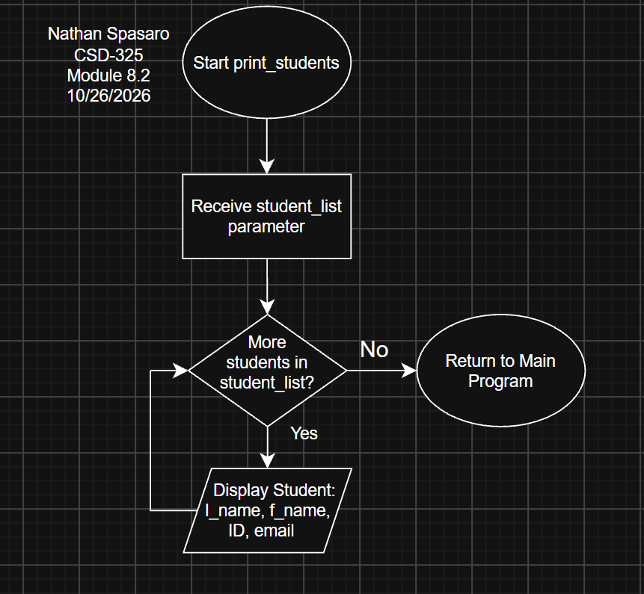

Results: 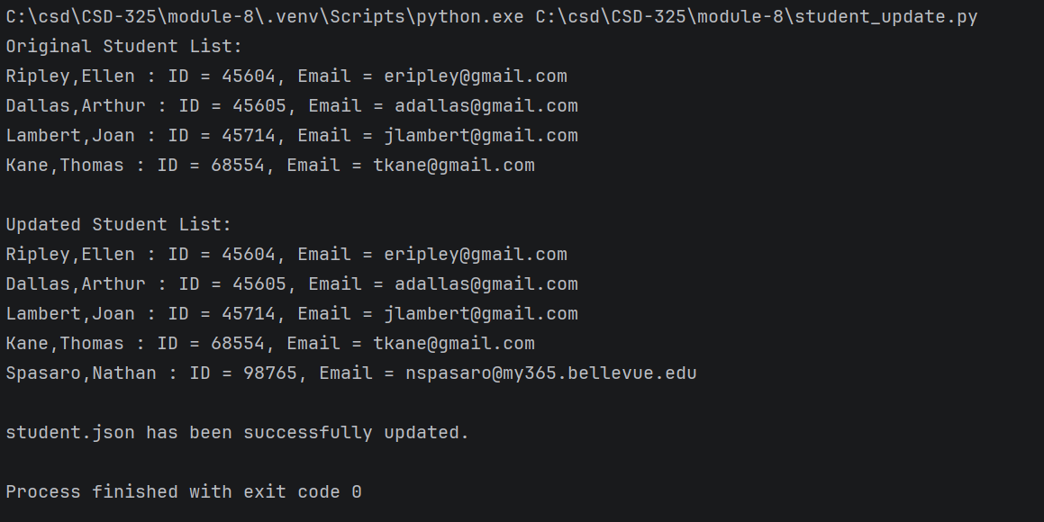

Updated .json file contents:
[
{
"F_Name": "Ellen",
"L_Name": "Ripley",
"Student_ID": 45604,
"Email": "eripley@gmail.com"
},
{
"F_Name": "Arthur",
"L_Name": "Dallas",
"Student_ID": 45605,
"Email": "adallas@gmail.com"
},
{
"F_Name": "Joan",
"L_Name": "Lambert",
"Student_ID": 45714,
"Email": "jlambert@gmail.com"
},
{
"F_Name": "Thomas",
"L_Name": "Kane",
"Student_ID": 68554,
"Email": "tkane@gmail.com"
},
{
"F_Name": "Nathan",
"L_Name": "Spasaro",
"Student_ID": 98765,
"Email": "nspasaro@my365.bellevue.edu"
}
]

IMPORTANT: The Python program successfully updated the student.json file using json.dump(). However, the development environments tested did not display an external file modification notification. The updated JSON file was verified to contain all five student records.

