Base flowchart (NO CHANGES NECESSARY FROM 5.2)
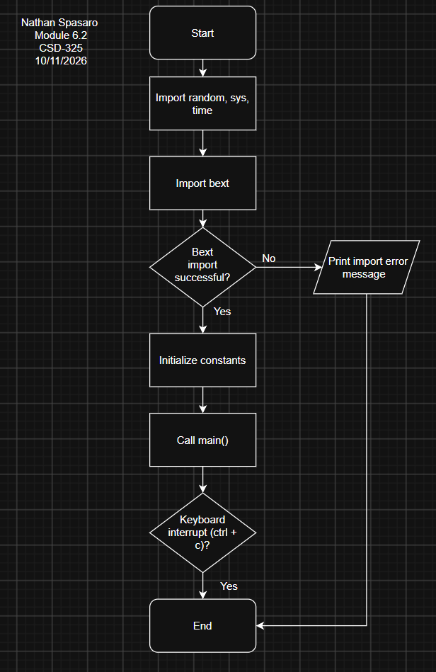
CreateNewForest flowchart (UPDATED FOR 6.2: CHECK AND CHANGE PIXEL TO WATER)
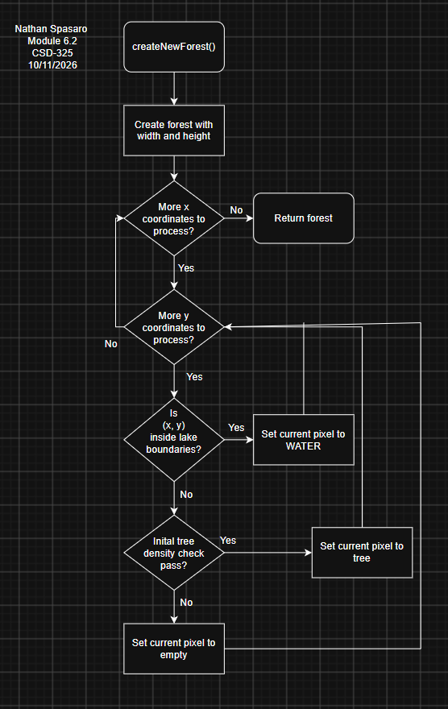
Main function pt.1 (UPDATED FOR 6.2: CHECK AND CHANGE PIXEL TO WATER)
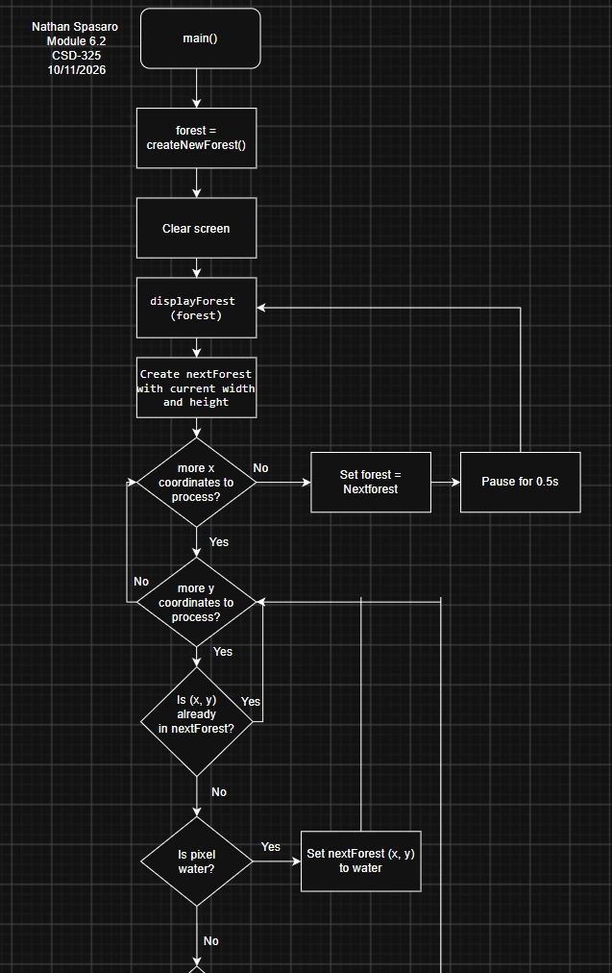
Main function pt.2 (UPDATED FOR 6.2: CHECK AND CHANGE PIXEL TO WATER)
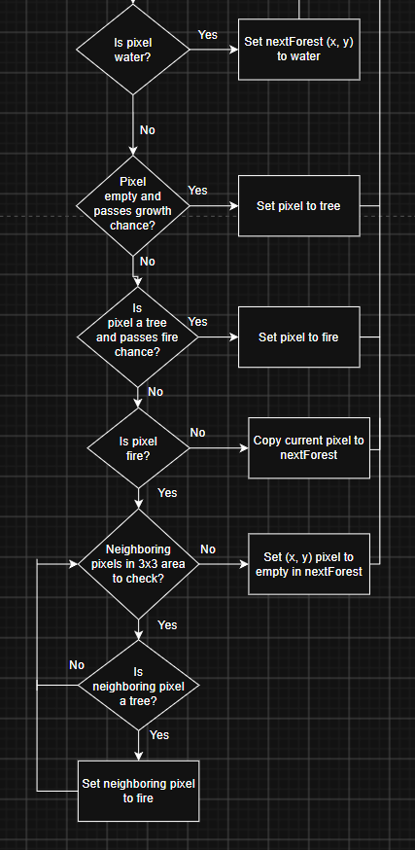
DisplayForest function (UPDATED FOR 6.2: CHECK AND PRINT WATER)
