Nathan Spasaro
Module 2.2
CSD 325
09/08/2026
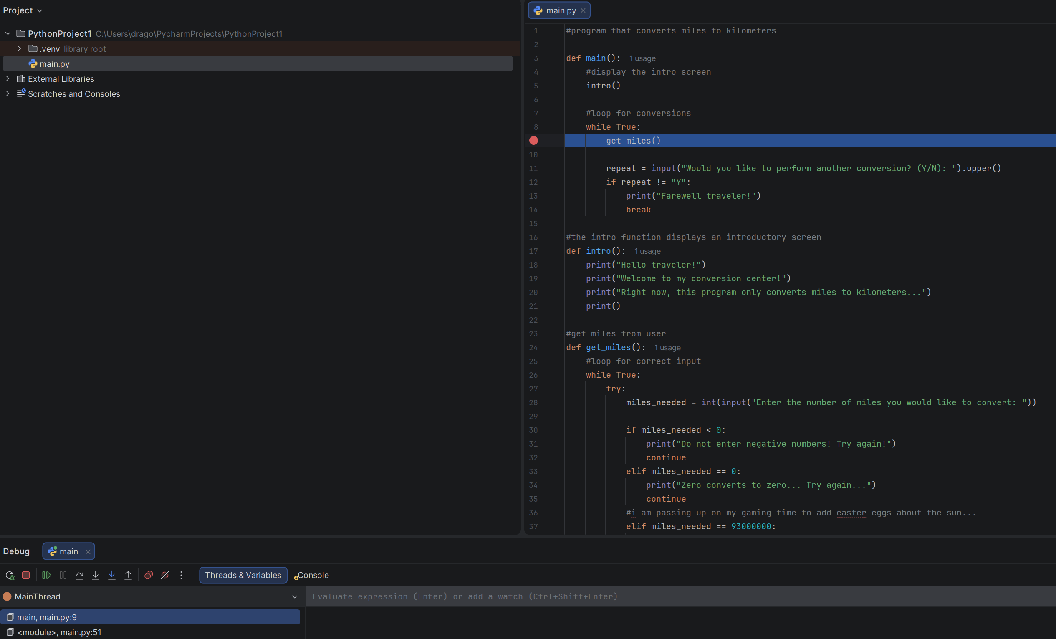
Inserted Breakpoint at call for get_miles function.
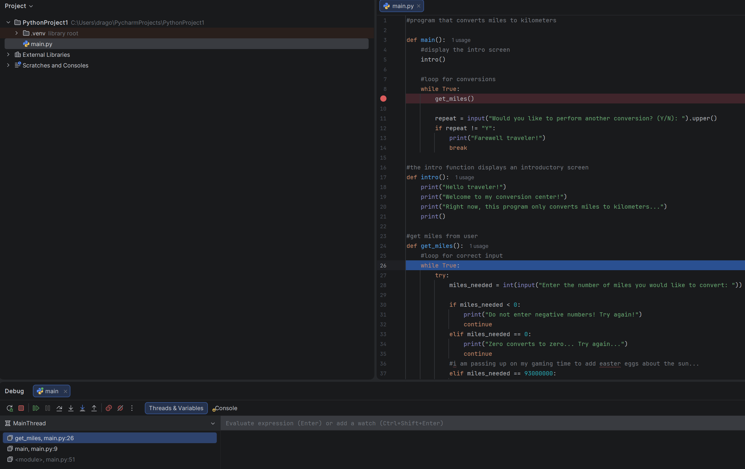Stepped into the get_miles function.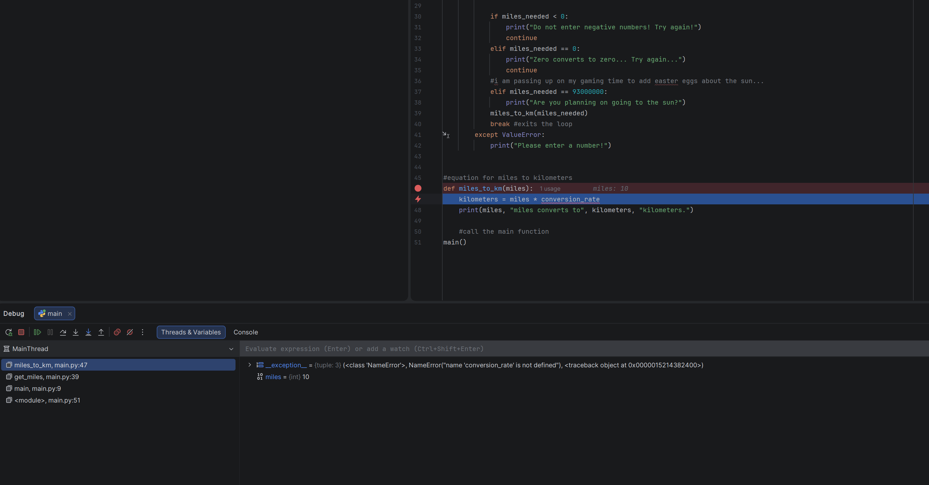Deliberately introduced a name error in the miles_to_km function. The debugger identified the error and displayed the name error in the Debug window.

