User guide
Before anything, make sure requirement listed in Table 2 are met. For software installation, see 5.2 necessary software.

Starting an analysis

Create a folder for analysis.
First, create the main folder for analysis. For this guide, we will name it “CABaNe_TEST” (Figure 1)
If you wish to automatically sort your images, to remove non-analysable images, you can automatically create the subfolders, as referred in “3 Sorting images”. Otherwise, it can be done manually.
Figure 1: Main folder

Create or make sure you have sub-folders.
If done manually, the folder has to be created within “CABaNe_TEST”. Here, we named the folder for input “IMAGES_TO_TREAT”, the output “RESULTS”, and our unsorted images in “RAW_IMAGES”. Put your unsorted images in “RAW_IMAGES”. “SUMMARY_RESULTS” is the excel we will use to summarize large data set later. The input and output folders should contain a folder for each condition, named in the same manner (here we only have one but the number is not limited). The input condition’s folder should be containing every un-merged images. A visual representation of the folder is available in Figure 2.
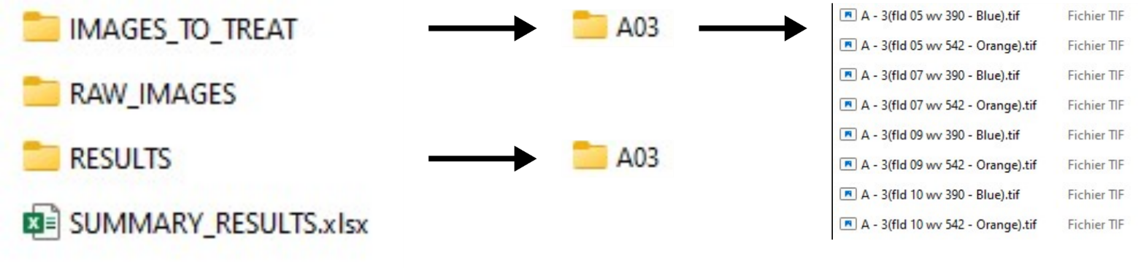
Figure 2: Folder and subfolder to start the analysis

Start CABaNe.
Open your current version of CABaNe in FIJI, make sure you have the MorpholibJ plugin. Regularly check for CABaNe updates on the GITHUB. Run it.
The following interface will appear (Figure 3).
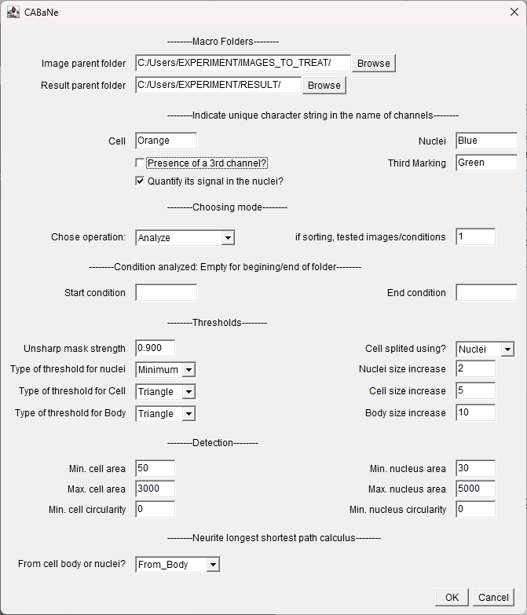
Figure 3: Main interface and default parameters

Select the paths:
Select the main input folder (IMAGES_TO_TREAT) in “Image parent folder”,
and the path of your main output folder (RESULTS) in “Result parent folder”.

Choose the parameters.
Each parameter is explained in “4 Parameters”.
Here, we chose the parameters already optimised for this data set, as displayed in Figure 4.
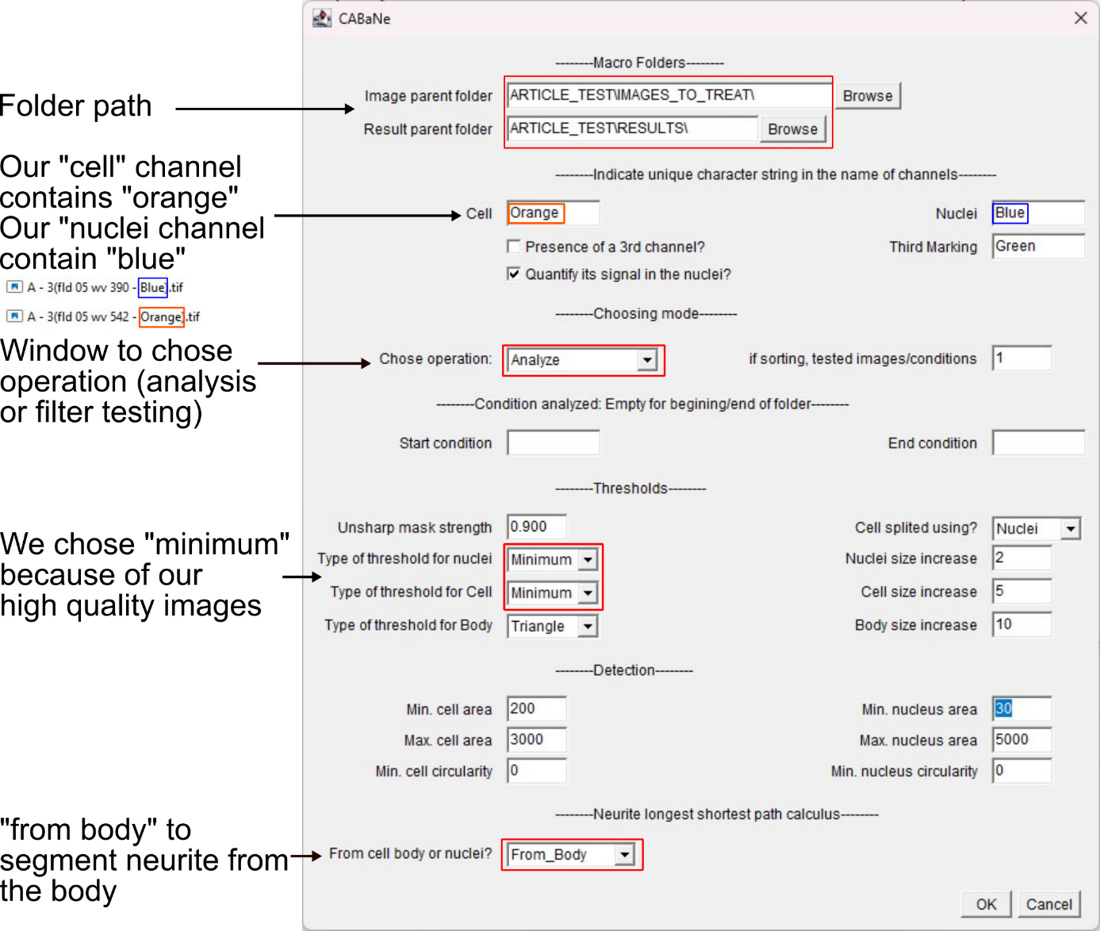
Figure 4: Main interface and parameter for test

Test filters
For a first-time analysis of a type of data set, it suggested to run a “Test_filter” to verify our parameters (Figure 5). Click “Ok” to initiate. Filtering will run automatically, and will display a verification image (Figure 5), as well as intermediates images. This will happen for each condition, by the number of tested images/conditions inputted. Start and end condition folder can be inputted, if it wished not to test the whole dataset at once. When finished, the main CABaNe page will appear again with the same parameters as before. It is possible to change parameters to tune the analysis to the current dataset.
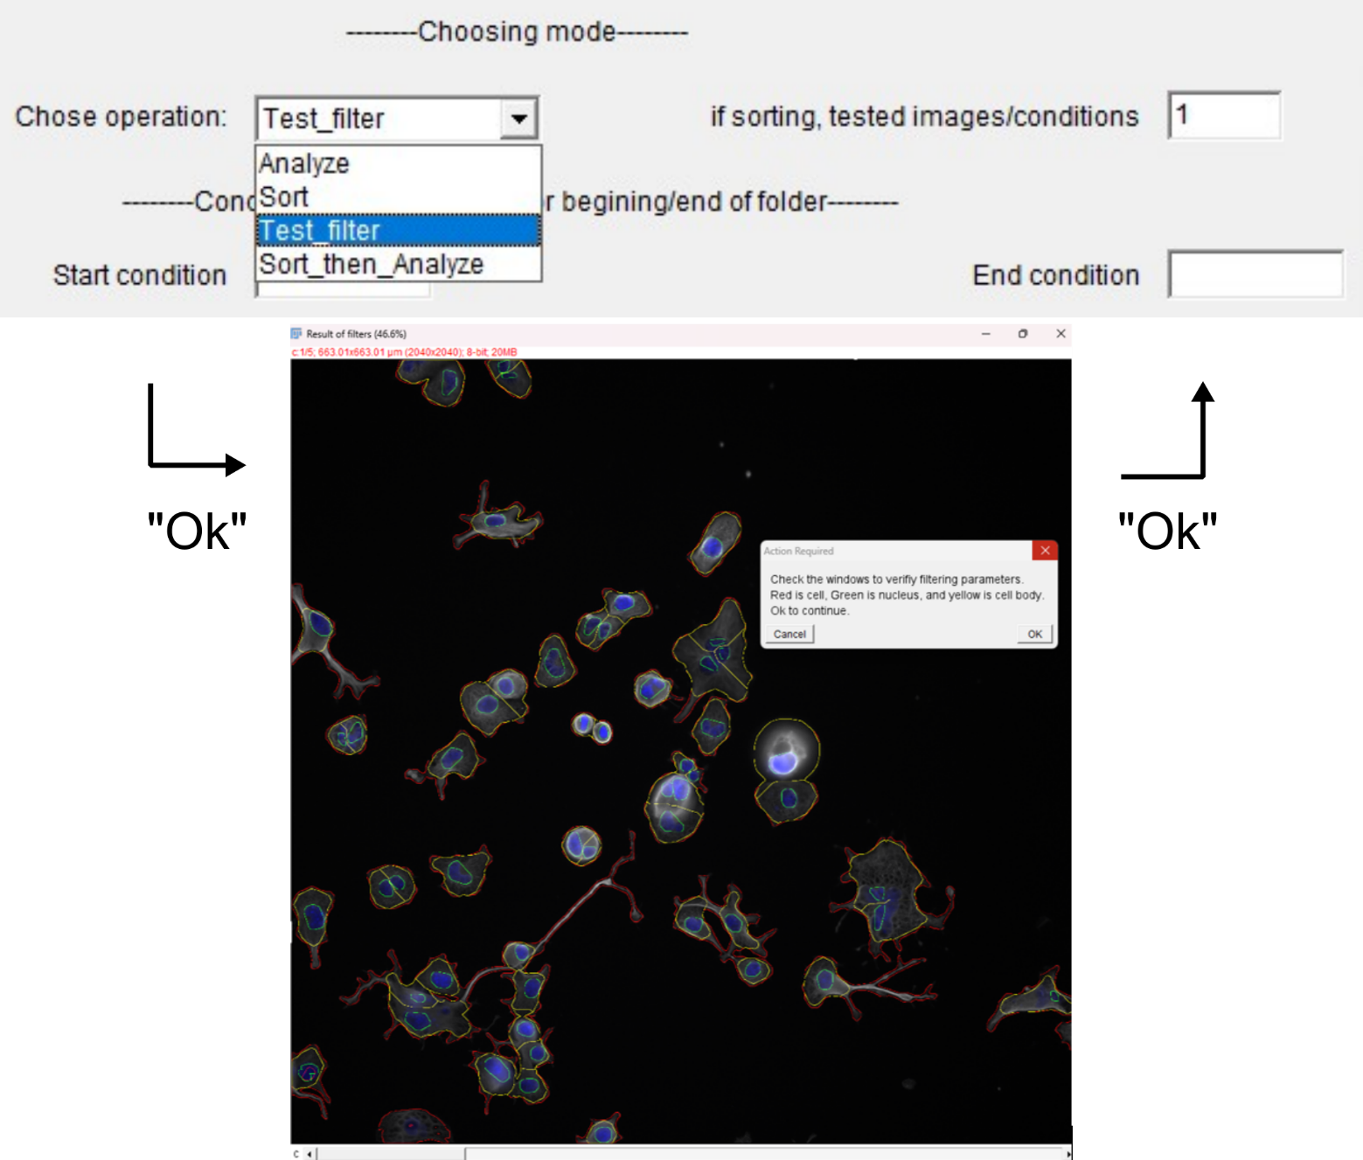
Figure 5: Test filter mode

Start analysis
To start analysis, select “Analyze” in “chose operation” and click “Ok”. Analysis is automated.
After clicking ok, CABaNe will start running in background. Depending on the number of images and cells, and the hardware used, the analysis can be quite long. We estimate the duration to 2min per images, for approximately 50 cells/images. While it is running, it might be complicated to use the computer, due to the nature of ImageJ macros, as they are given priority when opening a new window. We generally avoid using personal PCs for analysis when they are needed for other tasks. As an alternative, we run the analysis overnight. It should continue to run even on a locked computer. The log window indicates overall progression, for each image.
A message will indicate the end of the run. It is then possible, depending on needs, to go to the files to get the results or to check the analysis.

Get results

Result architecture
For each condition, following architecture will be created. “_Metadata” contains a file with all the values for the parameters used. “_Segmentation checks” contains, for each field of view, the ROI for the cell, nuclei, and body segmentation, as well as a recapitulative TIF image. The overall architecture is available in Figure 6.
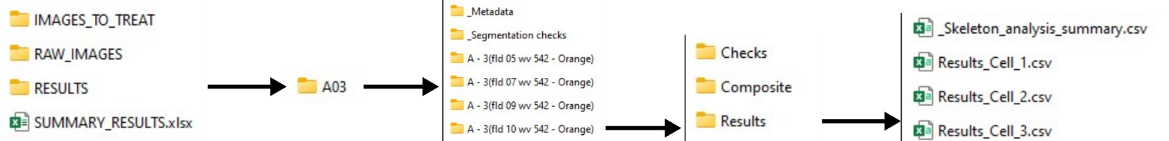
Figure 6: Folder and sub-folder architecture for results

Result architecture per field of view
For each field of view, 3 folders are available: “Checks” and “Composite” are single cell segmentation of cells while “Results” contains all the measures obtained for each cell, in a CSV file named “Results_Cell_X” (detailed single cell results, where X is the number of the cell in the image). A summary single cell analysis file, “_Skeleton_analysis_summary” reports the measures obtained in the current field of view and all the previous fields of view of the condition.
ImageJ default decimal separator is the dot, and column separator the comma. Depending on your operating system parameters, result may appear condensed in one column in the csv. The “data””Convert” option in excel can be used to rectify it.

Automated result retrieval (optional)
Additionally, we provide a python macro for automated data summarization.
It simply copies all the last summary csv table from each condition in a premade excel. The python code, as well as an example premade excel, are available on the Github. Each summary goes in a excel page baring the name of the condition. The last page can be used to summarise all the data in one table. If previously used, the excel pages of conditions have to be emptied starting line 3, before starting the python code. Path to the main folder have to be changed in the code; mind the direction of the slashes. The summary file has to be in the same folder as the same parent folders, here “CABaNe_TEST”, with “RESULTS”, as displayed in Figure 2.
When running the python code, conditions names should be displayed in the log.

Sorting images
Sorting image allows to remove the images that would make CABaNe stop working. Additionally, under specific conditions, it can store the images directly in the conditions folders.

Set parameters for image sorting
Either use default parameters, or select a few test images to tune the analysis. To do so, create a temporary folder following Figure 2 architecture. Then, refer to above (Point 1.3.3). Select “Sort” in the “Chose operation” window.
Once you know what parameter to use, remove the images from “IMAGES_TO_TREAT”. Create your main folder, named here “ARTICLE_TEST” (can be changed) (Figure 1) and put all of your unsorted images in the “RAW_IMAGES” (name and location can be changed).

Start sorting
Click “Ok”. A new interface will open (Figure 7).
“Where are the images?” is the path to all the images to sort. In our case, it would be “RAW_IMAGES”.
“Where to save images?” is the path to the main folder, here “ARTICLE_TEST”.
If file name has a distinct condition name in their title, the “Shall images be automatically sorted in conditions folders?” option can be ticked on, with said character reference in the following case, and indication if the condition name if before or after it. In our example, “A – 3(fld05 wv 390 – Blue).tif” have a well reference, “A – 3”, that is before a “(“. Therefore, we indicate “(“ as the character, and that the name is before the character. As a consequence, a folder name “A – 3” will be automatically be created in the “IMAGES_TO_TREAT” and “RESULT” folders, when sorting this image. For the next images from well A4, a folder name “A – 4” would be created and so on.
If the option is ticked off, images will be sorted in a generic folder, named “sorted_images”, within “IMAGES_TO_TREAT”, and the user will have to manually put the images in different condition folders.
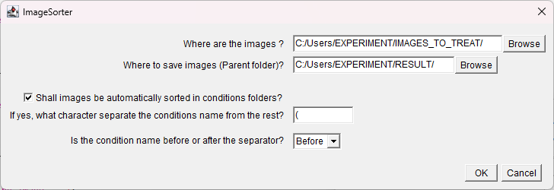
Figure 7: Sort interface

Parameters, by category

Macro folders
Image parent folder: Selection of the path to the folder containing the conditions folder, containing the images to analyse.
Result parent folder: Selection of the path to the folder containing the conditions folder, containing the results of analyzed images

Indicate unique character string in the name of the channels
“Cell” is the channel with cell staining. “Nuclei” is the channel with nuclei staining. “Third marking” is an optional channel if analysis of the intensity of an additional channel needs to be measured. If used, “Presence of a 3rd channel?” has to be ticked on. Additionally, whether the signal is measured in the nuclei or in the whole cell can be changed by ticking on or off the “Quantify its signal in the nuclei?” option.
For “Cell”, “Nuclei”, and “Third marking”, a character string only found in the name of this channel have to be put. In our example, “Orange” is only found in the cell staining channel.

Choosing mode
“Chose operation” will determine what happen when you click ok. “Analyze” will run the analysis and “test filter” will give you a visual feedback of filtering parameters. Both uses the parameters and path inputted. “Sort” will sort the images using current parameter, and will open an extra window to choose the path to the raw image, and to the parent folder for analysis. “Sort then analyse” will do these two steps one after the other, using the folder created by the “Sort” operation.
“If sorting, test images/conditions” will determine the number of images tested per conditions when running the “test filter” operation.

Condition analyzed: empty for beginning/end of folder
“Start condition” is the first condition to be analyzed or used to test filter, in alphabetical order.
“End condition” works in a similar manner, but for ending the analysis of the filter test.
If empty, operation will respectively start at the first folder or end at the last.

Thresholds
“Unsharp mask strength” is a number comprised between 0 and 1, influencing the strength of unsharp mask. This filter is used to differentiate cells from their background, but can generate unexpected result when a large portion of the image is empty.
“Cell split using?” will determine how cells will be differentiated from one another. Cell nuclei or cell bodies will be used to split cells that are touching. Nuclei is the default option, but in the case where no nuclei staining is available, body can be used as a backup.
For each shape detected (Nuclei, Cell, Body) different threshold are available. They all have different formulas, making them more or less robust or precise depending on the quality of the image. We advise “minimum” for high quality images, and “mean” or “triangle” for lower quality staining, and images with more graphical noise. Typically, “minimum” will be the most exact but also the most prone to failure if the element to highlight is not clearly distinct from the background, or of too low intensity. “mean” and “triangle” are less exact and will often segment more than the wanted element, but are less sensible in case the element is not as distinct from the background.
In a similar manner, for each shape we apply a size compensation that can be changed in the “size increase” to slightly tune the shape detection.

Detection
Minimal and maximal area for cell and nuclei shape detection are set in µm². Object outside of these values will not be accounted. Typically, the minimal value can be increased to remove debris, noise or an unwanted cell population. The maximal value can be reduced to prevent the analysis of larger particle, defect, or blurry agglomerates of cells.
Similar filtering can be applied using a minimal circularity.

Neurite longest shortest path calculus
The longest shorted path, or neurite length, can be calculated from the nuclei or the body, by changing the value in the “From cell body or nuclei?” window. Calculation from cell body is more representative of the true neurite length and do not suffer from false positive (cells with large cell body in regard to their nuclei), but require a good cell body segmentation.

Additional information

Verify images
To check the analysis, it is possible to check cell and nuclei segmentation in the image, opening the .tif in the “Segmentation checks” folder. For single cell pathing, images in “checks” represent the segmentation and pathing of single cells. To choose which channel to see, use the Channel tool (ctrl + shift + Z) in image J. Channel 1 is the cells contouring after watershed. Channel 2 is the nucleus segmentation. Channel 3 is the skeleton of cells. Channel 4 is the result of the masks on the cell channel. Channel 5 is the base image. Channel 6 is the body of each cell, after watershed.

Necessary software

Fiji can be found at that address: https://imagej.net/software/fiji/downloads with all information for installation.
All information for MorpholibJ 1.6.3 installation can be found on that page: https://imagej.net/plugins/morpholibj

