**TASK:**

* ‘*Develop and submit an original logic circuit for a basic alarm clock. The interface must display the time in 12-hour format, indicate AM/PM, and provide the facilities to set the time and an alarm. When the alarm is enabled, an alarm LED is turned on when the time is reached.*’

**DUE DATE + WEIGHTING:**

* September 18th 2022, Midnight. (Start of Week 7)
* 20% of aggregate mark for unit

**DESCRIPTION:**

* In Logisim, building a 12-hour formatted alarm clock
* Including a ‘Set Time’ function where in enabling it will pause the clock, and inheriting the ability to add minutes or hours to the existing value on the clock
* The utilisation of logic gates such as AND, OR, XOR gates, as well as the use of inverters
* The utilisation of 4-bit ripple counters converting binary into a single decimal value to enter into the clock. These are with implemented with the use of 4 JK Flip flops
* The utilisation of 4 Hex Digit Displays to mimic the face of a digital alarm clock.
* 1 Clock within the whole circuit located within the 10’s column of the minutes section of the circuit.

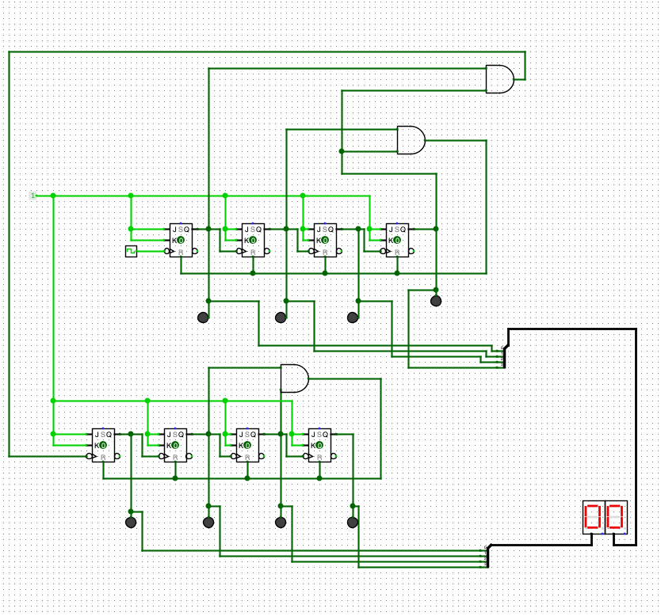**DEVELOPMENT STAGE:**

***STAGE 1:***

* Implementing the following;
* Separate counters for the ones and tens column of the minutes counter
  + 0-9 for the one’s
  + 0-5 after the ten’s, wrapping back to 0 after reaching 5.
* Both counters wrap to 0 after the two counters display together 59.
* Used a 4-bit ripple counter with the presence of a splitter to connect

the counter to a Hex Digit Display. (2 of these, one for each column)

* 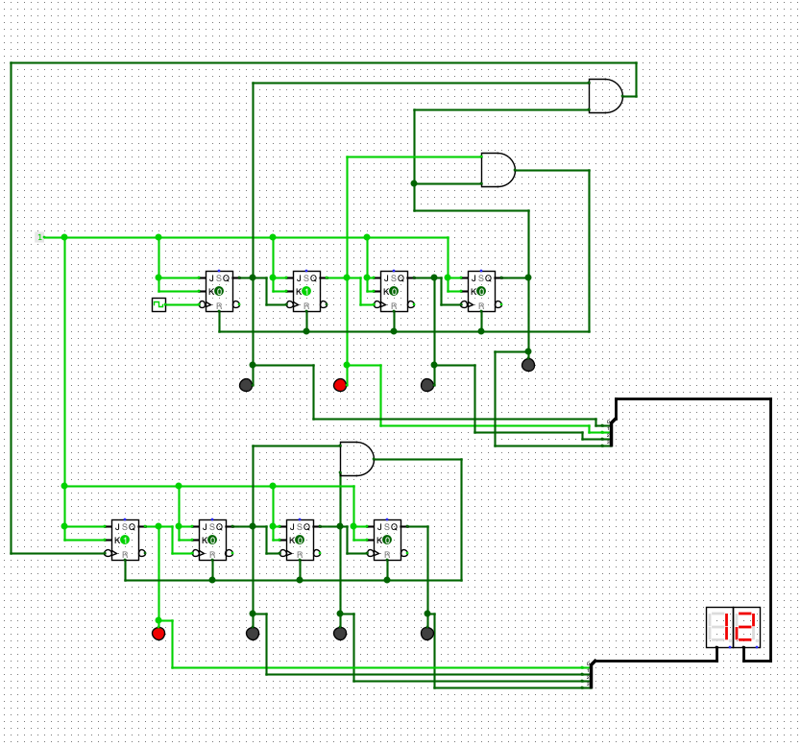Set up wires from the output of the least and most significant bit in the

one’s column (value 9) to create a rule where once the two outputs are high,

through a AND gate it will reset all the JK flip flops (ripple counter entirely)

* + Like-wise with the ten’s column however, wiring up the second and third

Least significant bits to reset once the value 5 is reached

***STAGE 2:***

* 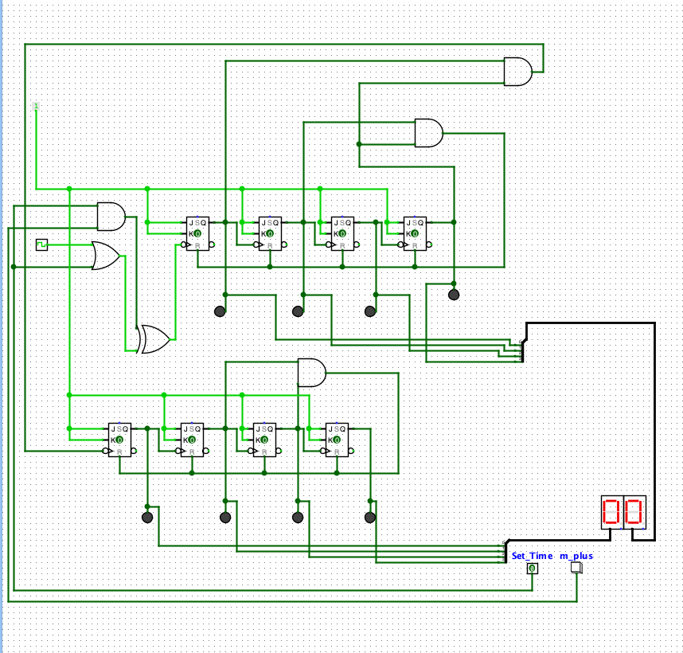Implement the following;
* Button/Pin that switches the clock into a ‘Set Time’ mode 🡪 Will pause the

clock

* + When disabled, normal ticking should resume
* A m+ button that allows for manually incrementing the minutes by 1 with

each click.

* Used a Pin for the Set Time mode and button for the incrementing the

minutes

* Moved the clock to be placed in a OR gate with Set Time, this will enable

the clock to be paused when Set Time is enabled, and each click of the

minutes plus will instead act as a clock pulse.

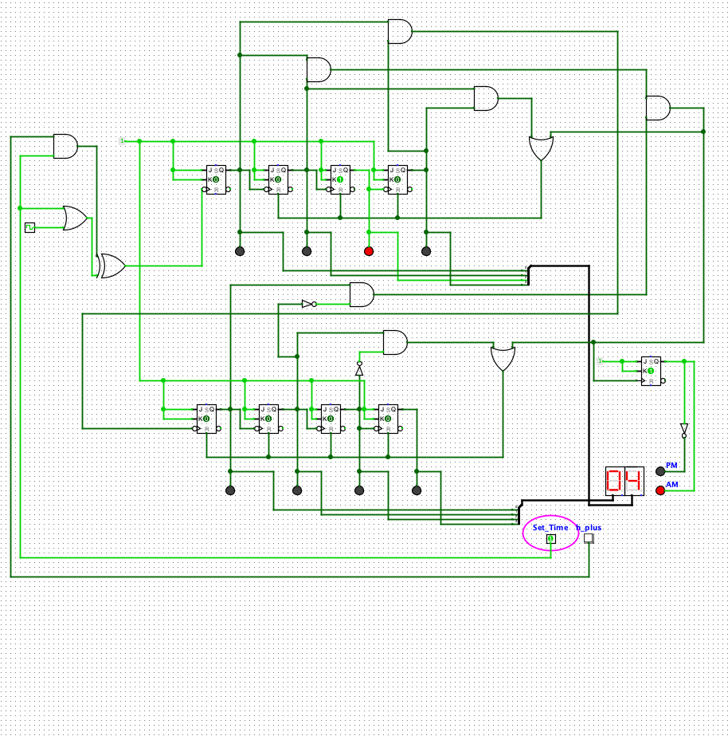***STAGE 3:***

* Implementing the following;
* Separate counters for the ones and tens column of the hours counter
  + 0-9 for the one’s, wraps back to 0 after reaching one, and

once reaching 12 entirely in the hours display will wrap back

to 1

* + 0-1 for the ten’s, wrapping back to 0 after reaching 12 entirely

in the hours display

* A h+ button that increments the hour display by one once the Set Time

pin is set to high

* A AM/PM LED that toggles between on and off after reaching 12.

* Wiring to a AND gate from the output of the second most significant bit and

the least significant, to convert into the value 9 and reset the one’s counter

* + Also another set of wiring from output of most significant bit

and second most significant bit to a AND gate (other wire is from

ten’s column once 1 is reached paired with 2 from the ones counter)

that wires for the reset of both counters

* Use of a single JK Flip flop which takes in inputs from a constant, and the clock

Pulse running from the AND gate for the reset of both counters. The output of

one LED switching on and off the clock pulse after 12 hits.

* + Inverted an output to have a opposite effect on another LED, in my

opinion is a more accessible means in reading the time

***STAGE 4:***

* Combine the hours and minutes counters together!
* From both the minute’s counter, once reaching the value 59, this will push through a clock pulse to the hours counter, thus incrementing it by one
* Wired both separate Set Time buttons from Stage 2 and 3 into one button, thus, there is only one button now that will pause the whole clock.

