MXB332

Case Study

12/5/2021 Semester 1

n10217240 – Nathan Larnach

Mathematical Model

Let s be a school within set S, where S = {BE, BES, CEE, CD, CS, EAS, EER, IS, MMPE, MS}.

Let f be a floor within set F, where F = { 1, 2, 3, 4, ….., 33 }.

Let C­­­­f be the capacity of each floor f.

Let X0 be the initial faculty layout of the HDR spaces.

Let Y0 be the initial faculty layout of the AS spaces.

Let Xfl be the optimised faculty layout of the HDR spaces.

Let Yfl be the optimised faculty layout of the AS spaces.

Let X be a RV of the number of relocations of HDR spaces.

Let Y be a RV of the number of relocations of AS spaces.

Let Nx be the total number of HDR spaces in X0.

Let Ny be the total number of HDR spaces in Y0.

Let A be a binary variable indicating the presence of a school s HDR space in floor f.

Let B be a binary variable indicating the presence of a school s AS space in floor f.

Objective function : $MIN X+2×Y$

Subject to:

1. Floor capacity:
$$\sum_{s=1}^{10}{\left( X_{fl}+2×Y_{fl}\right)≤ C_{f}}$$

2. Total No. of spaces:

$$\sum_{f=1}^{33}{X_{fl}= N_{X}}$$

$$\sum_{f=1}^{33}{Y_{fl}= N_{Y}}$$

1. Min to Max objective function:
$$X≥X_{fl}-X_{0}$$

$$Y≥Y_{fl}-Y_{0}$$

2. Single school per floor:
$$\sum_{s=1}^{10}{\left( A+B\right)≤ 1}$$

3. Isolation Constraint:

$$X_{fl}≤10000×A$$

$$4-X_{fl}≤10000×A$$

$$Y_{fl}≤10000×B$$

$$8-Y_{fl}≤10000×B$$

Faculty Layout solutions

Ideal Solution

This solution required no time limit as it only 1.55 seconds for CPLEX to find an optimised solution. 358 out of 492 AS spaces and 550 out of 663 HDR spaces needed to relocate to fit the optimised layout.

This ideal solution has no floors housing more than a single a school.

The optimised faculty layout relocated almost every space for each school.

The BE school has 46 AS relocations and 86 HDR relocations, the school is spread over 3 different floors in three buildings, H, P, and R.

The BES school has 57 AS relocations and 38 HDR space relocations out of 56 HDR spaces. This school was originally spaced out over 11 floors over 4 buildings, but is optimised to be spread over a total of 2 floors, in buildings S and P.

The CEE school initially had 29 AS spaces spread over floors S7 and S8, and 61 HDR spaces spread over S7, S8, and S9. All 29 AS spaces were reallocated into a floor each in buildings H and Y, all 61 HDR spaces were placed in a single floor in building M.

The CP school was initially spread out amongst numerous buildings. There were 3 AS spaces isolated all on their own individual floor. In the optimised floor plan, these spaces are much more incorporated and less isolated. 29 of the 55 AS spaces were relocated into floor S11 were there was already 26 of the spaces in the initial floorplan. 69 of the 90 HDR spaces were relocated from 4 floors in building S to 3 floors across blocks E, H and S.

The CS school were definitely better off from the optimised layout, having the spread of AS spaces being reduced from 11 floors across 5 buildings to 3 floors across 3 buildings and the number of floors containing HDR spaces reduced from 13 floors across 6 buildings (5 of which were the same as the CS AS spaces) to 1 floor in building S. The AS relocations were minimal with only 43 of the 76 spaces having to move, but all 110 HDR spaces were moved to a single floor.

The EAS school only had to relocate 19 out of 63 AS spaces and the number of floors (3) stayed the same after optimisation, the floor in building Y is still allocated in the optimised layout but while 2 of the initial floors where in building O, one of these floors was relocated to E block. The HDR faction of the EAS school also seemed to be fortunate in the optimisation, only 17 spaces were relocated to O5 to add to the already located 34, so there is minimal relocation for the school and now the HDR spaces for that school are all on the same floor.

Both the AS and HDR spaces for the EER school were relocated such that each faction had their own individual floor. 30 of the 31 AS spaces were relocated to O7 and the 43 HDR spaces were relocated to S9.  
Initially, the 78 IS school AS spaces were spread across 14 different floors in 7 of the 8 different buildings, but the optimised layout moved them all to S10. The HDR spaces for this school were affected in a similar manner, initially spread over 16 different floors and 7 buildings, this was optimised and 75 of the 104 HDR spaces were relocated to 2 consecutive floors in block O.   
The MMPE school has been allocated floors R2, R4, S12,and E2 in the optimised layout. 15 of the 21 AS spaces and 32 of the 40 HDR spaces need to relocate to fit this new layout.

The optimised layout of the MS school has 12 out of 36 relocations of AS space, unfortunately while the number of floors in the new layout have stayed the same, the AS spaces are now spread across buildings Y and H. All 19 HDR spaces were reallocated from 2 floors to a single floor in building R.

Ideal AS layout

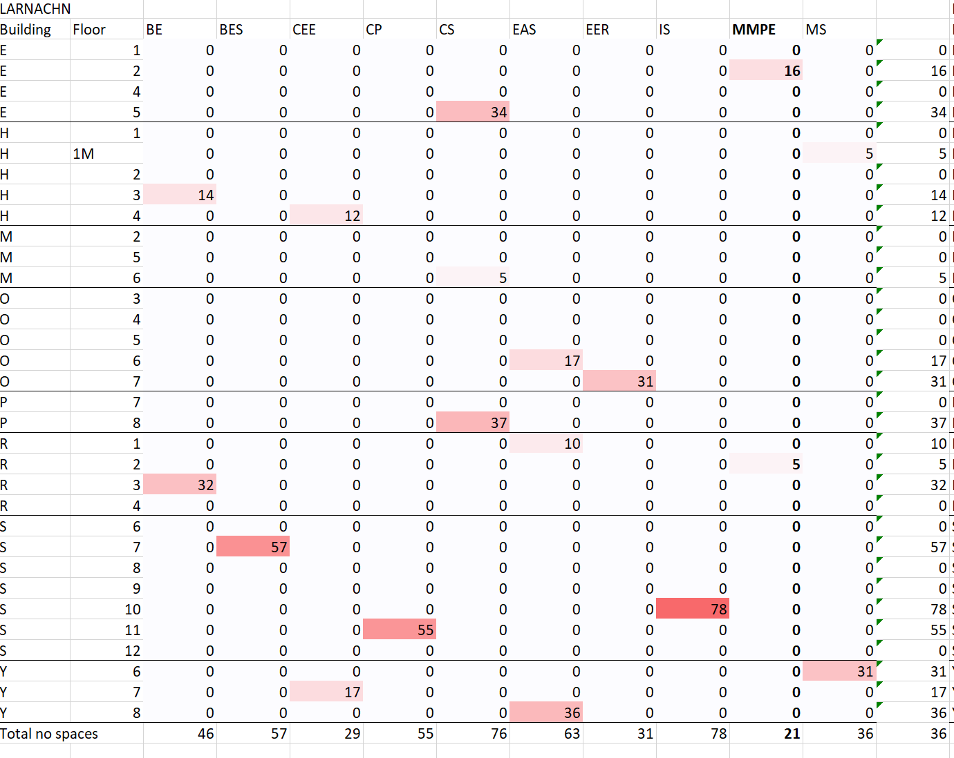

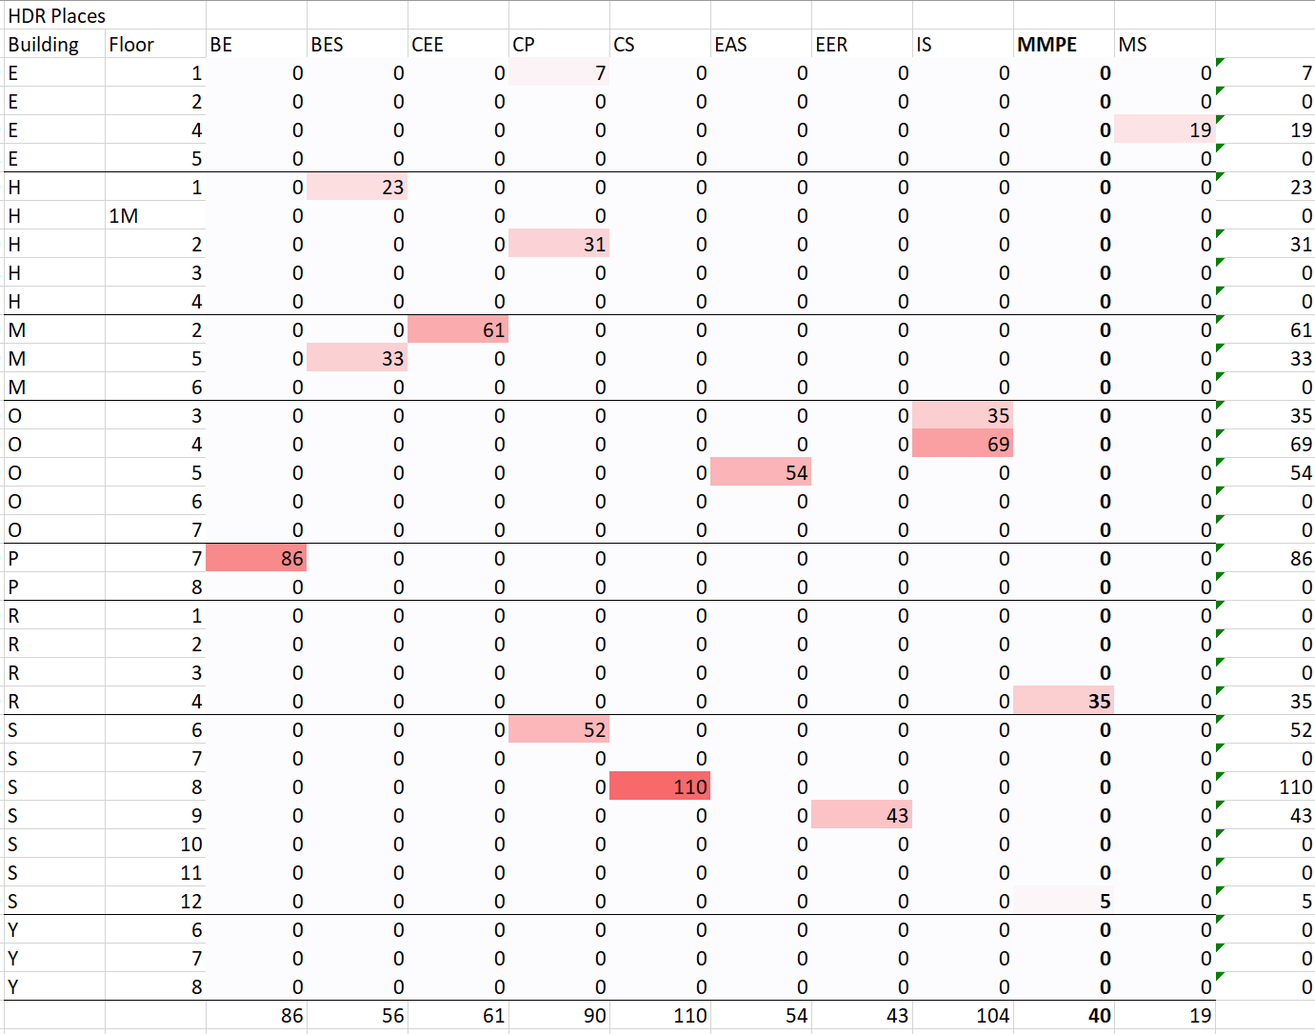Ideal HDR layout

Compromised Layout

This solution required no time limit as it only 0.50 seconds for CPLEX to find an optimised solution. 25 out of 492 AS spaces and 18 out of 663 HDR spaces needed to relocate to fit the optimised layout.

This compromised layout has 20 floors housing 2 or more schools.

The optimised faculty layout barely relocated the spaces.

The BE school has 3 AS relocations out 46 and 1 HDR relocation out of 86, the school is now spread over 2 different floors in building S.

The BES school has 3 AS relocations out of 57 and 1 HDR space relocations out of 56 HDR spaces. This school is still quite spaced out, spread over 4 buildings.

The CEE school is only required to move a single AS space and 2 HDR spaces, reducing the number of buildings this school was initially spread over a single building.

Within the CP school, there were 3 AS spaces relocated, reducing the number of buildings occupied from 3 to 2. No HDR spaces were moved.

The CS school were minimally affected as well, only having to move 4 AS spaces and 3 HDR spaces. The number of buildings this school is spread over was reduced from 6 to 5.

The EAS school only had to relocate 2 out of 63 AS spaces to reduce the number of buildings that they occupied from 4 to 2. No HDR spaces we reallocated in the optimised layout.

Only 1 AS and 3 HDR spaces were relocated so that the EER school is contained within 2 consecutive floors in the same building.

Initially, the 78 IS school AS spaces were spread across 14 different floors in 7 of the 8 different buildings, unlike the ideal layout, the compromised layout does not change much for this school. Only 4 AS spaces were moved, and the AS faction of this school is still spread out over 7 buildings. 5 HDR spaces were moved to reduce the number of floors so that the spaces were not isolated, the HDR spaces share the same 7 buildings as the AS spaces.

4 of the MMPE school AS spaces and 3 of the HDR spaces for the same school were moved, the school is still contained within 4 buildings.

With the compromised optimisation, none of the AS or HDR spaces belonging to the MS school were moved at all, and the school is still contained to a single school.

Compromised AS layout

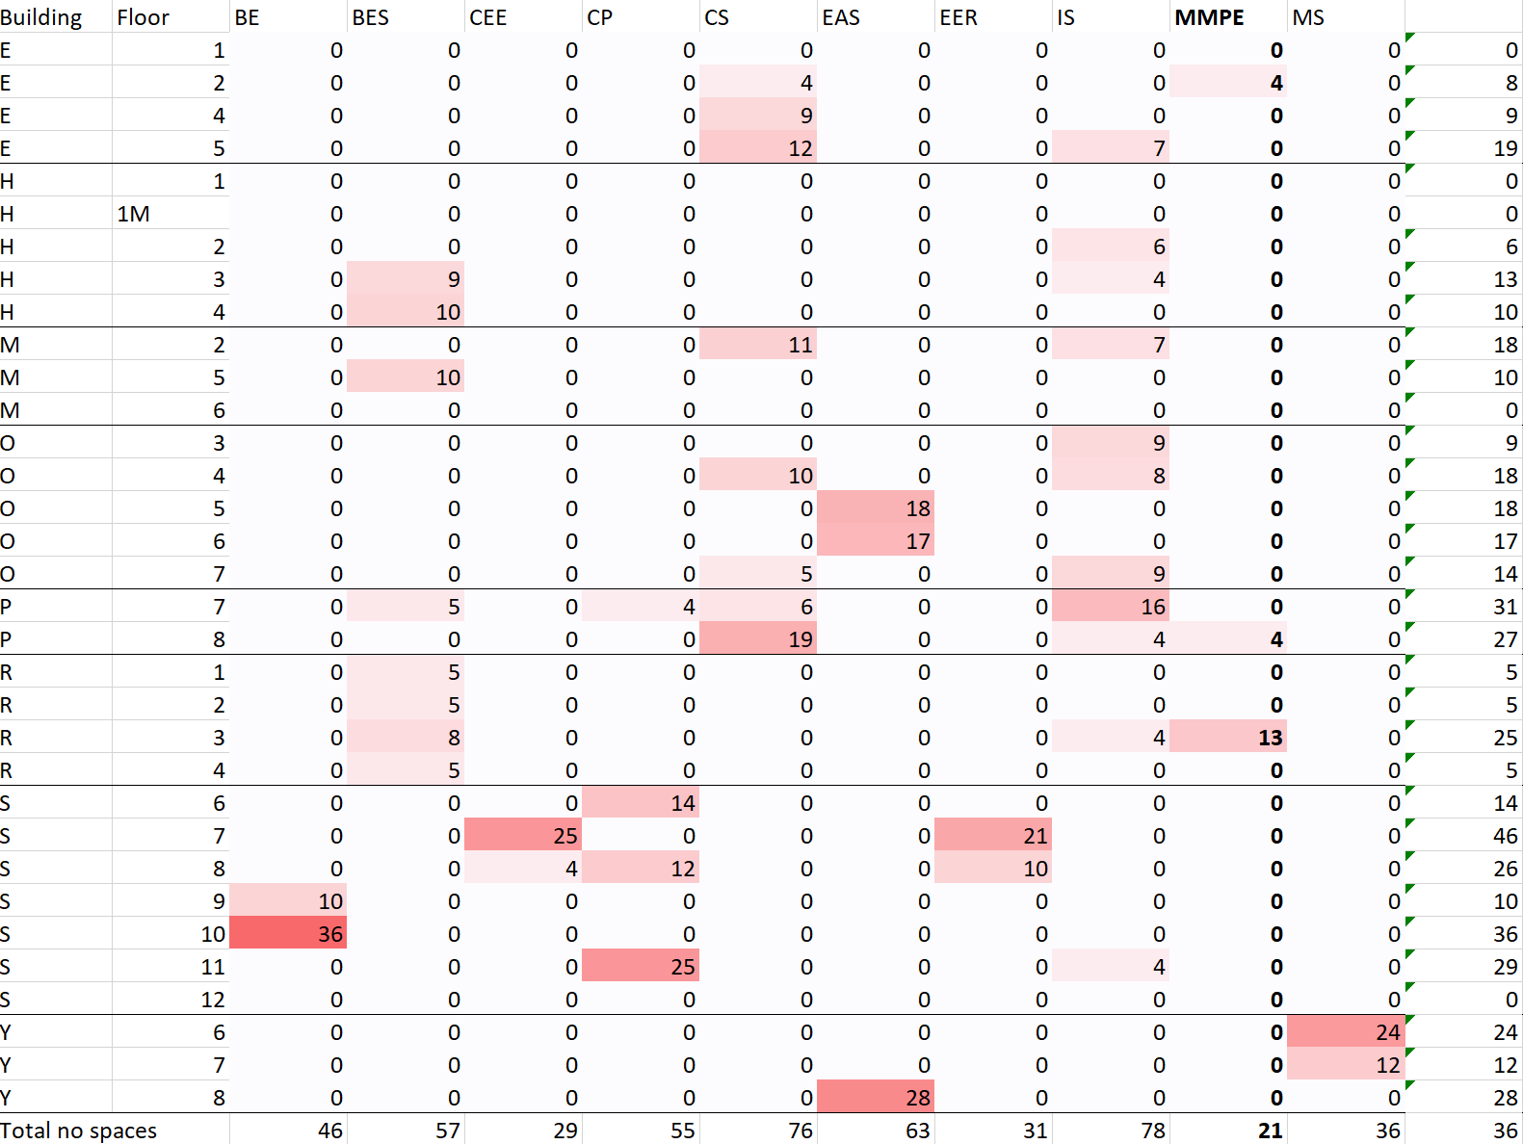

Compromised HDR layout

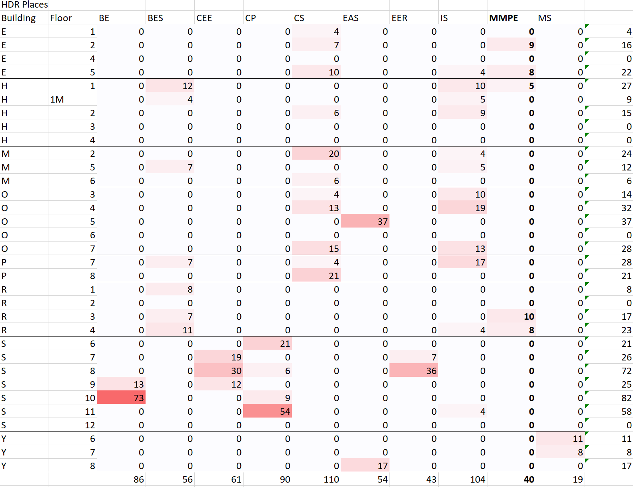

In conclusion, the compromised layout provided a relatively “easy” optimisation of the layout, barely any AS or HDR spaces were relocated. The few spaces that were reallocated, reduced the number of floors and/or buildings that the school was spread across. The affect of the optimisation was more “general” in the sense that the layout of all the schools were slightly improved or at least grouped together so that there were less isolated spaces.   
In contrast, the ideal layout seemed to have more of an effect on the “Worse off” schools, greatly altering the schools that were spread across 10 or more floors. For example, all 104 HDR spaces within the IS school were relocated into 2 consecutive floors after initially belonging to 16 different floors within7 buildings. On the other hand, the HDR spaces within the CP school were spread across 4 floors in the same building, but after the “optimisation”, were relocated to 3 floors across 3 different buildings.