Loading the data from the cleaned csv file:

> movies <- read.csv("C:/Users/nws36/OneDrive/Desktop/Projects/IMDB Project/movie_data_cleaned.csv")

Code and output for the domestic box office analysis:

> model_bo <- lm(bo_gross ~ year, data = movies)

> plot(movies$year, movies$bo_gross, main = "Domestic Box Office of Samuel L. Jackson Movies Over Time", xlab = "Release Year", ylab = "Domestic Gross (US dollars, millions)")

> abline(model_bo)

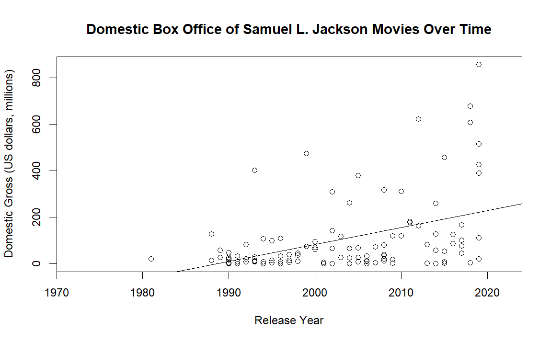

> summary(lm(bo_gross ~ year, data = movies))

Call:

lm(formula = bo_gross ~ year, data = movies)

Residuals:

Min 1Q Median 3Q Max

-209.46 -92.25 -27.55 18.39 637.54

Coefficients:

Estimate Std. Error t value Pr(>|t|)

(Intercept) -14465.090 2958.771 -4.889 3.59e-06 ***

year 7.274 1.477 4.925 3.09e-06 ***

---

Signif. codes: 0 ‘***’ 0.001 ‘**’ 0.01 ‘*’ 0.05 ‘.’ 0.1 ‘ ’ 1

Residual standard error: 149.1 on 107 degrees of freedom

(28 observations deleted due to missingness)

Multiple R-squared: 0.1848, Adjusted R-squared: 0.1772

F-statistic: 24.25 on 1 and 107 DF, p-value: 3.092e-06

> res_bo <- resid(model_bo)

> plot(fitted(model_bo), res_bo)

> abline(0,0)

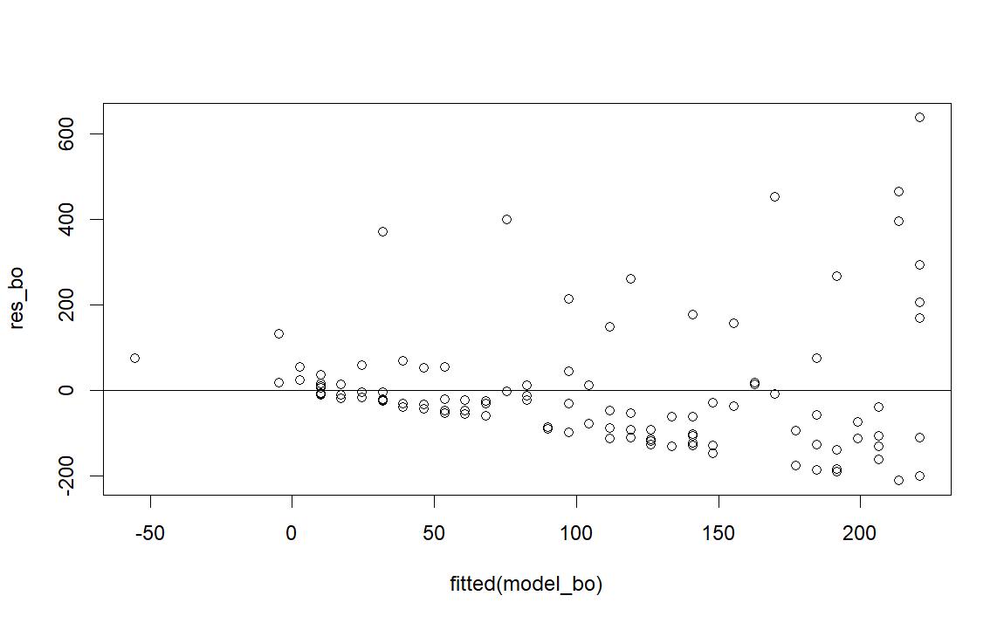

> qqnorm(res_bo)

> qqline(res_bo)

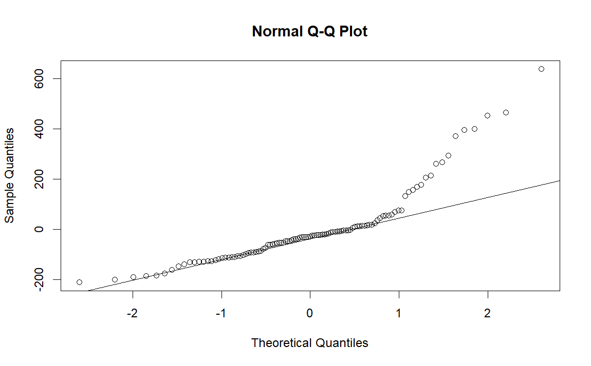

Code and output for the IMDB rating analysis:

> model_imdb <- lm(imdb ~ year, data = movies)

> plot(movies$year, movies$imdb, main = "IMDB Ratings of Samuel L. Jackson Movies Over Time", xlab = "Release Year", ylab = "IMDB Rating")

> abline(model_imdb)

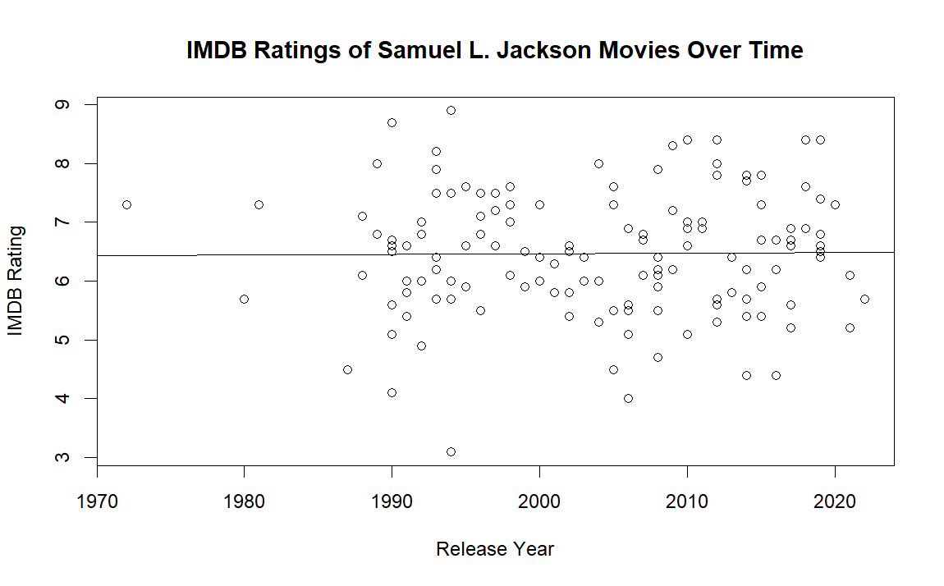

> summary(model_imdb)

Call:

lm(formula = imdb ~ year, data = movies)

Residuals:

Min 1Q Median 3Q Max

-3.3635 -0.6842 0.0310 0.7332 2.4365

Coefficients:

Estimate Std. Error t value Pr(>|t|)

(Intercept) 4.290644 17.035951 0.252 0.802

year 0.001090 0.008501 0.128 0.898

Residual standard error: 1.054 on 135 degrees of freedom

Multiple R-squared: 0.0001217, Adjusted R-squared: -0.007285

F-statistic: 0.01643 on 1 and 135 DF, p-value: 0.8982

> res_imdb <- resid(model_imdb)

> plot(fitted(model_imdb), res_imdb)

> abline(res_imdb)

> abline(0,0)

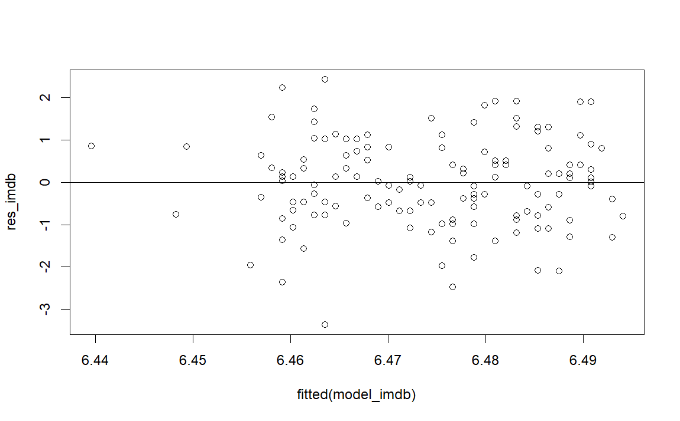

> qqnorm(res_imdb)

> qqline(res_imdb)

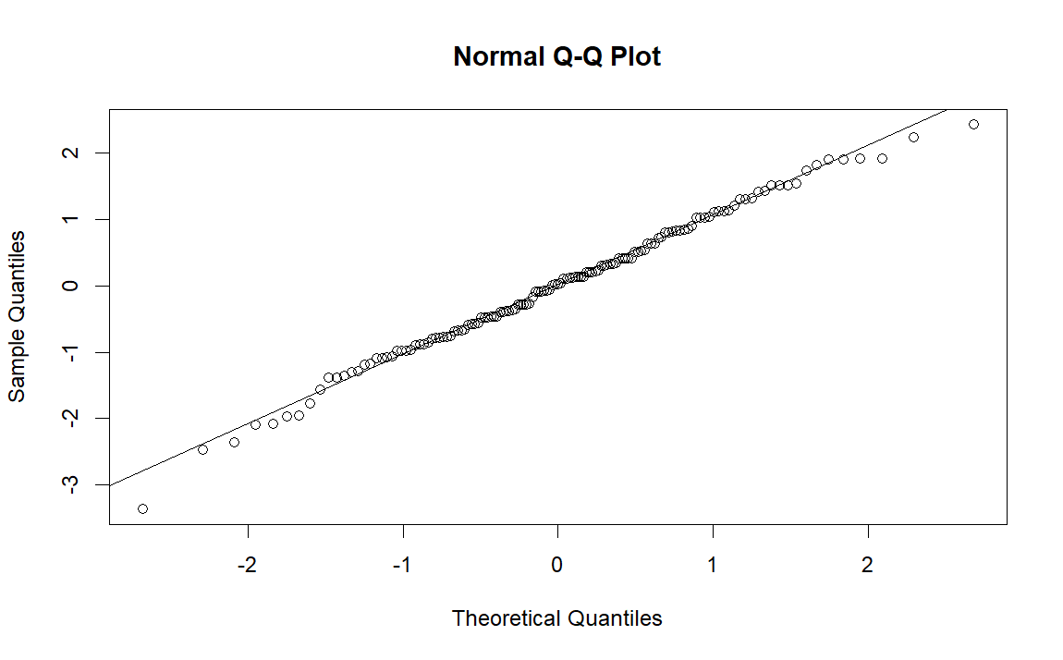

Code and output for the IMDB vs Box Office analysis:

> model_3 = lm(bo_gross ~ imdb, data = movies)

> plot(movies$imdb, movies$bo_gross, main = "Domestic Box Office of Samuel L. Jackson Movies by IMDB Rating", xlab = "IMDB Rating", ylab = "Domestic Gross (US dollars, millions)")

> abline(model_3)

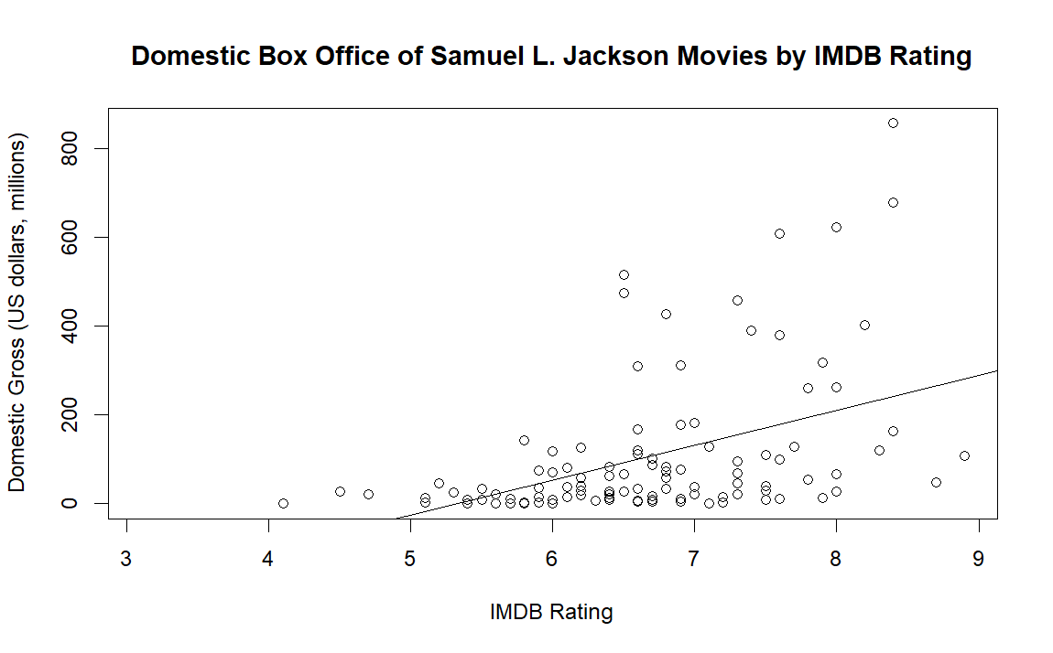

> summary(model_3)

Call:

lm(formula = bo_gross ~ imdb, data = movies)

Residuals:

Min 1Q Median 3Q Max

-218.88 -88.25 -30.36 28.35 616.27

Coefficients:

Estimate Std. Error t value Pr(>|t|)

(Intercept) -419.17 102.11 -4.105 7.92e-05 ***

imdb 78.72 15.18 5.187 1.02e-06 ***

---

Signif. codes: 0 ‘***’ 0.001 ‘**’ 0.01 ‘*’ 0.05 ‘.’ 0.1 ‘ ’ 1

Residual standard error: 147.6 on 107 degrees of freedom

(28 observations deleted due to missingness)

Multiple R-squared: 0.2009, Adjusted R-squared: 0.1935

F-statistic: 26.91 on 1 and 107 DF, p-value: 1.019e-06

> res_3 = resid(model_3

> plot(fitted(model_3), res_3)

> abline(0,0)

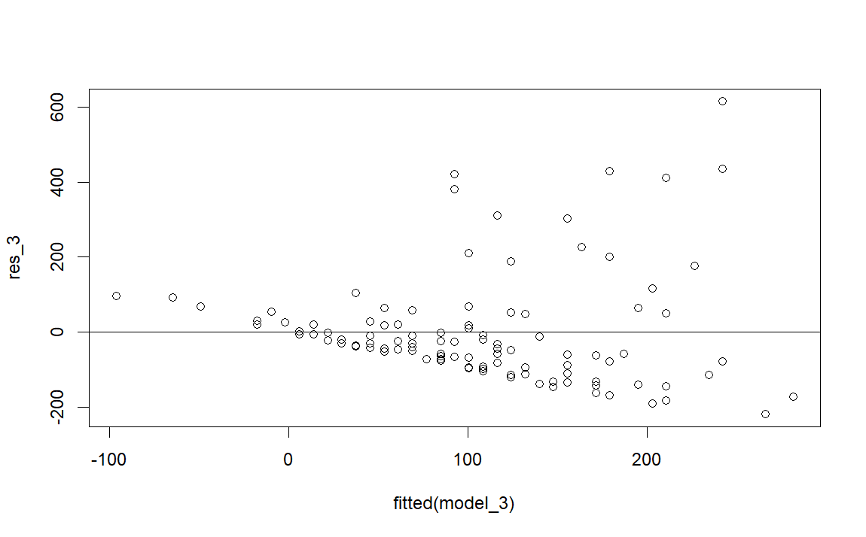

> qqnorm(res_3)

> qqline(res_3)

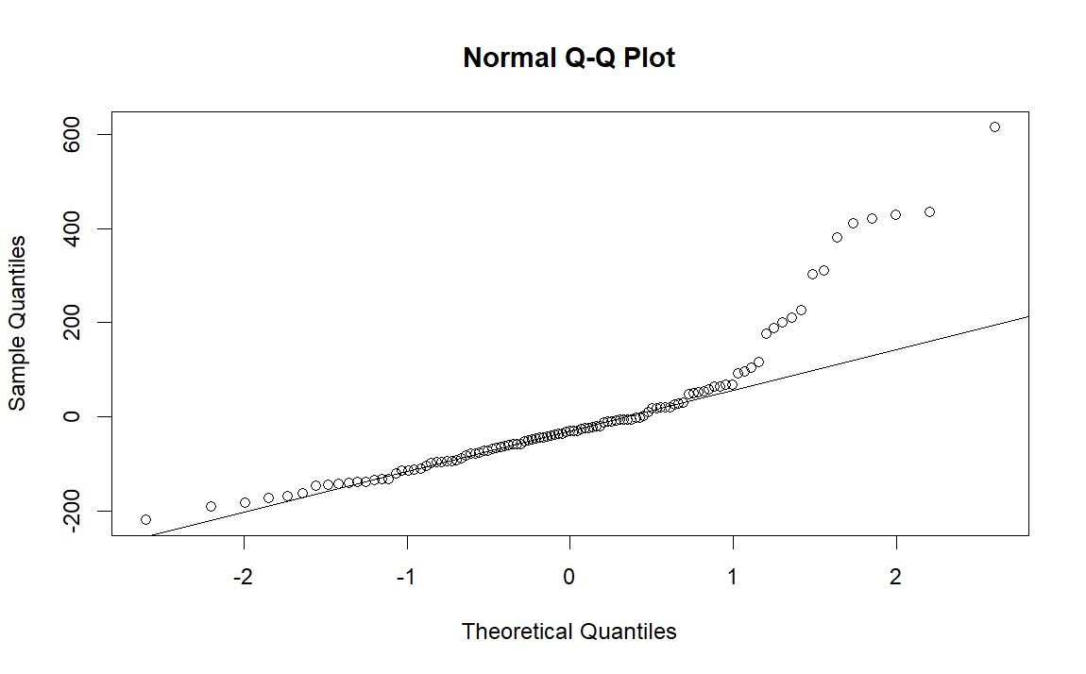

Code and output for the Metacritic score analysis:

> model_mc <- lm(metacritic ~ year, data = movies)

> plot(movies$year, movies$metacritic, main = "Metacritic Scores of Samuel L. Jackson Movies Over Time", xlab = "Release Year", ylab = "Metacritic Score")

> abline(model_mc)

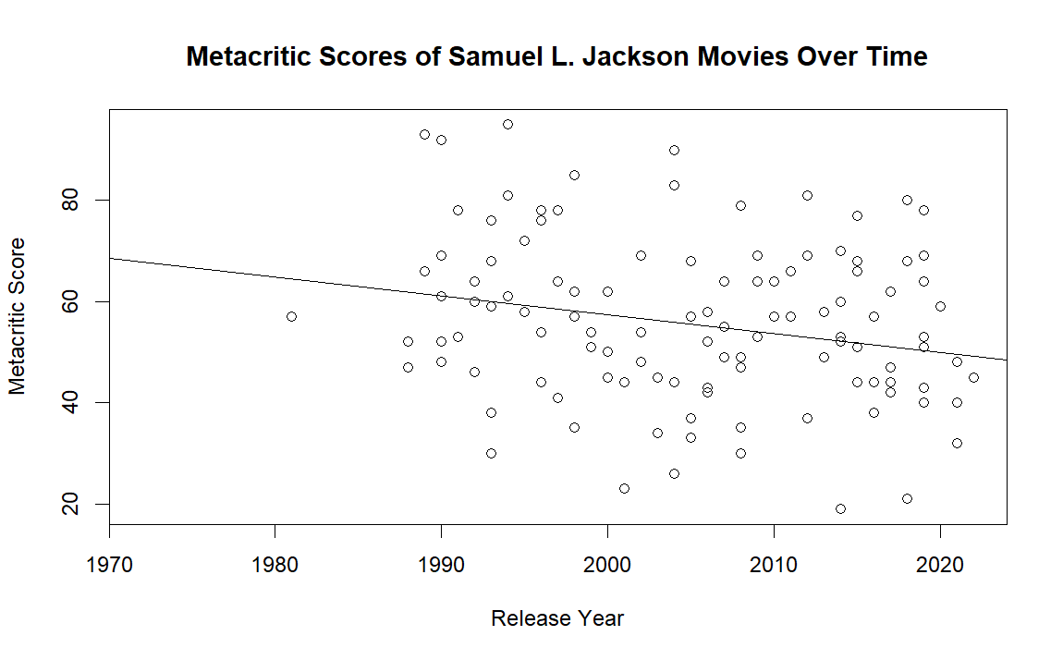

> summary(model_mc)

Call:

lm(formula = metacritic ~ year, data = movies)

Residuals:

Min 1Q Median 3Q Max

-34.028 -10.099 -0.997 11.628 35.374

Coefficients:

Estimate Std. Error t value Pr(>|t|)

(Intercept) 799.8767 297.3171 2.690 0.00822 **

year -0.3712 0.1483 -2.504 0.01371 *

---

Signif. codes: 0 ‘***’ 0.001 ‘**’ 0.01 ‘*’ 0.05 ‘.’ 0.1 ‘ ’ 1

Residual standard error: 16 on 113 degrees of freedom

(22 observations deleted due to missingness)

Multiple R-squared: 0.05256, Adjusted R-squared: 0.04418

F-statistic: 6.269 on 1 and 113 DF, p-value: 0.01371

> res_mc <- resid(model_mc)

> plot(fitted(model_mc), res_mc)

> abline(0,0)

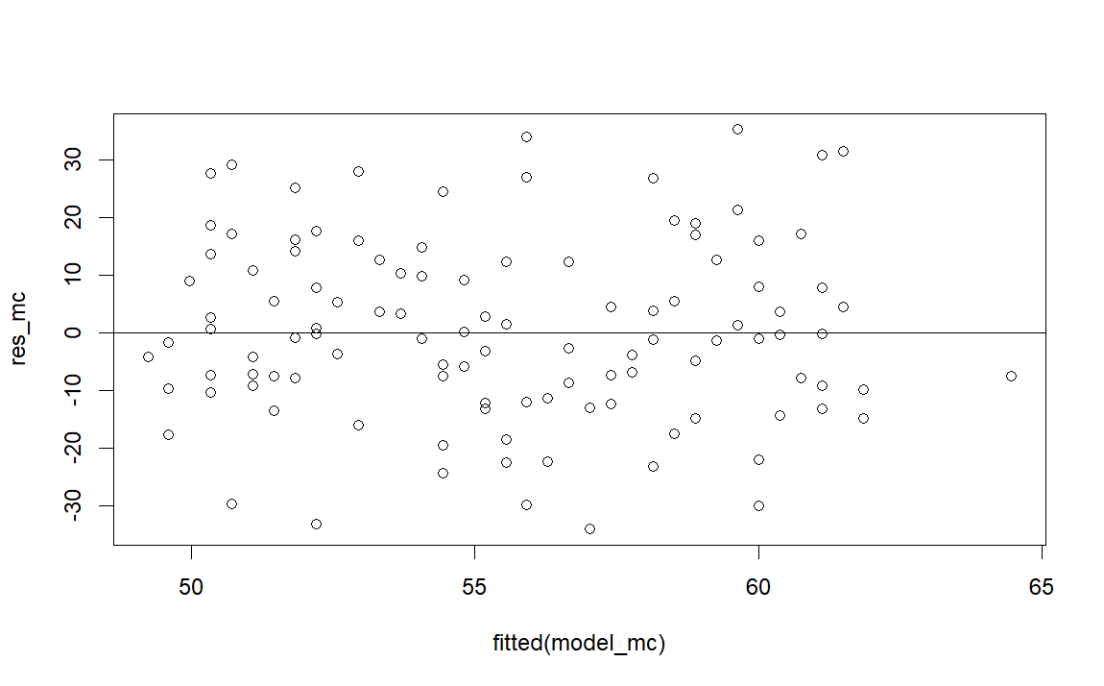

> qqnorm(res_mc)

> qqline(res_mc)

