**3. APPROACH**

Comfort Control is designed to control the temperature in each room based on user specified settings. The main thermostat hub will communication through wifi to thermometers which will then open or close the vents based on the room temperature. Each user with the smartphone application will be able to monitor and change the settings of each room from their phone. This will allow for individualized control and comfort in each room of the house.

**3.1 System Overview**

Comfort Control makes use of multiple hardware and software components in order to keep temperatures constant. This system involves a mobile application which will allow the user to control the thermostat from anywhere with an internet connection. The system incorporates smart vents that are hardwired to the thermostat HUB which will open or close based off of the temperature in each room.

Figure 3.1 shows a complete overview of Comfort Control and the major components.



Figure 3.1. Comfort Control Overview

**3.2 Hardware**

The Comfort Control design utilizes multiple hardware components to accomplish its function. Each component interacts with the microcontroller in order to make decisions based on the changing environment that is being measured. The following section discusses the components in detail along with the factors that impacted the decision making process. All components were chosen based on several factors such as cost-effectiveness, functionality, and availability. A comparison between alternative components is also provided in this section.

Figure 3.2 shows the hardware layout of the system and the interaction between components.



Figure 3.2 Comfort Control Hardware Layout

**3.2.1 Thermostat Hub Microcontroller**

The Comfort Control thermostat will be controlled by a Raspberry Pi Zero, a very capable and popular development board. Raspberry Pi Zero has many features ready to be integrated which will allow for ease of use and is economically a good product.

**3.2.2 Thermostat Hub Power Supply**

Since Comfort Control is using a Raspberry Pi Zero that requires 5VDC to power, the use of a 24VAC to 5VDC power supply is necessary. This design that is used in the system will include a simple full-wave rectifying circuit and a DC-DC converter that was purchased from an outside source. Several factors were considered when locating a capable converter, but these were narrowed down to size, max input voltage, and max load current. The three converters that were considered for the design are reflected in Table 3.2.2 below.

Table 3.2.2 DC-DC Converter Comparisons

|  |  |  |  |
| --- | --- | --- | --- |
| **Component** | **Max Input Voltage** | **Max Load Current** | **Size** |
| **SMAKN LM2596 DC-DC Converter** | **35VDC** | **3A** | **1.85 x 1.02 x 0.47 inches** |
| **DROK LM2596 Numerical Control DC-DC Converter** | **32VDC** | **1.5A** | **5 x 3.1 x 1.3 inches** |
| **TRACO Power TSR-1-2450** | **36VDC** | **1A** | **0.46 x 0.3 x 0.4 inches** |

The design will use the SMAKN converter due to a couple factors. First the max load current was the greatest out of the three choices we considered. Second, the design calls for a converter that can handle a 33VDC input voltage coming out of the rectifier circuit. This requirement eliminated the DROK converter from further consideration. The final factor that impacted the decision came down to lead time. The lead time on the TRACO Power converter, which was the smallest in size of the three, was over a month. However, the lead time on the SMAKN was a couple of days, since it was eligible for Amazon Prime shipping. The SMAKN converter will aid in making a capable power supply for the thermostat and will be able to withstand any additions that may be made to the thermostat due to the max load current it can handle.

**3.2.3 HVAC Unit Control**

A major aspect of the Comfort Control thermostat hub is being able to control an existing HVAC unit. The majority of residential HVAC units use a transformer to step-down the voltage to 24VAC. This 24VAC supply is used to control the function of the HVAC unit i.e. cool, heat, and fan via electromechanical relays. The challenge this poses to the design is controlling such relays with a microcontroller that is not able to output enough current to pull the contacts in. In order to accomplish this a seperate relay module is used that is compatible with microcontrollers. The relay module must allow control from a 5VDC source and must be rated for at least 24VAC to pass through the contacts.

Various relay modules were considered for the design and following much research the list was narrowed to three candidates. Table 3.2.3 below showcases the technical attributes of the three relay modules that were considered.

Table 3.2.3 Relay Module Comparisons

|  |  |  |  |
| --- | --- | --- | --- |
| **Component** | **Relay Voltage** | **Contact Rating** | **Price** |
| **Sainsmart 4 Channel Relay** | **5VDC** | **250VAC-10A**  **30VDC-10A** | **$8.79** |
| **JBtek 4 Channel Relay** | **5VDC** | **250VAC-10A**  **30VDC-10A** | **$6.99** |
| **Foxnovo 4 Channel Relay** | **5VDC** | **250VAC-10A**  **30VDC-10A** | **$7.69** |

All three relay modules are widely used in applications similar to Comfort Control and as result there is extensive resources for using such relays. The deciding factor was cost, as each relay module is identical to the other. The Jbtek module was chosen based on this fact and is used in the system. The relay will utilize the power supply for relay power and will use the digital I/O pins to control the opening and closing of the relay. The JBtek based on these attributes is the best option to use in the design.

**3.2.4 Human Machine Interface**

The Comfort Control system will be designed to be controlled either through the mobile application or from the main thermostat hub. The main thermostat hub will be equipped with a PiTFT touchscreen. This will give the user the ability to control the entire system. It will have the option to turn the system from heat to cool and the ability to turn the fan on or put it in auto. It will also be set up so that each room will have its own page so that the individual temperatures can be monitored and set.

Some of the main concerns when picking the touchscreen are size and compatibility with the microcontroller. The PiTFT was chosen to ensure there would be no compatibility issues with the temperature hub. The 3.5” display will allow for a compact design of the temperature hub. This particular touchscreen will draw a max current of about 100mA when the backlight is fully illuminated. [1]

**3.2.5 Wireless Communication**

The Comfort Control thermostat and thermometer probes are WiFi enabled to allow for wireless communication. The thermostat's controller, a Raspberry Pi Zero, is equipped with an Edimax WiFi adapter, and the temperature probe's controller, an ESP8266, has onboard WiFi. However, only the thermostat hub is connected to the internet and the temperatures probes use WiFi to communicate room temperatures to the hub. The thermostat hub connects to the internet to communicate the current room temperatures, the set temperatures, and user commands to and from the Comfort Control mobile application. **3.2.6 Temperature Probe**

The Comfort Control thermometer probes used to monitor the temperature of each room will be controlled by a ESP8266 System on a Chip (SoC) that includes a Tensilica Xtensa LX3 processor and WiFi capability.

**3.2.7 Vent Control**

The Comfort Control vents are 3D printed and equipped with servo motors controlled via a wired connection to the thermostat. The vent consists of two main parts, a housing with small slits that allow for airflow from the duct and another sheet with matching slits that is slid back and forth by the servo motor and a gear system to shut or open the vent.

**3.3 Software**

Figure 3.3 shows the flowchart of how Comfort Control will determine which vent needs to be open.

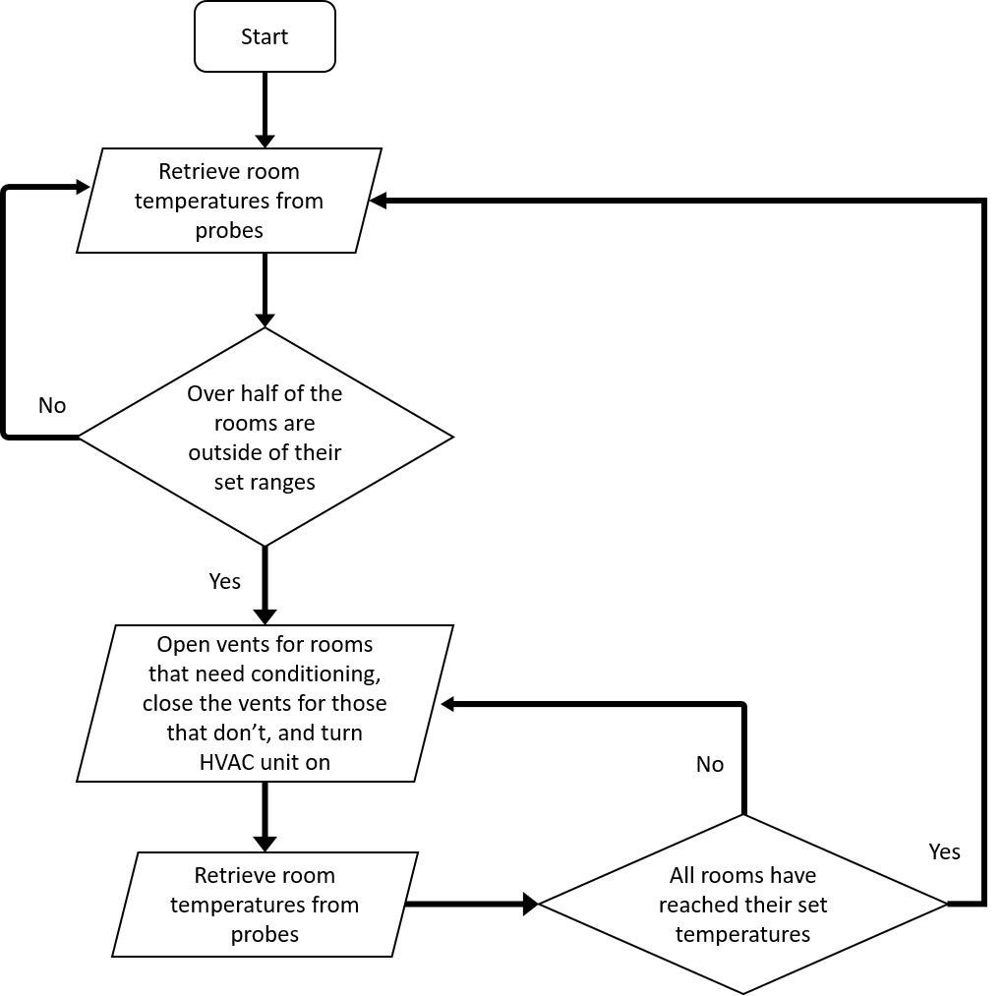

Figure 3.3 - Room Conditioning Flowchart

**3.3.1 Implementation Details**

The Comfort Control system software will be written in Python for the thermostat hub, C# for the mobile application, and C++ for the thermometer probe. With the thermostat hub being controlled by a Raspberry Pi Zero, Python is a great option since it integrates so well with the Raspberry Pi, the Python development community is large which has produced many useful libraries, and Python is arguably one of the easiest languages to use. The Comfort Control smartphone application is written in C# using Xamarin, a cross-platform development software that allows developers to reuse code for varying mobile operating systems, e.g., Android, iOS, and Windows.

**3.3.2 Room Temperature Monitoring**

The temperatures of each room are monitored using the Comfort Control temperature probes placed in each room. The temperatures probes wait for a temperature query from the Comfort Control thermostat over WiFi, read the temperature sensor, and return the temperature reading to the thermostat.

**3.3.3 Room Conditioning**

Using the temperature probes, the Comfort Control thermostat will record the temperatures of the rooms, compare them to their set temperatures, and systematically turn the HVAC unit on or off to reduce how often the HVAC unit is turned on, reduce the amount of time that the HVAC unit remains on, and bring the temperatures of each room to those set by the user.

To further reduce how often the HVAC unit comes on, the Comfort Control thermostat will allow the temperatures of each room to reach two degrees Fahrenheit above or below their set temperatures before considering the rooms as out of their set temperature ranges.

Once at least half of the rooms' temperatures are outside of their set ranges, the thermostat will turn on the appropriate mode of the HVAC unit, open the vents to each room outside of its set range, and continue to condition each room until their set temperatures are met. The thermostat will then close the vents to the rooms that meet their set temperatures until all rooms are at their set temperatures, at which point the thermostat will turn the HVAC unit off.

Figure 3.3.3 is a room conditioning interaction diagram that visualizes this process.

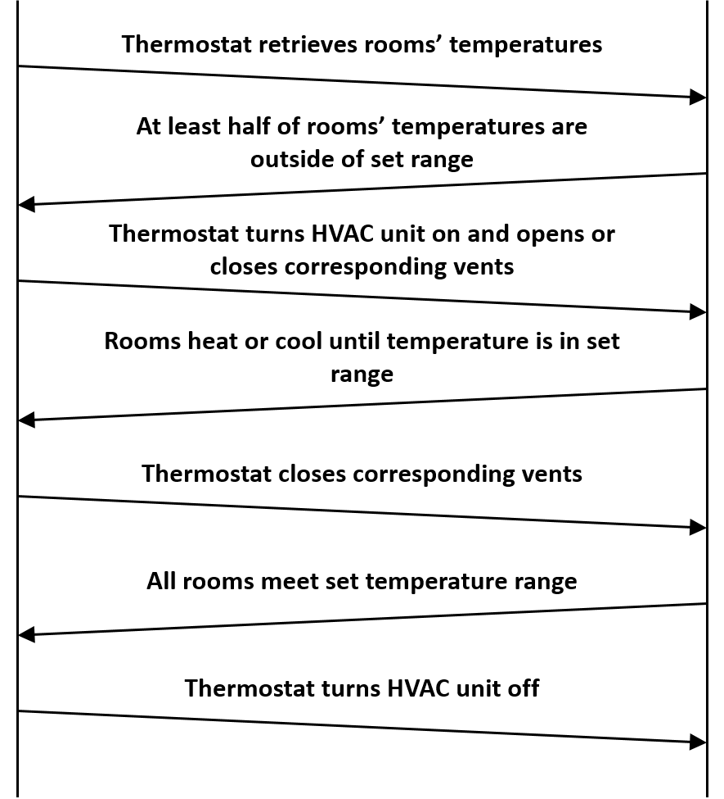

Figure 3.3.3 - Room Conditioning interaction

**3.3.4 Mobile Application**

Once the user has logged into the Comfort Control application, all of the rooms associated with their account is displayed on the screen with their room names, current temperatures, and set temperatures. The user can then select any of the rooms to bring up a separate section of the app that allows the user to change the set temperature of that room and add or edit schedules for that specific room.

**3.3.5 Case Scenarios**

The ideal "sunny day" scenario is as follows.

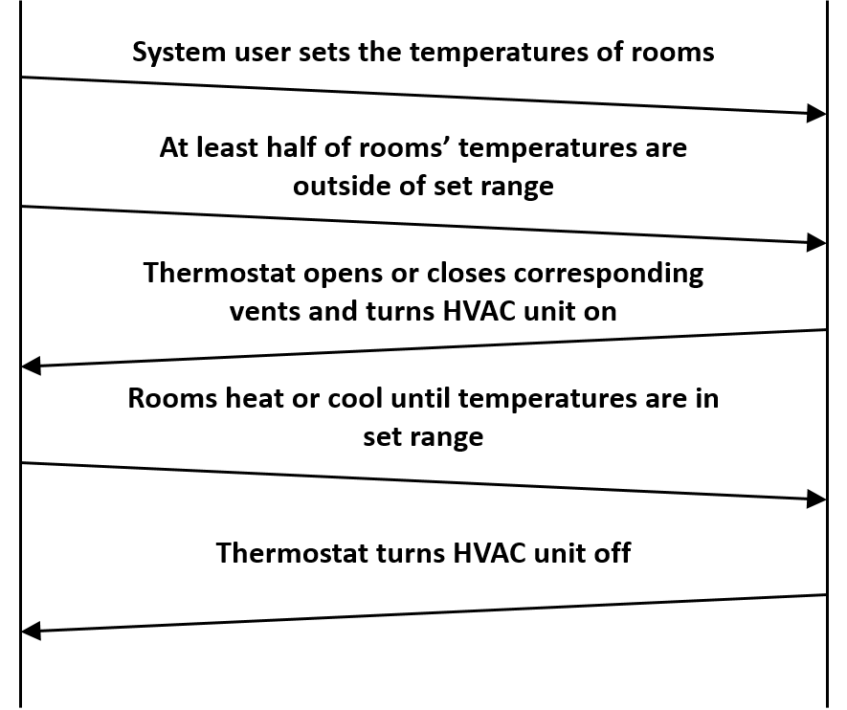

Figure 3.3.5a - Sunny Day System Interaction

A "rainy day" scenario where power to the thermostat is lost is as follows.

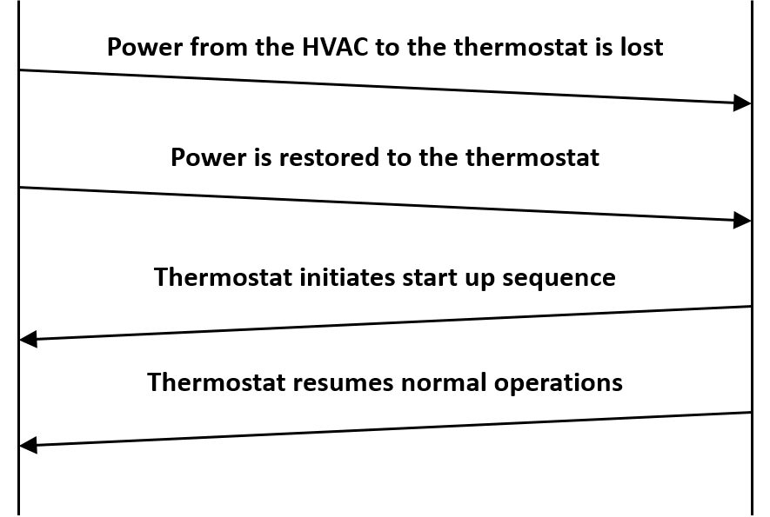

Figure 3.3.5b - Rainy Day Power Loss Interaction

A "rainy day" scenario where WiFi connection is lost is as follows.

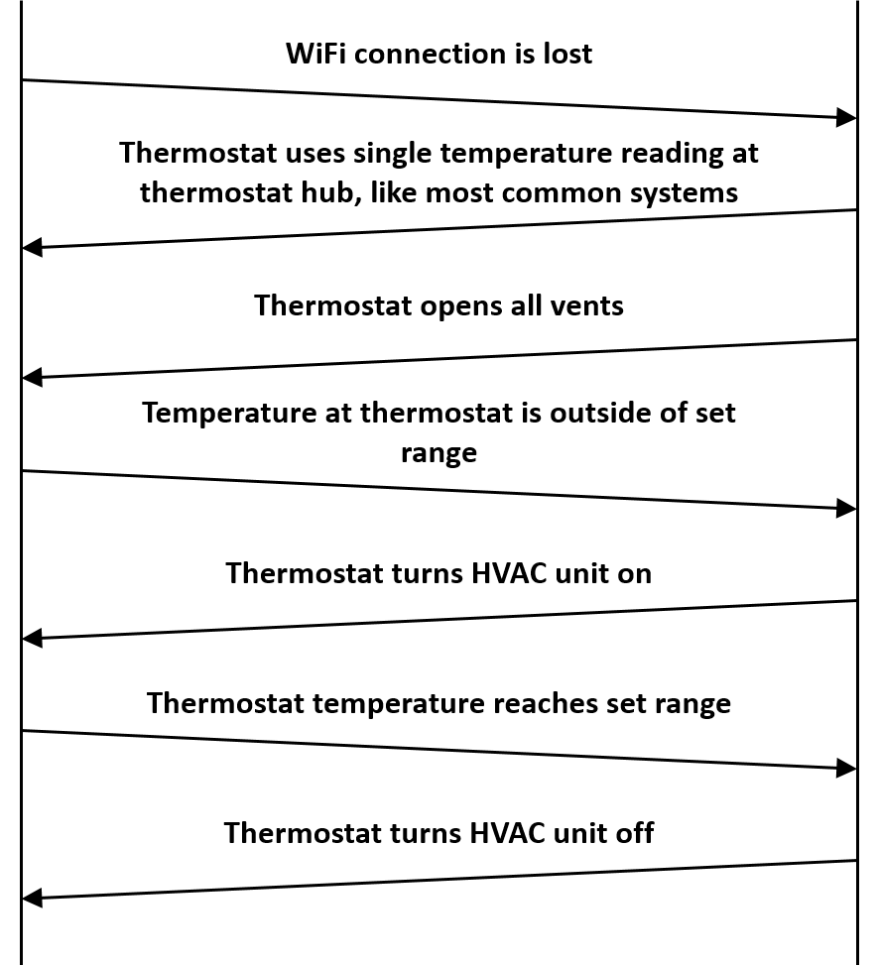

Figure 3.3.5c - Rainy Day Wifi Loss Interaction

**References**

[1] PiTFT - Assembled 480x320 3.5 TFT+Touchscreen for Raspberry Pi ID: 2097 - $44.95 : Adafruit Industries, Unique & fun DIY electronics and kits 2016 [Online]. Avalible <https://www.adafruit.com/product/2097>. Accessed: Sept. 25, 2016.