Graphing Markups

Nathan Wise

2023-09-28

library(ggplot2)  
setwd("C:/Users/wisen/OneDrive/Desktop/Work Stuff/PHD/Second Year/IO/Project/Markups")  
  
mumulti <- read.csv("mumulti.csv")  
musingle <- read.csv("musingle.csv")  
mumonop <- read.csv("mumonop.csv")  
  
mufull <- mumulti  
mufull$multi <- mumulti$X0  
mufull$single <- musingle$X0  
mufull$monop <- mumonop$X0  
  
plot <- ggplot() +  
 geom_density(data = data.frame(x=mufull$multi), aes(x=x),color = "black") +  
 geom_density(data = data.frame(x = mufull$single), aes(x=x),color = "blue") +   
 geom_density(data= data.frame(x = mufull$monop), aes(x=x), color = "red") +  
 labs(title = "Density Plot")  
  
plot <- plot +   
 xlim(-.005,.005)  
  
plot

## Warning: Removed 500 rows containing non-finite values (`stat_density()`).

## Warning: Removed 529 rows containing non-finite values (`stat_density()`).

## Warning: Removed 483 rows containing non-finite values (`stat_density()`).

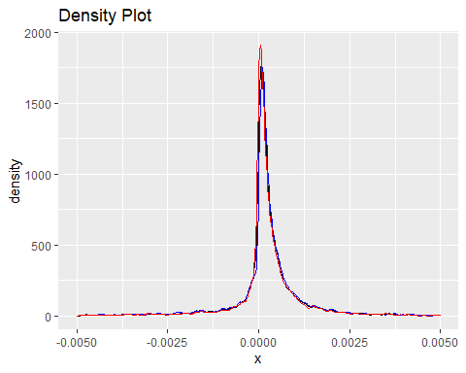

plot2 <- plot + xlim(-.002,.002)

## Scale for x is already present.  
## Adding another scale for x, which will replace the existing scale.

plot2

## Warning: Removed 1234 rows containing non-finite values (`stat_density()`).

## Warning: Removed 1336 rows containing non-finite values (`stat_density()`).

## Warning: Removed 1157 rows containing non-finite values (`stat_density()`).

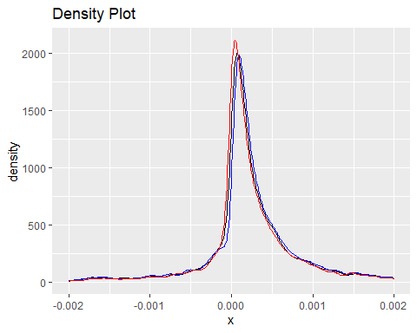

plot3 <- plot + xlim(-.00075,.00075)

## Scale for x is already present.  
## Adding another scale for x, which will replace the existing scale.

plot3

## Warning: Removed 2758 rows containing non-finite values (`stat_density()`).

## Warning: Removed 2945 rows containing non-finite values (`stat_density()`).

## Warning: Removed 2581 rows containing non-finite values (`stat_density()`).

