CS303 Project #1

Ahrayahlab Coimin

Nathan Woodard

Dongni Tan

UML Diagram

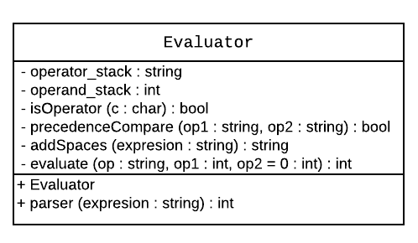

Big-O performance

1.

2.

3.

References

1. Lecture 6 ppt Page 25.
2. <https://tomassetti.me/parsing-in-javascript/>
3. <http://www.cplusplus.com/doc/tutorial/classes/>
4. https://stackoverflow.com/questions/7244321/how-do-i-update-a-github-forked-repository