Mental Toughness in Leadership

Hypotheses

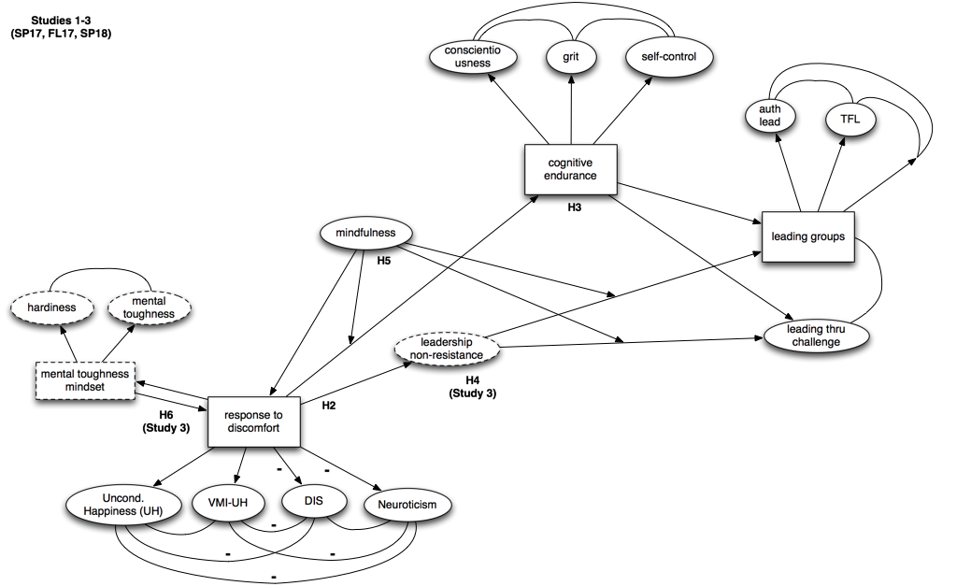

Some boxes and circles have dotted lines to indicate that these data were only collected in Study 3 and should therefore be ignored for Studies 1 and 2.

*Transparency Note:* This version of the hypotheses is different from previous versions in that it incorporates the leadership non-resistance scale, hardiness scale, and mental toughness scale (all from Study 3). This version also uses the path model to simplify and more clearly organize the hypotheses outlined in earlier versions. These changes were made before running the analyses.

*Analysis Notes:* **Run all analyses using only participants with [chalFreq > 0 AND (formalExp > 0 OR informalExp > 0)].** If running data for different semesters separately, should run analyses in chronological order: SP17, FL17, then SP18. We will also need to calculate Cronbach's Alpha (or its Bayesian alternative) for all scales as well. A Bayesian approach should be used for all analyses if possible. We may wish to also report frequentist results for some/all of the analyses since this is what most readers will be familiar with.

For all hypotheses involving latent constructs, the relevant scales are hypothesized to be positively associated with one another (or negatively associated, in the case of the DIS and Neuroticism). Please also calculate Bayesian correlation matrices for included scales.

H1: leadChal scale is distinct from (factor analysis), but positively associated with, the other leadership scales.

* In Study 1, should run factor analysis on leadChal items. 3 subscales were hypothesized – I believe items are labeled accordingly (with E, P, or F)
* In Study 3, should also explore whether leadership non-resistance items come out as a different factor from the leadChal scale.

H2: Response to discomfort is positively associated with leading through challenge and the other leadership scales, though this association is stronger for leading through challenge.

* If the leadership scales don't have an underlying latent factor, we'd need to look at each leadership scale individually.

H3: The relationship between response to discomfort and both leading through challenge and other leadership scales is partially mediated by cognitive endurance.

H4: The relationship between response to discomfort and both leading through challenge and other leadership scales is partially mediated by leadership non-resistance (assuming factor analyses showed it to be a distinct scale). In this relationship, the association between leadership non-resistance and leading through challenge will be stronger than the relationship with the other leadership scales.

H5: Mindfulness is not only positively associated with response to discomfort, but also moderates the relationship between response to discomfort and cognitive endurance, and also the relationship between response to discomfort and both leading through challenge and leading groups (Studies 1 & 2). In Study 3, it moderates the relationship between leadership non-resistance and both leading through challenge and leading groups. In all of these cases, the moderation is such that mindfulness will dampen these relationships when low and amplify these relationships when high.

H6: There is a positive bidirectional relationship between mental toughness mindset and response to discomfort.

H7: The above path model does a good job capturing the data.

The map below is the same as above, but uses the scale names as defined in R to facilitate analyses.

NOTE for analyses: Many scales have items that are reverse scores. In many instances, this was handled by creating a separate reversed variable, leaving the original reversed item. Be careful of this when including these variables in analyses (e.g., when throwing all scale items in to identify latent constructs) – only the newly reversed items should be used in analyses.

