Mental Toughness

Hypotheses V8

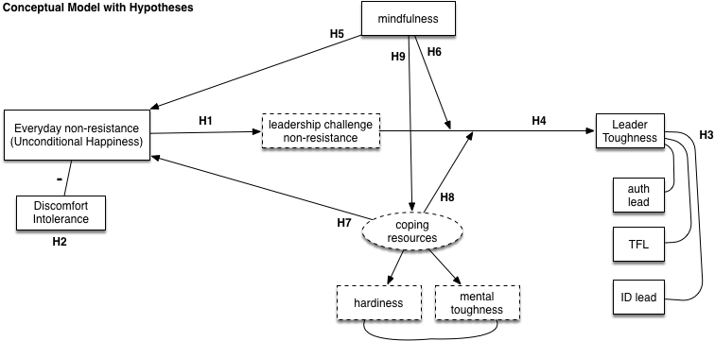

Note: The above figure is a conceptual model depicting the different study hypotheses. It is NOT the path model to be tested for SEM analyses.

*Pre hypothesis testing:* We should do (Bayesian) factor analyses to determine whether the leader toughness scale should be treated as a single factor or multi-factor construct. This will influence how some of the hypotheses below are tested.

*Hypothesis 1:* Everyday non-resistance to emotional, social, and physical discomfort (i.e., Unconditional Happiness) is positively associated with leadership challenge non-resistance.

*Hypothesis 2:* Physical discomfort intolerance will be negatively associated with everyday non-resistance, leader toughness, and leadership challenge non-resistance (Study 3).

*Hypothesis 3:* Leader toughness will have a moderate positive association with subscales of authentic leadership, transformational leadership, and identity leadership.

* Note the emphasis on subscales of these measures. Past research for at least the AL and TL scales has found that a single overall score shouldn't be used.

*Hypothesis 4:* Everyday non-resistance and leadership challenge non-resistance are positively associated with leader toughness and the subscales of the other leadership measures (AL, TL, IL), though these associations with everyday and leadership non-resistance are stronger for leader toughness.

*Hypothesis 5:* Mindfulness will be positively associated with everyday non-resistance.

*Hypothesis 6:* Mindfulness moderates the relationship between everyday non-resistance and leader toughness. In Study 3, it moderates the relationship between leadership challenge non-resistance and leader toughness. In all of these cases, the moderation is such that mindfulness will dampen these relationships when low and amplify these relationships when high.

* This would be a standard interaction, perhaps using multiple regression (frequentist and Bayesian).

*Hypothesis 7:* Coping resources (mental toughness and hardiness) are positively associated with everyday non-resistance.

*Hypothesis 8:* Coping resources (mental toughness and hardiness) moderate the relationship between everyday non-resistance and leader toughness (Studies 1 & 2). In Study 3, they moderate the relationship between leadership challenge non-resistance and leader toughness. In all of these cases, the moderation is such that coping resources will dampen these relationships when low and amplify these relationships when high.

* Again, an interaction using multiple regression.

*Hypothesis 9:* Mindfulness is positively associated with coping resources.

*Hypothesis 10:* The proposed path model focusing on non-resistance as a core driver of leader toughness does a better job accounting for the data than models focusing on mindfulness as the driving force behind leader toughness or on coping resources as the driving force.

*Mindfulness alternative:* The mindfulness-driven alternative model proposes that mindfulness drives leader toughness. Mindfulness also leads to non-resistance, but non-resistance is not a core driving force behind leader toughness.

*Coping resources alternative:* The coping-driven alternative model proposes that coping resources drive leader toughness. Coping resources also lead to non-resistance and are influenced by mindfulness, but neither non-resistance nor mindfulness are core driving forces behind leader toughness.

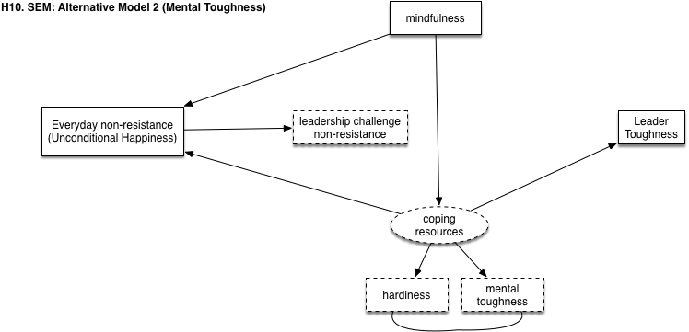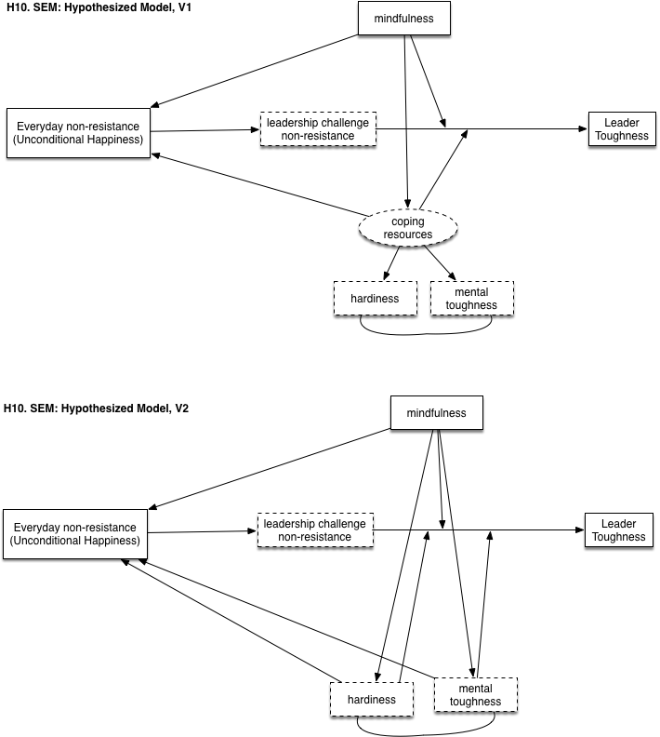*Note:* The two versions of the hypothesized SEM model differ in the treatment of coping resources. This will be tested with the first dataset and the best approach should be used for testing the alternative models as well. Also, boxes in the maps are in the same positions in the alternative maps to facilitate visual comparison of different hypothesized causal relationships.

