Description:

Monster Application Project

Application used for adding and looking up information from Monster Hunter Rise, on monsters, their parts, and materials they drop.

Stories:

As a normal user I will be able to login to my account, in order to add or update information on a monster, item or terrain.

As a logged in user I will be able to change my password, in order to secure and be able to easily log in to my account.

As a logged in user I will be able to add a terrain, in order to have terrains to assign to monsters.

As a logged in user I will be able to add a monster, in order to have a list of monsters.

As a logged in user I will be able to add a monster part, in order to have a list of monster parts assigned to a monster.

As a normal user I will be able to view a full list of monsters in order to select a monster.

As a normal user I will be able to select a monster from a list of monsters in order to view detailed information on selected monster.

As a logged in user I will be able to add a monster material, in order to have a list materials a monster can drop.

As a normal user I will be able to view a full list of monster materials, in order to select an material.

As a normal user I will be able to select a material from a list of materials, in order to see the materials drop rates and information.

As a logged in user I will be able to update a monster record, in order to insure the monster record is accurate and up-to-date

As a logged in user I will be able to update a part record, in order to insure the monster part record is accurate and up-to-date

As a logged in user I will be able to update a material record, in order to insure the monster material record is accurate and up-to-date

As a normal user I will be able to search for a monster by name, in order to view a list of monsters that match the searched name.

As a normal user I will be able to search for a material by name, in order to view a list of materials the match the searched name.

ER Diagram:

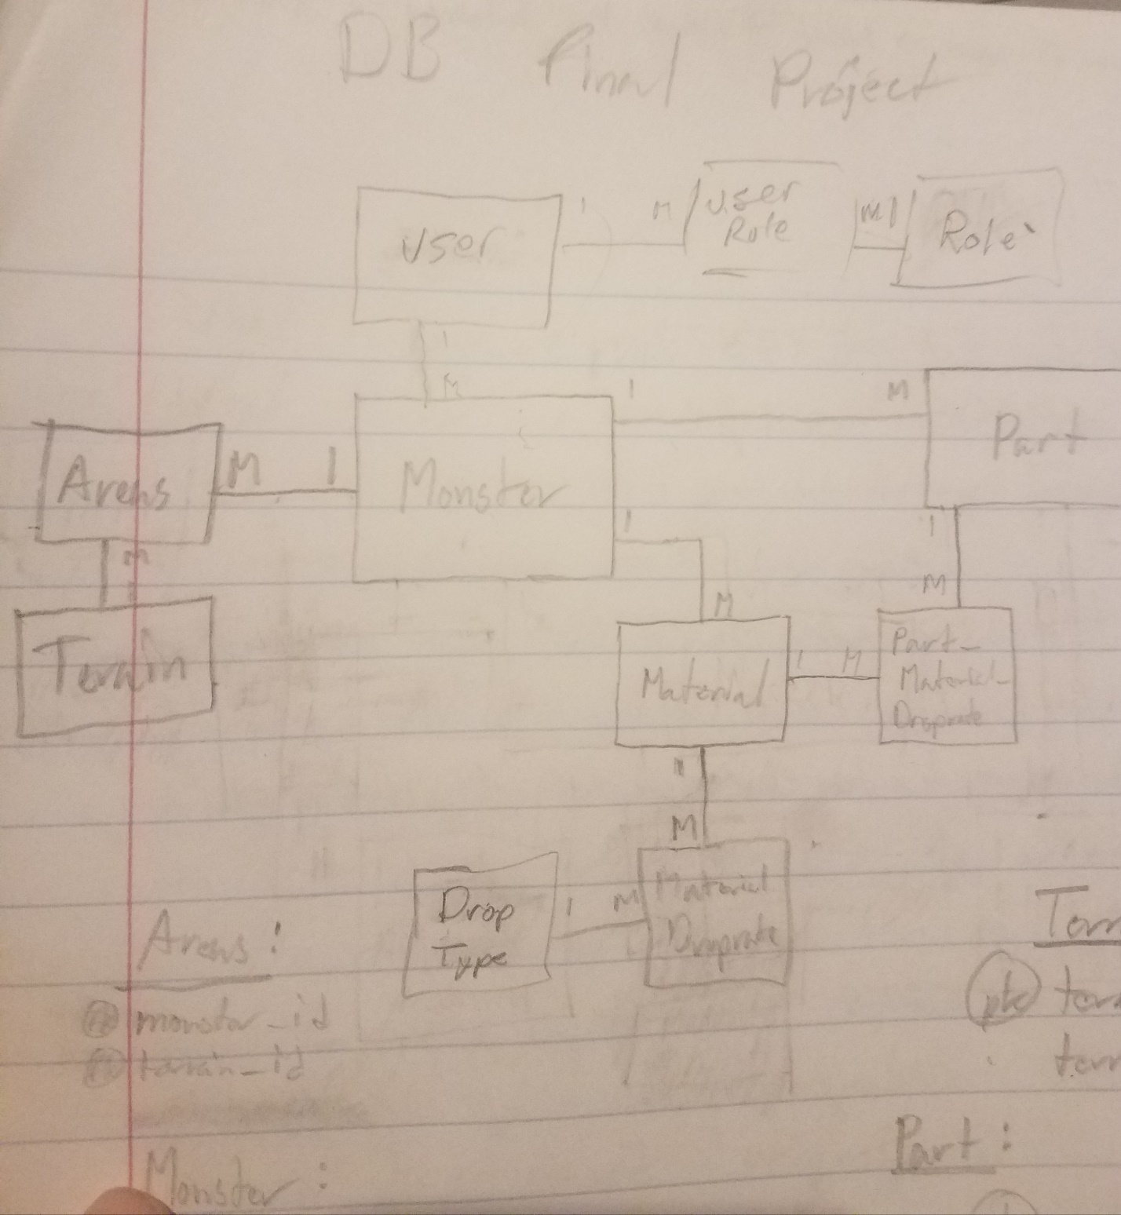

User Interfaces:



