Monthly Report

March

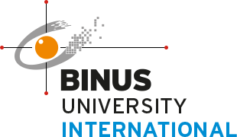

**Nathanael Setiawan – 2440042866**

**Computer Science - Internship Track**

# **Introduction**

March is the second month working for PT Exa Teknologi Indonesia (Exalogi), as well as the month where the pace assigned work accelerated. This month mostly consists of both training and getting certifications for the company, as well as going to the field with real clients to provide support on their IT needs.

# Activity Report

1. **Week 1**

For the first week of March, I mostly continued from February and focused on learning products created by Barracuda, mostly about backups, which includes cloud-to-cloud and traditional backup options. The end goal is to get certified eventually.

1. **Week 2**

For the second week of March, my employer instructed me to accompany him to go to a client trip, and that was my first real experience with a client. Additionally, I also got the certification for Barracuda Backup and then continued with Nutanix products.

1. **Week 3**

For the third week of March, I was instructed to carefully study about Mikrotik routers. This is different as the end goal is not to just earn a certificate, but actually understand how to setup the routers with different configurations. This is because a client I visited this week requested help with configuration of the router, which includes VPN services, remote working, and basic configuration as well.

1. **Week 4&5**

Finally, for the fourth and fifth week of March, I mostly went with my employer to a client for a pretty sizeable project. It took 3 whole days to completely relocate a server to a datacentre, which includes disassembling at initial location, moving the server physically, re-installing the server, and finally re-configuring the network. This is where my knowledge of Mikrotik was put into use, as the client primarily utilized Mikrotik. And for the rest of the week, I continued attempting to utilize different VPN services.

# Conclusion

March is a much more eventful month compared to February, with new experiences working with clients, as well as building the hard skills and soft skills necessary to grow as an individual. The month has been filled with challenges, but overcoming those challenges is a reward in itself, and I look forward for the rest of this Internship.