CanoPie Quick Start User Guide
Comprehensive User Manual & Technical Reference V_1_0_0
Software Version  CanoPie V_1_0_0 | Classification  Complete Technical Reference | Date  August 2026

Executive Summary & Document Overview
CanoPie is a high-performance desktop Geographic Information System (GIS) and remote sensing image annotation suite built in Python using PyQt5, OpenCV, NumPy, Shapely, and scikit-learn. Designed specifically for high-resolution Unmanned Aerial Vehicle (UAV) orthomosaics, multispectral imagery, and phenocam time-series monitoring in forestry and agriculture, CanoPie eliminates the radiometric distortions and spatial resampling artifacts common to conventional GIS software by evaluating non-destructive analytical pipelines directly against raw image captures.
This Quick Start User Guide provides an end-to-end operational manual and technical specification covering 100% of CanoPie’s user interface controls, tools, dialog windows, vector editing engine, raster processing pipeline, shapefile ingestion system, and data export facilities.
Document Structure
- Section 1: Getting Started & Workspace Management: Describes workspace creation, multi-tab management, folder loading modes, navigation controls, and session saving (project.json and .ax sidecars).
- Section 2: Viewport & Display Controls: Details the multi-layered graphics scene, GDAL-free high-resolution tile overlay engine, stretch algorithms, band mapping, and band math AST evaluation.
- Section 3: Annotation Tools & Interactive Vector Editing: Covers vector creation modes, group styling, scale-invariant vertex editing, batch relocation, undo/redo macro integration, and polygon copying workflows.
- Section 4: Shapefile & Data Ingestion Pipeline: Explains pure-Python binary .shp/.dbf/.prj parsing, 5-stage CRS coordinate transformations, dual-tier spatial indexing (STRtree & KDTree), ring classification, and random shape generation.
- Section 5: Data Analysis, Band Math & Export Pipeline: Outlines non-destructive 9-step .ax pipeline replay, histogram matching, background export workers, 11 polygon summary statistics, machine learning classification, and the standalone CSV viewer.
- Section 6: Complete Reference Tables: Provides comprehensive, itemized lookup tables for all 22 toolbar buttons, 30 menu items, 38 keyboard shortcuts, and mouse interactions.

Section 1: Getting Started & Workspace Management
1.1 Application Launch & Main Window Layout
Upon launching CanoPie, the main window (MainWindow) initializes with the title "CanoPie V_1_0_0" and a default window dimension of 1200 x 800 pixels. The main interface is structured around a central movable tab widget (QTabWidget), allowing users to run and organize multiple independent project sessions in parallel.
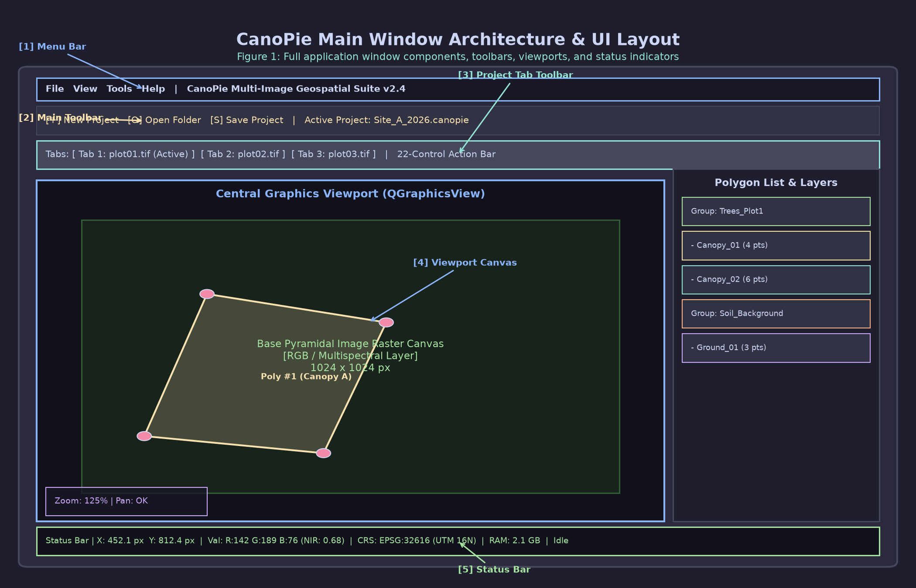
Figure 1: Main window interface layout showing central tab widget, top-right undo/redo buttons, main menu bar, top toolbar, and status bar.
The key structural components of the main window include:
- Central Tab Bar: Movable tabs (tab_widget.setMovable(True)) initialized with a single project tab ("Project 1"). Tabs can be dragged to reorder or managed using shortcut commands.
- Top-Right Quick Action Corner Widget: Positioned in the upper-right corner of the tab bar, containing two dedicated buttons:
- Undo Button (QPushButton with SP_ArrowBack icon, tooltip "Undo (Ctrl+Z)").
- Redo Button (QPushButton with SP_ArrowForward icon, tooltip "Redo (Ctrl+Y)").
- Status Bar: A standard QStatusBar connected to a custom thread-safe logging handler. It displays operational messages (logging level INFO and higher) with an automatic 4-second timeout.
- Logging Subsystem: Writes diagnostic logs to %TEMP%/CanoPie/app.log using a rotating file handler capped at 2 MB per file with up to 3 backup logs retained.
TIP: You can view the real-time application log stream at any time by pressing F12 to open app.log in your system's default text editor.

1.2 Project Tab Lifecycle & Navigation
CanoPie supports multi-project workflows, enabling users to switch between different field sites, spectral datasets, or processing runs without closing the application.
Creating New Tabs
- Click the Add Tab button (SP_FileIcon) on the main application toolbar, select File > New Tab from the menu bar, or press Ctrl+N.
- A new tab named Project N (where N is the next sequential integer) will be created and focused automatically.
Navigating Between Tabs
- Click directly on any tab header in the central tab bar.
- Use keyboard shortcuts: Alt+1 switches to the previous tab (left), and Alt+2 switches to the next tab (right).
Closing Tabs
- Click the Close Tab button (SP_DialogCloseButton) on the main toolbar, select File > Close Current Tab, or press Ctrl+W.
- If the current tab contains unsaved polygon annotations or project modification changes, CanoPie displays a confirmation dialog (QMessageBox with Yes, No, and Cancel options) prompting you to save your work before the tab is removed from memory.

1.3 Image Ingestion Modes & Folder Structures
CanoPie provides two primary image ingestion workflows designed for different aerial and ground sensor modalities, managed by the internal ImageData controller.
+-----------------------------------+
| Image Ingestion Engine |
+-----------------------------------+
|
+-----------------------+-----------------------+
| |
v v
+-----------------------+ +-----------------------+
| Dual-Folder Mode | | RGB / Stack Mode |
| (Ctrl+O) | | (Ctrl+R / Ctrl+Shift+R) |
+-----------------------+ +-----------------------+
| - Multispectral Dir | | - Single RGB Directory|
| - Thermal/RGB Dir | | - Multi-Band Stacks |
| - Index Offset Shift | | - Interactive Picker |
+-----------------------+ +-----------------------+

1. Dual-Folder Mode (dual_folder — Ctrl+O)
Designed for multi-sensor payload flights (e.g., simultaneous MicaSense multispectral and FLIR thermal capture).
- Trigger: Select File > Open multispectral/multiple Folders or press Ctrl+O.
- Operation: Prompts the user to select (1) the primary multispectral image directory and (2) the paired thermal or RGB image directory.
- Synchronization: CanoPie matches image capture files based on alphabetical root names. If capture timestamps or frame counts differ between sensors, an index shift can be specified using the Root Offset calibration tool.
2. RGB / Stack Folder Mode (rgb_only — Ctrl+R / Ctrl+Shift+R)
Designed for single-camera survey flights, single RGB orthomosaics, phenocam series, or multi-band TIFF stacks.
- Single Folder Ingestion (Ctrl+R): Select File > Open RGB/stack Folder to load an entire directory of images directly.
- Interactive Multi-File Picker (Ctrl+Shift+R): Select File > Open Image files (Select Files…). This dialog provides image preview thumbnails and allows you to set the Batch Size (number of images grouped into a single root position).
- Drag-and-Drop Ingestion: You can drop image files (.png, .jpg, .jpeg, .bmp, .tif, .tiff) or entire folders directly onto the active workspace tab. CanoPie will ingest the dropped files using a default batch size of 10 images per root.

1.4 Multi-Image Tab Navigation & Root Concept
The "Root" Abstraction
To seamlessly process multi-spectral sensor bands or multi-view drone capture points, CanoPie groups synchronized image files into a single logical entity called a Root. For example, a single multispectral capture comprising 10 distinct spectral band TIFFs represents 1 Root.
Navigation Controls
Navigation across image roots within a project tab is handled via the Project Tab Toolbar and interactive controls:
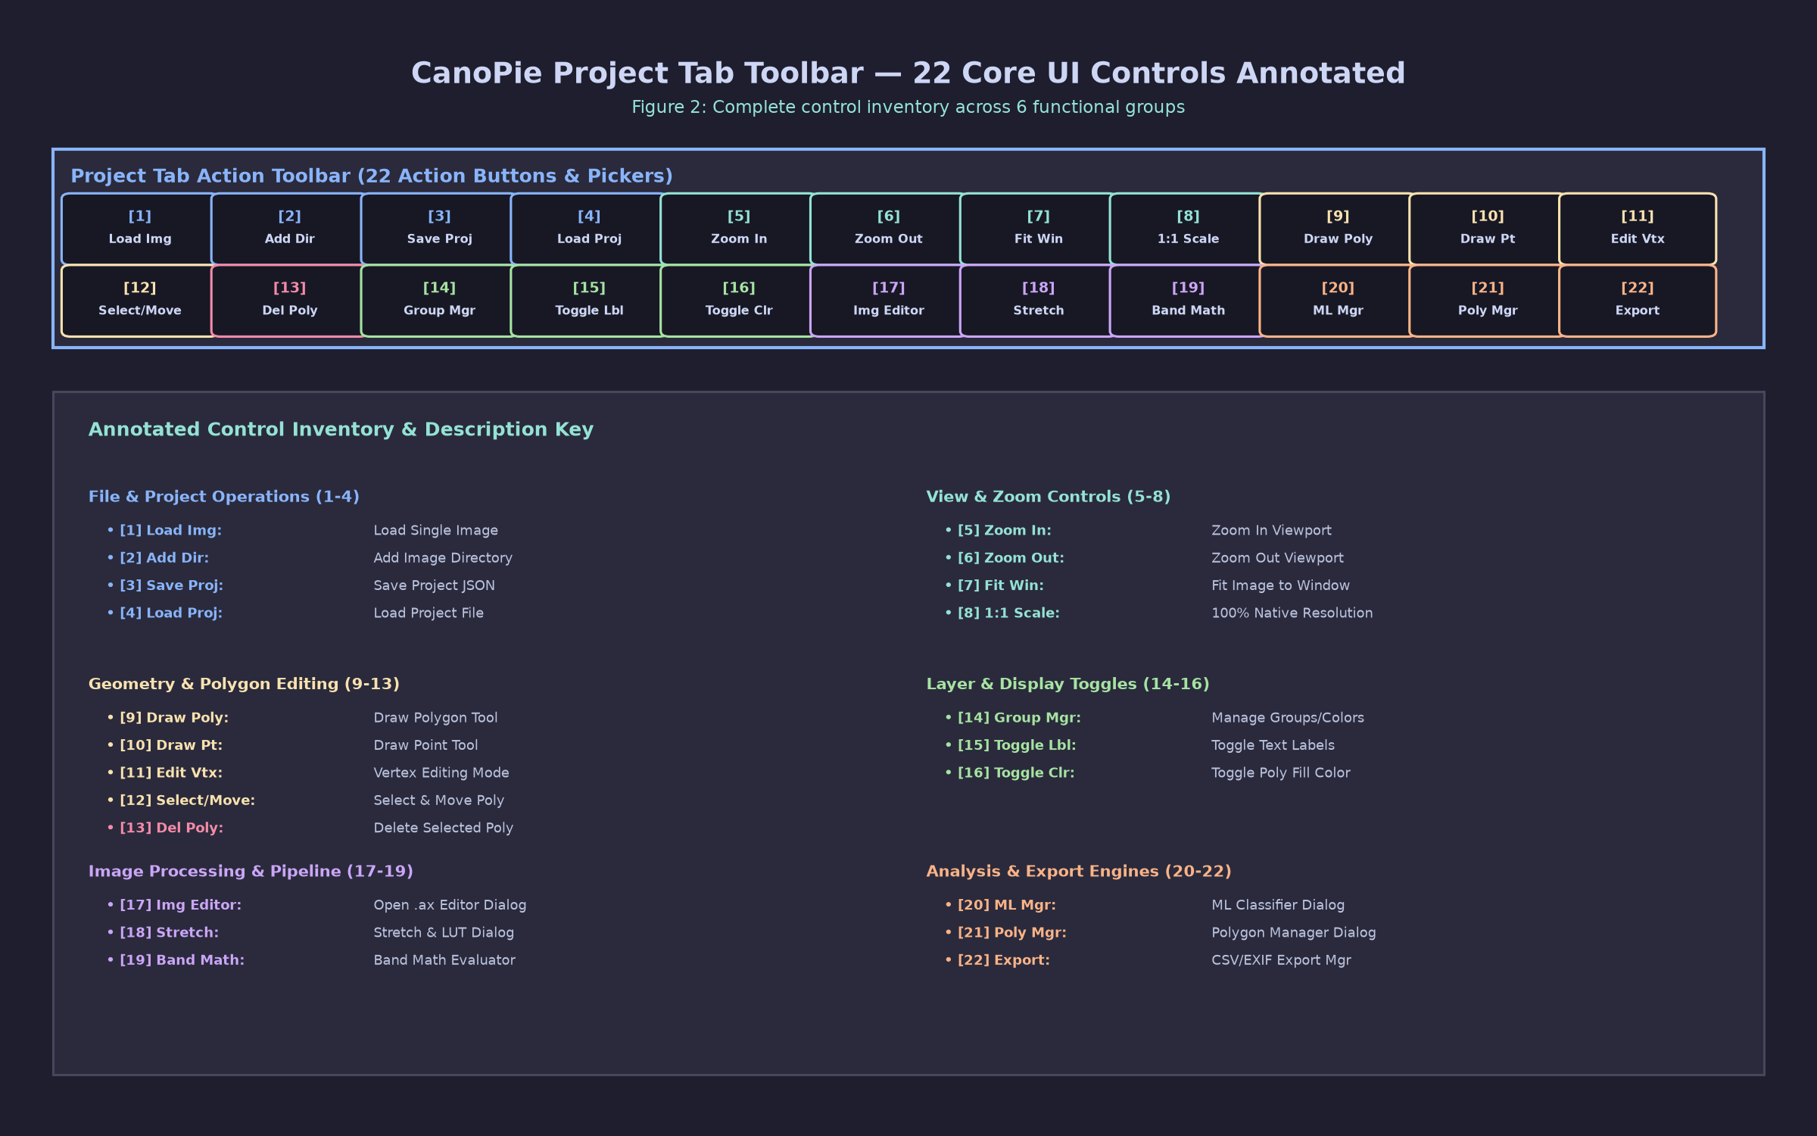
Figure 2: Project tab toolbar illustrating navigation buttons, sync toggle, drawing tools, polygon manager, root slider, and zoom controls.
- First Root Button (btn_first): Jumps to index 0 (first capture set).
- Previous Root Button (btn_prev / Left Arrow / A): Steps backward to the previous image group.
- Next Root Button (btn_next / Right Arrow / D): Steps forward to the next image group.
- Last Root Button (btn_last): Jumps to the final image group (N-1).
- Direct Jump Input (root_number_input + Go Button): Enter a specific root ID string or numeric index into the text box and press Enter or click Go to navigate directly to that frame.
- Interactive Root Slider (group_slider): Drag the horizontal slider handle across the capture timeline.
- Live Preview Floating Tooltip (`_SliderPreviewTooltip`): As you hover over or drag the slider handle, a top-level preview window pops up dynamically above the slider, rendering 4 live thumbnail previews of the candidate root frame to facilitate rapid visual navigation.
Debounced Navigation & Multi-Threaded I/O
To maintain 60 FPS UI responsiveness during rapid slider dragging:
- Navigation events increment an internal sequence counter (_nav_seq) and cancel pending per-viewer polygon loading operations.
- A single-shot idle timer (_poly_idle_timer, 150 ms timeout) debounces user inputs. Polygons and high-resolution overlays are loaded once when slider movement pauses.
- Image file loading is executed asynchronously using _ImageLoadRunnable worker threads managed by a QThreadPool. To prevent CPU thread contention during OpenCV reads, OpenCV multi-threading is pinned (cv2.setNumThreads(0)) inside runnables.

1.5 Session Persistence & Project Schema (project.json & .ax)
CanoPie preserves complete analytical sessions without modifying original raw data files through a dual persistence architecture: project metadata files (project.json) and non-destructive image sidecars (.ax).
1. Project Configuration File (project.json)
Saving a project (File > Save Project, Ctrl+Shift+S, or Quick Save Ctrl+Q) writes a structured project.json file to the root of the project folder:
{
"project_name": "Forest_Plot_Alpha",
"mode": "dual_folder",
"multispectral_folder_path": "C:/Data/Plot_Alpha/MS",
"thermal_rgb_folder_path": "C:/Data/Plot_Alpha/Thermal",
"rgb_folder_path": null,
"root_offset": 0,
"current_root_index": 4,
"batch_size": 1,
"multispectral_root_names": ["IMG_0001", "IMG_0002", "IMG_0003", "IMG_0004", "IMG_0005"],
"root_coordinates": {
"IMG_0001": {"lat": 45.51234, "lon": -122.65432},
"IMG_0002": {"lat": 45.51238, "lon": -122.65430}
},
"root_id_mapping": {"IMG_0001": 1, "IMG_0002": 2},
"all_polygons": { ... }
}

Polygons are simultaneously mirrored to disk under <project_folder>/polygons/<group>_<image_stem>_polygons.json.
TIP: Enable the Auto checkbox (autosaveCheckbox) on the project toolbar to activate background 1-minute auto-saving for modified polygon annotations.

2. Non-Destructive Edit Sidecars (.ax)
Any image modification (cropping, rotation, spatial resampling, registration, histogram matching, or band math) creates or updates a JSON sidecar file named <image_path>.ax (or <project_folder>/<image_name>.ax). Raw image arrays on disk are never overwritten.
{
"crop_rect": [120, 80, 1800, 1200],
"crop_rect_ref_size": [2048, 1536],
"rotate": 90,
"hist_match": {
"mode": "meanstd",
"ref_stats": {"mean": [112.4, 145.2, 98.1], "std": [42.1, 38.5, 31.0]}
},
"resize": {"width_pct": 50.0, "height_pct": 50.0},
"band_expression": "(b2 - b1) / (b2 + b1 + 1e-6)",
"registration": {"matrix": [[1.0, 0.0, 4.2], [0.0, 1.0, -2.1], [0.0, 0.0, 1.0]]},
"classification": {"model_path": "C:/Models/rf_tree_classifier.pkl"},
"appended_bands": ["(b3 - b1) / (b3 + b1)"],
"nodata_values": [-9999, 65535, "b1 > 60000"],
"mask_polygon": ["Group_Exclusion_1"]
}

Section 2: Viewport & Display Controls
2.1 Viewport Graphics Architecture
The primary image view area is managed by ImageViewer (canopie/image_viewer.py), a customized QGraphicsView operating on an interactive QGraphicsScene.
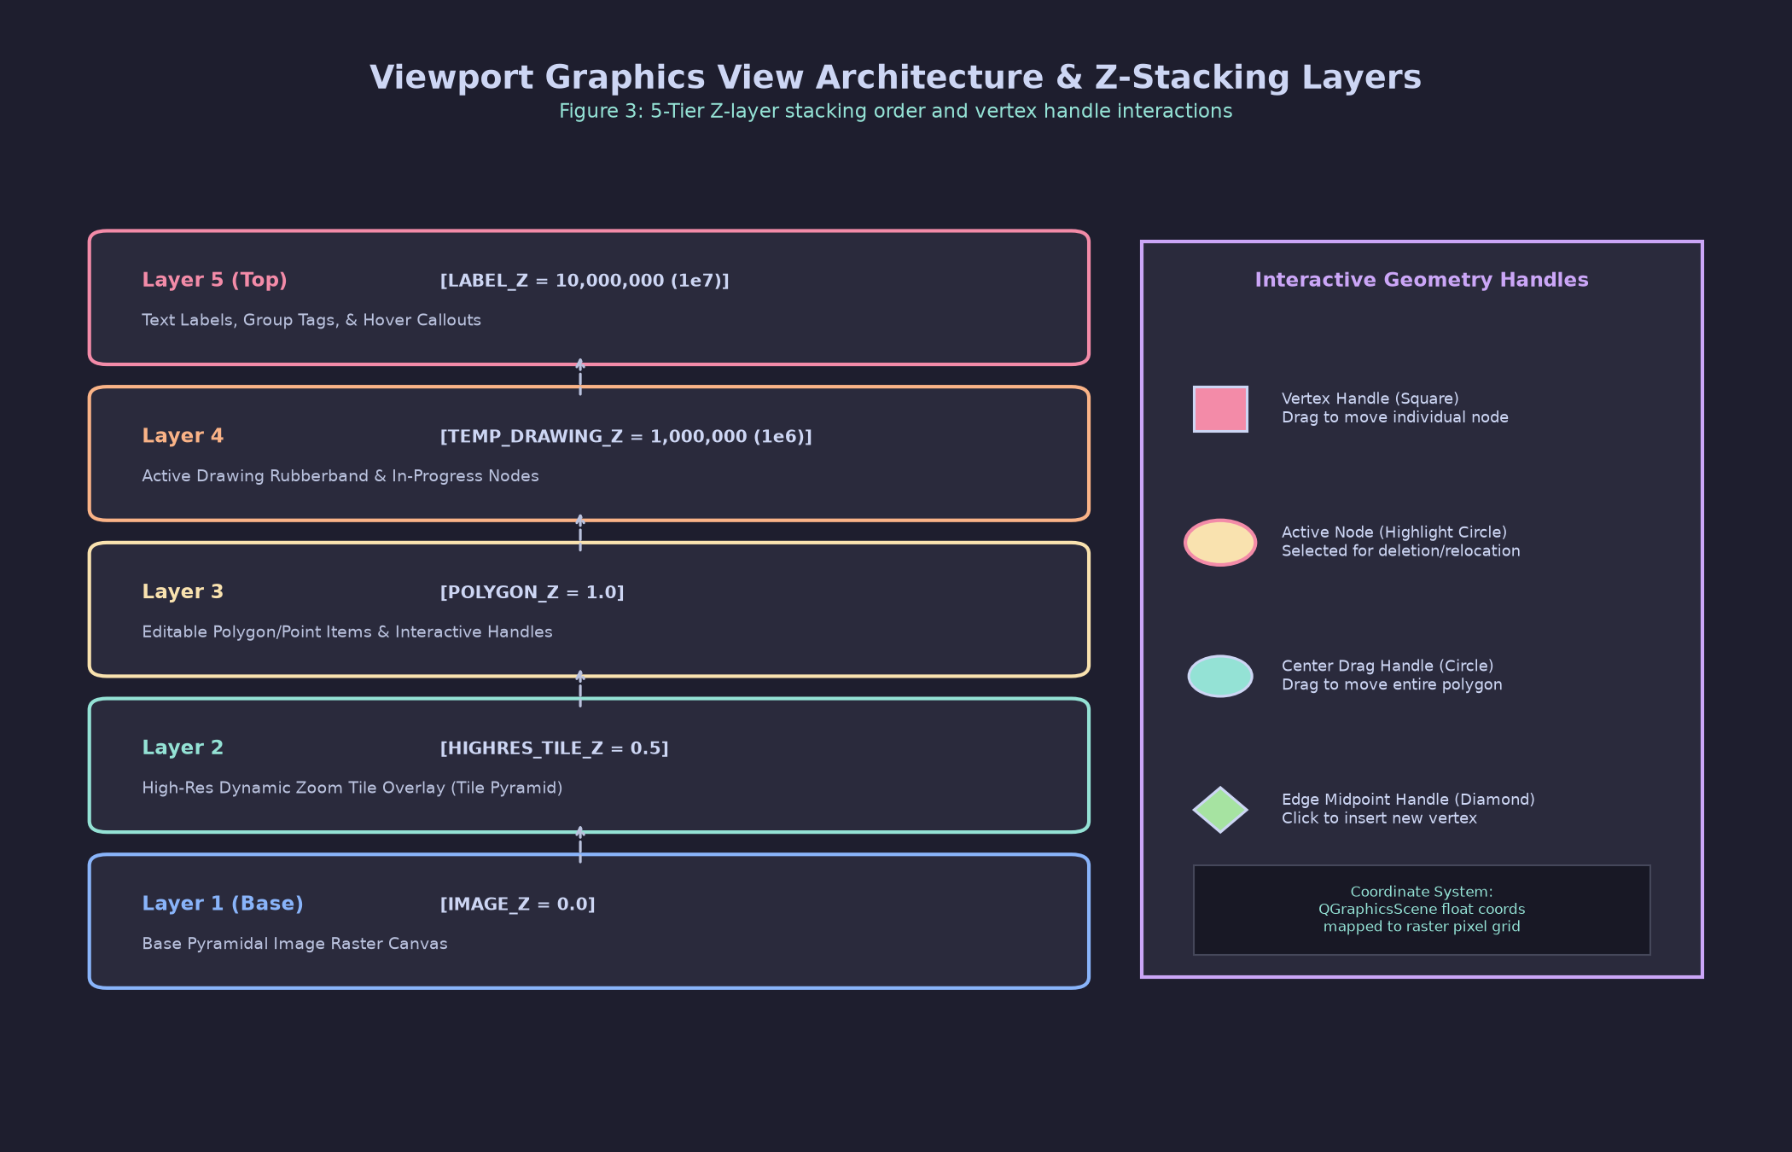
Figure 3: Diagram of the 5 Z-stacking layers in the ImageViewer scene rendering hierarchy.
Z-Stacking Layer Hierarchy
To ensure that vector annotations, labels, vertex handles, and temporary drawing geometries remain crisp and correctly ordered above high-resolution raster tiles during deep zooming, scene items strictly observe a 5-tier Z-value hierarchy:
Z-Value Constant | Numeric Z-Value | Item Description | Function / Purpose
IMAGE_Z | 0.0 | Base Preview Pixmap (QGraphicsPixmapItem) | Base low-resolution or full-frame raster display
HIGHRES_TILE_Z | 0.5 | High-Res Viewport Zoom Overlay | Dynamically loaded high-resolution viewport tile
POLYGON_Z | 1.0 | Vector Geometries (EditablePolygonItem) | Polygon boundaries, point shapes, and filled masks
TEMP_DRAWING_Z | 1,000,000.0 | Temporary Rubber-Band Item | Interactive in-progress drawing shape outline
LABEL_Z | 10,000,000.0 | Labels & Handles (VertexHandle) | Text labels, point markers, and vertex handles (always top)

Navigation & Canvas Interaction
- Smooth Zoom: Rotate the Mouse Scroll Wheel to zoom in or out, automatically centered on the current mouse cursor location.
- Canvas Panning: Press and hold the Middle Mouse Button or Left Mouse Button (in default selection mode) and drag to pan across the viewport.
- Fit View to Screen: Press Z or select Zoom > Zoom All (fit) from the toolbar to instantly fit the entire image extent within the viewer window.
- Movable Overlay Button (`OverlayButton`): A floating circular button positioned directly on the image canvas. It stays locked to the viewport screen space (ItemIgnoresTransformations enabled) and can be dragged anywhere on canvas to open a tool pop-up menu.

2.2 High-Resolution Zoom Overlay Engine
When loading multi-gigabyte orthomosaics or hyperspectral cubes (e.g., 284-band AVIRIS rasters), loading the complete pixel array into memory causes severe memory spikes and UI freezing. CanoPie solves this via a GDAL-free, lazy-tiling raster engine (canopie/raster_reader.py).
+-----------------------------------------------------------------+
| ImageViewer Viewport |
| +-----------------------------------------------------------+ |
| | Visible Viewport Bounding Box (Screen Coordinates) | |
| +-----------------------------------------------------------+ |
+-----------------------------------------------------------------+
|
v
+-----------------------------------------------------------------+
| TiledRasterReader Tile Intersection Query |
| - Probes TIFF Header without loading full array |
| - Reads ONLY tiles intersecting visible bounding box |
| - Decodes compressed TIFF chunks (Deflate, ZSTD, Predictor 3) |
+-----------------------------------------------------------------+
|
v
+-----------------------------------------------------------------+
| High-Res Overlay Tile (Rendered at HIGHRES_TILE_Z = 0.5) |
+-----------------------------------------------------------------+

Operational Mechanics
- Header Probing: TiledRasterReader reads TIFF headers using tifffile without pulling raster data into RAM.
- Bounding Box Intersect: As you zoom into a sub-region of an image, ImageViewer computes the scene coordinates of the visible screen rectangle and queries TiledRasterReader.
- Chunk Decoding: The reader fetches only the compressed TIFF tiles that intersect the visible viewport, decoding them on-the-fly using imagecodecs (supporting Deflate, ZSTD, LZW, and Predictor 3 compression).
- Bounded Tile Cache: Decoded tiles are stored in a memory-bounded cache (_DEFAULT_CACHE_BYTES = 640 MB). Least Recently Used (LRU) tiles are evicted automatically as you pan across the dataset.

2.3 Image Stretch Controls & Rendering Engine (ImageStretchDialog)
To optimize visual contrast across 12-bit, 16-bit, or floating-point sensor rasters, CanoPie includes an advanced contrast stretch engine.
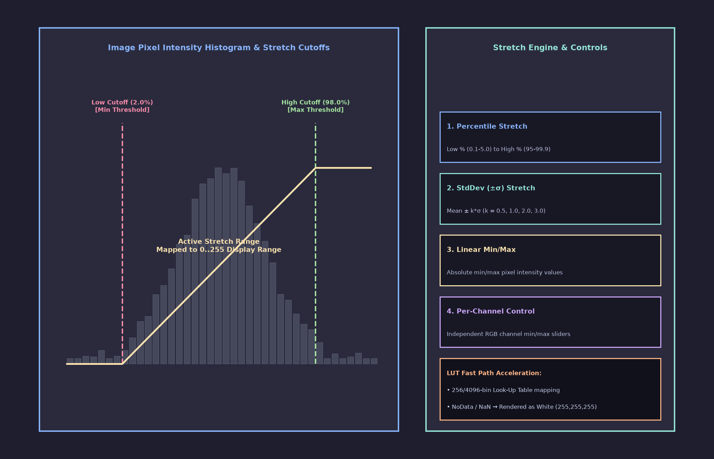
Figure 4: Image Stretch Dialog window showing percentile, stddev, and min/max stretch parameters.
Stretch Modes
Access the Stretch dialog via View > Image Stretch or double-clicking the status bar stretch readout:
- Percentile Stretch (Default): Clips intensity extremes to specified lower and upper percentiles (e.g., Low = 0.5%, High = 99.5%). This mode effectively removes bright solar glint or dark cloud shadows.
- Standard Deviation ($k$-Sigma) Stretch: Normalizes pixels based on mean (\mu) and standard deviation (\sigma):
\text{Min} = \mu - k \cdot \sigma, \quad \text{Max} = \mu + k \cdot \sigma
where k is selected from the multiplier dropdown (e.g., k = 2.0).
- Linear Min / Max: Maps specified minimum and maximum intensity values directly to the display range.
- Absolute Band Range: Enables manual per-band minimum and maximum numeric thresholds.
Mathematical Normalization Algorithm
For non-8-bit datasets, intensity values x are normalized using vectorized float32 scaling:
\text{out} = \text{clip}\left( \frac{x - \text{low}}{\text{high} - \text{low}}, 0.0, 1.0 \right) \times 255.0
- 8-Bit Fast Path: For standard 8-bit imagery (uint8), contrast adjustments use a pre-calculated 256-entry Look-Up Table applied via OpenCV's SIMD-accelerated cv2.LUT(), providing zero-latency contrast adjustments.
- NoData Pixel Rendering: To distinguish invalid or missing data from valid dark canopy pixels, pixels identified as NoData are explicitly rendered in PURE WHITE (out[nd] = 255).
Stretch Scope Selection
- Viewer: Applies stretch settings only to the active pane.
- Root: Applies stretch settings to all spectral band viewers within the current image root.
- Project: Applies stretch settings across all open project tabs.

2.4 Display Band Selector Bar & Channel Composite Rendering
Multi-band imagery can be visualized as either single-band grayscale maps or false-color RGB composites using the Band Selector Bar (BandBar).
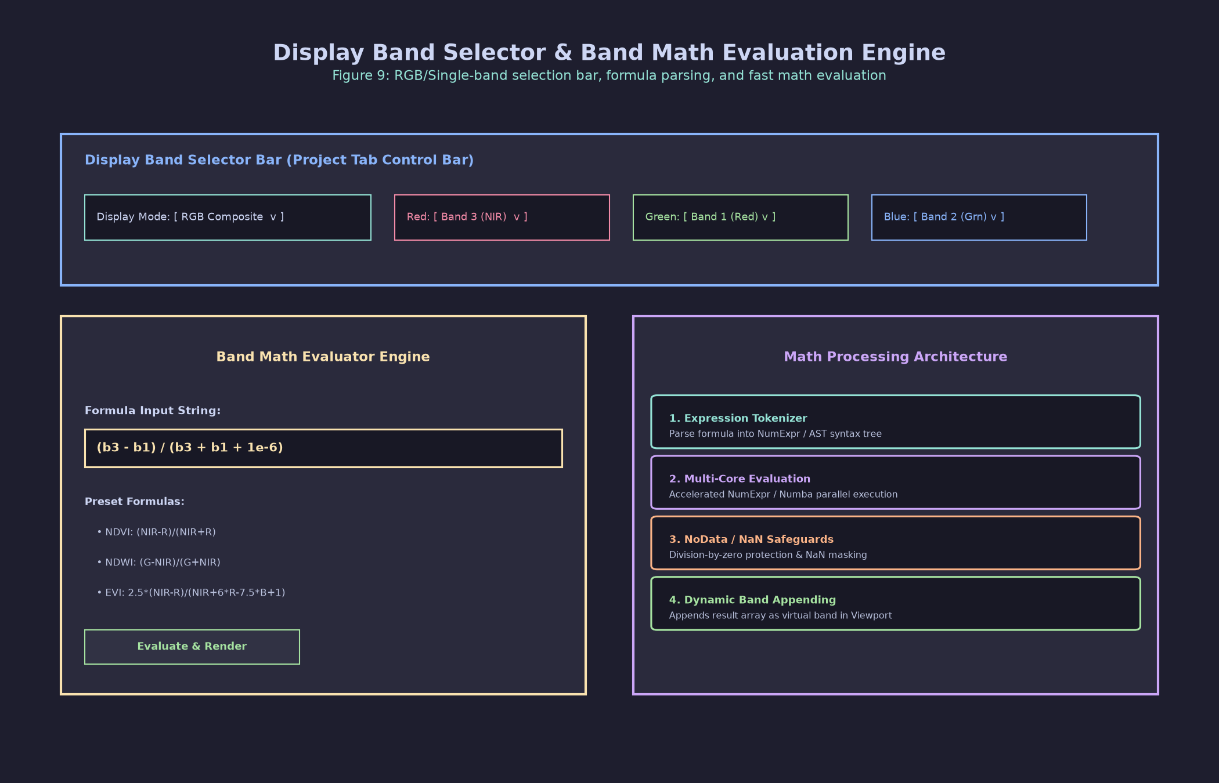
Figure 5: Display Band Selector bar showing single-band vs RGB composite controls.
- Single Band Mode: Select a single band from the dropdown list (e.g., Band 5 - Near Infrared). The raster is rendered in 8-bit grayscale contrast.
- RGB Composite Mode: Select independent bands for the Red, Green, and Blue display channels:
- Standard True Color: Red = Band 3 (Red), Green = Band 2 (Green), Blue = Band 1 (Blue).
- Color Infrared (CIR): Red = Band 5 (NIR), Green = Band 3 (Red), Blue = Band 2 (Green).

2.5 Band Math Formula Evaluation & Vegetation Indices Engine
CanoPie contains a built-in mathematical engine capable of evaluating complex band expressions and spectral vegetation indices on-the-fly.
Expression Syntax & Operators
- Band Tokens: b1, b2, b3, ..., bN (1-indexed, case-insensitive).
- Arithmetic Operators: Addition (+), Subtraction (-), Multiplication (*), Division (/).
- Comparison Operators: <, <=, >, >=, ==, !=.
- Logical Operators: & (AND), | (OR), ~ (NOT).
- Supported Functions: mean(x), std(x), min(x), max(x), median(x), clip(x, low, high), where(cond, true_val, false_val), abs(x), sqrt(x), log(x), exp(x).
Dual Processing Engines
- Reference AST Engine (`utils.eval_band_expression`): Parses formulas into Abstract Syntax Trees using Python's ast module. Validates node types against a strict whitelist (_ALLOWED_NODES) to block arbitrary code execution, substituting non-finite results safely via np.nan_to_num().
- Accelerated SIMD Engine (`performance.FastBandMathEngine`): Compiles expressions into multi-threaded SIMD execution routines using NumExpr. Employs weak-reference caching (_weak_or_none) to reuse compiled expression binaries across thousands of polygon calculations.
Built-In Vegetation Index Library
CanoPie includes standard built-in equations optimized for plant phenology and canopy cover extraction:
\text{ExG (Excess Green)} = (2 \times G) - (R + B)
\text{GCC (Green Chromatic Coordinate)} = \frac{G}{R + G + B + \epsilon}
\text{BCC (Blue Chromatic Coordinate)} = \frac{B}{R + G + B + \epsilon}
\text{GBD (Green-Blue Difference)} = \frac{G - B}{G + B + \epsilon}
\text{WDX (Weighted Difference Index)} = (2 \times B) + R - (2 \times G)
\text{SHD (Sum / Brightness Index)} = R + G + B
(where $\epsilon = 10^{-6}$ prevents division-by-zero errors in dark shadow regions).

Section 3: Annotation Tools & Interactive Vector Editing
3.1 Drawing Modes & Tool Operations (Alt+D)
Vector annotations are created directly on the image canvas. Press Alt+D on the project tab to cycle through the 5 interactive drawing modes, or select the mode from the toolbar drop-down menu.
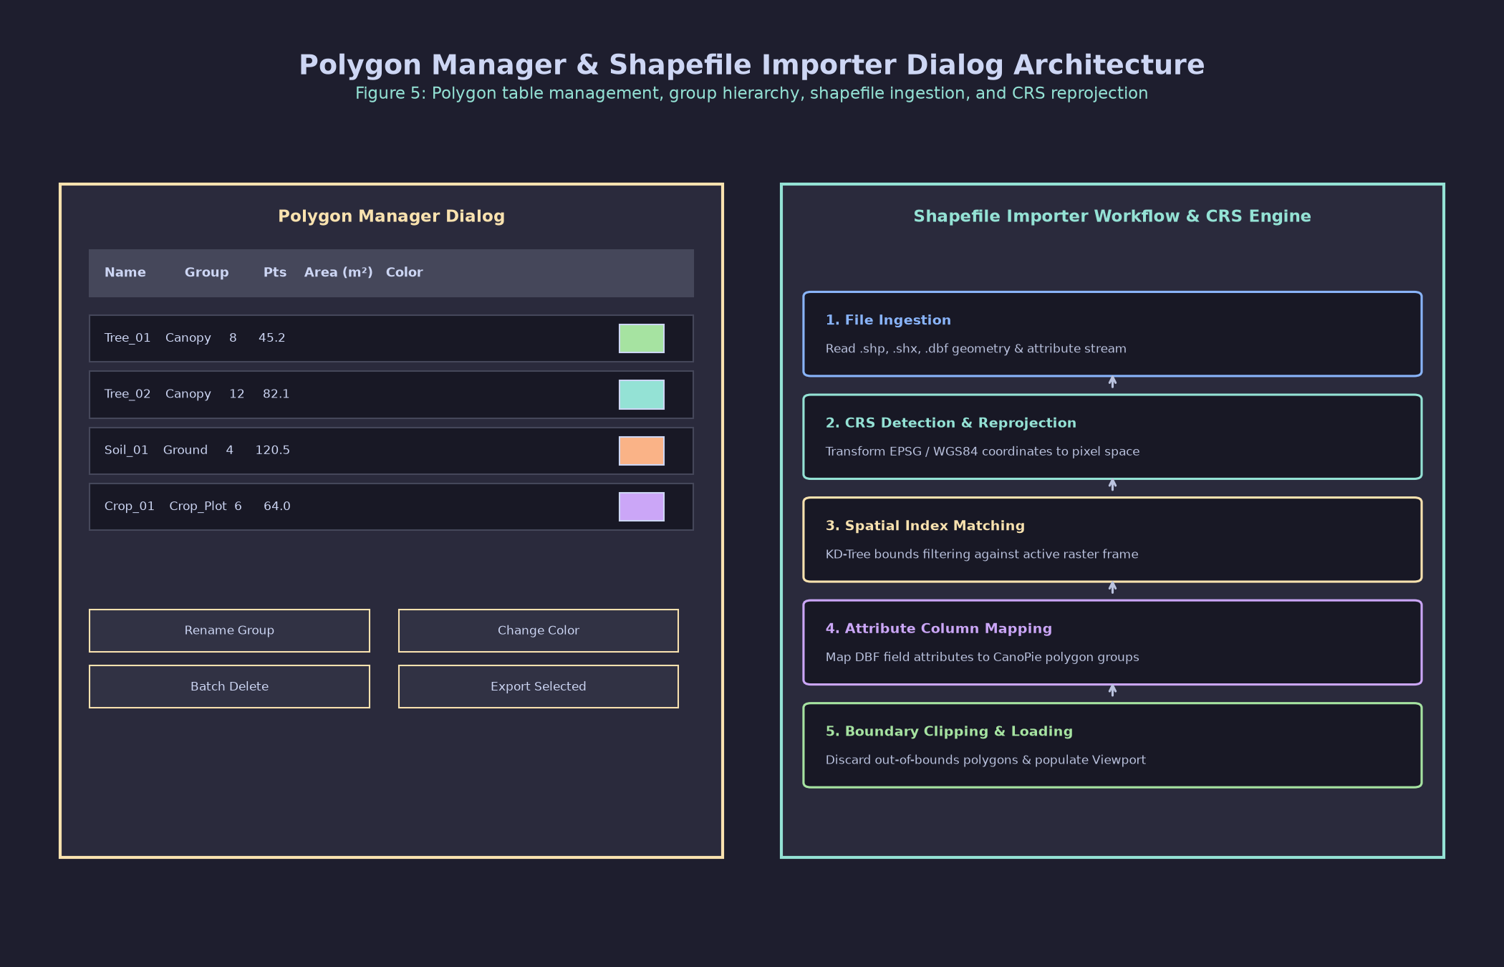
Figure 6: Visual representation of the 5 annotation drawing modes: Polygon, Point, Rectangle, Circle, and Random Points.
+-----------------------+
| Drawing Mode Toggle |
| (Alt+D) |
+-----------------------+
|
+----------------+-----------+-----------+----------------+
| | | |
v v v v
+--------------+ +-----------+ +--------------+ +-----------+
| 1. Polygon | | 2. Point | | 3. Rectangle | | 4. Circle |
+--------------+ +-----------+ +--------------+ +-----------+
| - Freehand | | - Single | | - 2-Click / | | - Radial |
| - Double- | | Click | | Drag Box | | Drag |
| Click End | +-----------+ +--------------+ +-----------+
+--------------+ |
v
+---------------+
| 5. Random Pts |
+---------------+
| - ROI Prompt |
+---------------+

- Polygon Mode (`"polygon"`): Left-click on the image canvas to place consecutive vertices. A rubber-band line tracks cursor movement. Double-click or press Enter to close the polygon shape.
- Point Mode (`"point"`): Left-click anywhere on the image canvas to instantly place a single-pixel coordinate annotation (EditablePointItem).
- Rectangle Mode (`"rectangle"`): Click and drag from top-left to bottom-right (or click start point and end point) to construct an axis-aligned 4-vertex rectangular polygon.
- Circle Mode (`"circle"`): Click to anchor the circle center and drag outward to define the radius. CanoPie automatically computes a smooth N-vertex polygon boundary:
N = \min\left(64, \max\left(32, \text{int}\left(\frac{\text{radius}}{3}\right)\right)\right)
- Random Points Mode (`"random_points"`): Triggers an interactive generator (_generate_random_points()). Prompts for the desired point count via a dialog window and distributes random points across the current viewport extent.

3.2 Selection & Group Styling
Selection Workflows
- Single Selection: Left-click directly on any polygon or point shape.
- Rubber-Band Selection: Press and hold Ctrl + Left-click and drag a marquee selection box across the canvas (RubberBandDrag). All intersecting shapes will be selected.
- Additive Selection: Hold Ctrl or Shift while clicking shapes to add or remove individual items from the current selection set without clearing previous selections.
Group Assignment & Sensor Color Coding
Polygons are organized into named groups (e.g., Tree_Canopy, Shadow, Ground_Plot) managed via the Polygon Manager.
- RGB Images: Rendered by default with a crisp solid Red outline (Qt.red). Hovered or selected shapes switch to bright Magenta.
- Multispectral / Thermal Images: Rendered with a Blue outline (Qt.blue). Hovered/selected shapes switch to Magenta.
- Mask Polygons: Polygons designated as spatial exclusion masks (is_mask_polygon = True) are rendered with a distinctive semi-transparent Orange fill (QColor(255, 165, 0, 80)) and orange border. Highlighted mask shapes use magenta fill (QColor(255, 0, 255, 100)).
Adaptive Label Suppression (_LABEL_SCALE_THRESHOLD)
To maintain high frame rates and eliminate clutter when zoomed out:
- Label text rendering is automatically suppressed when the viewport scale falls below 0.35 (_LABEL_SCALE_THRESHOLD = 0.35).
- Labels reappear automatically when zooming in beyond 0.35 or when hovering/selecting a shape.
- Font sizes adjust dynamically to image resolution and scale:
\text{px} = \text{int}\left(\max\left(14, \min\left(220, \text{round}\left(\frac{\text{base\_px} \times \text{res\_boost}}{\text{scale}}\right)\right)\right)\right)

3.3 Vertex Editing Subsystem
To fine-tune polygon boundaries (e.g., fitting tight crown perimeters), CanoPie provides a vertex modification mode.
Figure 7: Scale-invariant VertexHandle controls rendered at polygon vertices during active vertex editing.
Operating Mechanics
- Activation: Right-click any polygon and select Edit vertices from the context menu (image_viewer.py:678).
- Handle Rendering (`VertexHandle`): A square handle (black fill, red border, turning yellow/orange on hover) appears at every vertex position. Handles are scale-invariant—they retain a constant, easily clickable screen pixel size regardless of zoom level.
- High-Density Resampling Guard: If a complex polygon contains more than 100 vertices (MAX_HANDLES = 100), handles are resampled at uniform index steps (\text{step} = N / 100) to prevent GUI lag.
- 60 FPS Throttled Movement: Handle dragging is throttled to 60 FPS (16.6\text{ ms} interval) using a single-shot timer (_vertex_update_timer), guaranteeing smooth visual feedback.
- Contextual Vertex Actions:
- Add Vertex: Right-click near an edge line and select Add Vertex to insert a new handle.
- Remove Vertex: Right-click an existing handle and select Remove Vertex.
- Exit Editing: Press Escape, press Enter, or double-click any vertex handle to finalize adjustments and emit polygon_modified.

3.4 Batch Relocation & Undo Integration
Multi-Item Relocation
Selected polygons or points can be moved collectively across the canvas. Click and drag any selected polygon—all co-selected shapes will move in unison.
Macro Undo Integration
When dragging finishes, CanoPie computes displacement vectors for all affected items:
\Delta X = X_{\text{end}} - X_{\text{start}}, \quad \Delta Y = Y_{\text{end}} - Y_{\text{start}}
The movement is packaged into ProjectTab's QUndoStack as a macro command (modify_polygon_command). Pressing Ctrl+Z (Undo) or Ctrl+Y (Redo) reverses or re-applies multi-polygon movements cleanly.

3.5 Deletion Operations
- Single Shape Deletion: Select a shape and press Delete or Backspace. The deletion is recorded on the undo stack.
- Group Deletion: In the Polygon Manager, right-click a group name and select Delete Group. All polygons assigned to that group across all images in the project are deleted via an undo macro.
- Project-Wide Complete Clear: In the Polygon Manager, click Delete ALL Polygons (Project). After confirming the safety prompt, every *_polygons.json file in the project folder is deleted and graphics items are removed.

3.6 Polygon Operations & Copy Pipelines
To eliminate redundant annotation work across multi-image flight paths or multi-spectral tabs, CanoPie provides polygon copying tools:
- Clean Root Polys (Ctrl+X): Clears all polygon annotations from the active image root.
- Copy Polygons Menu Dropdown:
- Copy Polys Next (Alt+Right): Copies all polygons from the active root to the immediately following root index (i \to i+1).
- Copy Polys Previous (Alt+Left): Copies all polygons from the active root to the preceding root index (i \to i-1).
- Copy Polys $\to$ All Roots (Ctrl+Shift+A): Duplicates all polygons from the current root across every root in the project tab.
- Copy Polygons to Next Tab (Alt+3): Copies all active polygons to the identical root position in the adjacent open project tab.

Section 4: Shapefile & Data Ingestion Pipeline
4.1 Ingestion Architecture & ShapefileImportWorker
CanoPie imports external vector datasets (such as UAV canopy segmentations, plot boundaries, or forestry inventory shapefiles) using a non-blocking background thread worker (ShapefileImportWorker, canopie/polygon_manager.py:66).
Figure 8: Architectural diagram of the 5-stage coordinate transformation pipeline for shapefile ingestion.
- User Action: Click Import Shapefile (.shp) in the Polygon Manager window.
- Background Thread: ShapefileImportWorker spawns to parse binary files (.shp, .dbf, .prj), reproject coordinates, match features to target images via spatial indexing, and convert shapes into pixel-space dictionary records.
- Main Thread Callback: _on_shapefile_import_finished receives converted polygons, updates all_polygons, performs an incremental save (save_incremental()), and populates graphics scenes without locking the user interface.

4.2 Pure-Python Binary Parsers (shapefile_io.py)
CanoPie contains zero-dependency, pure-Python binary parsers for GIS file formats:
- `read_shapefile` (`shapefile_io.py:1443`): Unpacks the 100-byte main file header, checks the file magic code (9994), and parses binary record contents using Python's struct module. Supports Shape Types 1 (Point), 3 (PolyLine), 5 (Polygon), and 8 (MultiPoint).
- `read_dbf` (`shapefile_io.py:1328`): Parses 32-byte dBASE III/IV headers and 32-byte field descriptor arrays. Decodes field data types:
- N / I: Integers
- F: Floating-point numbers
- L: Logical booleans (T/F/Y/N)
- D: YYYYMMDD dates
- C: Character strings
- Accommodates _fields.csv legend sidecars to restore original long field names truncated by dBASE limits.

4.3 5-Stage Coordinate Transformation Pipeline
When importing geographic shapefile features onto un-georeferenced or modified raster images, coordinates pass through a 5-stage coordinate transformation pipeline (reproject_shapefile_geometry_to_image_pixels):
\text{Geo Points (Shapefile CRS)} \xrightarrow{(1)} \text{Geo Points (Image CRS)} \xrightarrow{(2)} \text{Raw Image Pixels} \xrightarrow{(3)} \text{Modified (.ax) Pixels} \xrightarrow{(4)} \text{Stored Ref Pixels}
- CRS Reprojection (`pyproj.Transformer`): Parses Shapefile WKT from .prj and Image CRS (GeoTIFF tags or EXIF GPS estimation). Transforms coordinates from Shapefile CRS to Image CRS.
- Geographic to Raw Image Pixels: Applies the inverse affine transform matrix D^{-1} derived from GeoTIFF bounds:
\begin{bmatrix} \text{col} \\ \text{row} \end{bmatrix} = \begin{bmatrix} a & b \\ d & e \end{bmatrix}^{-1} \begin{bmatrix} X_{\text{geo}} - c \\ Y_{\text{geo}} - f \end{bmatrix}
- Raw Pixels to Modified (.ax) Pixels: Applies affine matrix M combining .ax modification transformations in strict sequence (Rotation \to Crop \to Resize):
\begin{bmatrix} x_{\text{mod}} \\ y_{\text{mod}} \\ 1 \end{bmatrix} = M \begin{bmatrix} x_{\text{raw}} \\ y_{\text{raw}} \\ 1 \end{bmatrix}
- Modified Pixels to Stored Reference Pixels: Scales modified pixel coordinates by reference dimensions ratio:
s_x = \frac{\text{target\_ref\_w}}{\text{out\_w}}, \quad s_y = \frac{\text{target\_ref\_h}}{\text{out\_h}}
x_{\text{stored}} = x_{\text{mod}} \cdot s_x, \quad y_{\text{stored}} = y_{\text{mod}} \cdot s_y
- Canvas Display Mapping: Converts stored reference coordinates into interactive viewport scene positions.

4.4 Dual-Tier Spatial Indexing Engine (spatial_index.py)
To automatically match imported shapefile polygons to the correct drone image frame, SpatialIndexManager uses a two-tier spatial index:
Figure 9: Dual-tier spatial index flow chart showing STRtree Tier 1 footprint overlap matching and KDTree Tier 2 camera GPS distance matching.
+-----------------------------------+
| Input Vector Feature |
+-----------------------------------+
|
v
+-----------------------------------+
| Tier 1: Shapely STRtree Match |
| (Image Footprint Polygons) |
+-----------------------------------+
|
+----------+----------+
| Overlap | No Overlap
v v
+-----------------------+ +-------------------------+
| Calculate IoA Ratio | | Tier 2: SciPy KDTree |
| (Intersection / | | (Camera GPS Distance) |
| Feature Area) | +-------------------------+
+-----------------------+ |
| v
+-------------------------+
|
v
+-----------------------------------+
| Matched Image Target |
+-----------------------------------+

Tier 1: Ground Footprint Search (Shapely STRtree)
Computes the 4-corner ground boundary polygon for every image using GeoTIFF metadata or EXIF GSD estimation. Builds an STRtree spatial index over EPSG:4326 geometries. For each shapefile polygon, queries the STRtree and evaluates the Intersection Over Area (IoA) ratio:
\text{IoA} = \frac{\text{Area}(\text{Feature} \cap \text{Footprint})}{\text{Area}(\text{Feature})}
If \text{IoA} \ge 0.01 (1% minimum overlap), the shapefile feature is assigned to the image. Features overlapping multiple images are assigned to the frame yielding the highest IoA score.
Tier 2: Camera Geodesic Distance Search (SciPy KDTree)
For non-georeferenced images with EXIF camera GPS tags where ground footprints cannot be constructed, Tier 2 queries a scipy.spatial.KDTree built from camera GPS coordinates (\text{lat}, \text{lon}). Calculates exact geodesic distance in meters using geopy.distance.geodesic and assigns the shapefile feature to the nearest camera position.

4.5 DBF Attribute Parsing, Ring Classification & Edge Cases
Hole vs. Outer Ring Classification
When multi-ring polygons are imported, CanoPie computes the signed area of each ring using the Shoelace formula (calculate_signed_area):
A = \frac{1}{2} \sum_{i=0}^{n-1} (x_i y_{i+1} - x_{i+1} y_i)
- The ring with the largest absolute area |A| is designated as the primary outer boundary (outer).
- Smaller interior rings are classified as interior holes (holes), ensuring complex crown geometries with internal gaps render correctly.
DBF Feature Identity Resolution (resolve_feature_identity)
Extracted DBF attributes are mapped to standardized internal properties:
- `base_group`: Extracted from DBF fields GROUP, CLASS, LAYER, CATEGORY, SPECIES, or TYPE. Defaults to shapefile stem if absent.
- `display_name`: Extracted from DBF fields NAME, ID, TREE_ID, POLY_ID, LABEL, TAG, or PLOT_ID.
- `entry_key`: A disaggregated key (e.g., Tree_Canopy_042) generated to prevent key collisions in all_polygons.
Out-of-Bounds Geometry Handling
Features falling entirely outside target image boundaries are gracefully filtered out. A detailed warning report listing unmapped feature IDs is returned in the status bar and log file.

4.6 Synthetic Random Shapes Generator (random_shapes_generator.py)
For statistical benchmarking or synthetic training dataset generation, CanoPie includes an automated shape generation engine (Modules > Random Shapes...).
Parameters & Placement Modes
- Shape Types: Point, Circle, Rectangle.
- Size & Units: Specify dimensions in real-world meters (converted via image GSD) or raw pixel units.
- Placement Modes:
- Unrestricted Mode: Samples shape centroids uniformly across the image bounding box.
- Restricted Mode (`restrict_valid = True`): Restricts shape generation strictly to valid, non-NoData image pixels.
Spatial Indexing & Rejection Sampling
- Grid Index (`_SpacingIndex`): Divides the image canvas into a spatial grid of cell size \frac{\text{min\_dist}}{\sqrt{2}}. Checks only 25 (5 \times 5) neighboring cells to enforce minimum separation distance (d^2 \ge \text{min\_dist}^2) in O(1) time.
- Stratified Patch Sampling (`_stratified_centers`): For fragmented canopy imagery, identifies valid pixel clusters using connected component analysis (cv2.connectedComponentsWithStats). Samples shapes across patches in a round-robin sequence so small isolated tree canopies receive proportional representation.
- Morphological Erosion Containment: To guarantee that 100% of a generated shape's footprint lies inside valid data, the valid pixel mask is eroded using cv2.erode with a kernel matching the shape's footprint size prior to sampling.

Section 5: Data Analysis, Band Math & Export Pipeline
5.1 Image Editor Non-Destructive Editing Pipeline (ImageEditorDialog)
The Image Editor dialog (Modules > Edit Image Viewer - Crop) defines non-destructive image modification workflows stored in .ax sidecars.
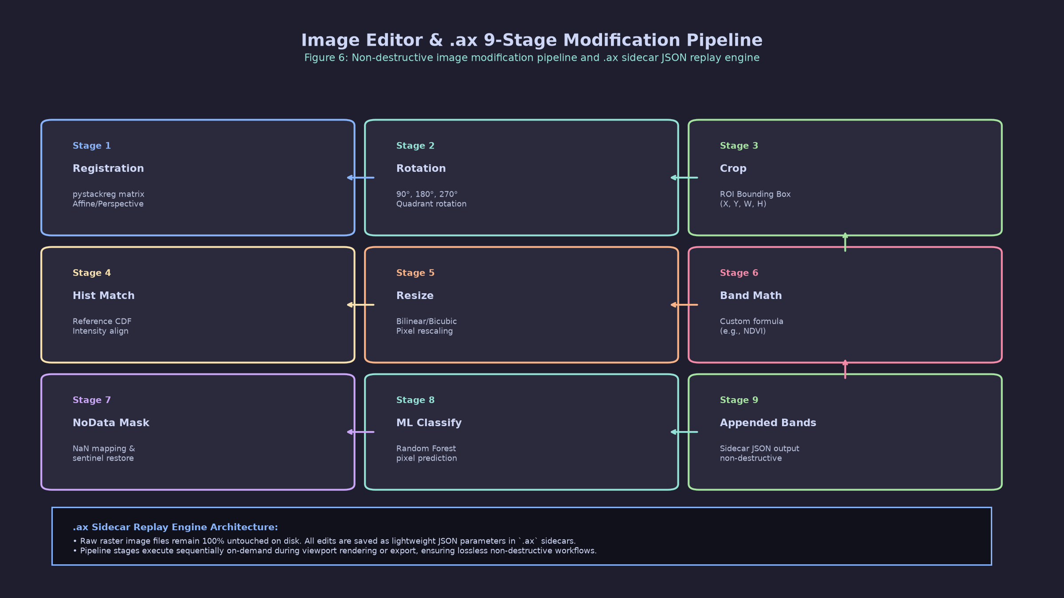
Figure 10: Image Editor Dialog sidebar showing crop, rotate, resize, hist match, registration, band expression, and NoData controls.
[Raw Image File on Disk]
│
▼
1. Registration Matrix (pystackreg affine warp with raw-space coordinate translation)
│
▼
2. Crop & Rotate (Dynamic order based on crop_rect_ref_size / do_rotate_first)
│
▼
3. Histogram Normalization / CLAHE (_apply_hist_match) [Executed EXACTLY ONCE]
│
▼
4. Spatial Resize (resize_safe with NoData NaN propagation)
│
▼
5. Band Math Expression (eval_band_expression / FastBandMathEngine)
│
▼
6. Classification (scikit-learn pixel classification model)
│
▼
7. Appended Bands (Appended numeric/boolean expressions or classification maps)
│
▼
8. Global NoData Mask Re-application
│
▼
[Rendered Viewport Pixmap / Export Data Array]

The 9-Step Replay Pipeline
When an image is displayed or exported, transformations are executed in strict order:
- Registration Matrix: Applies image alignment via PyStackReg (Translation, Rigid Body, Scaled Rotation, Affine, Bilinear). Coordinates are translated to raw space to prevent black border artifacts.
- Crop & Rotate: Executes cropping (crop_rect) and rotation (90^\circ, 180^\circ, 270^\circ). Order is determined automatically by comparing reference dimensions (crop_rect_ref_size).
- Histogram Normalization: Executes histogram matching (_apply_hist_match). Executed EXACTLY ONCE per replay pipeline.
- Spatial Resize: Resizes arrays using cv2.resize(). Converts NoData pixels to NaN prior to scaling so invalid values propagate across tile boundaries, restoring sentinel values post-scale.
- Band Math Expression: Evaluates custom band math formulas across rasters.
- Classification: Evaluates trained scikit-learn Random Forest models per-pixel.
- Appended Bands: Appends calculated vegetation index planes or classification maps as extra image channels.
- Global NoData Mask Re-application: Re-asserts NoData masks across all output bands.
- Final Output: Delivers the transformed array to the display renderer or export thread.

5.2 Histogram Matching Subsystem (_apply_hist_match)
Histogram matching normalizes illumination variations across multi-temporal imagery or adjacent flight lines.
Matching Modes
- Mean / Std Mode (`meanstd`): Z-score match aligning mean (\mu) and standard deviation (\sigma) with a reference image:
\text{out}_c = (x_c - \mu_{\text{src}, c}) \times \frac{\sigma_{\text{ref}, c}}{\sigma_{\text{src}, c}} + \mu_{\text{ref}, c}
- Quantile CDF Mode (`cdf`): Matches cumulative distribution functions using fine histogram binning (4,096 bins for 16-bit and float data).
NoData & Mask Polygon Exclusion
Reference statistics computation excludes pixels marked as NoData or falling inside mask polygons (contaminated_reference_bands()), preventing invalid background pixels from skewing target brightness.

5.3 CSV Polygon Data Export Pipeline (ExportWorker)
Extracting polygon summary statistics to CSV is offloaded to a background QThread (ExportWorker, canopie/project_tab.py).
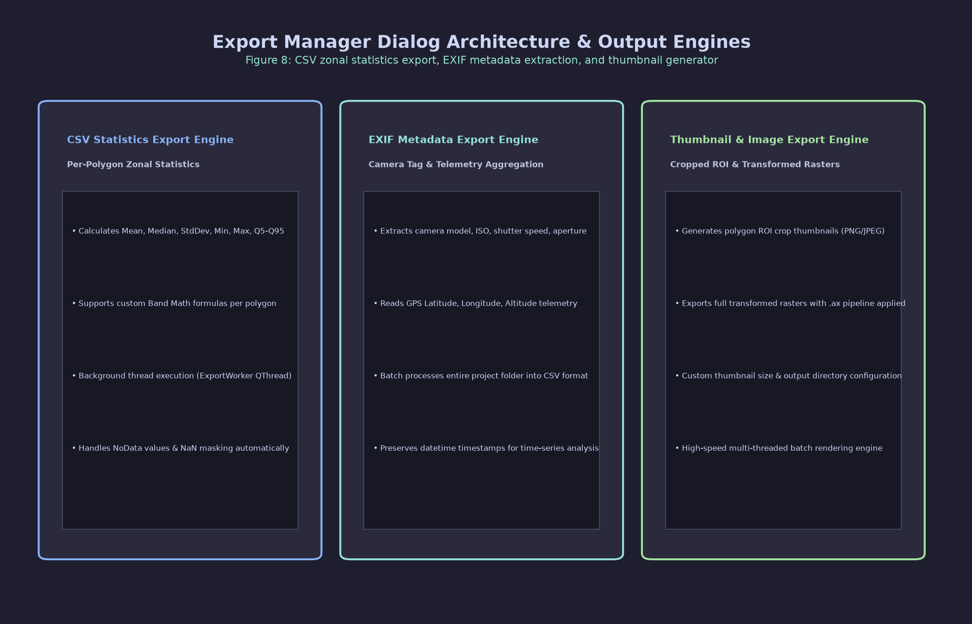
Figure 11: Export Manager Dialog window tracking active CSV, EXIF, thumbnail, and image export background jobs.
Execution Safeguards
- OpenMP and BLAS multi-threading are disabled (OMP_NUM_THREADS=1, cv2.setNumThreads(1)) inside worker threads to prevent CPU thread contention.
- _is_exporting = True is asserted on the project tab to prevent UI edits during export runs.
11 Computed Metric Statistics
For every polygon annotation, CanoPie rasterizes the boundary using cv2.fillPoly and extracts pixel arrays across all bands and vegetation indices, calculating 11 metric statistics:
Metric Name | Formula / Description
Mean | \mu = \frac{1}{N} \sum x_i (Arithmetic mean of valid pixels)
Std | \sigma = \sqrt{\frac{1}{N} \sum (x_i - \mu)^2} (Standard deviation)
Median | 50th percentile pixel intensity value
Min | Minimum pixel intensity value within polygon
Max | Maximum pixel intensity value within polygon
Count | N (Total count of valid, non-NoData pixels)
Sum | \sum x_i (Sum of intensity values)
Q5 | 5th percentile intensity value
Q25 | 25th percentile (1st quartile) intensity value
Q75 | 75th percentile (3rd quartile) intensity value
Q95 | 95th percentile intensity value

Canonical Column Ordering (order_csv_columns)
Output CSV files strictly observe a canonical column layout:
- Metadata: Project, Root ID, Group Name, File Name, Polygon ID, Area_px, Area_m2.
- EXIF Metadata Tags: GPSLatitude, GPSLongitude, DateTimeOriginal, ExposureTime, FNumber, ISO.
- Scene-Level Statistics: Scene_Mean_b1, Scene_Std_b1, etc.
- Per-Polygon Band Statistics: Mean_b1, Std_b1, Median_b1, Min_b1, Max_b1, Q5_b1, Q25_b1, Q75_b1, Q95_b1, Count_b1, Sum_b1, followed by b2..bN and custom index columns.

5.4 Auxiliary Export Workers & UI Dialogs
- EXIF Metadata Exporter (`ExifExportWorker` — Ctrl+E / Ctrl+Shift+E): Uses exiftool to extract raw camera EXIF tags across project files into CSV tables.
- Thumbnail Exporter (`ThumbnailExportWorker` — Ctrl+T): Crops individual polygon thumbnails from .ax-replayed RGB images, scaling coordinates from image_ref_size.
- Project Image Exporter (`ProjectImagesExportWorker` — Ctrl+Shift+X): Exports full-frame project images with .ax modifications applied and original EXIF tags preserved.
- Export Manager Dialog (`ExportManagerDialog`): Non-modal progress monitor showing active background jobs with progress bars, status updates, and cancellation controls.
- Machine Learning Manager (`MachineLearningManager` — Ctrl+Shift+M): Trains scikit-learn Random Forest classifiers directly on polygon ROI spectral features. Configures patch window sizes (1\times1, 3\times3, 5\times5, 7\times7), feature band sets, and exports .pkl model bundles.
- CSV Viewer Dialog (`CSVViewerDialog` — Ctrl+Shift+V): A standalone tabular data preview window with search, sorting, TSV clipboard copy shortcuts (Ctrl+C, Ctrl+A, Ctrl+Shift+C), and reservoir sampling for large files (> 25\text{ MB}).
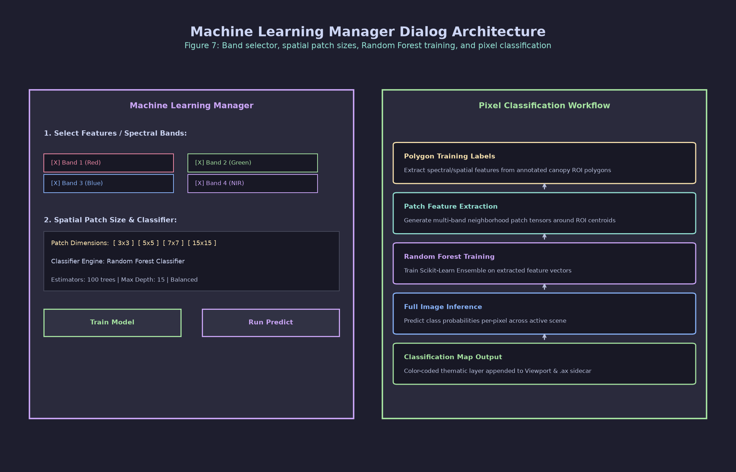
Figure 12: CSV Viewer Dialog interface displaying sampled tabular data with search and copy buttons.

Section 6: Complete Reference Tables
Reference Table 1: Toolbar Buttons (All 22 Toolbar Controls)
# | Toolbar Location | Icon / Label | Internal Action Name | Keyboard Shortcut | Exact Behavior / Operation
1 | Main Toolbar | SP_FileIcon | add_new_tab | Ctrl+N | Creates and appends a new empty project tab (Project N).
2 | Main Toolbar | SP_DialogCloseButton | close_current_tab | Ctrl+W | Prompts unsaved safety warning dialog, then closes active tab.
3 | Main Toolbar | SP_DirOpenIcon | open_project_folder | — | Opens the active project directory in the OS file explorer.
4 | Main Toolbar | SP_BrowserReload | load_random_forest_model | — | Opens file dialog to load a trained scikit-learn .pkl model.
5 | Project Toolbar | Previous | prevAct | Left / A | Navigates to the previous image root position (i - 1).
6 | Project Toolbar | Next | nextAct | Right / D | Navigates to the next image root position (i + 1).
7 | Project Toolbar | Sync On | syncAct | O | Toggles synchronized view panning/zooming across viewers.
8 | Project Toolbar | Clean root Polys | cleanAllAct | Ctrl+X | Cleans/deletes all polygon annotations on current root.
9 | Project Toolbar | Copy Polygons ▾ | Dropdown Menu | Various | Opens drop-down menu for multi-root polygon copying.
10 | Project Toolbar | Polygon Manager | polygonManagerAct | P | Opens the Polygon Manager dialog window.
11 | Project Toolbar | Export Manager | exportManagerAct | Ctrl+E | Opens the background Export Manager progress monitor.
12 | Project Toolbar | Drawing Mode: [Mode] | toggleDrawingModeAct | Alt+D | Cycles drawing modes: Polygon \to Point \to Rect \to Circle \to Random.
13 | Project Toolbar | Save | saveQuickAct | Ctrl+Q | Executes fast incremental save of modified polygon annotations.
14 | Project Toolbar | Auto | autosaveCheckbox | — | Checkbox enabling 1-minute background auto-save.
15 | Project Toolbar | Root Input Box | root_number_input | Enter | Text field accepting root ID string or index for direct jumping.
16 | Project Toolbar | Go | goToRootAct | — | Navigates directly to the root ID entered in input box.
17 | Project Toolbar | Zoom ▾ | Dropdown Menu | R / Z | Dropdown menu: Rectangle Zoom (R) & Zoom All Fit (Z).
18 | Project Toolbar | Modules ▾ | Dropdown Menu | Various | Dropdown menu for Map, ML Manager, Random Shapes, Offset.
19 | Project Toolbar | Root Slider | group_slider | — | Horizontal slider displaying floating _SliderPreviewTooltip.
20 | Project Toolbar | Slider Label | slider_label | — | Displays active root ID text label (e.g., Root: IMG_0042).
21 | Project Toolbar | Inspect | inspectAct | I | Toggles hover pixel inspection overlay showing raw values.
22 | Project Toolbar | Refresh Viewer | refreshViewerAct | E | Forces a complete re-render of graphics scene viewports.

Reference Table 2: Menu Items (All 30 Menu Bar Items)
# | Menu Path | Menu Action Name | Keyboard Shortcut | Function / Description
1 | File > New Tab | actionNewTab | Ctrl+N | Creates a new project tab (Project N).
2 | File > Close Current Tab | actionCloseTab | Ctrl+W | Closes active tab after unsaved prompt.
3 | File > Open multispectral/multiple Folders | actionOpenFolder | Ctrl+O | Ingests paired multispectral & thermal/RGB directories.
4 | File > Open RGB/stack Folder | actionOpenRGBFolder | Ctrl+R | Ingests a single directory of RGB or stacked rasters.
5 | File > Open Image files (Select Files…) | actionOpenRGBPicker | Ctrl+Shift+R | Launches multi-file picker with thumbnail previews.
6 | File > Load Project | actionLoadProject | Ctrl+L | Loads an existing project folder containing project.json.
7 | File > Load Multiple Projects | actionLoadAllProjects | Ctrl+M | Ingests all sub-projects from a root directory into tabs.
8 | File > Save Project | actionSaveProject | Ctrl+Shift+S | Saves project.json and polygon JSON files.
9 | File > Change Folders Path | actionChangeFoldersPath | Ctrl+Shift+F | Updates directory paths for active project session.
10 | File > Change Batch Size | actionChangeBatchSize | Ctrl+Shift+B | Modifies the images-per-root batch size setting.
11 | File > Filter Similar Images... | actionFilterSimilar | — | Filters image frames by color/histogram similarity.
12 | File > Extract polygons CSV from Current Project | actionSaveCSVCurrent | Ctrl+Alt+S | Exports 11 summary metrics for active project tab to CSV.
13 | File > Extract polygons CSV from All Projects | actionSaveCSVAll | Ctrl+Shift+A | Unified batch export of polygon metrics for all tabs.
14 | File > Extract all images EXIF from Current Project | actionSaveExifCurrent | Ctrl+E | Exports camera EXIF tags for active tab to CSV.
15 | File > Extract all images EXIF from All Projects | actionSaveExifAll | Ctrl+Shift+E | Batch exports camera EXIF tags for all tabs to CSV.
16 | File > Set exiftool Path | actionSetExifTool | — | Configures the binary file path for exiftool.
17 | File > Save All Thumbnails | actionSaveThumbnails | Ctrl+T | Exports cropped RGB thumbnail images for all polygons.
18 | File > Export Project Images | actionExportImages | Ctrl+Shift+X | Exports .ax-replayed project images with EXIF tags.
19 | File > Exit | actionExit | Ctrl+Q | Closes CanoPie application window.
20 | Edit > Undo | actionUndo | Ctrl+Z | Reverses last polygon annotation edit on undo stack.
21 | Edit > Redo | actionRedo | Ctrl+Y | Re-applies last undone action on undo stack.
22 | View > Open Log File | actionOpenLog | F12 | Opens system log file (app.log) in text editor.
23 | View > CSV Viewer… | actionOpenCSVViewer | Ctrl+Shift+V | Opens standalone CSV viewer dialog window.
24 | View > Select Display Bands… | actionChooseBands | Ctrl+Shift+B | Configures rendered band channels for multi-band rasters.
25 | Copy Polygons Menu > Copy Polys Next | actionCopyNext | Alt+Right | Copies polygons from current root to next root (i+1).
26 | Copy Polygons Menu > Copy Polys Previous | actionCopyPrev | Alt+Left | Copies polygons from current root to previous root (i-1).
27 | Copy Polygons Menu > Copy Polys → All Roots | actionCopyAllRoots | Ctrl+Shift+A | Copies polygons from current root to all project roots.
28 | Copy Polygons Menu > Copy Polygons to Next Tab | actionCopyNextTab | Alt+3 | Copies polygons to identical root in adjacent tab.
29 | Zoom Menu > Rectangle Zoom | actionRectZoom | R | Toggles right-click drag zoom rectangle mode.
30 | Zoom Menu > Zoom All (fit) | actionZoomAll | Z | Fits all image viewports to whole screen extent.

Reference Table 3: Keyboard Shortcuts (All 38 Shortcuts)
# | Keyboard Shortcut | Target Action / Feature | Context / Scope | Triggered Handler Method
1 | Ctrl+N | Add New Project Tab | Window | MainWindow.add_new_tab
2 | Ctrl+W | Close Current Tab | Window | MainWindow.close_current_tab
3 | Ctrl+O | Open Folders (Dual Mode) | Window | ProjectTab.open_folder
4 | Ctrl+R | Open RGB Folder | Window | ProjectTab.open_rgb_folder
5 | Ctrl+Shift+R | Open Image Files Picker | Window | ProjectTab.open_rgb_picker
6 | Ctrl+L | Load Project Folder | Window | MainWindow.load_project
7 | Ctrl+M | Load Multiple Projects / Map | Window / Tab | load_all_projects_from_folder
8 | Ctrl+Shift+S | Save Project | Window | ProjectTab.save_project
9 | Ctrl+Shift+F | Change Folders Path | Window | ProjectTab.change_folders_path
10 | Ctrl+Shift+B | Select Display Bands / Batch Size | Window / Tab | choose_display_bands
11 | Ctrl+Alt+S | Extract CSV Current Project | Window | MainWindow.save_all_csv_current_tab
12 | Ctrl+Shift+A | Extract CSV All / Copy All Roots | Window / Tab | save_all_csv_all_projects
13 | Ctrl+E | Extract EXIF / Export Manager | Window / Tab | save_exif_csv_current_tab
14 | Ctrl+Shift+E | Extract EXIF All Projects | Window | save_exif_csv_all_projects
15 | Ctrl+T | Save All Thumbnails | Window | save_all_thumbnails_current_tab
16 | Ctrl+Shift+X | Export Project Images | Window | export_project_images_current_tab
17 | Ctrl+Q | Quick Save (Polys) / Exit Window | Tab / Window | save_incremental / close
18 | Ctrl+Z | Undo Last Action | Window | MainWindow.undo_action_triggered
19 | Ctrl+Y | Redo Last Action | Window | MainWindow.redo_action_triggered
20 | F12 | Open System Log File | Window | MainWindow.open_log_file
21 | Ctrl+Shift+V | Open CSV Viewer Dialog | Window | MainWindow.open_csv_viewer
22 | Alt+1 | Switch to Previous Tab | Window | MainWindow.switch_to_previous_tab
23 | Alt+2 | Switch to Next Tab | Window | MainWindow.switch_to_next_tab
24 | Alt+3 | Copy Polygons to Next Tab | Tab | ProjectTab.copy_polygons_to_next_tab
25 | Left / A | Navigate to Previous Root | Tab | ProjectTab.prev_group
26 | Right / D | Navigate to Next Root | Tab | ProjectTab.next_group
27 | O | Toggle Synchronized Viewing | Tab | ProjectTab.toggle_sync
28 | Ctrl+X | Clean Root Polygons | Tab | ProjectTab.clean_all_polygons
29 | P | Open Polygon Manager | Tab | ProjectTab.show_polygon_manager
30 | Alt+D | Cycle Annotation Drawing Mode | Tab | ProjectTab.toggle_drawing_mode
31 | Alt+Right | Copy Polygons Next Root | Tab | ProjectTab.copy_polygons_to_next
32 | Alt+Left | Copy Polygons Previous Root | Tab | ProjectTab.copy_polygons_to_previous
33 | I | Toggle Pixel Inspection Mode | Tab | ProjectTab.toggle_inspection_mode
34 | Ctrl+Shift+M | Open Machine Learning Manager | Tab | show_machine_learning_manager
35 | E | Refresh Viewer Viewports | Tab | ProjectTab.refresh_viewer
36 | Z | Zoom All (Fit Image to Screen) | Tab | ProjectTab.zoom_all_viewers_out
37 | R | Toggle Rectangle Zoom Mode | Tab | ProjectTab.toggle_rect_zoom_mode
38 | Delete / Backspace | Delete Selected Polygon | Canvas | ImageViewer.keyPressEvent

Reference Table 4: Mouse Interaction Controls
Mouse Action | Context / Scope | Visual Feedback / Operational Behavior
Left-Click Drag | Canvas Viewport (Default) | Pans image viewport / draws interactive polygon shape boundary.
Middle-Click Drag | Canvas Viewport | Pans image viewport across canvas.
Right-Click Drag | Canvas Viewport (R Active) | Draws marquee rectangle zoom box; zooms into box on release.
Scroll Wheel | Canvas Viewport | Zooms viewport in or out, dynamically centered on cursor.
Left-Click Drag | Vertex Handle (VertexHandle) | Repositions specific polygon vertex handle in real time (60 FPS).
Double-Click | Vertex Handle | Exits vertex editing mode and finalizes polygon geometry.
Left-Click Drag | Selected Polygon | Relocates entire polygon annotation across canvas; records macro undo.
Right-Click | Polygon Geometry | Opens polygon context menu (Assign Group, Edit Vertices, Delete, etc.).
Single-Click | Polygon Manager Group List | Highlights group in viewers and centers view with 10% zoom cushion.
Double-Click | Polygon Manager Group List | Initiates inline group renaming edit mode.
Left-Click | Image Editor Pixel Picker | Samples raw pixel value under cursor and appends value to NoData list.
Hover / Drag | Root Slider Handle | Displays _SliderPreviewTooltip floating window showing 4 live thumbnail previews.

