## Home Page

Search bar to search for product

Banner to Advertise deals and sales on during a event

Symbols representing Log in and shopping cart

Menu to navigate website when mouse hover over header a drop down menu will appear

Items appear on home screen to allow users to see what are most frequently bought items are

Three Image buttons displaying a category of products such as kits or e-cigarettes that the user can click in that will redirect them to that category

Reviews of recent customers on products and of the service that they received using the live chat.

This is the footer this is where additional information will be visible. This includes the copyright information for the website, the name of the website's author, the business name and address, if applicable, and the date of the most recent update.

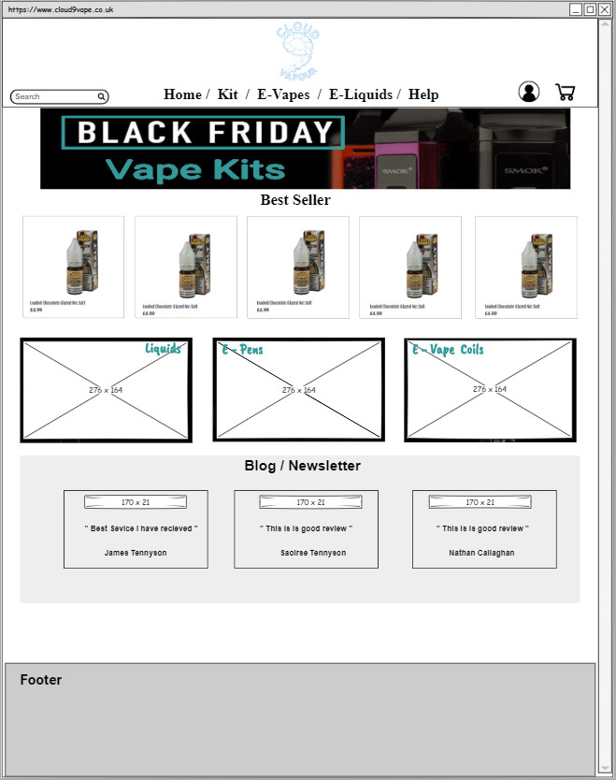

## Products Page

Tab allowing the user to sort the product in different ways such as price low to high etc.

Banner advertising free delivery when you spend £15 or more on your order

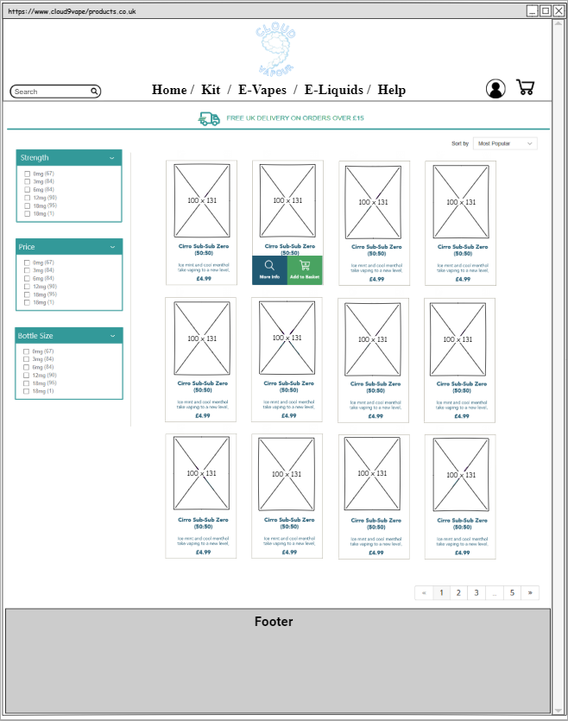

Paginated letting user to see the next page of the products

When mouse hover over product two buttons will appear, one allowing the user to see the details of the product and the other allowing you to add to cart

Card showing how product will be laid out, this will include the name of product price and a small description of product.

Tabs allowing the user to filter products to allow them to find the necessary product they are looking for such as the strength of a liquid, the amount you get in it etc.

## Contact Us Page

Three panels detailing the ways the user can get in contact with someone if they had a issue or enquiry. Three ways of contacting our by email, phone or texting via live chat

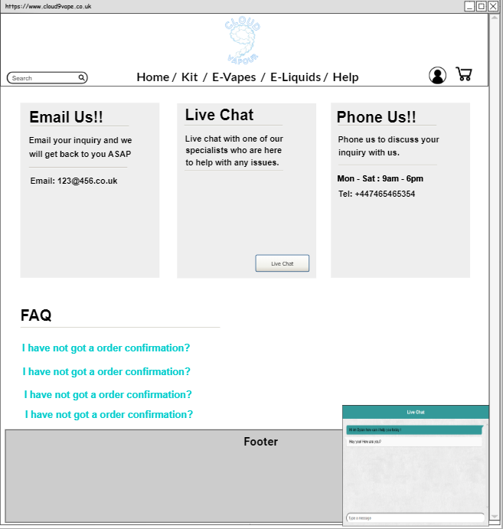

FAQ Section detailing most frequent questions that have been answered in case a user’s issue as already been solved before

Button that will allow a live chat tab to appear this will allow the use to chat with someone if they have any issues or need help with anything in real time.

## Shopping Cart

Display Image of Product that has been added to the users shopping cart.

Section allowing the user to see the amount of the product they have added to the store

Details section that will include the name description and price of the product that is in the cart.

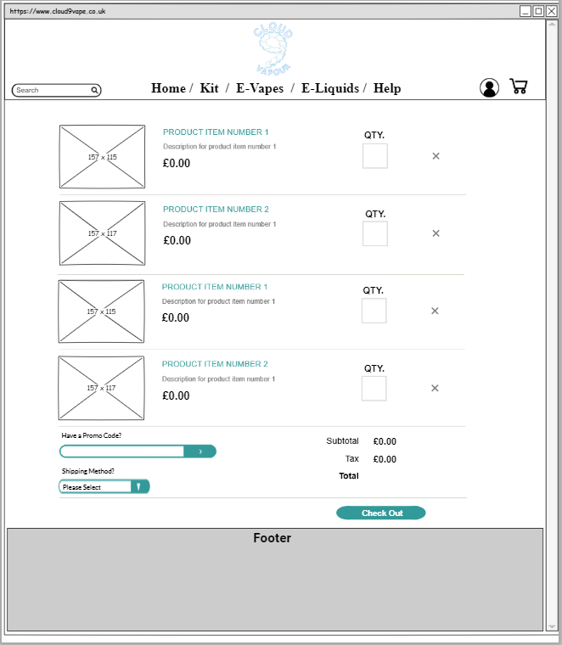

Delete button to remove the product from the cart

Text box that will allow user to input a discount/promo code to get a discount of their order

Drop down menu allowing user to pick type of delivery method such as next day delivery or standard delivery changing to next day will increase total cost

Cost section seeing the total cost and tax of product which will display the amount of money taken of via discounts or sales

## Log In/Sign Up

Sign in section to allow any users who do not have an account be bale to create an account. They will insert their details such as email and a password into these textboxes

Log in Section allowing user that have already signed up to be able to log into their account.

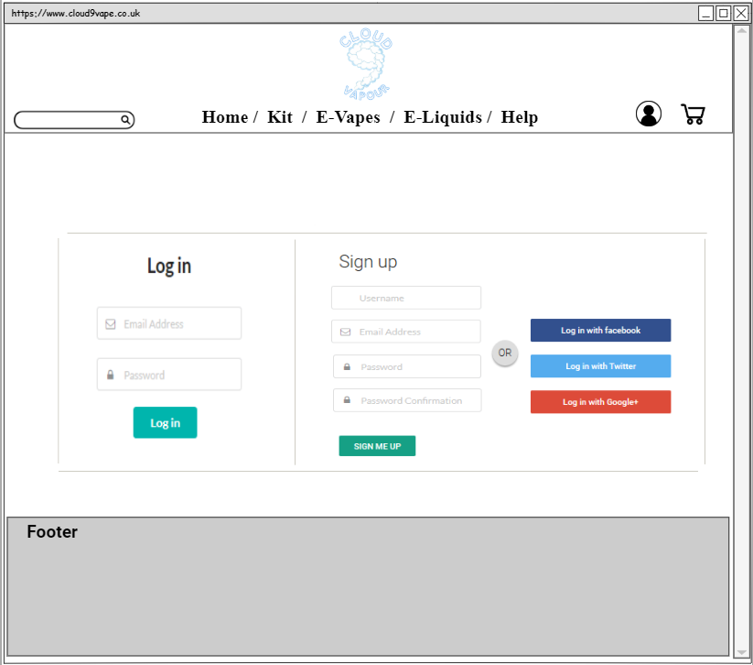

Buttons allowing the user to create a account using a account they have already create on a social page such as Facebook or Google+.

Sign up button that will save the users details creating their account and will log them into their new account

Log in button that will log the user in if they have entered their details correctly.

## Log In/Sign Up

Product list showing the details of all the products including description pricing and the stock level.

Admin menu that will display when a admin logs into the website this will allow an admin to navigate sections of the website that other users cannot.

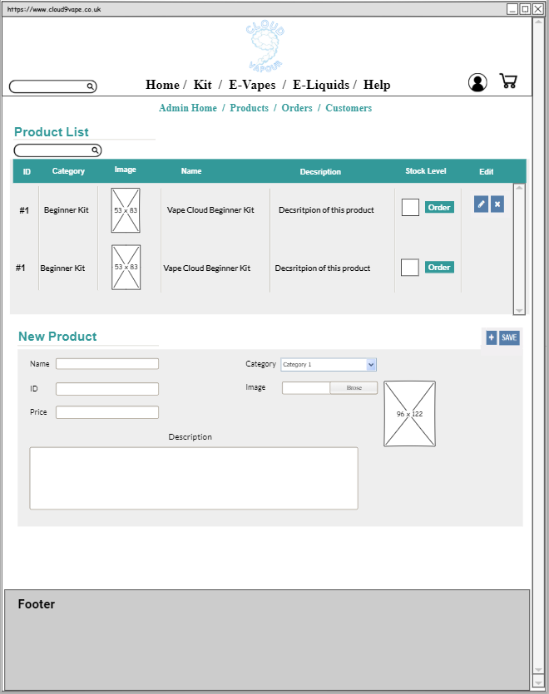

Search bar to search for products easier.

ADD/Save Buttons:

The add button will add the product that has been entered onto the database and onto the website.

The Save button is used to apply and changes that have been made to already existing products.

Order button to re order any low level stock this button will appear and the admin will get a notification if a stock has been sold out or is at low amount.

Edit Button will transfer details of product to new product section from here the admin can edit the details of the product and save the changes.

This is a section that will allow the admin to be able to add a new product onto the site.