|  |
| --- |
|  |

**School of Computing final year project**

**Nathaniel Michael Pankhurst**

**PJE40**

**Project Initiation Document**

**User Habit Correction in Typing**

Project Initiation Document

# Basic details

|  |  |
| --- | --- |
| Student name: | Nathaniel Michael Pankhurst |
| Draft project title: | User Habit Correction in Typing |
| Course: | Computer Science |
| Client organisation: |  |
| Client contact name: |  |
| Project supervisor: | Matthew Poole |

# 

# Outline of the project environment and problem to be solved

The average user of Personal Computers has developed poor typing habits over years of malpractice, and because of this usually has issues with typing speed, accuracy, and in some cases typing-related Repetitive Strain Injury (RSI).

This project will create a proof of concept for a software package that should provide an adequate learning environment for students, and working professionals alike to educate how best to use a keyboard, and eliminate any bad habits that the user might have. The key habits that this project aims to remedy are:

* **Over-Reaching**: Over-reaching occurs when you attempt to reach too far from the home row without moving your wrists; e.g. trying to type Y with the left hand. This is inefficient, and can lead to fatigue in the typist after long typing sessions.
* **Partial-Hand Typing**: Partial-hand typing is when the typist doesn’t use every finger on their hands during typing, and in the worst cases uses only a single finger on each hand. This vastly reduces typing efficiency, and speed.
* **Watching Keyboard During Typing**: Watching the keyboard during typing reduces typing efficiency, and speed. This is because it takes the typist’s attention away from the text that they should be typing, as they’re usually ensuring their hands find the letter on the keyboard, rather than trusting their muscle memory.
* **Shift Key Bias**: Shift key bias is where the typist favors one shift key over the other. This can result in the typist having to make unnecessary hand movements, and can lead to fatigue over long typing periods, and reduces the typist’s efficiency.

# Project aim and objectives

This project’s aim is to produce a proof of concept software package that provides personalized lessons to retrain the user’s muscle memory, and iron out the poor typing habits whilst simultaneously reinforcing good typing practices. This shall be done using an eye tracker to detect when the user’s gaze drifts to the keyboard, and other potential technologies that might be able to track finger movements with precision.

The objectives to reach this goal are:

* Research competing products, and technologies.
* Research modern technologies that could be useful in the development of the software artefact.
* Develop the artefact, implementing modern technologies to aid in the effectiveness of the software.
* Produce a report detailing the project’s results, the stages of development, and the effectiveness of the resulting artefact.

# Project deliverables

For this project, a typing-test based education software will be developed for the purpose of teaching the users how to touch-type, and promote good typing practices to improve overall typing efficiency.

Alongside the software artefact relevant documentation shall be submitted in the form of a report; labelling the requirements, development cycle, and reflections on how successful the development of the artefact was.

# Project constraints

As this project is focused on using recent human interface technologies to create a typing education software, the key constraints in the development of this project are likely to be the availability of the hardware. This is exacerbated by how the limited budget provided for this project means the likelihood of purchasing relevant hardware is slim.

Alongside this the project will be limited in complexity due to the time available dictated by the strict project deadline. This results in the list of potential technologies that the software artefact can be created with being restricted to only those that the developer has experience in, as learning new technologies would draw time away from furthering development of key features.

# Project approach

For the development of the software artefact, the chosen methodologies are Test Driven Development backed up by the use of a Kanban board. This should make it a lot easier to manage the project as a one developer team, whilst ensuring that there is a constant visual aid showing the progress of the project in real time.

Before the development of the artefact, research has to be made into other products that currently exist in the industry. This research will help refine the requirements of this project so that the software artefact can best provide a valuable solution to the problems stated in the project outline.

# Facilities and resources

The current plan for this project is to use C#, and WPF as the technologies that the software artefact will be written on. This limits the machine that the artefact will be run on to using an OS that has the .net libraries installed, and limits the developer to using Visual Studio. This shouldn’t be much of a problem as it is easy to get access to a windows machine, and student copies of Visual Studio are readily available, and free.

Alongside this, access to modern technologies is beneficial to the progress of this project. For this purpose, being able to borrow specialist equipment from the University of Portsmouth is going to be a blessing, and has already provided access to a Tobii eye tracker, and a Leap Motion controller.

# Log of risks

|  |  |  |  |  |
| --- | --- | --- | --- | --- |
| **Risk** | **Potential Impact** | **Probability** | **Mitigation** | **First Indicator** |
| Unexpected Illness | Small - Large | Severe | Including cushion time in project plan, tis should reduce the impact of colds, etc. | Cold symptoms, etc. |
| Losing access to specialist hardware | Severe | Unlikely | Submit a renewal request, if that fails research open-source libraries that can use readily available hardware for the same means. | Return date of hardware is closely approaching, and a renewal request hasn’t yet been submitted. |
| Incompatible OS | Medium | Unlikely | Either install .net on target system, or rewrite software artefact in Java due to the syntactic similarity between Java, and C#. | Have to change software package so that it supports Mac OS, and/or Linux. |
| Hardware failure in system used for development | Severe | Unlikely | Use source control to ensure that all code, and documentation is backed up, and accessible from other machines. | Irregular issues occur during run-time of system, or physical damage to system. |
| High influx of unrelated work / deadlines for other commitments | Severe | Likely | Work cushion time into project plan to ensure that there is leeway in the case of time being redirected from the project into other commitments | Approaching commitments with significant work demands start encroaching upon time allotted for project work. |
| Grievance in family | Severe | Unlikely | Work cushion time into project plan to ensure that there is leeway in place to allow for grievance time. | Family member in hospital with severe illness. |

# Starting point for research.

The research for this product began at the start of October, in which relevant technologies for the product were researched, and the Tobii eye tracker was chosen for ensuring the user is looking at the screen. Following this, further reading has been done into the Tobii eye tracker documentation, and C# SDK.

Additional research will be put into finding an adequate technology for tracking user finger movements; as this can be used to ensure that they are typing, and using the software correctly. This research is likely to occur further into the project if development is going smoothly, as the proposed feature is sure to take a large portion of the development period to implement.

# 

# Breakdown of tasks

Before starting the project, it was essential to do substantial research into relevant technologies that could be used in the development of the software artefact. It was also important to create the Development environment for the project, which included installing Visual Studio on the development PC, and setting up a git repository for the project.

The remainder of the tasks for the rest of the project are split into 4 substantial segments which are:

* **Market Research** - Research other products that are currently on the market, and features that they are missing that could be useful to introduce in the software artefact.
* **Development** - Develop the software artefact whilst adhering to the Test-Driven Development methodology, ensuring that a test suite is being constructed throughout development of the software to ensure constant testing.
* **Live Testing** - Spend a period of time introducing the finished prototype to select members of the public to receive feedback on how the prototype could be improved, and how well it combats the issues stated in the project outline.
* **Documentation Write-up** - Although this is ongoing, the final stage of the project shall be used to collate all the documentation that has been created in the duration of the development. This shall be presented in the form of a report.

# Project plan

The project plan for this project is shown in the image below.

No work has been planned to occur during the Christmas break to leave the time period open for catch-up work if the project is behind schedule. There is also a large amount of time available towards the end of the development stage for the introduction, and improvement of features.

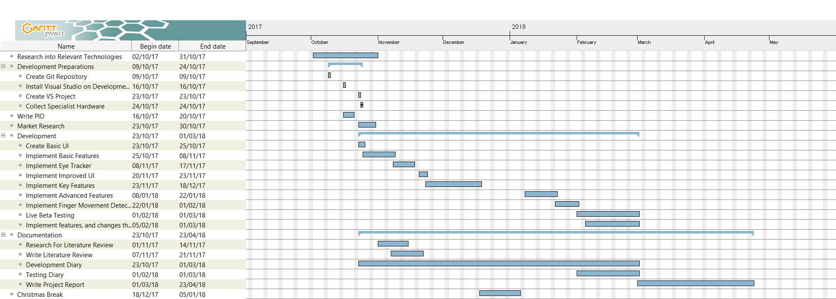

# Legal, ethical, professional, social issues

There are currently no legal or ethical issues with this project. This is because all data collected by the software artefact will be anonymous, and shall not contain any personal information.

In addition, any questionnaires, or feedback forms shall be purely anonymous, and shall only be used to receive feedback, and suggestions on how the software could be improved.



Signatures

|  |  |  |
| --- | --- | --- |
|  | Signature: | Date: |
| Student |  | 21/10/2017 |
| Client |  |  |
| Project supervisor |  |  |