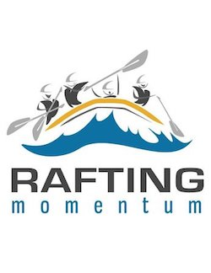Rafting Momentum About Us Page

primary-color: #1EA5FF

secondary-color #00FFFF

accent1-color: #F5F5F5

accent2-color: #909090

heading-font: Monteserrat

text-font: Dosis

https://coolors.co/00ffff-1ea5ff-f5f5f5-57a773-909070