Nathaniel Barnett – Adam Bergman – Urvish Shah

Project 1B

Professor Kuhail

CS 303

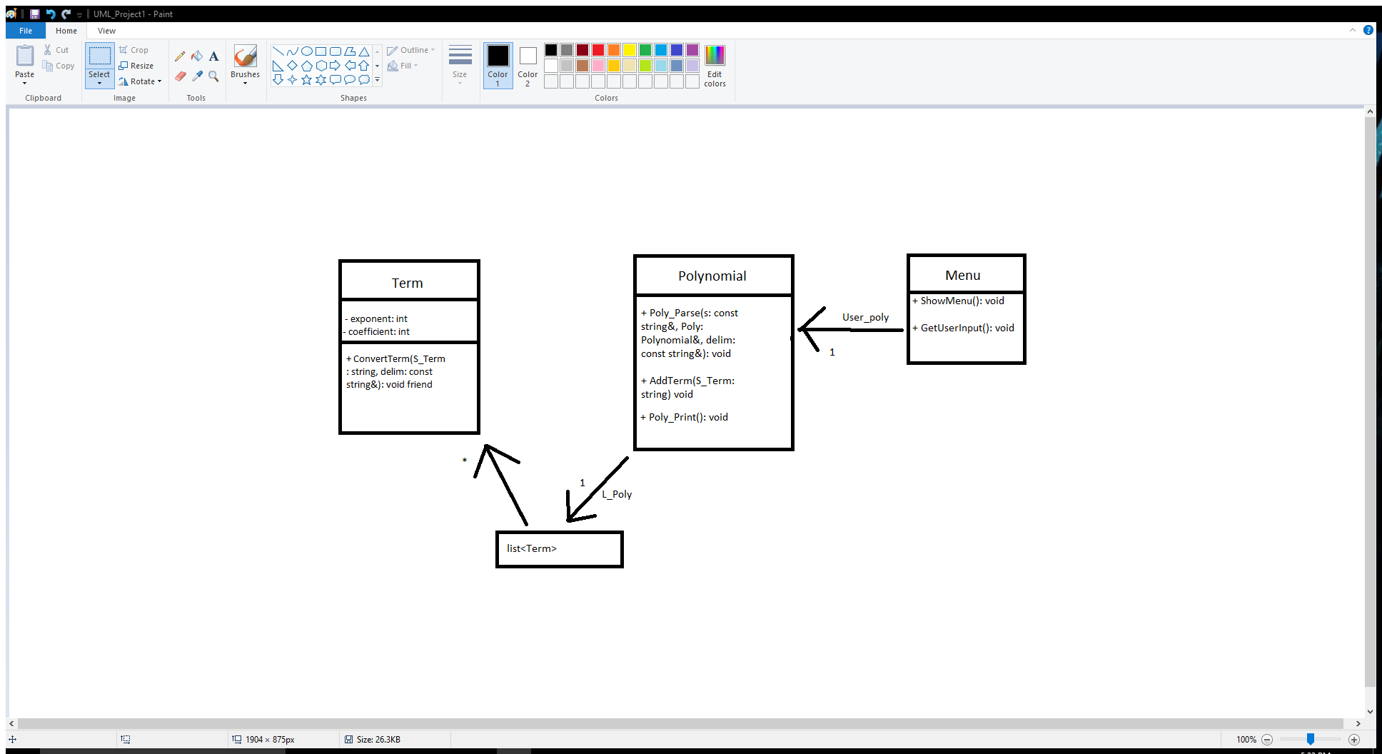

Big – O

Poly_Parse was O(n) because it has to go through every term in polynomial. Can’t be improved because each term requires parsing.

Add_Term was O(n) because it has to iterate through the list to find out where to add new items in the list. If we could narrow down where it needed to go beforehand it would reduce its cost.

Convert_Term was O(n) because it walks through each term and modifies it. Since each term needed to be evaluated there isn’t a way to improve its speed.

Print_Poly was O(n) because we iterate through a list from start to finish. Shouldn’t be changed since each term in a polynomial needs to be printed.

References

string:: find_first_of: http://www.cplusplus.com/reference/string/string/find_first_of/

string::find_first_not_of: http://www.cplusplus.com/reference/string/string/find_first_not_of/

Splitting a string: http://ysonggit.github.io/coding/2014/12/16/split-a-string-using-c.html