STEP 1

Disney+

|  |  |  |  |  |
| --- | --- | --- | --- | --- |
| **Key Partners**  Pixar  Marvel  Star Wars  National Geographic | **Key Activities**  Marketing  Streaming | **Value Propositions**  New features  Good for groups or families | **Customer Relationships**  Streaming | **Customer segments**  Market for people who want to watch Disney content |
| **Key Resources**  New shows  New movies | **Channels**  Website (www.disneyplus.com) |
| **Cost Structure**  Software | | **Revenue Streams**  Profit from people paying for Disney+ | | |

**Product Customer**

**BENEFITS**

Lots of content

New stuff is coming

**WANTS**

The ability to find what they’re looking for.

**EXPERIENCE**

Great unless the layout prevents you from finding something

**FEARS**

That nothing will change

**FEATURES**

Can stream movies and shows

**NEEDS**

The site to be organized better.

STEP 2

Problem Statement: “The layout and organization of Disney+ is terrible and it can be hard to find things.”

Layout does not make use of the space.

The organization does not always make sense

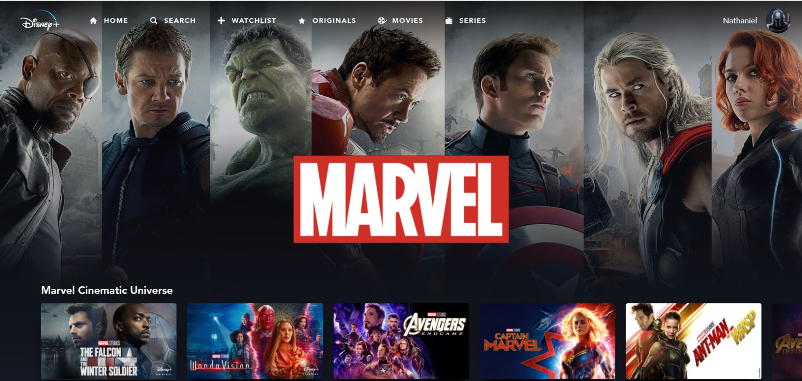It can be hard to find what you’re looking for.

Half the screen is just the background which is a waste of space. Each collection of movies is a different list and you cannot even see all of them on the screen unless you scroll. Each movie is then on a horizontal scroll which means you cannot view each movie.

The picture above shows just one of many lists, if I didn’t scroll down, I wouldn’t know there were more. If you look to the right, you can see that one of the movies is cut off because it is on a horizontal scroll. How would I know there would be more movies after that one?

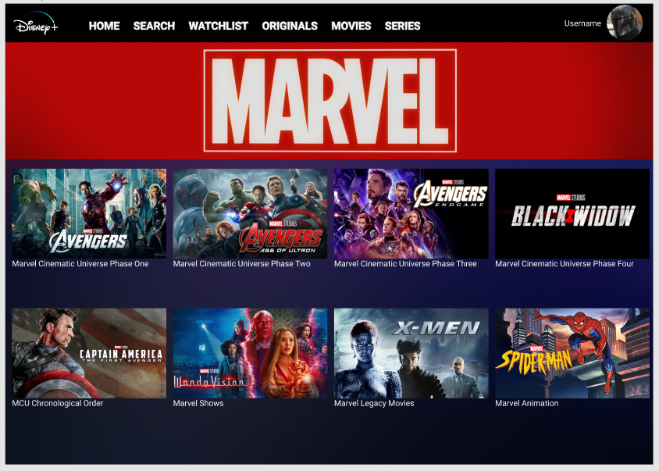

My new version makes each list visible at the same time by turning them into buttons and fills up most of the screen. It also organizes some of the lists better. For example the original had phase 3 and phase 4 as one list but phase 1 and phase 2 were separate lists, so I made all of them separate lists. You would click on the picture of the list that you would want to view and instead of horizontal scrolling it would pull up a vertical list of the movies.

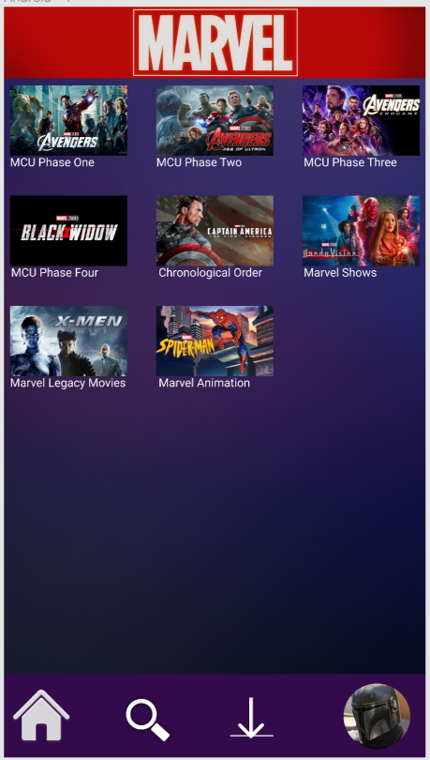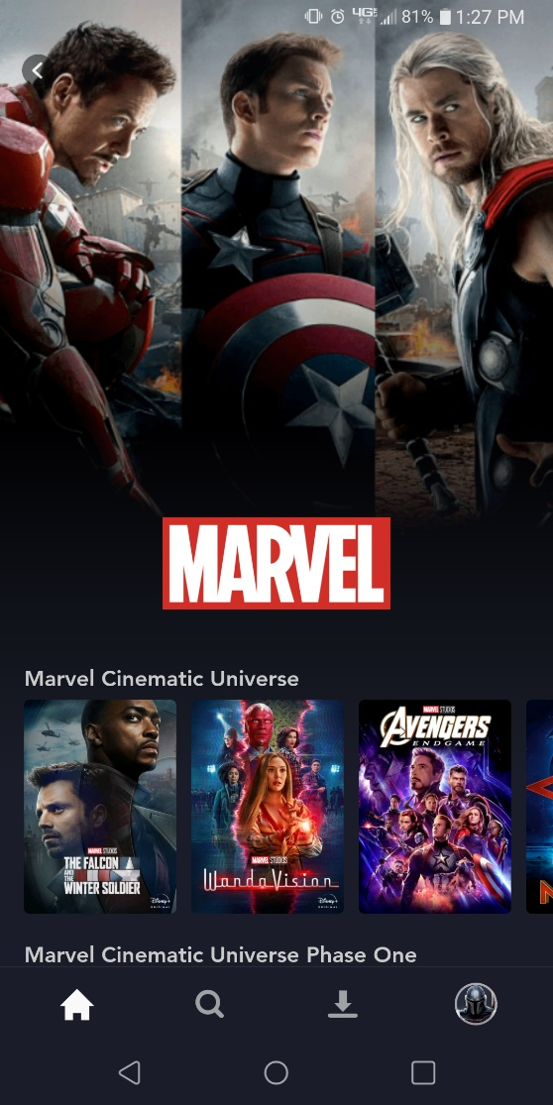

I also fixed the mobile version with the original on the left and mine on the right. It had the same problems as the web version.