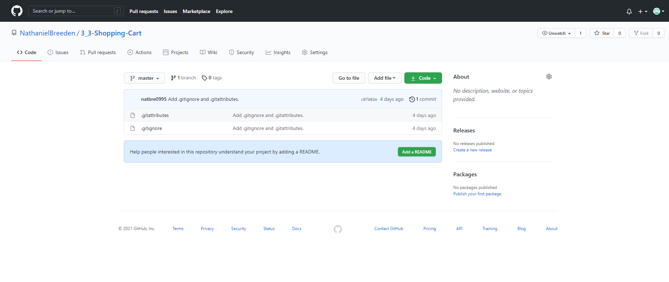

https://github.com/NathanielBreeden/3_3-Shopping-Cart.git