1. Learn JavaScript
   1. <https://www.w3schools.com/js/>

**JavaScript Tutorial**

* JavaScript Example Function
  + Change HTML Content using getElementById()
    - document.getElementById("demo").innerHTML = "Hello JavaScript";
    - Accept both double and single quotes
  + Change HTML Attributes Value like source, src
  + Change HTML Styles (CSS)
    - document.getElementById("demo").style.fontSize = "35px";
  + Can Hide HTML Elements
    - document.getElementById("demo").style.display = "none";
  + Can Show HTML Elmenets
    - document.getElementById("demo").style.display = "block";
* Code are inserted between <script> and </script> tags
* A JavaScript function is a block of JavaScript code, that can be executed when “called” for
* Scripts can be placed in the <body>, or in the <head> section of an HTML page, or in both
* Testing the first example program:

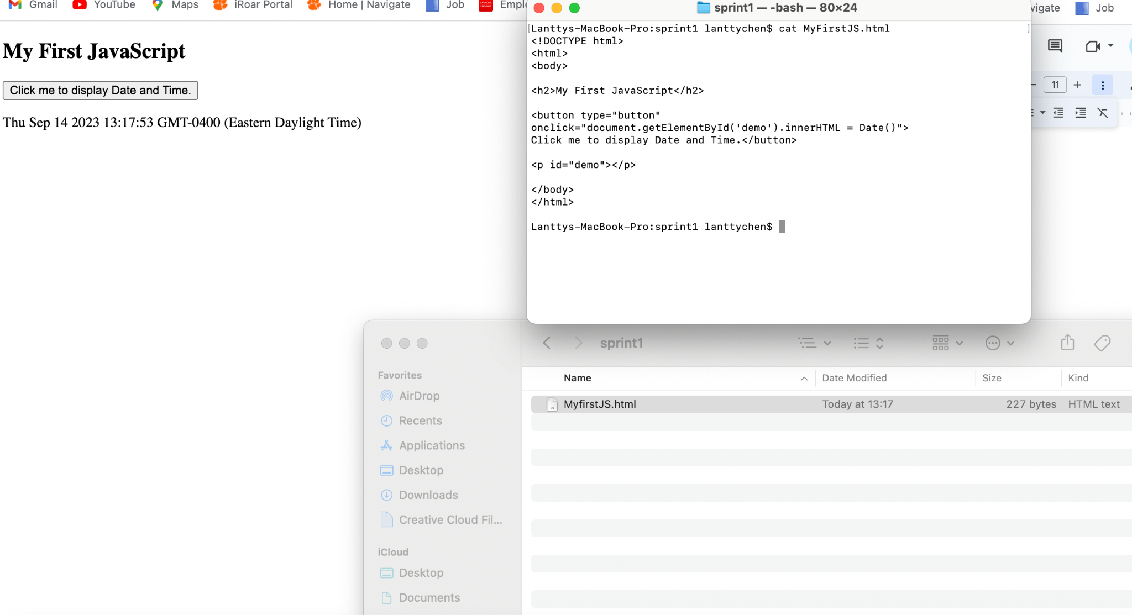

1. Learn How to use React Js
   1. <https://www.w3schools.com/REACT/DEFAULT.ASP>

**React Tutorial**

* What is React
  + React, sometimes referred to as a frontend JavaScrpit framework, is a JavaScript library created by Facebook
  + React is a tool for building UI components
* How does React Work?
  + React creates a VIRTUAL DOM in memory
  + React only changes what needs to be changed
  + You will need npm and Node.js installed to use React
* Creating a React application named my-react-app:
  + Npc create-react-app my-react-app
* In order to run
  + Npm start
  + Visit localhost:3000
* You can change the content of the HTML by changing whatever that is inside <div className = “App”> with a <h1> element
* Update React
  + Install newest React 18
  + Use the new root API
* React ES6
  + What is ES6
    - ES6 stands for ECMASCript 6
    - ECMAScript was created to standardize JavaScript, and ES6 is the 6th version of ECMScript, it was published in 2015, and is also known as ECMAScript 205
  + Class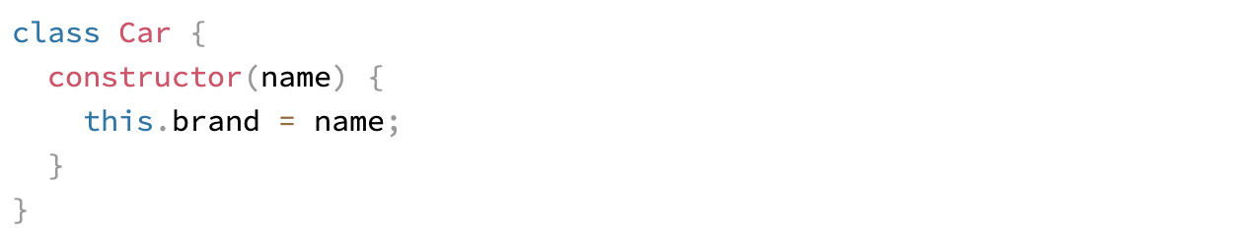
  + A class could have Method 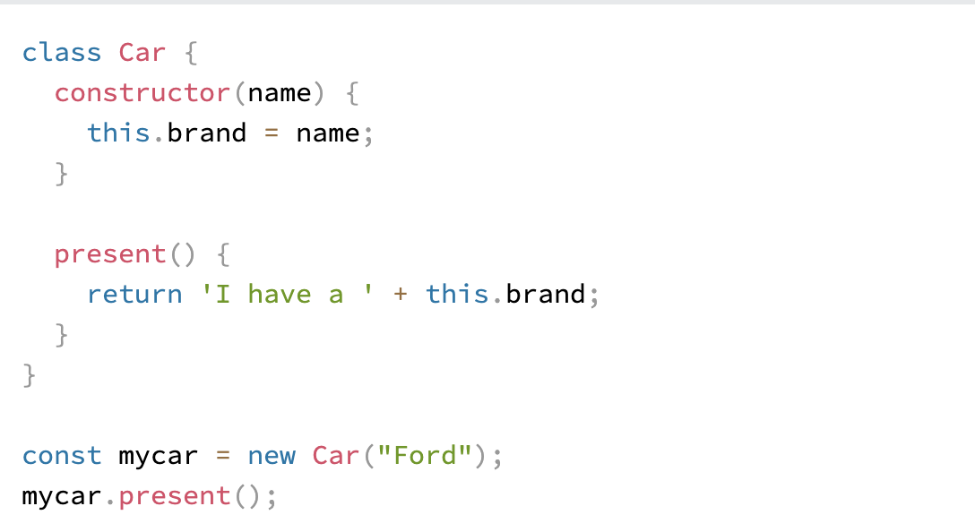
  + A class created with a class inheritance inherits all the methods from another class
  + Arrow Function
    - It allows us to write shorter function syntax

1. Learn How to use Microsoft SQL.
   1. <https://www.w3schools.com/sql/>

**Microsoft SQL Tutorial**

* SQL is a standard language for storing, manipulating and retrieving data in databases
* SELECT * FROM CUSTOMER
  + Select * → All
* What is SQL?
  + SQL stands for Structured Query Languages
  + SQL lets you access and manipulate databases
  + SQL became a standard fo the American National Standards Institute (ANSI) in 1986, and of the International Organization for Standardization (ISO) in 1987
* What Can SQL do?
  + SQL can …
    - execute queries, retrieve data, insert records, update records, delete records, create new, create stored procedures, create views, and set up permissions.
* SELECT, UPDATE, DELETE, INSERT, WHERE
  + SELECT —--- FROM —--------;
  + DISTINCT used to show differences in the list

1. Learn What AWS is
   1. <https://www.w3schools.com/aws/aws_cloudessentials_intro.php>

**AWS Tutorial**

* What is AWS Cloud?
  + AWS is cloud computing platform
  + The first product (S3) was released in 2006
  + AWS has grown a lot since then both size and product range
  + It is, to date, the largest cloud provider in the world
* Overview video
  + The Client-Server Model
    - Important concept in cloud computing
    - It is about many clients using services from a centralized server
    - About a client that interacts and makes requests to a computer server
    - A client is the way that the person interacts with server
  + What is Cloud Computing
    - Cloud computing is a computing service made available over the internet
    - Cloud computing is a pay-as-you-go model for delivering IT resources
    - You pay only for what you use
  + Deployment Models
    - There are three different kinds of deployment models
      * Cloud-based
      * On-premises
      * Hybrid
  + Why Choose Cloud Computing?
    - Cost savings
    - Security
    - Scalability
    - Flexibility

1. Learn How to use AWS.

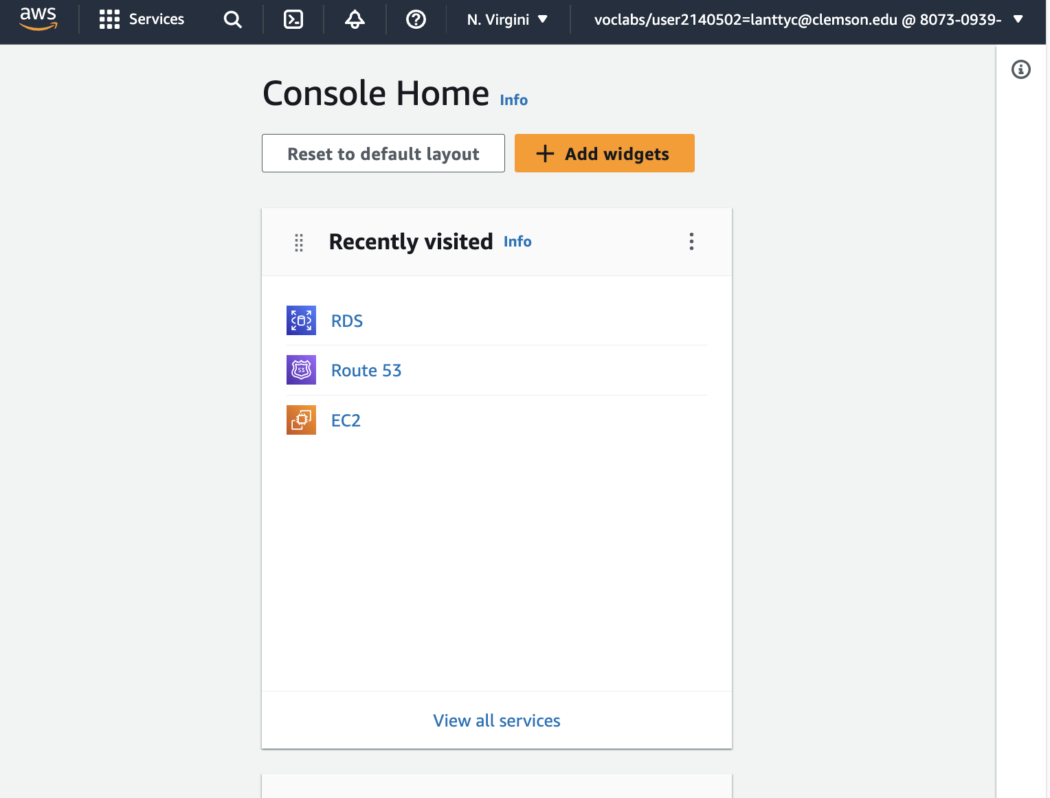

1. Watch Web App Tutorial.
   1. <https://www.youtube.com/watch?v=3JluqTojuME>

**Web App Tutorial**

* Html → webpage on web browser
  + <html> open tag
  + </html> closing tag
  + <head> and <body> is sibling
  + <title> the title of the webpage
  + <strong> something </strong> → making something bold
  + <em> italic </em> → making something italic
  + <a> something </a> → adding attribute to the text
    - For example <a href = “<http://www.google.com>”> google.com </a> →make hyper link
  + <img src =“some image link”> → how to get an image link
  + <br> → line break or \n
  + <ul> </ul> → unorder list
  + <li> </li> → list inside of unorder list
  + <ol> </ol> → order list, it will number the list
  + <p> </p> → paragraph, another way to separate the line
  + <h> → header tag
    - <h1>
    - <h2>
    - <h3>
* CSS → making the webpage prettier
* Javascript → Make the webpage function

1. Understand what EC2 and RDS do in Cloud.
   1. EC2: <https://www.w3schools.com/aws/aws_cloudessentials_ec2intro.php>
   2. RDS: <https://www.w3schools.com/aws/aws_cloudessentials_amazonrds.php>

**EC2 Tutorial**

* EC2 is a virtual server in the AWS Cloud
* AWS Ec2 is short for AWS Elastic Cloud Compute
* It makes scaling of capacity up and down easy
* Why AWS EC2?
  + It makes the process of increasing and decreasing capacity easier
  + As a result, you can access the resources at demand
  + No upfront investment is needed
  + You only pay for what you need
  + EC2 is secure
* Instance Type
  + General Purpose Instances
  + Compute Optimized Instances
  + Memory Optimized Instances
  + Accelerated Computing Instances
  + Storage Optimized Instances

**RDS Tutorial**

* AWS Relational Database Service
* RDS is a service that automates database task
* It enables running relational databases in AWS Cloud
* It support many database engines
* AWS RDs database engines offer data encryption while data is stored, sent, and received
* AWS RDS helps you complete administrative tasks faster
* Decreasing the time needed for administrative tasks gives you more time to develop application features
* A relational database commonly use SQL to store and query data

1. Learn How to use MS SQL server (Pick the one suitable for your machine)

**Installing MS SQL Server on MAC**

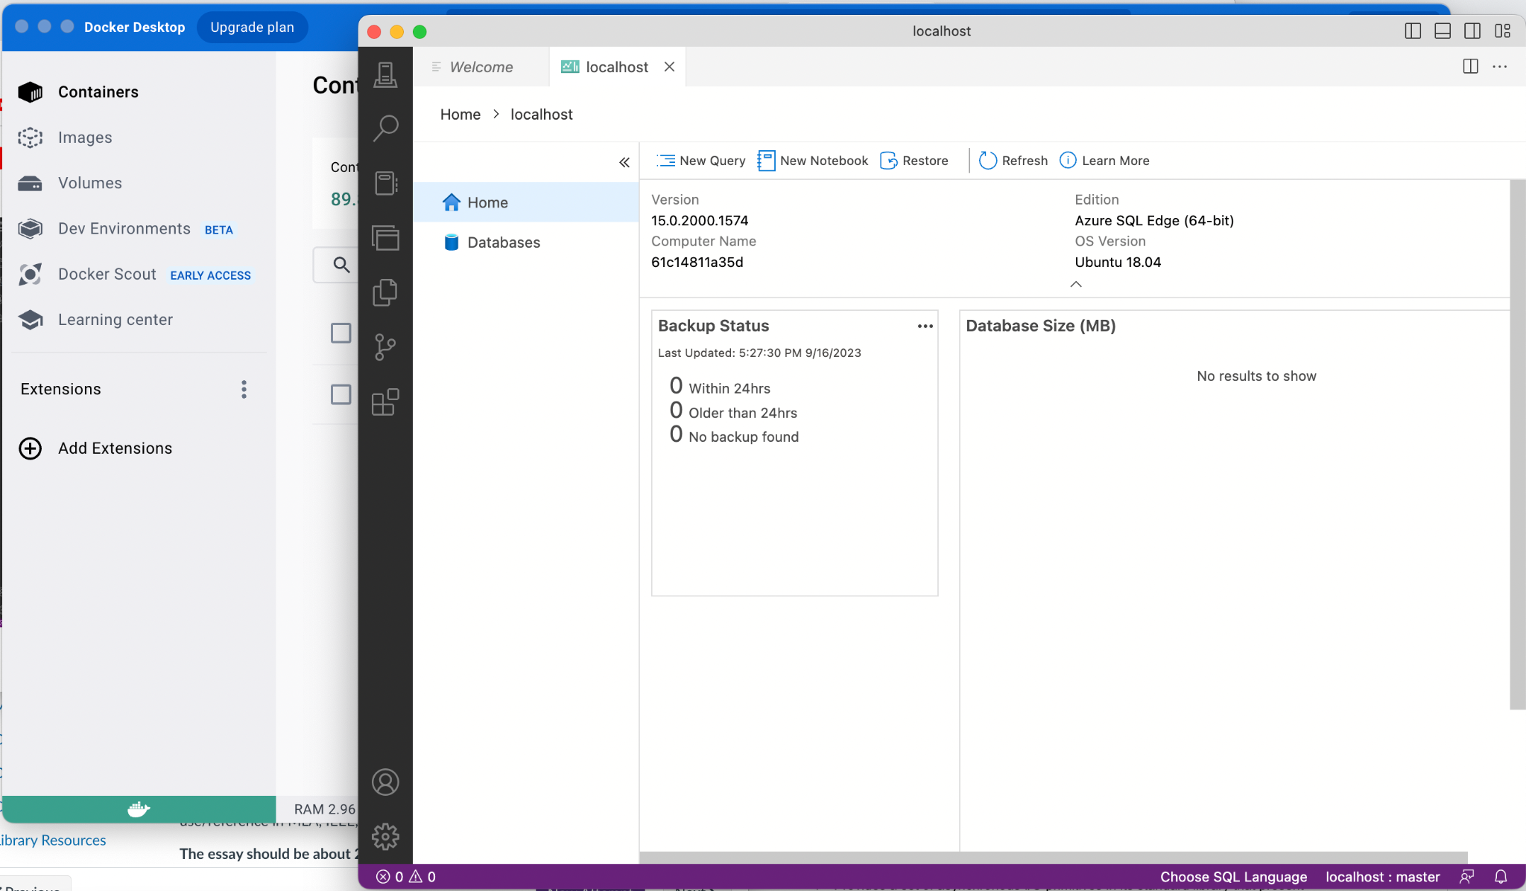

1. Learn how to use NodeJS
   1. <https://nodejs.dev/en/learn/>

**NodeJs Tutorial**

* Open-source and cross-platform JavaScript runtime environment.
* Runs the V8 JavaScript engine; the core of Google Chrome, outside of the browser
* Runs in a single process, without creating a new thread for every request
* Provides a set of asynchronous I/O primitives in its standard library that present JavaScript code form blocking and generally

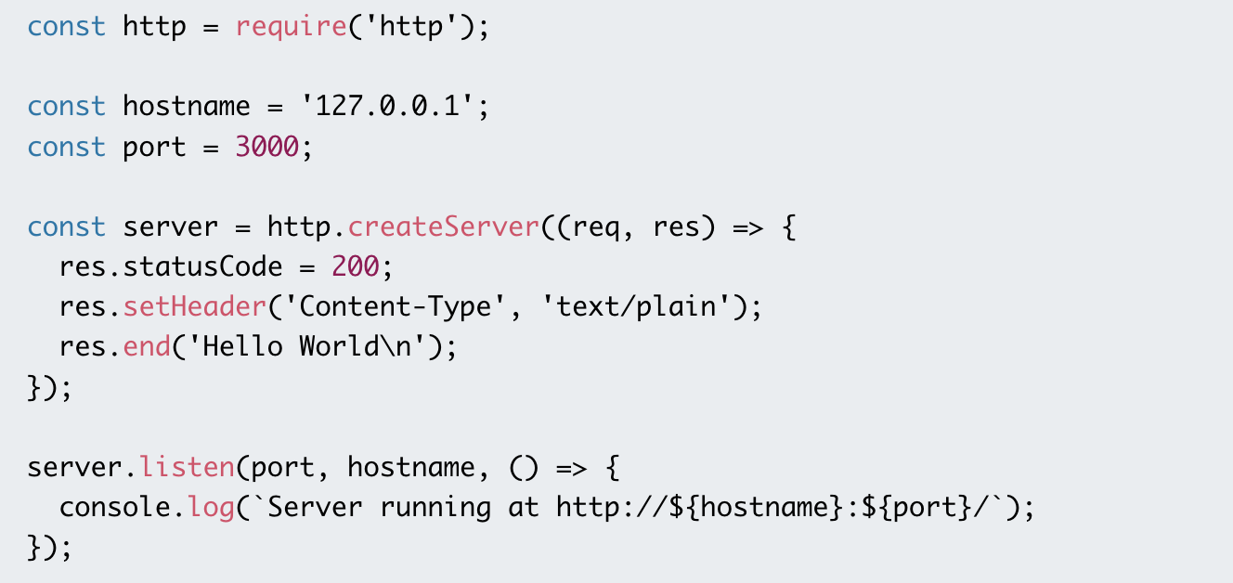

1. Learn basic HTML
   1. <https://www.youtube.com/watch?v=qz0aGYrrlhU>

HTML Crash Course

* Install VS Code
  + Install Prettier
  + Install Live Server
* You’ll Learn
  + The languages & tools of web development
  + Key concepts (eg. URL, HTTP, DOM, etc)
  + How websites work
  + Inspect network traffic using DevTools
  + Basic HTML & CSS
  + Validating Web Page
* Front-End
  + HTML → Hypertext Makeup Language
  + CSS → Cascading Stylesheet
  + JavaScript → Adding Functionality to the webpage
* How the Web Works
  + URL → Uniform Resource Location
    - Resources → HTML, image, font, etc
  + Client and Server
  + HTTP → Hypertext Transfer Protocol, HTTPS → add encryption
  + DOM → Document Object Model

1. Learn basic CSS
   1. CSS Basics: <https://www.youtube.com/watch?v=1PnVor36_40>

**CSS Tutorial**

* What is CSS?
  + Not a Programming Language → Styling Language
  + Used for Presentation
* CSS Syntax
  + Selector {
    - Property1: value;
    - Property2: value;
  + }
* CSS selectors
  + Element
  + Class
  + ID

1. Watch a Node Js tutorial.
   1. Node basics: <https://www.youtube.com/watch?v=ENrzD9HAZK4>

**NodeJs Tutoria**l

* What can Node do?
  + Using nvm install and update Node
* Hello World
  + 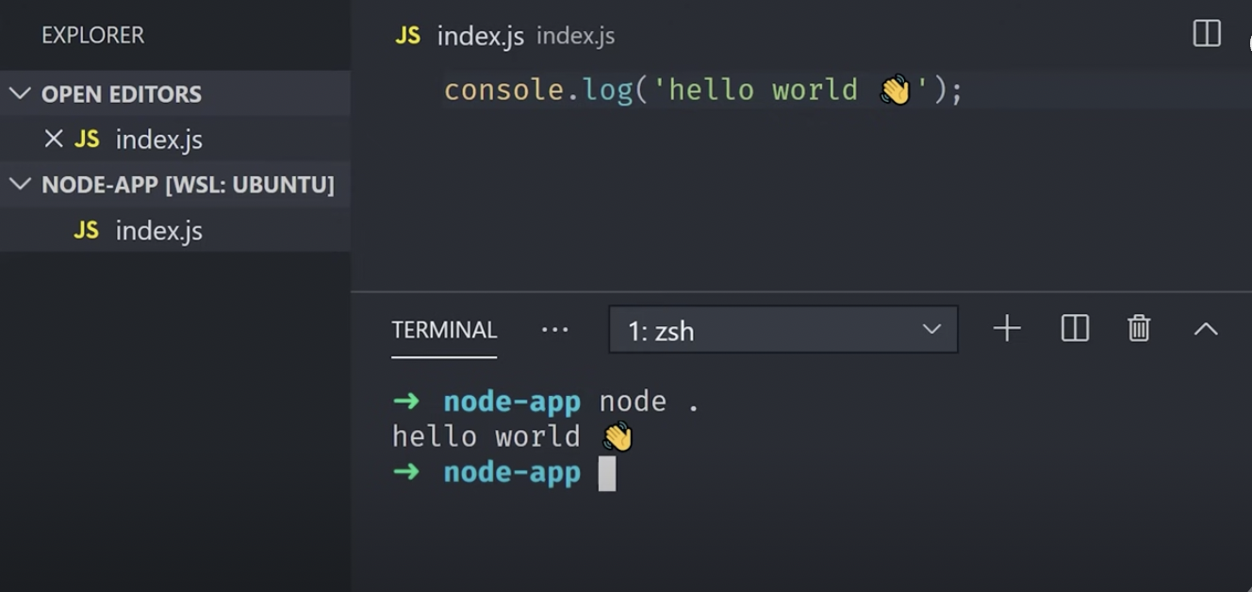
* Know Your Runtime
* File System → FS
  + read and write
* Modules and NPM
  + require()
  + Import and export
* Build the webpage with the knowledge you have

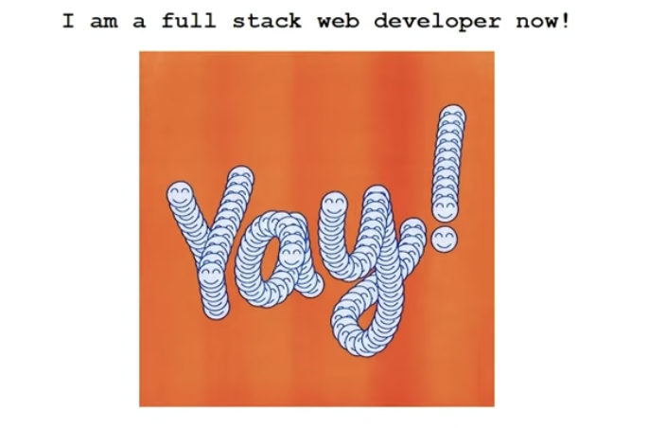

1. Watch a React Js tutorial.
   1. <https://www.youtube.com/watch?v=Tn6-PIqc4UM>

**ReactJS tutorial**

* Develop by Facebook
* It is just a JavaScript Function
* JSX
* Components help us write reusable, modular, and better-organized code

1. Watch a database tutorial.
   1. Relational database concepts: <https://www.youtube.com/watch?v=NvrpuBAMddw>

**Database Tutorial**

* Basic Concepts on how relational databases work. Explains the concept of tables, key IDs, and relations at an introductory level.