**Laboratory Exercise – Host Based Network Security Basics**

**1. Overview**

This laboratory exercise will provide some hands-on *layered defense* experience with hardening a *LAMP* (Linux, Apache, MySQL, PHP) server by examining what ports, IPs and services are exposed to the network, and work on addressing and securing the outstanding network security issues layer by layer.

**Background**

The *network profile* of a system or host is how it appears to the outside networks of the world, or put another way, what aspects of a system can be seen, probed and exploited by those on the network. The less services you run, the less you expose to the outside world. Further in on the server, the more you harden a host’s various *layers,* the better the system’s overall hardened network profile or *layered defense* becomes.

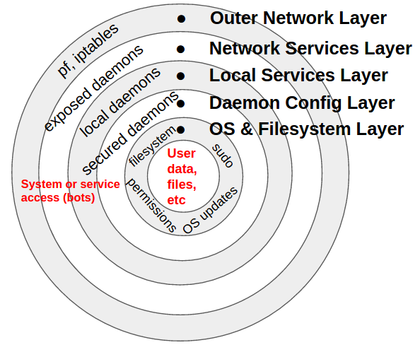While no system should ever be considered 100% secure, one can imagine a system’s network security profile as consisting of various *layers* from the outside in. Each layer in builds upon the outer layers, ultimately protecting system access and user data at the center. The more layers and controls that are in place, the more secure the host’s overall network security profile.

These defensive layers can be generalized into five or so defensive layer categories and this lab will only examine the first two layer categories:

* Outer Network & Access Layer
* Network Services Layer

Layers of a Network Host

**2. Resources required**

An Internet-connected web browser and student login to the Cyber Range are required for this lab exercise. This lab exercise uses two Cyber Range virtual machines: a networking server (networking.example.com) you are tasked with locking down on the network and an auditing server (audit.example.com) from which you can scan your networking server. Your main Cyber Range login will provide a GUI desktop session to the networking.example.com virtual machine (VM). From there, you will open a local root terminal and a second root terminal with an ssh session to the audit server.

**3. Initial Setup**

Log into the Cyber Range. Once logged in, select the Host Based Network Security Basics lab and the click "Join Exercise" button. Within your browser, you will be presented with a ssh terminal Linux login screen. Log in using these credentials:

Username: **student**

Password: **V4CR-n3t53cB451c5**

Next, open two terminals. In the first simply become root with **sudo su -** . This will be your network server (networking.example.com) terminal within the range where most of your work will take place. In the *second terminal*, also become root with **sudo su -** , and then ssh in to audit with **ssh student@audit.example.com** and become root there also by typing **sudo su -**.

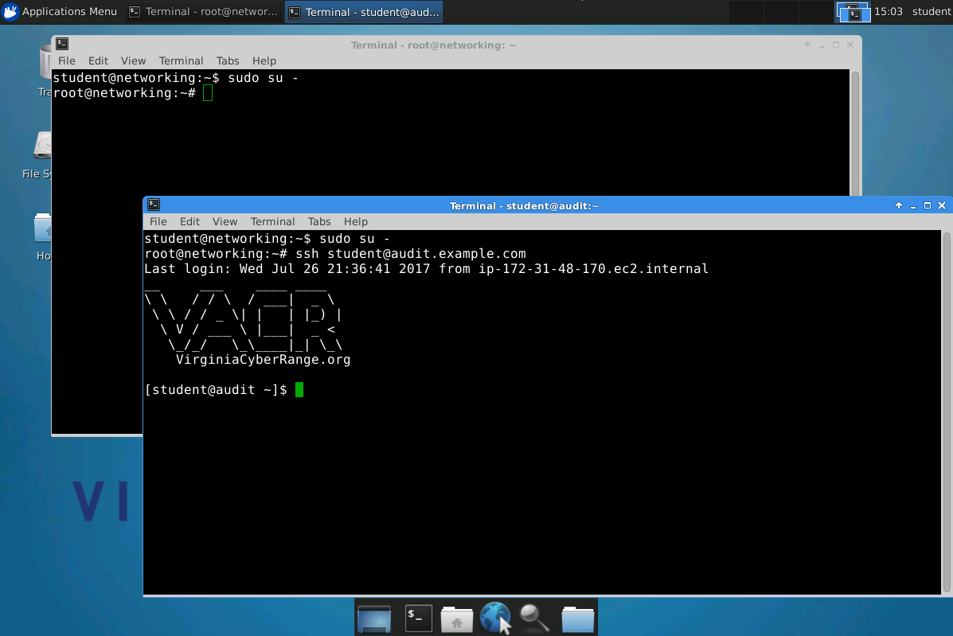

This audit ssh session is where you will scan and audit your networking server from. Before continuing, ensure you have a setup that looks something like the figure above. You should have two root terminals up, one locally on the networking server and one on the audit server.

**4. Tasks**

**Challenge:**

The system you are being tasked with hardening (networking.example.com) is a vanilla, freshly provisioned Ubuntu Linux web/ssh server with a few vulnerable or network exposed services. You need to examine what ports, IPs and services are exposed to the network, and work on addressing and securing the outstanding network security issues layer by layer.

Hardening a *LAMP* server (Linux, Apache, MySQL, PHP) is typically done by securing the following layers of the system:

1. **Outer Layer:** Kernel level network and access controls
2. **Running Services Layer:** Network exposed services
3. **Local Services Layer:** Restrict local services to localhost
4. **Daemon Config Layer:** Harden exposed daemons
5. **OS & Filesystem Layer**

Let’s take an in depth, hands on look at how to attack each of these layers. You may find the Useful Commands and Config Files Cheat Sheet Handout helpful as you go through the tasks.

**Task 1: Outer Layer: Kernel level network and access controls**  
On the networking server, configure the following network and system *Mandatory Access Controls* to limit network and system access:

* 1. **Network:** Looking at your iptables firewall (**mousepad /etc/firewall.sh &**):  
       
     These typical firewall *access control lists* (ACLs) rules, as well a few others, are already set up in the top of your firewall.sh script:

This ACL entry allows all lo interface (localhost) traffic in: **iptables -A INPUT -i lo -j ACCEPT**

This entry allows inbound TCP ssh port 22 sessions in on eth0: **-A INPUT -i eth0 -p tcp --dport 22 -m state --state NEW,ESTABLISHED -j ACCEPT**

And this entry allows in RDP (remote desktop) port 3389 sessions: **-A INPUT -i eth0 -p tcp --dport 3389 -m state --state NEW,ESTABLISHED -j ACCEPT**

**WARNING:** Don’t edit these two rules in the top half of the **/etc/firewall** script! They maintain your connectivity to the cyber range system.

* + 1. From the audit server’s root login terminal, run this **nmap** stealth scan (**-sS**) against the networking server:

# **nmap -sS networking.example.com**

Not shown: 994 closed ports

PORT STATE SERVICE

22/tcp open ssh

25/tcp open smtp

80/tcp open http

631/tcp open ipp

3306/tcp open mysql

3389/tcp open ms-wbt-server

This is what the stock networking server looks like from the outside (without any firewall in place).

* + 1. Back on the networking server’s root prompt, run the *stock* firewall script as is:

# **/etc/firewall.sh**  
APPLYING FIREWALL RULES: Use "testing" option to have it auto-flush in 2 minutes.  
Done!

* + 1. Next switch back to the audit server’s terminal and run the same **nmap** scan of the networking server and compare the new scan’s output (like below) to what you saw before.

Provide screenshots when answering the following questions.  
  
Q1 (10pts): What ports are now open from the outside with this stock firewall script in place?

22/tcp and 3389/tcp ports are now open from the outside with this stock firewall script in place

Q2 (10pts): What services do those ports represent?

They represent ssh and ms-wbt-server services.

Q3 (10pts): Given the requirements of this as a web server with access ports 22 and 3389 open, what are all of the ports should one should be seeing as “open”?

The other tcp and/or udp ports ranging from 0 to 64000.

**NOTE:** Ports 22 and 3389, are the SSH and RDP ports, respectively, that the Cyber Range uses to provide you the remote login and “Remote Desktop” service.

* + 1. Switch back on the networking server, open the firewall.sh script and go to the bottom where there is the space for additional firewall ACL “ALLOW” entries.   
         
       One example rule allowing in port 22 /ssh sessions (just as a template) can be seen, followed by a line REJECTing all other incoming traffic (that has not been previously allowed).   
         
       **NOTE:** With firewall or ACL rules, **order matters**. First you let in specific ports & protocols, then you block everything else. Get your ACLs out of order and nothing will work correctly.  
         
       Use the --dport 22 line to poke similar “holes” in the firewall to allow all web traffic through the firewall:  
         
       iptables -A INPUT -p tcp -m tcp --dport 22 -j ACCEPT **# <-- enter your rules here**  
        iptables -t filter -A INPUT -j REJECT

Q4 (10pts): Which ports did you add to your firewall script?

**WARNING:** Do **not** modify the ACCEPT lines for ports 33xx (for RDP) or port 22 (ssh) in the upper section of the firewall script. Otherwise you could lock yourself out of the system.

**TIP:** When testing the firewall script the first few times, invoke it with the testing option which will disregard (flush) you firewall changes 2 minutes after running it:

# **/etc/firewall.sh testing**  
TESTING: Will auto-flush in 2min...  
Done!

If you do lock yourself out of the system without the **testing** option, then simply stop and restart your exercise session through the Cyber Range web interface.

* + 1. After editing the firewall script to allow web traffic through, then re-run **/etc/firewall.sh** on the networkingserver and then rescan (using **nmap** ) networking.example.com from the audit.example.com server again and adjust the firewall script entries until you get the following results from the audit scan:

# **nmap -sS networking.example.com**  
PORT STATE SERVICE  
22/tcp open ssh  
80/tcp open http  
443/tcp closed https  
3389/tcp open ms-wbt-server

**TIP:** If you mess up your firewall script, there’s a backup of the original file called /etc/firewall.sh_ORIG that you can copy back over the main firewall script.

**NOTE:** In a production system, the firewall script must be loaded every time the system boots *before* the network brings the system fully on line. One should never load a firewall *after* the networking subsystem is up, else the system could briefly be on line (e.g. by using rc.local, etc) with no firewall blocks in place. Doing so leaves makes the system vulnerable to “reboot window” attacks.

* 1. **System:** Employ & test AppArmor *Mandatory Access Control (MAC)* system  
     MAC suites such as AppArmor or seLinux are typically kernel level, system wide safety nets that keep rogue or unapproved processes or services from accessing parts of the system they should not. MAC systems are good to run on any system, but are most commonly utilized on externally facing, networked systems that could see hacking attempts, buffer overflows, illegal applications or user privilege escalation attempts. Unexpected or unauthorized applications get scope-restricted to a subset of system resources. Even root can be *sandboxed* to only do certain operations on a tightly restricted MAC enabled system.  
       
     Configuring AppArmor to apply sshd profile restrictions:  
     AppArmor profiles are kernel level MAC configurations files called profiles that restrict system, applications and user access. Adding new application profiles requires the reloading or restarting of the AppArmor service. But before this can be done for ssh (in this exercise), the additional profiles package needs to be installed and the ssh profile added to the active AppArmor service.

* + 1. On the networking server, now install the packages apparmor (user space tools) and apparmor-profiles for additional AppArmor profile configs:

# **aptitude install apparmor apparmor-profiles**  
**Tip:** In this Debian/Ubuntu based Linux system the **apt-get install <package-name>** or **aptitude install <package-name>** is used to install packages. On newer Debian based systems, **apt** is used and on Red Hat/rpm systems the **yum** meta package manager is used to download and install packages from approved repositories.

Q5 (10pts): How many daemon profile config files do you currently see in the /etc/apparmor.d/ directory? Provide a screenshot showing all the files under this directory.

0 packages upgraded, 0 newly installed, 0 to remove and 150 not upgraded packages.

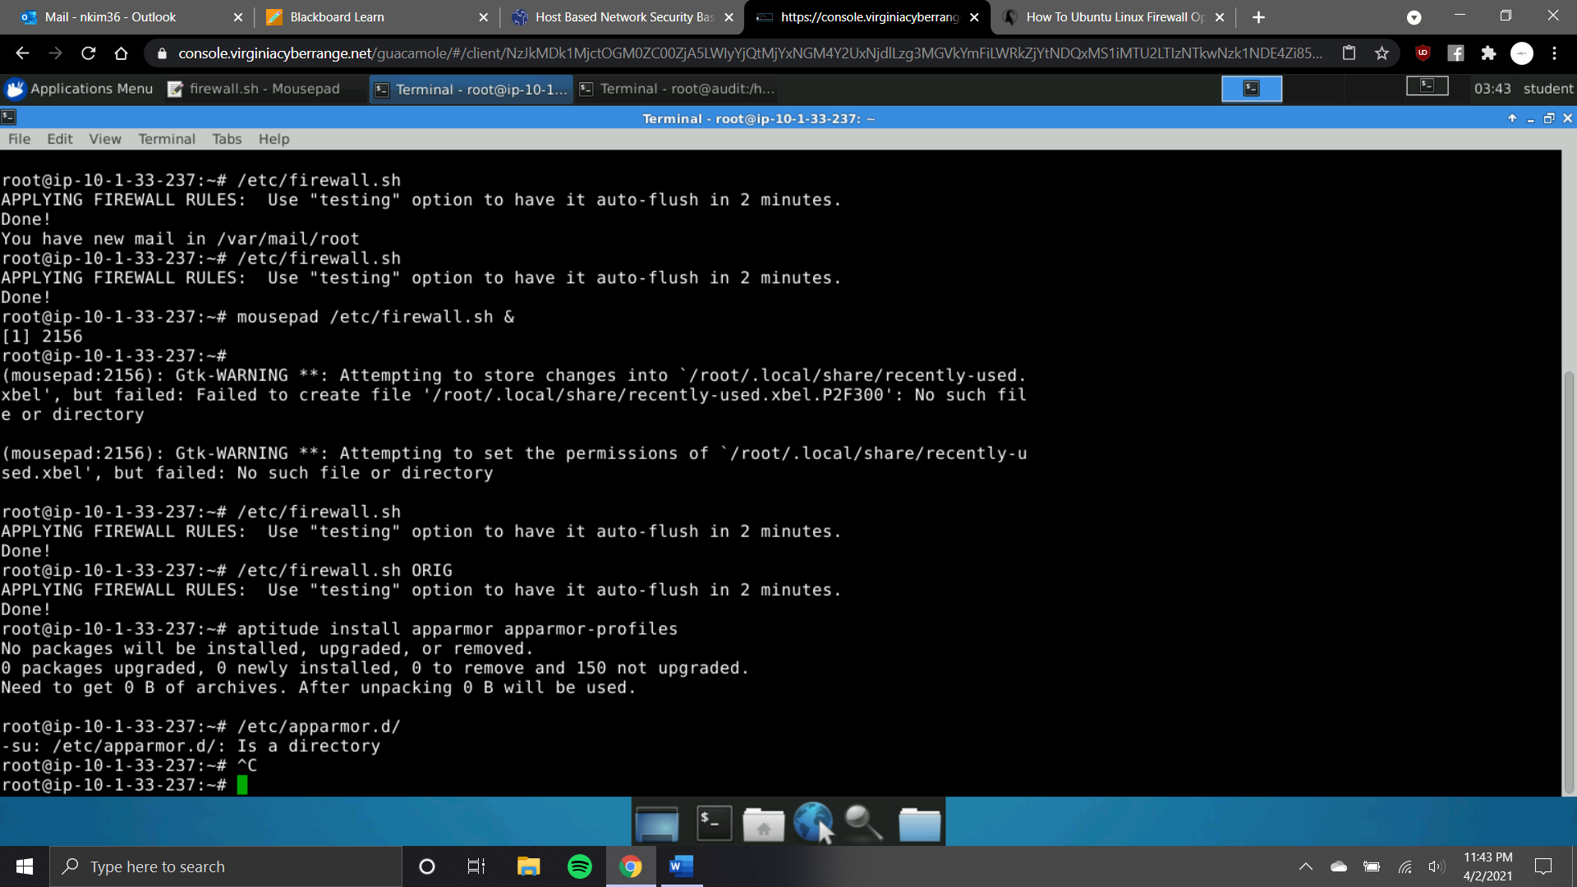

**TIP:** Daemon programs are almost always in the /sbin or /usr/sbin directories. And in the /etc/apparmor.d/ directory, the files are named to reflect the path of the protected program, for example, usr.sbin.cupsd points to the program in the path /usr/sbin/cupsd.   
________________________________________________________

* + 1. Reboot-Check: After a reboot that you can verify apparmor by either running the **apparmor_status** command (showing all running profiles) or the following command and getting a “Y” response:

# **cat /sys/module/apparmor/parameters/enabled**Y

**Hint-2:** To ensure the AppArmor MAC suite starts up and is configured to start, use the **service** command to start and stop it, and the **update-rc.d** command to configure it to start at boot time. Newer systems use the systemd **systemctl** suite to control this.

* + 1. To enable or write other apparmor profiles, you would place them into the /etc/apparmor.d/ profile config directory and restart the service:

# **cp -a /usr/share/doc/apparmor-profiles/extras/usr.sbin.sshd \   
 /etc/apparmor.d/**# **service apparmor restart** * Reloading AppArmor profiles

**Task 2: Running Services Layer: Network exposed services**

Configuring system to shut down services/ports not being used:

* 1. **cupsd:** Disable/Remove cups/631

The cups service can be seen running with the service command:

# **service cups status**  
cups start/running, process 1768

You can also see it is bound to a public IP address with the **netstat** command:

# **netstat -antp|grep -e ^Proto -e cupsd**

Proto Recv-Q Send-Q Local Address Foreign Address State PID/Program name

tcp 0 0 0.0.0.0:631 0.0.0.0:* LISTEN 1768/cupsd

Since this is a headless web server, we do not need or want the unused cupsd printer daemon running at all, much less being exposed to the world. You could stop + disable a service using the update-rc.d cups stop + update-rc.d -f cups remove (on older upstart/Ubuntu systems) or systemctl stop cups.service + systemctl disable cups.service (on newer systems). However, in this case on a non-GUI non-desktop based system, it should probably just be removed completely from the system.  
  
Stop the service (above) and then remove it from the system using apt-get/aptitude so we don’t have to worry about it from now on.

**NOTE:** Record the command you use to remove the cups package, and record how many related sub packages are also removed.

**Tip:** CUPS (formerly an acronym for Common UNIX Printing System) is a modular printing system for Unix-like computer operating systems which allows a computer to act as a print server.

**Hint:** To remove packages, see the man page for apt-get / aptitude (on older Ubuntu systems) or just apt on newer systems.

After removing the cups package, reboot the system to ensure your configuration is persistent. After rebooting, the same netstat command should look like this:

# **netstat -antp|grep -e ^Proto -e cupsd**

Proto Recv-Q Send-Q Local Address Foreign Address State PID/Program name

Once you indeed have the **netstat** results seen above, answer the following questions and provide complete screenshots to support your answer.

Q6 (10pts): What command did you run to remove the cups package?

Apt command

Q7 (10pts): How many packages were removed?

806 packages

**5. References**

* Useful Commands and Config Files Cheat Sheet

**KSAs, from NIST SP 800-181:** <http://nvlpubs.nist.gov/nistpubs/SpecialPublications/NIST.SP.800-181.pdf>

**Knowledge:**

* K0033: Knowledge of host/network access control mechanisms (e.g., access control list).
* K0224: Knowledge of system administration concepts for Unix/Linux and/or Windows operating systems.
* K0537: Knowledge of system administration concepts for the Unix/Linux and Windows operating systems (e.g., process management, directory structure, installed applications, Access Controls).
* K0608: Knowledge of Unix/Linux and Windows operating systems structures and internals (e.g., process management, directory structure, installed applications).

**Skills:**

* S0007: Skill in applying host/network access controls (e.g., access control list).

**Knowledge Units (KUs) Addressed:**

**From:** <https://www.iad.gov/NIETP/documents/Requirements/CAE-CD_2019_Knowledge_Units.pdf>

(you may need to accept an invalid iag.gov SSL certificate to reach this PDF)

* Cybersecurity Foundations (CSF)