Stage 2 Summary:
Determine the deflection magnitude of the load frame:
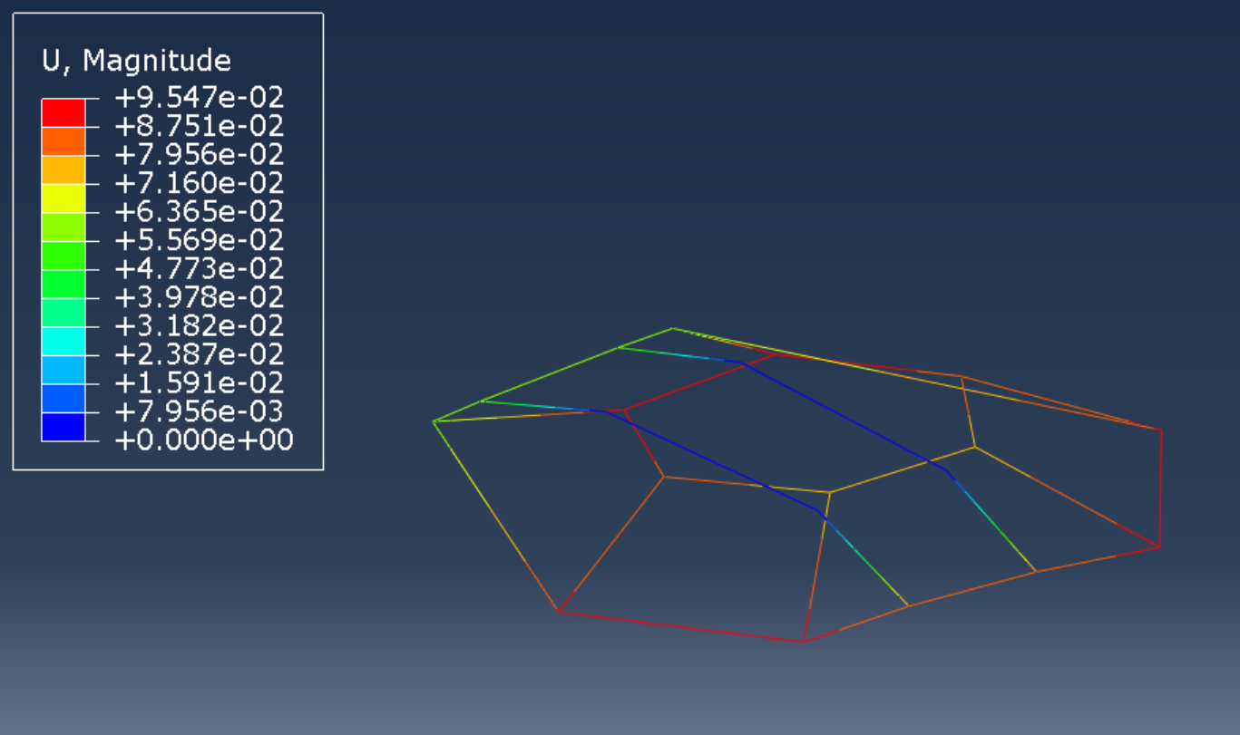
In inches.
Determine the reactions at the base points, “A”, “B”, “C” and “D”?
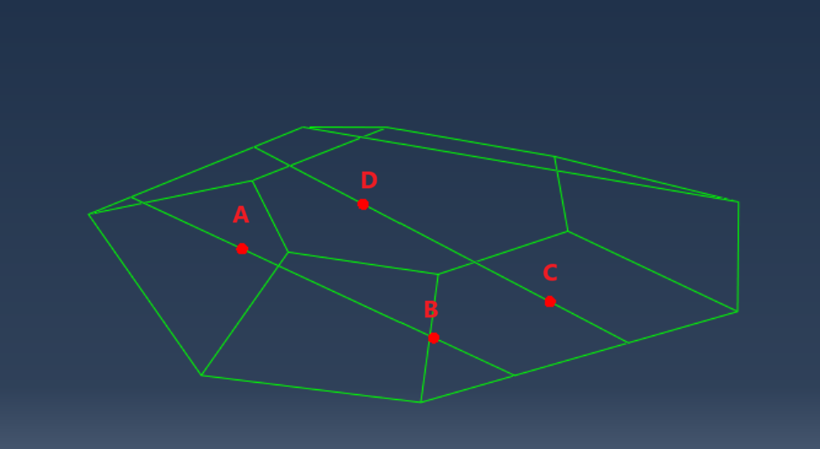
A: 2.52681E+01 lbf
B: 3.47321E+01 lbf
C: 3.47321E+01 lbf
D: 2.52681E+01 lbf
Determine the “critical stresses”, in the load frame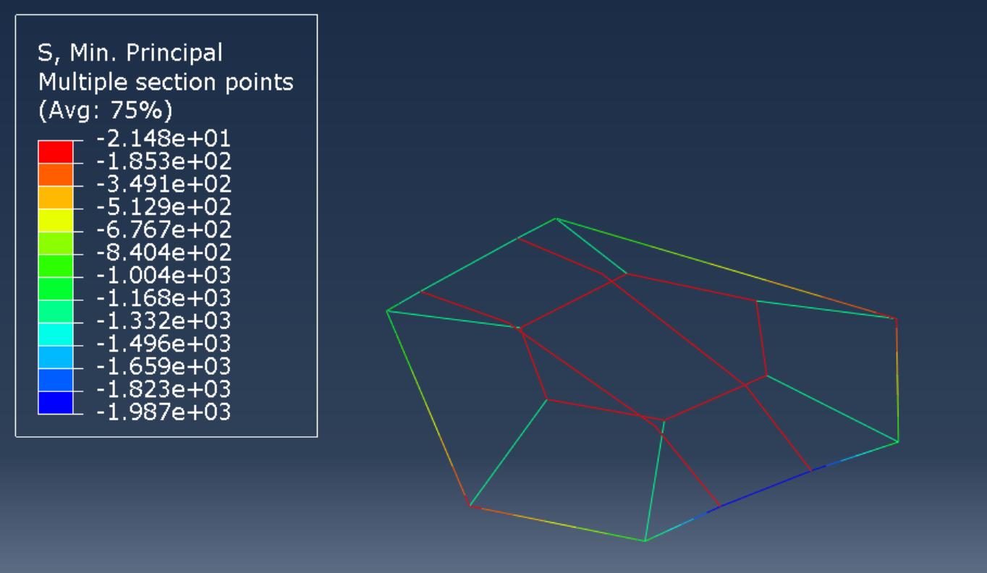
Critical elements highlighted:
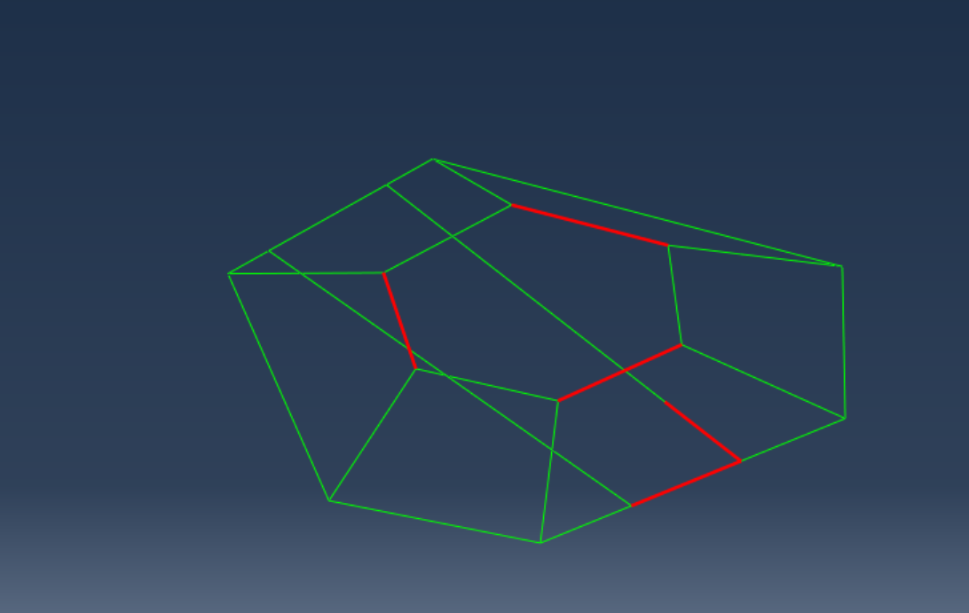
- critical stress location and value on the top hexagonal load frame members: -61.3414 psi
- critical stress location and value on the bottom hexagonal load frame members: -1856.79 psi
- critical stress location and state gimbal shafts: -28.4264 psi
Determine the critical section on the load frame and what is the stress state?
-1856.79 psi on the highlighted element:
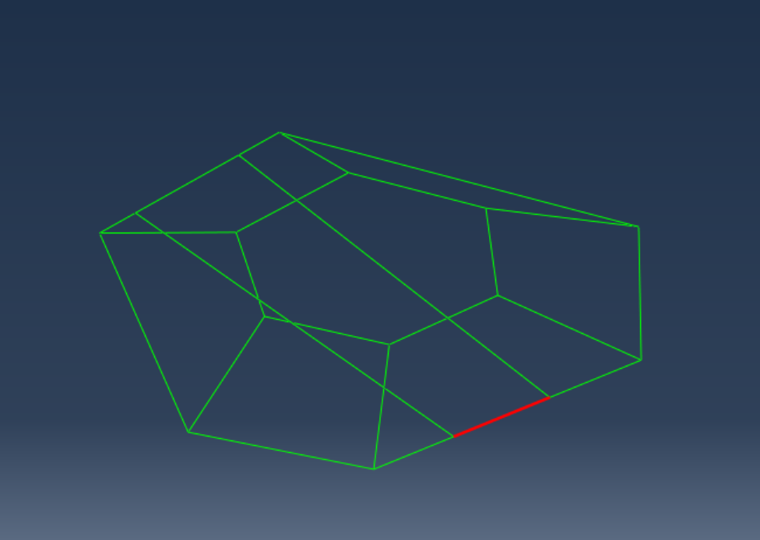
- Where is the minimum deflection per span and what is the value? Is it less than 1%?
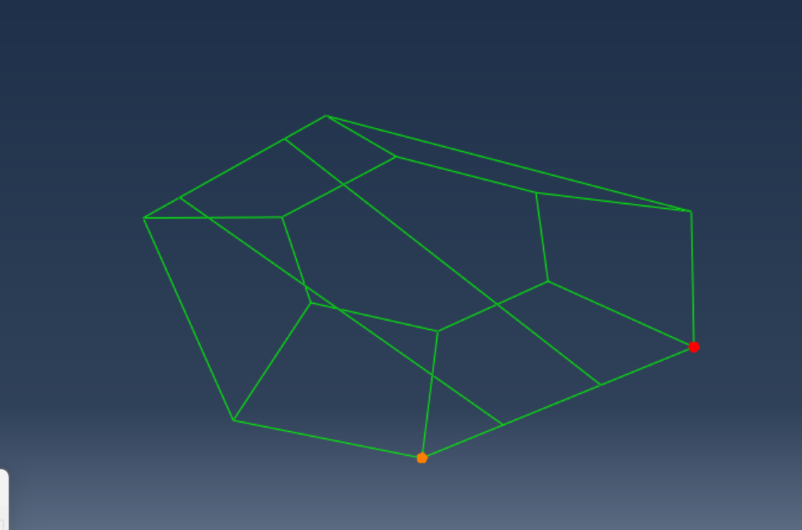
Deflection = 0.0914152 in
Span = 26.6726in
Deflection per Span = 0.0914152in / 26.6726in = 0.3427%
It is less than 1%
- Where is the maximum stress and what is the value? Determine the factor of safety in Yield.
Max Stress = 1856.79 psi
Factor of Safety = 42290psi / 1856.79 psi = 22.7758659 
- If the noise in the strain gages is expected to be εNoise = 50 μstrain, what is the signal-to-noise ratio?
Strain in gauges = 122.072 μstrain
Signal to noise ratio = 122.072 μstrain / 50 μstrain = 2.44144

