Image Classification Using Feedforward Neural Networks in MATLAB

Nathaniel A. Parizi
Email addresses: napari9094@ung.edu

Abstract— The Feedforward Neural Network is a machine learning algorithm whereby connections between nodes will propagate data forward through a network of proceeding nodes for a resulting output in an attempt to represent knowledge of a given objective. This paper aims to analyze the performance of MATLAB’s Pattern Recognition Feedforward Neural Network in classifying and properly identify images by training on a set of handwritten digits.
Keywords— Feedforward Neural Network, Image Classification, Pattern Recognition, Gradient Descent, ANN, Perceptron.

Introduction
Machine learning algorithms that simulate the biological nervous system of an organism are referred to as Artificial Neural Networks and have seen a significant rise in applications regarding business and technology in recent years. Methods used during implementation are mentioned in detail throughout the introduction of this paper. The field had a modest beginning with the introduction of the Perceptron in the 1950s which began as a network of single layered nodes that had limited efficacy in recognizing various classes of patterns, causing research to slow down over the years. Then innovations led to the Feedforward Neural Network with multiple layers allowing for greater processing and recognition. The Feedforward Neural Network seeks to simulate the brain of an organism, which is characterized by nodes that represent neurons, axons are seen as the transmitters of data while dendrites are seen as the receivers, and the synapse allowing passing electrical impulses are seen as an activation function. A single layer perceptron will have input nodes sending data toward an output layer with their given set of weights acting as adjacent edges carrying unique values for which the resultant could be a binary output. A single neuron processing data alone doesn’t solve much but a network of many neurons will perform tasks much better. This led to the hidden layer, the set of nodes which exists between the input layer and the output layer. Each input has weighted connections leading to the subsequent hidden nodes proceeding it, and then on to the output node thereafter as illustrated in the following image.
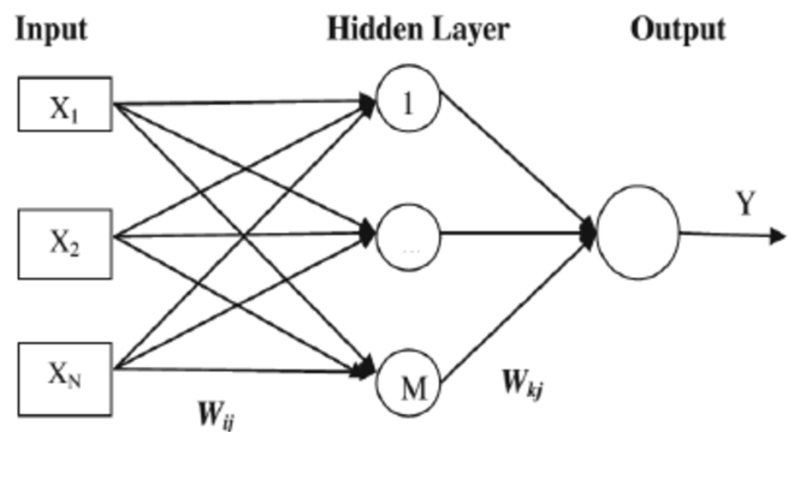
The Feedforward Neural Network can only propagate data in one direction, forward, and contains no cycles or loops whereby each iteration is referred to as Epochs. The value that is passed from the neuron after every weight is summed up is dictated by the activation function. A simple example is the threshold function, whereby if the cumulative value passed to the neuron is more than 0 the resulting output will be 1 and the data is passed on. Therefor activation function of a given node defines the proceeding output of that node.
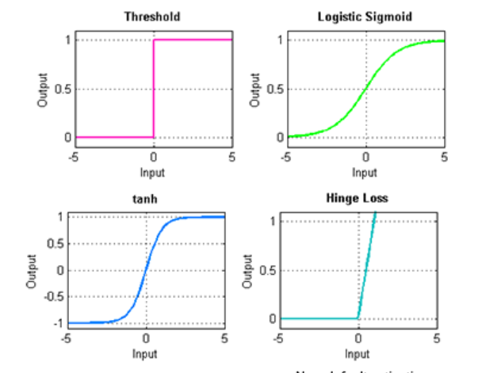
Many different activation functions can be employed in a neural network, for example the Sigmoid function which are commonly used to model probability or chances in a stochastic environment, such as the odds a player beating an opponent in a chess match with ELO scores. Most activation functions have their own unique characteristics of which can be applied to better fit problems, the most common being Rectified Linear, Threshold or Binary Step, Sigmoid, and Hyperbolic Tangent functions. After weights have satisfied the activation condition for these functions they resulting data output proceeds.
Multi-layer networks can utilize a multitude of various learning methods, and most commonly used is the feedforward neural network is back-propagation. A predefined error-function will be determined by comparing the output values to the correct answer labeling the data. This error is fed back through the network whereby the network will readjust weights according to new data thereby reducing the value of the error-function incrementally. The weights are initialized to a value over zero and usually are better small. The neural network is seen to have sufficiently learned the target function after iterating through this cycle and reducing the error-function to a sufficiently small amount and producing repeatable accurate results to the given objective task.

The fundamental component used to compare error is calculating the gradient to obtain the minimum of that function which is referred to as Gradient Descent. The local minimum is found as the gradient is negative and if it is positive the local maximum is being approached, as this cycle is repeated the network descends toward optimal error. This optimizes the performance of the network during training as the local minimum is further approached.
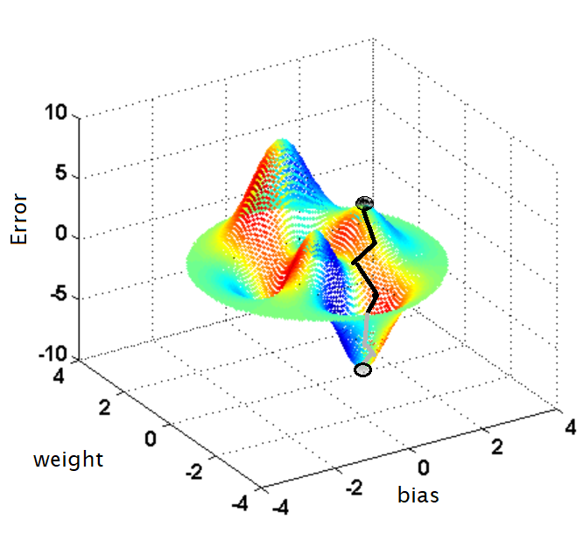 An issue with this method is that the global minimum may be missed, generating a result that is less favorable. A solution for this problem is Stochastic Gradient Descent which selects samples randomly instead of a single ordered group so that new and entirely random minimums are approached in effort to find the ideal global minimum as well as being able to use on data or training samples which are nonlinearly separable which is useful in image recognition. Training weights such that they minimize the squared error as follows:
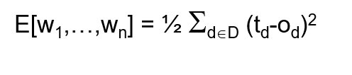
If the network is to be trained on a set of data which is not normalized to represent a standardized format that best represents all the data among that class, it could produce unfavorable results. By normalizing values the comparisons of corresponding normalized common values for different data we can return results that will best satisfy the neural network during training and save on processing while errors are minimized. The gradient of the error-function follows the partial derivative of each proceeding weight in the network as follows:
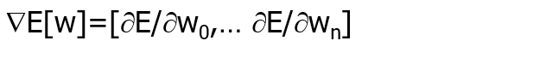An example shows how gradient descent must navigate through the error surface much more to locate the minimum on data which is unnormalized versus the same data which has been normalized to some best representative standard. The discrepancy is clear in the performance through each epoch.
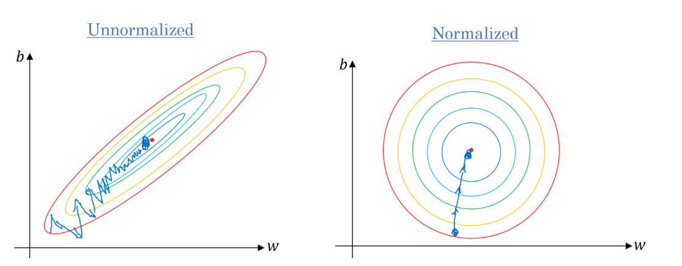
For image recognition, the goal is to make sure that each image file is scaled to the same resolution, as during implementation each image represents a 28x28 pixel image resolution. If the neural network is to process lower resolutions with high definition images, the resulting training set will become so convoluted the target function may never be met.
The computation complexity of the Feedforward Neural Network requires a lot of overhead mostly due to the amount of hidden nodes, input data to be trained on, as well as the bulky runtime of propagation back and forward through the network.
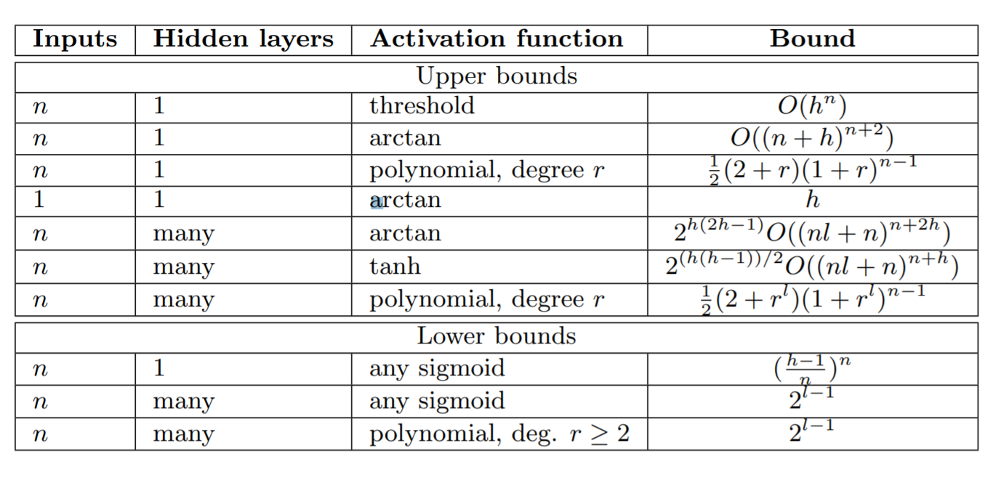
As we can see most feedforward neural networks will perform at an O(N²) runtime, where h represents the hidden nodes while n represents input data. In practice, we must wait a considerable amount of time for the network to converge toward an ideal minimum error, however once training is complete, a more refined and potentially more accurate algorithm emerges. The time it takes to apply the network to that given task may be quickly executed. Over saturation of activation functions can lead to gradients unable to propagate well and consequently units that offer no value toward the network’s objective task which should be avoided [3].
Neural networks have been applied to special research in a range of different fields, bio-technology, financial economics, weather forecasting, cybersecurity, astronomy, marketing, to even predicting crimes before they happen. Research done in 1987 had shown a network trained on chaotic processes to accurately mimic and predict such dynamic nonlinear systems. Their results show that ANNs can be used for modeling and forecasting nonlinear time series with very high accuracy. Following research done by Lapedes and Farber in this experiment, a number of papers were devoted to using ANNs to analyze and predict deterministic chaotic time series with and/or without noise [2]. With sufficient implementation of these algorithms many things can be achieved.

Experiment Implementations and Results

The data being used for training is the MNIST database of handwritten digits, with a training set of 60,000 examples, and a test set of 10,000 examples. The digits have been size-normalized and centered in a fixed-size image of 28*28 pixel resolution. Since the digits have been scaled as such, we are avoiding issues concerning unnormalized data and the network is likely to generate quality results against the training data. The neural network training set is stored in a variable denoted by x, while the testing set is stored into a variable denoted by t, which represents the labels of corresponding training data. If implemented successfully the network should be able to classify the handwritten image file to it’s corresponding value, properly identifying it at an accuracy above 90%, without any complications on the machine’s processor since the data is stored in the MSB first format, the processor being utilized is an Intel i5 7’th Generation throughout this implementation.
Initializing the Pattern Recognition Networks are feedforward networks that can be trained to classify inputs according to target classes. The target classes in this case being the representative digits 0-9, whereby the value 10 corresponds to 0. The target data for pattern recognition networks should consist of vectors of all zero values except for a 1 in element i, where i is the class they are to represent [1]. This element of i represents the handwritten stroke of the number which is displayed in white while 0 is displayed in black.
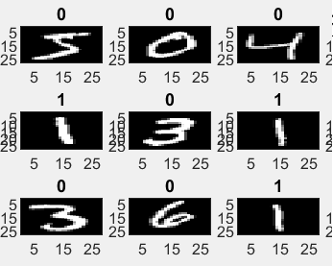
Since we are dealing with 28*28 pixels, each individual pixel will represent a given input node in the neural network. This data will be transmitted towards the proceeding hidden layer of the network where I will cover findings of different results in performance when the number of hidden nodes are adjusted. As such the network should propagate data forward using gradient descent for training function and Mean Squared Error for the performance function which will allow us to see minimization of error throughout the epoch time series of training. MATLAB’s built in Pattern Recognition Feedforward Neural Network can be initialized with the following code.
patternnet(hiddenSizes,trainFcn,performFcn)

The Training function called requires a few inputs to be passed in the argument such as what type of neural network is being used which in this case being denoted as net which is the Patternnet neural network as provided by MATLAB. The next variable required is the training data images denoted by x, and lastly the labels denoted by t. the epoch time series of training. MATLAB’s built in Pattern Recognition Feedforward Neural Network can be initialized with the following code.
[net,tr] = train(net,x,t);

This is assigned to the network as well as the training record, denoted by tr, (epoch and perf), returned as a structure whose fields depend on the network training function (net.NET.trainFcn)[1]. Once this is complete, assessment of the performance of the network will require to define test and validation sets, as well as performance metric. The training will terminate when either the gradient will go lower than 1e-5, or exceed the number of specified iterations displayed in the Epoch progress bar. Lastly the accuracy of the network’s proper classification of handwritten digits will be calculated through the set of 10,000 labeled testing data. A bar chart is plotted with the neural network’s predicted outputs measuring the accuracy in a 0-100% scale by passing that data through the Patternnet object.
Now we can experiment with different parameters to track the overall performance of the algorithm. Using a hidden layer of 10 nodes to begin, the resulting prediction is immediately returned as heavy processing time is not needed for training. Such a simplistic network features very few operations to propagate data forward as previously described in this paper, allowing for quick training, however this means that the correct predictions will be low in quality as we can see in the following results:
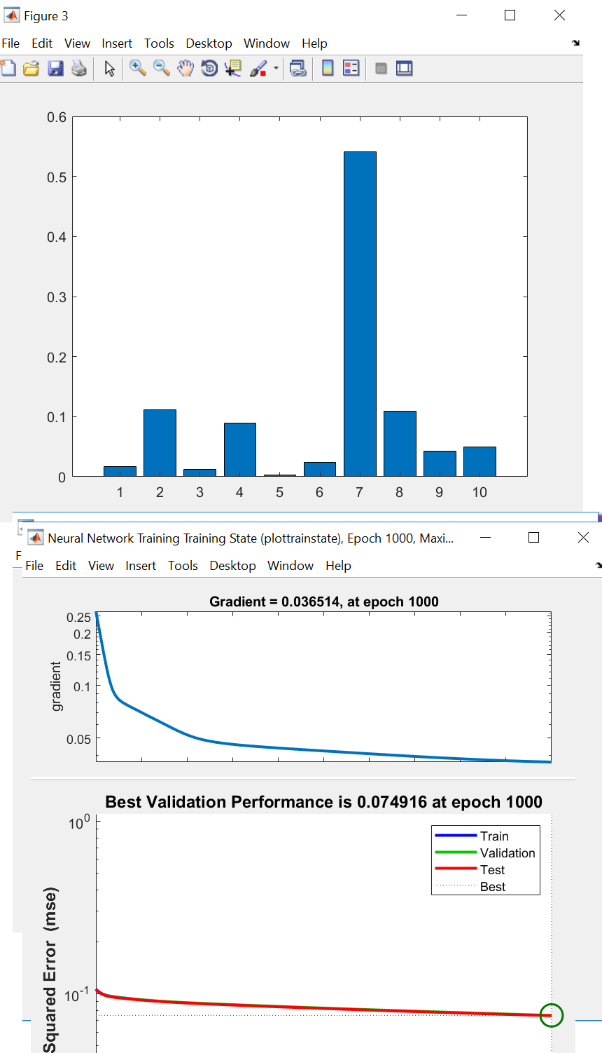

The algorithm managed to correctly predict the handwritten number being 7, however the accuracy is near random at 50%. Most problems that ANNs are applied to may not be as simplistic and the results would become more ambiguous under these contrains. The gradient was reduced down to 0.365 within 1000 epochs of iterations, this is a bit shallow compared to other hidden neuron quantities in this particular case. Proceeding this experiment, 50 hidden nodes were used next resulting in training terminating within several minutes. The following is the resulting performance under such constraints:
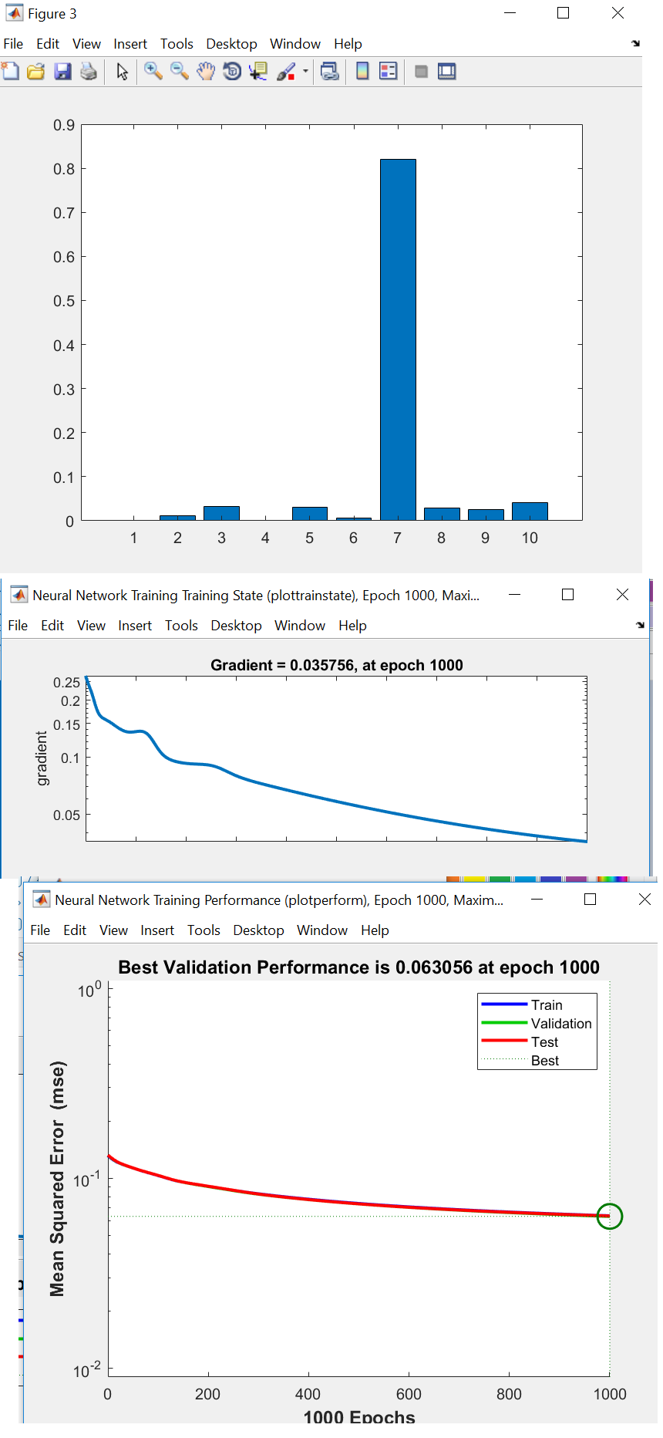
Interestingly, as we can see there was a bit of volatility in the gradient during the onset of training. This is due to ascending gradient values away from the desired minima in the error plane. This of course should converge toward a more smooth curve as training continues on. With a bit of patience we are able to converge toward a smaller gradient 0.0357 value than before, allowing for a deeper descension in the plane. Next, 100 hidden nodes were tested under the same constraints, this process took a little over a half an hour yielding a much more effective result in accuracy of prediction with surprisingly a higher gradient value near 0.044 after 1000 epochs as displayed in the following image.

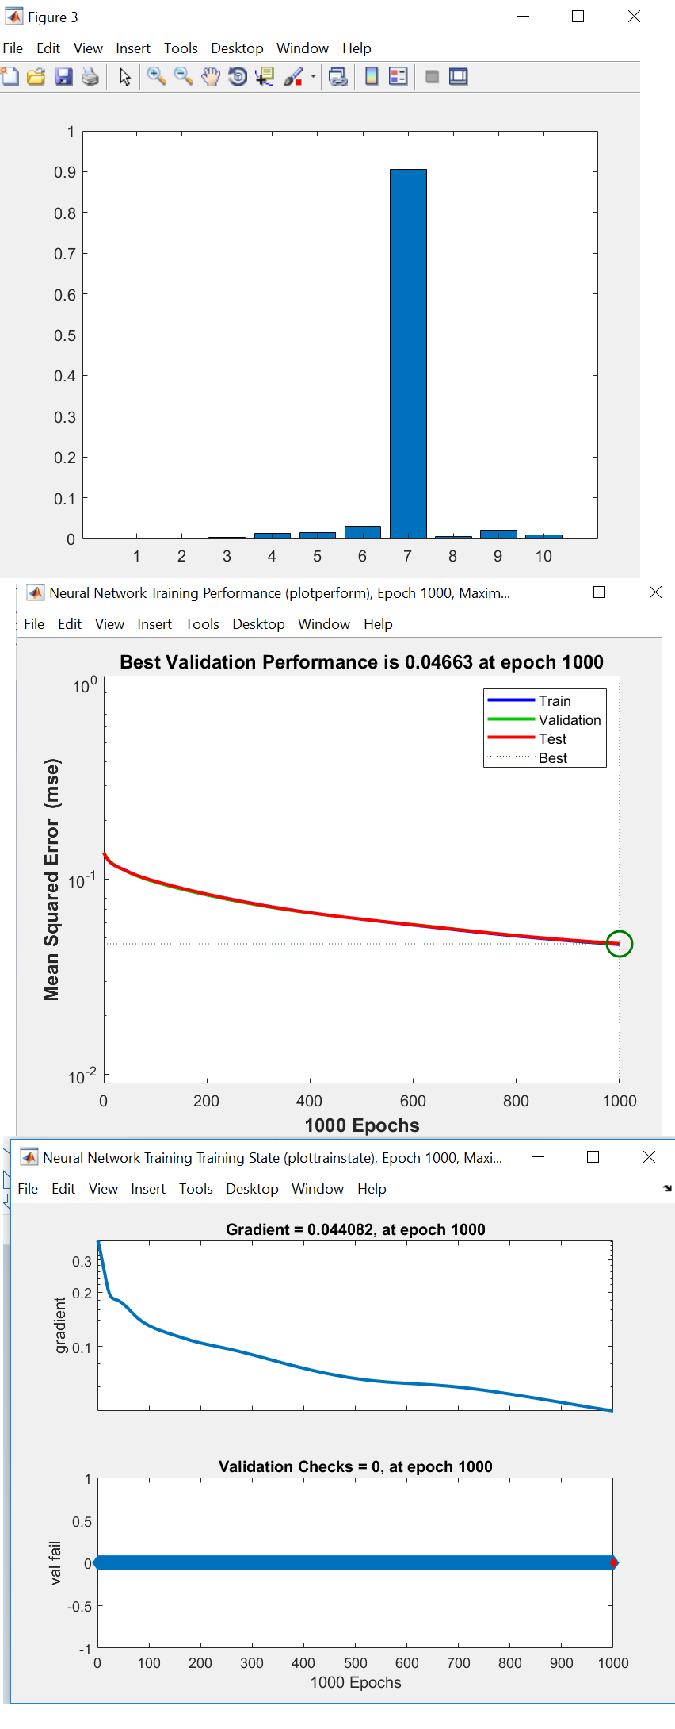
The last test was adjusted to 500 hidden nodes which took around 1 hour and 26 minutes to terminate which yielded the most unique and interesting results. As we can see the accuracy was close to 98% successfully. The variance in the distribution of the classifications of each number were also very limited with the surprising exception of 3 having a little attraction somehow. In experimenting with these algorithms, we never really know what kind of results could emerge during training which can be a powerful thing. The following image displays the results from the 500 hidden node training.
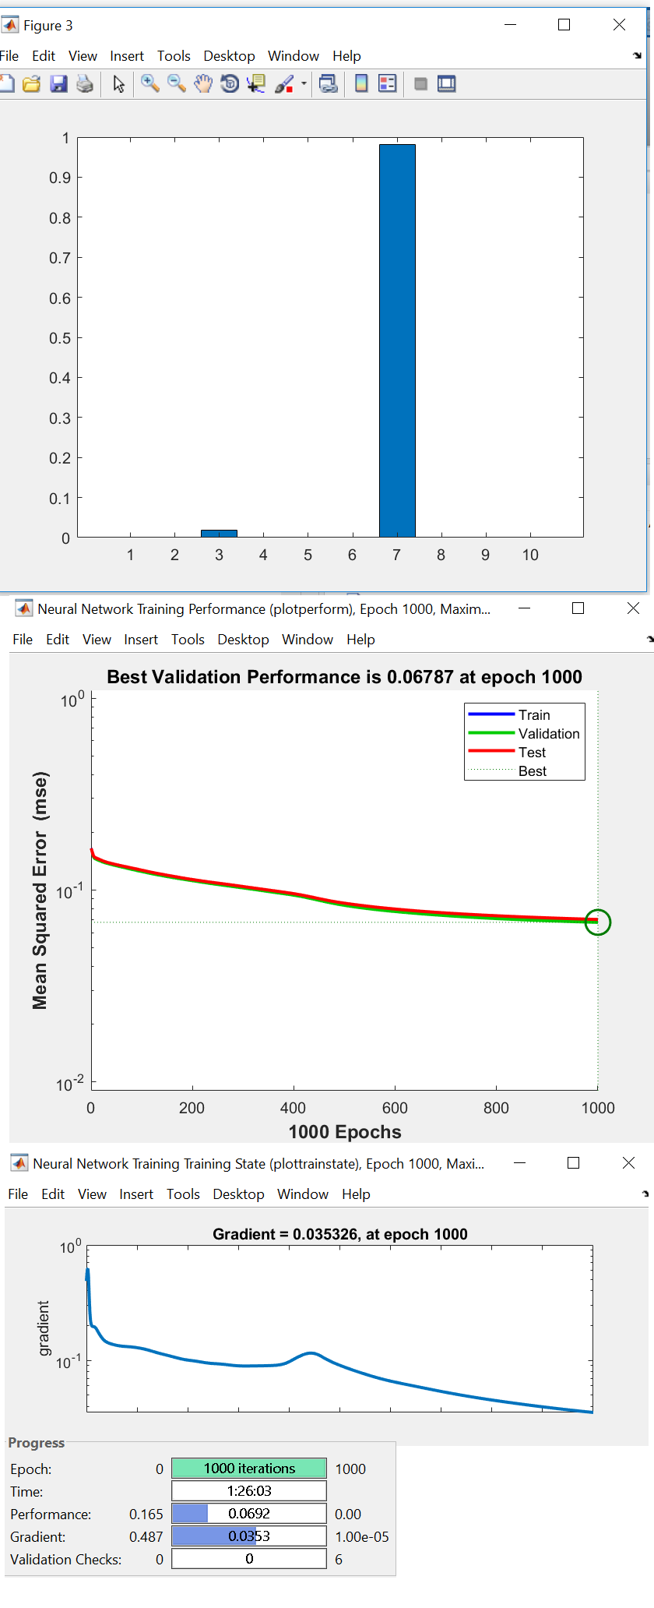

Conclusions
Through analyzing the Pattern Recognition Feedforward Neural Network in MATLAB, it’s clear that a variety of different factors must be taken under consideration during implementation of such algorithms, alongside computational challenges in processing for massive datasets. The feed forward neural network offers a practical and effective means of successfully being able to classify handwritten characters allowing for more applications toward image recognition as they have influenced the evolution of many new neural network approaches have emerged in popularity within the industry such as deep learning, and convolutional neural networks. Given these algorithm’s efficacy and ability to detect patterns for which is impossible for humans, it’s probable that prediction will remain to be the artificial neural network’s major use in the tech industry and continue to evolve as time moves on.

References

- “Pattern Recognition Network.” Reconstructing an Image from Projection Data - MATLAB & Simulink Example, www.mathworks.com/help/deeplearning/ref/patternnet.html?searchHighlight=patternnet&s_tid=doc_srchtitle.
- Bianchini Monica, Scarselli Franco, “On the complexity of shallow and deep neural network classifiers”, Department of Information Engineering and Mathematics, University of Siena, 2014.
- B. Guoqiang Zhang, “Forecasting With Artificial Neural Networks”, Graduate School of Management, Kent State Univerity, 1997.

