Assignment 2 - My Snake Game
The game which I decided to make from scratch was Snake. The game consists of a snake made from a LinkedList which is directed around the game board, avoiding obstacles and collecting Apples to get a high score. You are not allowed to touch the sides, or the top of the grid displayed, or it will result in game death, you are also not allowed to touch the pink squares as they also cause in game death. The aim of the game is to beat the top score. The user can use the W, S, A, D, Up direction key, Down directional key, Left directional key, and the Right directional key to control the orientation of the snake. The player can also restart the game by clicking the left mouse button on screen. Each apple is worth 50 points and they are coloured green to allow the player to understand that they are good and that they are what the user should be targeting. The obstacles on the other hand are pink which the user must avoid, to allow them to stay alive in game.
Obstacles are extracted from a collection of Shapes which is a LinkedList which allows me to draw them to the gameboard calling the specified shape. If I wanted to draw the apples, I called the collection of shapes and specified that I would like to draw the Apples which uses the Oval class to do so. The Oval class Extends the Shape class. This is the same for my obstacles. The Square class extends shape and I would call a collection of shapes to draw the Squares(Obstacle).
When the game starts the user will see a grid with a welcome message stating which action to perform to begin playing and to the right will see the Scores panel, which provides to the user basic information on score. It should display the highest score, the players current score, the total apples the player has consumed and the apple value. Below will provide feedback to the user, displaying top scores of all time and highest previous game scores.
If the user beats the high score, the user if given a prompt to enter their name and allow their score to be saved to the file and for their score to be allocated to the highest score position.
Below are two buttons, one which gives the user the optional functionality to restart the game with a click of a button instead of clicking the game board, the other button allows the user to open the text file which stores the scores in.
In the table below, I will provide testing screenshots, a small description as to what I am testing within my game and an output screenshot.
Program Testing Output
Input Screenshot | Description
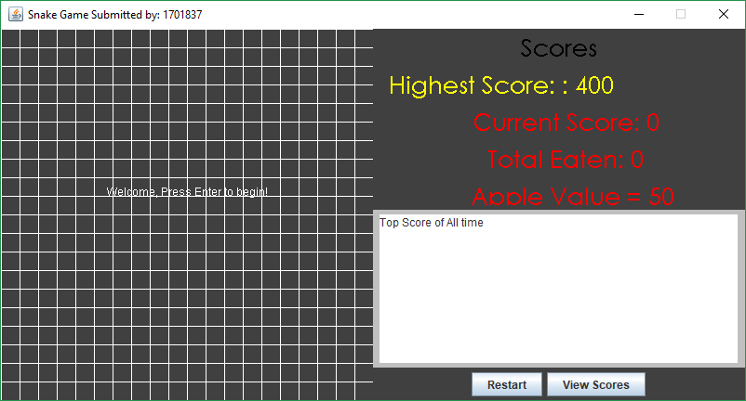 | a) My UI is an application that uses a grid of filled squares in which shapes object(s) are moved. My grid is 20 x 20.  The application also displays my registration number at the title of the frame  The initial setup is very specific to my game type and provides full functionality.  The screenshot to the left is what the user will see when the start the game for the first time if the score files exist.
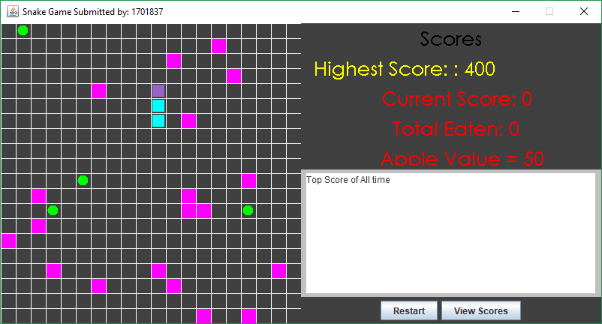 | b) Shapes are encapsulated in their own classes. An Abstract class shape was first created and then to create an Oval or a Square I stored them in a single Collection (a LinkedList). Each shape encapsulated methods to allow them to be drawn to my game screen at the required positions, and sizes.  Effectively I used what I done In lab 3 to successfully complete this.
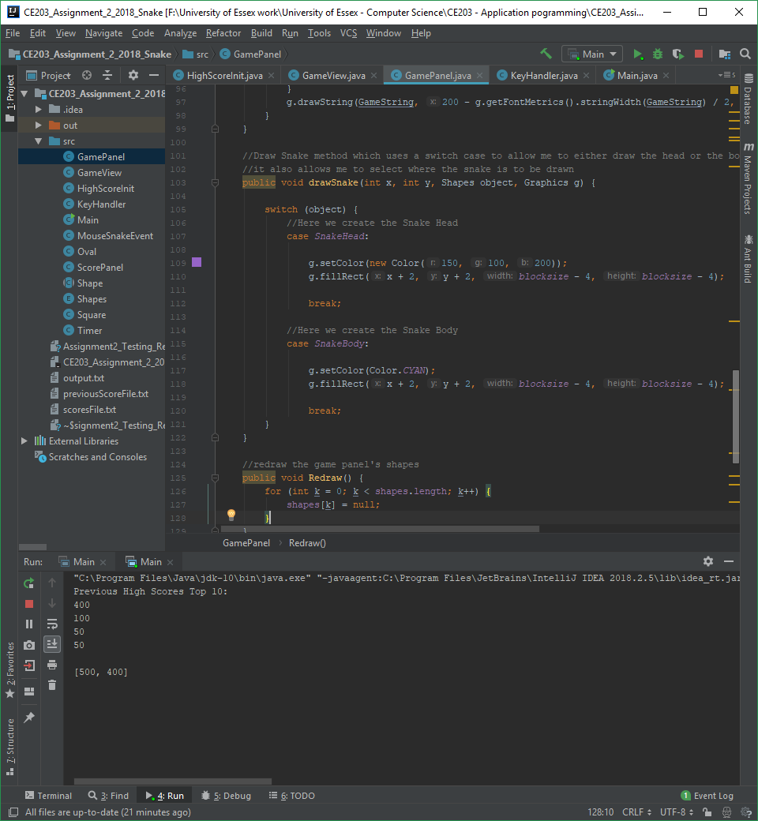 | c) Here there are two classes KeyHandler and MouseSnakeEvent. The KeyHandler allows user to interact with the game using the keyboard. To direct the snake in the direction of their choosing.  The MouseSnakeEvent allows the user to click and restart their game when left clicking the game board.
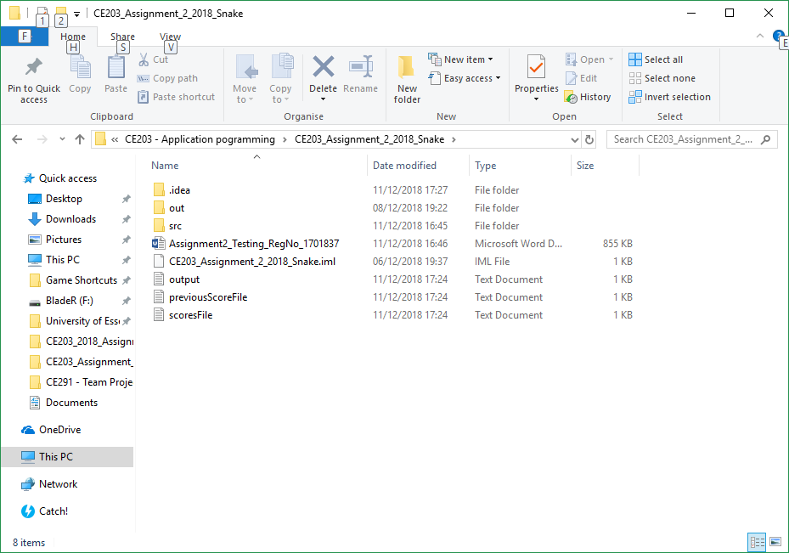  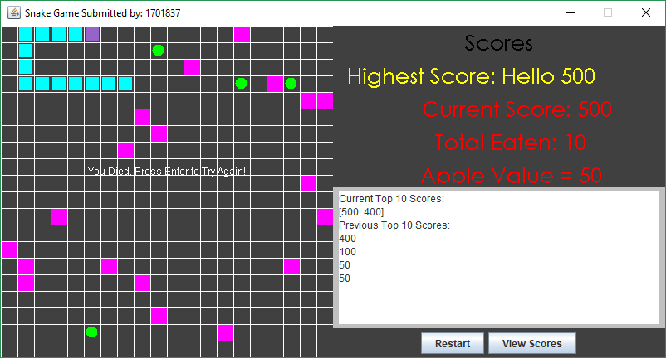 | d) The game constantly keeps a record of scores and saves them in text files. Methods are available to return the top 10 scores. The scores are displayed on screen at the end of a round and whenever the game is reopened. There are many exception handlers in my code to ensure that if there is no file, one will be created, or you shall be notified as such.  In the image you can see the score files and the output of the score in screen in a JTextArea.
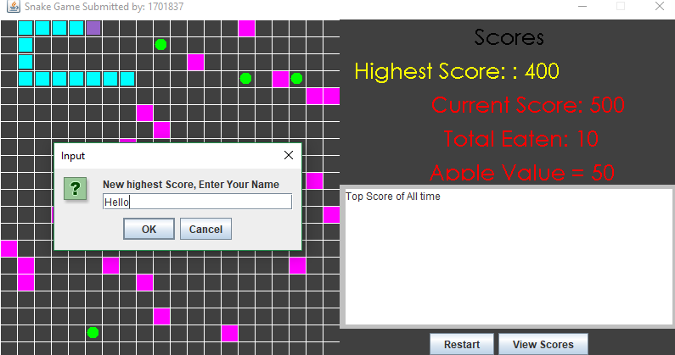 | d)If you beat the high score, a JOptionPane, input dialog will appear allowing you to input your name and place it in the high score area on screen.  Below in the next screenshot is the output of pressing enter when completed entering your name.
 | d) As you can see the high score name and value has changed to those specified.
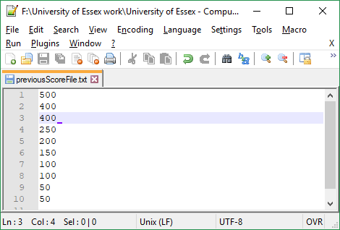 | This is the output of one of the score text files.
 | e) My code uses excellent object orientate principles and does not save all code in one class. In the screenshot to the left you can see my class names, and this separates the code from the main program code and makes it easier to read and implement on.
 | g) If you die you are prompted with a message to ask if you would like to play again by pressing the enter key.
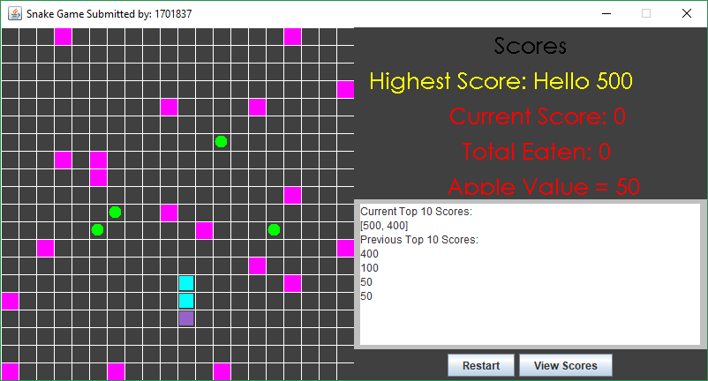 | g) the down key or the s key allows the snake to move downward.  The same applies for up, left, and right, w, a, and d.
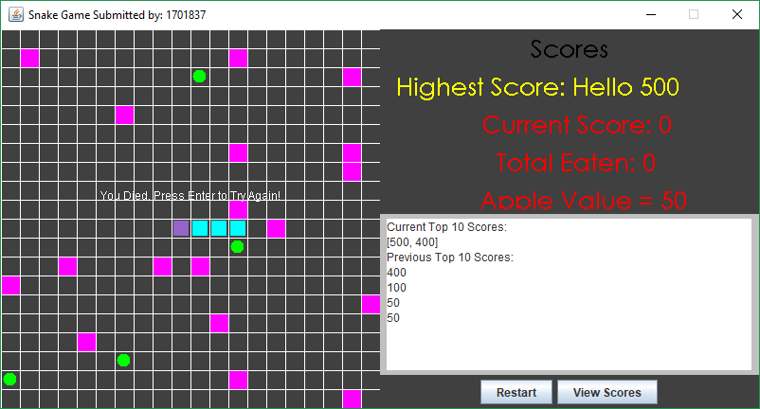 | g) If the snake hits an obstacle (pink square) then it dies. If the snake hits the edges of the grid, then it dies.
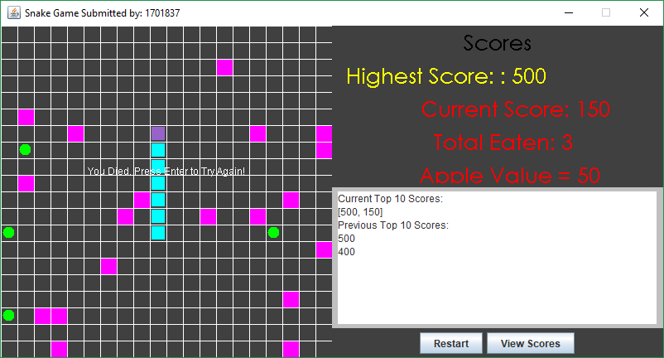 | g) If the user eats an apple, score in increased by the value of the apple which is 50. The current score is 150 and the player has eaten 3 apples.  You can also see the current top 10 scores and the previous top 10 scores.
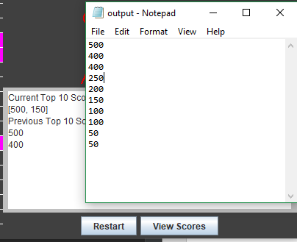 | g) if the user hits the View Scores button, the outputfile.txt is displayed showing the top 10 scores which has also been ordered depending on the score value. It has been sorted using Collections.sort, in reverseOrder().  This uses an added Desktop path reader which open the file specified when pressed.
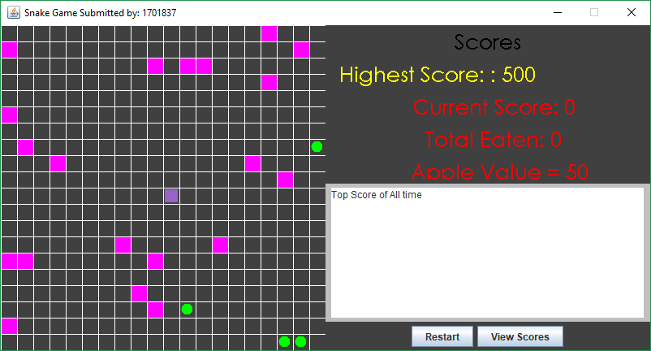 | g) When the user presses enter, no movement is automatically made so the user must press up down left or right (WSAD, or directional keys) to begin moving the snake.
Initial setup as specified to game type: Y  Each shape in its own class extended from abstract class: Y  Shapes can all be drawn and held in Collection: Y  Functioning Keyboard event handler class: Y  Functioning Mouse event handler class: Y  Scores can be stored in a text file: Y  Top 10 over all-time can be retrieved: Y  Report Structure: Y  Functionality and Testing: Y  Access Control: Y  Decomposition: Y  Use of Shapes to create game environment: Y  Use of event handlers to allow interavtion: Y  Playable game: Y  Allocation of score at end: Y  Ranking of score and display of top 10: Y | In my game I have successfully implemented all these functions specified by the marking criteria and hopefully they will continue to work and please when the code is passed on to be marked.

