**Roles Taken on by Each Group Member**

Please see Iteration_Plan.docx for a list of tasks and artefacts completed by individual members.

|  |  |
| --- | --- |
| **Group Member** | **Roles** |
| Tessa | Manager, Developer, User Interface Designer, Test Designer for black box functional |
| Nathaniel | Manager, Developer, User Interface Designer, Application Integrator, Database Designer |
| Selene | Developer, User Interface Designer, Test Designer for black box functional, Test Implementer |
| Toby | Developer, User Interface Designer, Tester – white box unit tests |

**Overall Summary of Minutes and Agendas**

**First Meeting For Assignment 2 Held on 12h September 2016**

All members attended.

**Items and Reports Discussed:**

No reports as starting new assignment.

Created a list of artefacts to be completed during the construction phase. See Appendix A attached.

Decided to use QT Creator to build the application using c++

Everyone will build a log-in and register form to learn QT.

Everyone will each take on the roles of Developer, Manager and Tester, changing as required. Nathaniel will take on the program Integrator and database designer role.

|  |  |  |
| --- | --- | --- |
| **Action – what is to be done** | **Who will do it** | **When will it be done by** |
| Build the functionality and gui for use case: User wants  to log in | Everyone | Monday 19th September |
| Begin the Project Plan for the project | Tessa | Monday 19th September |

1. Date and time of next meeting  
   Monday 19/09/2016 2:30pm Building 3 Room 127
2. **Agenda for Next Meeting:**

* Evaluate progress on the build of each component.
* Create an architectural design
* Create a database design.

**Summary of Meeting Held on 19/09/2016**

All members attended.

**Items and Reports Discussed:**

The group voted to use Selene’s log-in and register form in the program.

Decided to use a variation of the model view controller design pattern to base architecture on.

Decided to use MySQL database, everyone needs a local SQL database.

Discussed the next steps needed to build the program and assigned actions as appropriate.

**Action List:**

|  |  |  |
| --- | --- | --- |
| **Action – what is to be done** | **Who will do it** | **When will it be done by** |
| Create SQL database class and entity classes Bug and User | Nathaniel | Monday 27th September |
| Build Report A Bug User Interface.  Start Iteration Table | Tessa | Monday 27th September |
| Build Edit Profile User Interface | Selene | Monday 27th September |
| Build Search user User Interface | Toby | Monday 27th September |

Date and time of next meeting:

Tuesday 4th October 2016

Location: Building 3

**Agenda For Next Meeting:**

* Assess the build so far
* Record functionality still to complete for each interface
* Discuss Test Plan

**Summary of Meeting Held on 4th October 2016**

All members attended

**Items and Reports Discussed:**

Each member reported on their interface so far, copies of the outcome of each iteration are available in the Iteration Plan document Iteration_Plan.docx. There is still some minor functionality to complete by individuals for Add Bug, View Profile and Search User has not been started. Mainly due to holiday.

The Test Plan Document was downloaded and the group viewed it to see what needs to be done. We need to get a working application before any functional requirement testing can be done.

Decided on what to do for the next iteration and added to the action list.

|  |  |  |
| --- | --- | --- |
| **Action – what is to be done** | **Who will do it** | **When will it be done by** |
| Start on the build of the main window user interface | Nathaniel | Monday 11th October |
| Complete AddBug functionality and start building ViewBug | Tessa | Monday 11th Otober |
| Complete view profile functionality and start building View Profile | Selene | Monday 11th October |
| Start Search User interface | Toby | Monday 11th October |

Date and time of next meeting:

Monday 11th October 2016

Location: Building 3

**Agenda For Next Meeting:**

* Test Plan
* Program Integration
* Outstanding functionality

**Summary of Meeting Held on 11th October 2016**

All members attended

**Items and Reports Discussed:**

It was decided all members will complete their remaining functionality and upload to github so Nathaniel can integrate and get it ready for testing.

Each member discussed what’s left to do for their previous weeks task.

New action items were assigned.

|  |  |  |
| --- | --- | --- |
| **Action – what is to be done** | **Who will do it** | **When will it be done by** |
| Integrate the application into one | Nathaniel | Monday 17th October |
| Start Test Plan Doc | Tessa | Monday 17th Otober |
| Complete remaining functionality for add password | Selene | Monday 17h October |
|  |  |  |

**Date and time of next meeting:**

Monday 17h October 2016

Building 3

**Agenda For Next Meeting:**

Demonstrate application

Assess what to test

**Summary of Minutes for Meeting Held 17th October 2016**

**Items Discussed and Reports:**

All members had completed their part of the build of the program as outlined in the iteration plan.

Nathaniel had integrated each interface and functionality created by individual members and produced a working application.

The application was presented to the tutor in the lab. Some extra functionality is needed to calculate reputation points for developers and reporters.

The group will now focus on documentation.

Action Items:

|  |  |  |
| --- | --- | --- |
| **Action – what is to be done** | **Who will do it** | **When will it be done by** |
| Test functional and non-functional requirements | Everyone | Monday 24h October |
| Unit Testing | Toby | Monday 24th October |
| Architectural Design Project Management Docs | Tessa | Monday 24th October |
| Data Dictionary, ER diagram and user interface | Nathaniel | Monday 24th October |
| State diagram | Xinwei Jiang | Monday 24th  October |
| Class and sequence Diagrams | Everyone to complete for the interface they made | Monday 24th October |

**Date of Next Meeting:**

Tuesday 25th October 2016

Building 3

**Agenda:**

Organize presentation of Application

**Summary of Meeting 25th October 2016**

Discussed how to present the application and made some prompts to be used in the presentation.

Discussed what features to include in the presentation and how to present a walk through by different types of users to showcase their individual functionality.

It was decided to make a short slide of features specific to different types of users as well as run the application.

**Date of Next Meeting:**

Thursday 27th October 2016

**Agenda**:

Collate the Final Documents and hand in.

# **Appendix A:**

# List of Artefacts

* Design and implementation
  + Architectural Design
  + Uses Cases
  + Sequence Diagrams
  + Class Diagrams
  + State Diagrams
    - Bug - Status
    - User - reputation
  + Data persistence design
  + User – interface design
* Presentation
* Summary detailing the aspects
* Details of the construction phase
  + Elements added/updated
  + Unit Testing procedures
  + Summarise data from defects and integration reports
* Code
  + List all elements
  + Samples of support code such as unit testing
* Testing
  + Test plans
  + Test cases
  + Test reports
* Program
  + Forms
    - Login/Register()
    - Main/Search Bug(User Obj)
    - View Bug(User, Bug Obj)
    - Add bug(User, bug)
    - Edit Bug(user, bug)
    - Search User(User)
    - View Profile(User)
    - Edit Profile(User1, User2)
    - Add user()
    - Generate Report()
  + Classes
    - Bug.cpp
    - User.cpp
* Database Creation

# Coding Practices

do use **PascalCasing** for class names and method names.  
do use **camelCasing** for method arguments and local variables.

This->variable1 = variable1  
  
Example  
  
AddToBug(std::string bugTitle)

{

this->title = bugTitle

}

login_LoginTextArea

addBug_OkButton  
addUser_OkButton

**Screen shots of GitHub Account**

Overall GitHub Account:

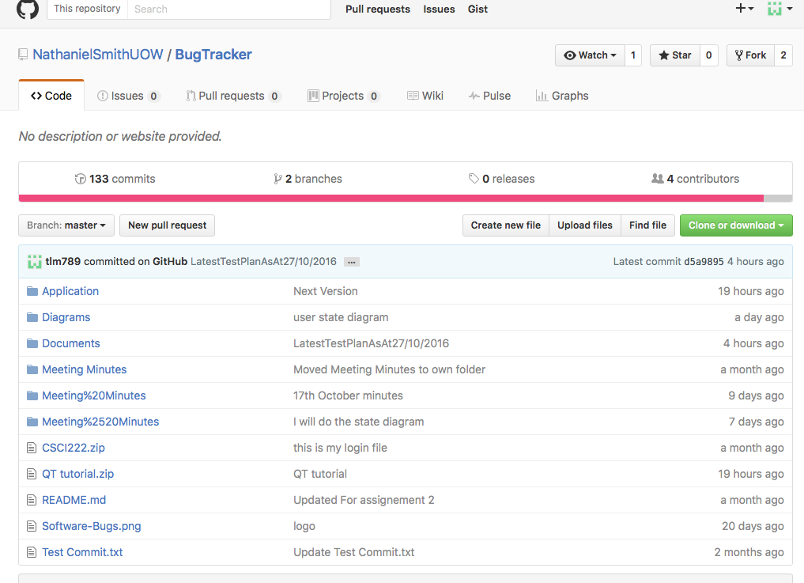

**Last few days commits**

