**Moodboard**

**Color Palette**

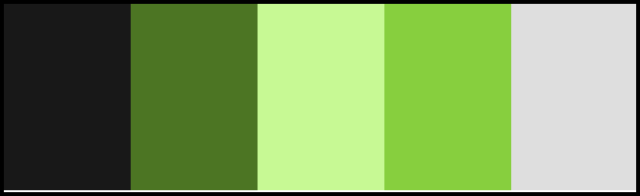

* Black represents strength, discipline, and seriousness.
* Dark green represents stability, reliability, and deep focus.
* Light green represents renewal, progress, and balance.
* Bright green represents motivation, success, and energy.
* Gray represents neutrality, calmness, and minimalism.

**Typography**

* Headings & Titles: Use bold sans-serif fonts like Montserrat or Poppins for clarity.
* Body Text: Choose simple fonts like Open Sans or Roboto for easy reading.
* Emphasis: Use bold for important updates (for example "You have completed 75% of your goal!") and light for details (for example "Your next step is to create a plan.").

**Iconography**

* Action Icons:
  + Checkmark Icon ✅: Icon for completed tasks. This icon can appear next to completed goals or tasks.
  + Plus Sign Icon ➕: Icon for adding new goals or tasks. A rounded, friendly plus sign can convey approachability, encouraging users to expand their goals.
  + Edit Icon ✏️ or⚙️: A pencil or gear symbol indicating the ability to modify existing goals. Using the pencil or gear is intuitive and consistent with other edit icons so helps with recognition.
* Progress Icons:
  + Progress Indicator: A visually appealing circular graphic that fills in as the user progresses toward their goal. Use color variations to indicate different completion levels (like red for 25%, yellow for 50%, orange for 75% and green for 100%).
  + Milestone Icons ⭐🏆: Use icons like stars, trophies, or flags to represent achievements. These can be awarded when users hit specific targets (completing a certain number of tasks or have a streak of 1 month) and can serve as visual motivation.
* Motivational Icons:
  + Encouragement Icons 😊👍👏: Use icons like a happy face, thumbs up, or applause to celebrate user achievements. These accompany notifications or messages, reinforcing positive behavior.
  + Calendar Icon 📅: Represents deadlines or important dates. A simple calendar graphic can help users visualize their timeline and upcoming tasks.
* Categorization Icons
  + Different icons for various goal categories (like fitness, financial, hobby) can help users quickly identify and differentiate their goals. Use symbols that represent each category (a dumbbell for fitness, a dollar sign for financial).

**Imagery**

* Motivational Elements:
  + Achievement Badges: Simple, visually appealing badges that users can earn for milestones. Badges can have vibrant colors and friendly shapes to create a sense of accomplishment. Example: "7-Day Streak" or "Goal 50% Completed."
  + Encouraging Pop-Ups: Use engaging visual designs for notifications. For example, a small, friendly graphic alongside a positive message can make the user feel supported (for example "You're making great progress!").
* User Experience Enhancements:
  + Visual Progress Updates: Integrate images that reflect user achievements, such as progress snapshots or celebratory graphics when a user completes a goal. Examples: confetti animations, cheerful images or snapshots of their progress.
  + Inspirational Quotes: Visually appealing typography for quotes about motivation or success in the app’s design. This can enhance the overall atmosphere and encourage users.