1. Windows 10
2. **Steps to Install Visual Studio Code on Windows10**

**1:** Visit the [**Official Website**](https://code.visualstudio.com/docs/?dv=win) of the **Visual Studio Code** using any web browser like [Google Chrome](https://www.geeksforgeeks.org/how-to-browse-in-google-chrome-browser/).

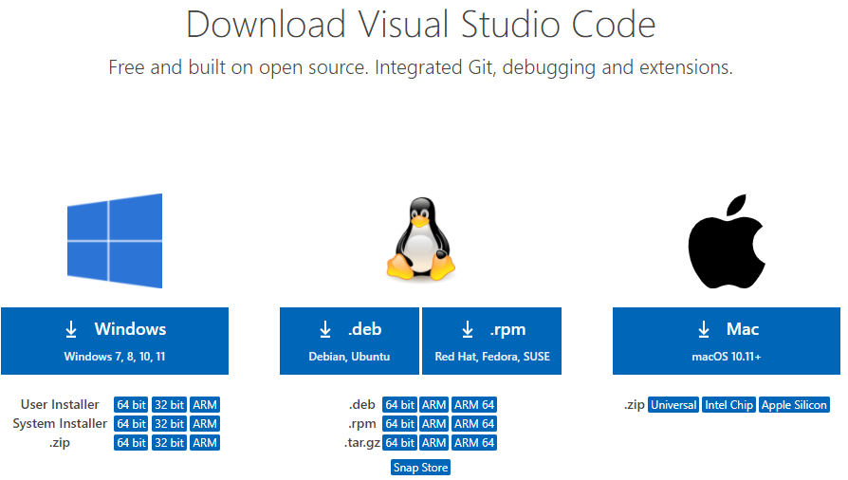

**2:** Press the “**Download for Windows**” button on the website to start the download of the Visual Studio Code Application.

**3:** When the download finishes, then the **Visual Studio Code Icon** appears in the downloads folder.

**4:** Click on the **Installer** icon to start the installation process of the Visual Studio Code.

**5:** After the Installer opens, Click on **I accept the agreement**and then clickthe **Next**button.

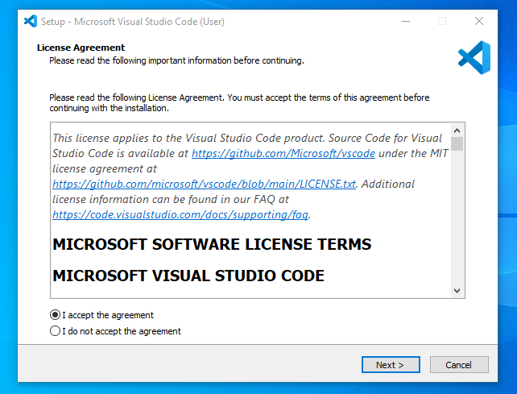

**6:** Choose the location data for running the Visual Studio Code. It will then ask you to browse the location. Then click on the **Next** button.

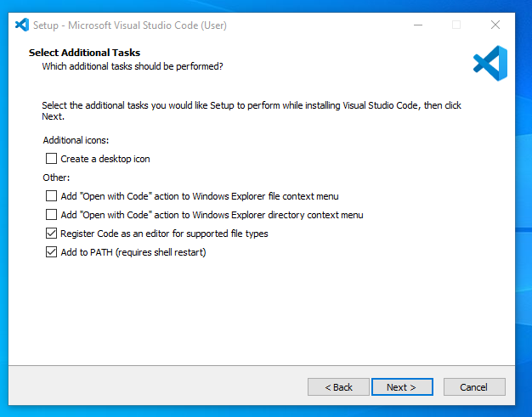

**7:** Then it will ask to begin the installation setup. Click on the**Install** button.

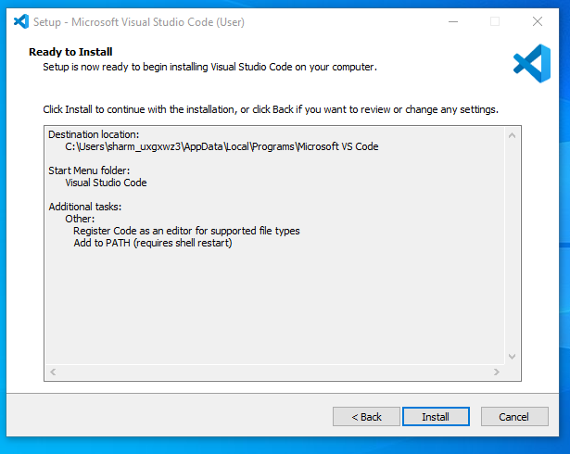

**8:** After clicking on Install, it will take about 1 minute to install the Visual Studio Code on your device.

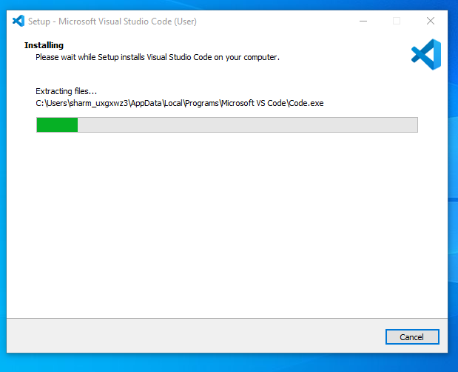

**9:**After the Installation setup for Visual Studio Code is finished, it will show a window like this below. Tick the “**Launch Visual Studio Code**” checkbox and then click **Next**.

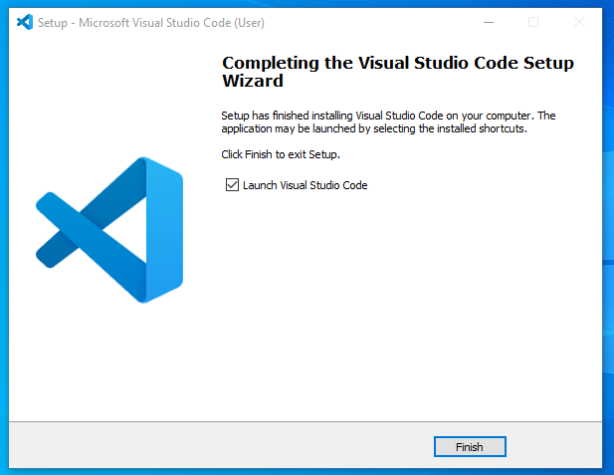

**10:** The **Visual Studio Code window** opens successfully. Now you can create a new and choose a language of your choice to begin your programming journey.

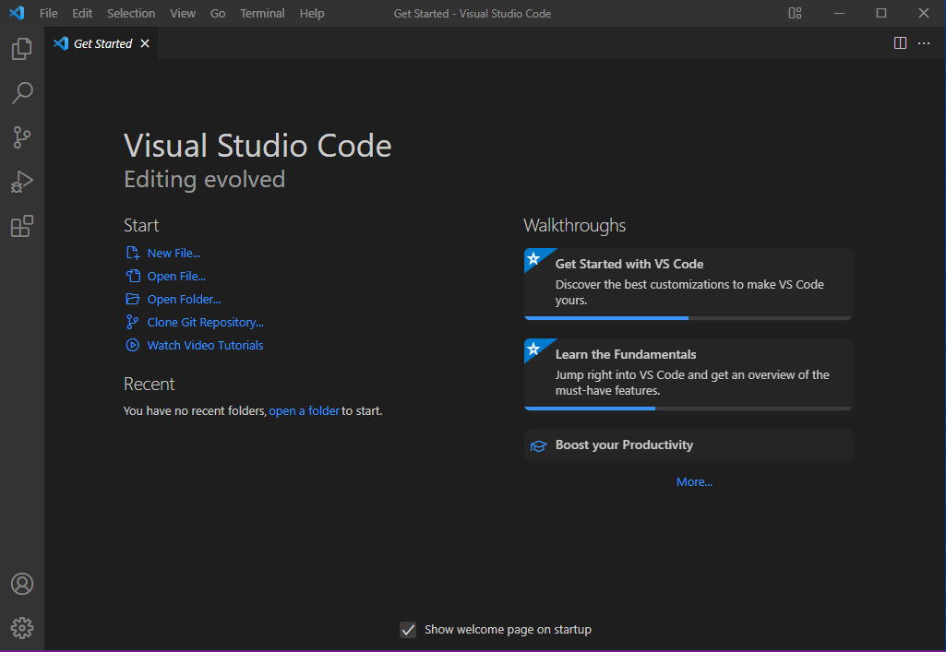

1. **Git installation steps on windows environment**
2. Download the Git installer from [git-scm.com](https://git-scm.com/download/win) , choose the 64/32 bit version and run the installer.

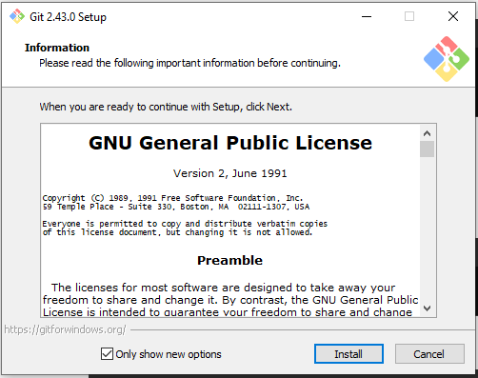

1. Select destination and location and Review the [GNU General Public License](https://phoenixnap.com/glossary/gnu-general-public-license), and when you are ready to install, click Next.

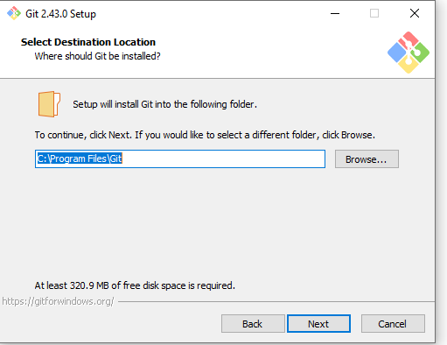

1. Select components which should be installed, and click **Next**.

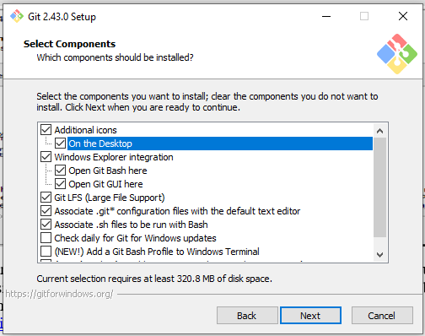

1. Click on install to install into the system.

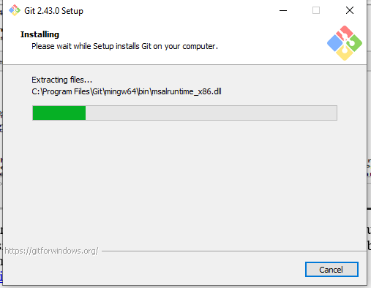

1. Then finish installation and the next step is to configure.

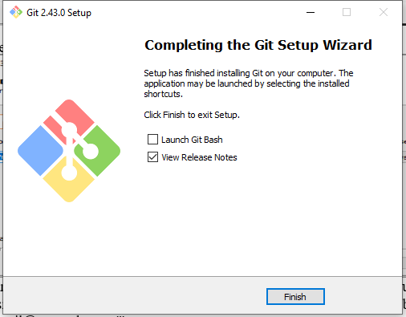

1. Configure Git, open your terminal or command prompt and set your Git username and email using **git config --global user.name "Your Name"**, and **git config --global user.email "your-email@example.com"'.**
2. Go to [GitHub](https://github.com) and create account if you don’t have one.
3. Check for git version **git –version**
4. Create a new directory and initialize it as a Git repository by, Opening Git Bash interface and use the syntax **mkdir [directory_name]** to create a new test directory (folder).
5. Change your location to the newly created directory with the cd command **cd [directory_name].**
6. Initialize the directory as Git repository by running, **git init.**
7. Open Git Bash and create a new file with the [touch command](https://phoenixnap.com/kb/touch-command-in-linux) **touch File_name.**
8. Add your new file to the tracking index **git add File_name** and **r**un **git status** command to make sure the file has been added.
9. Commit the changes using the syntax **git commit -m "[commit_message]".**
10. Finally, push the changes to the remote GitHub repository **git push [remote_repository]**
11. My initialized github repository <https://github.com/Nathankomen/demo.git>
12. **Installing Necessary Programming Languages and Runtimes.**

Step 1. **Download Python Installer** Click on the "Download Python" button

Step 2. **Run the Installer**: Locate the downloaded file **(e.g., python-3.x.x.exe)** and double-click to run it.

Step 3. **Install Python**: On the first screen, check the box that says "Add Python 3.x to PATH" and Click "Install Now".

Step 4. **Verify Installation**: Open Command Prompt, Type **python --version** and press Enter. You should see the installed Python version.

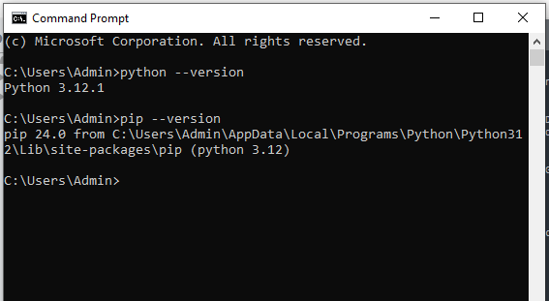

1. **Installing Package Managers(pip)**

Step 1. **Download get-pip.py**, Visit <https://bootstrap.pypa.io/get-pip.py> and save the file as get-pip.py.

Step 2. **Run get-pip.py** on cmd

Step 3. To check if pip is installed, open your command line interface (CLI) and run the command **pip --version**

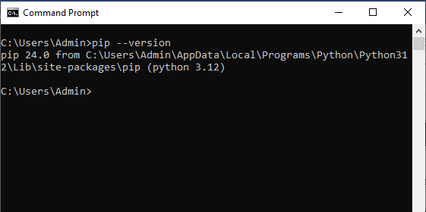

1. **Downloading and installing MySQL database.**

Step 1: Download MySQL Installer

Go to the [MySQL downloads page](https://dev.mysql.com/downloads/installer/). <https://dev.mysql.com/downloads/installer/>

Choose the appropriate version for your system and download the MySQL Installer.

Step 2: Open the .msi file that was downloaded

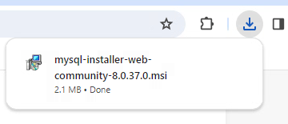

Step 2: Run the Installer

Locate the downloaded file and run the MySQL Installer.

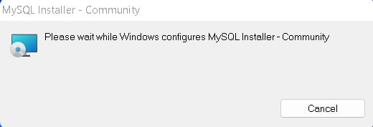  
Step 3: Choosing a setup type

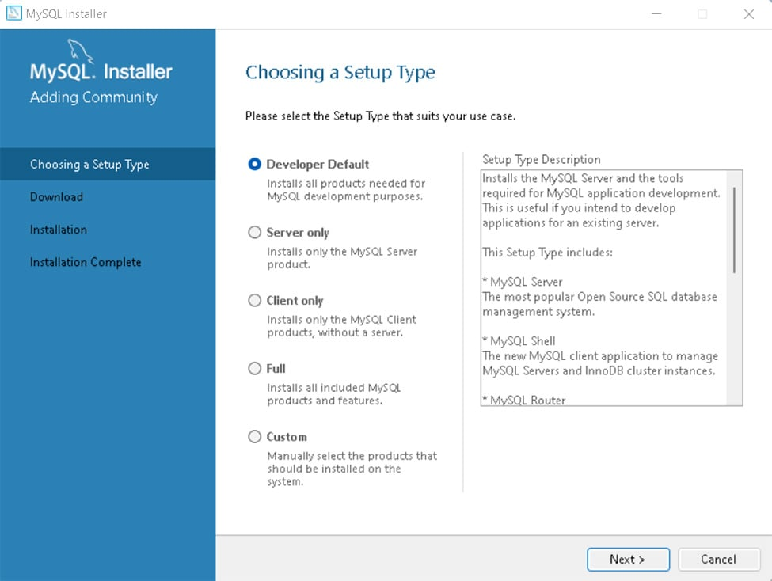  
After you choose the setup option, click Next.

Step 4: Installing the softwares

Install some required software

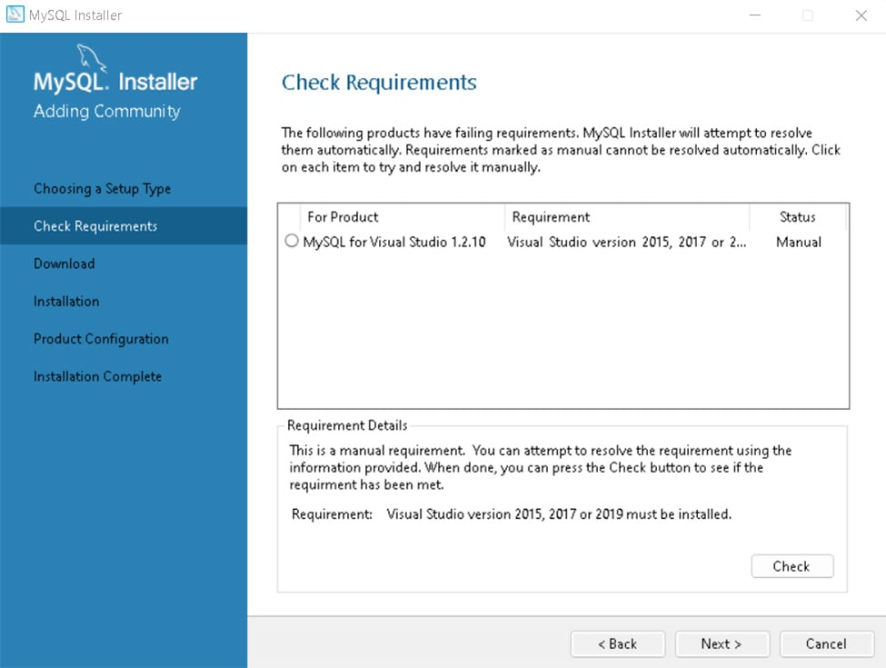

Step 6: Downloading the files

### https://www.dataquest.io/wp-content/uploads/2022/06/image4.jpg Click on Execute and the download will start, it might take a few minutes to be concluded, you'll see all the tick marks to show download complete:

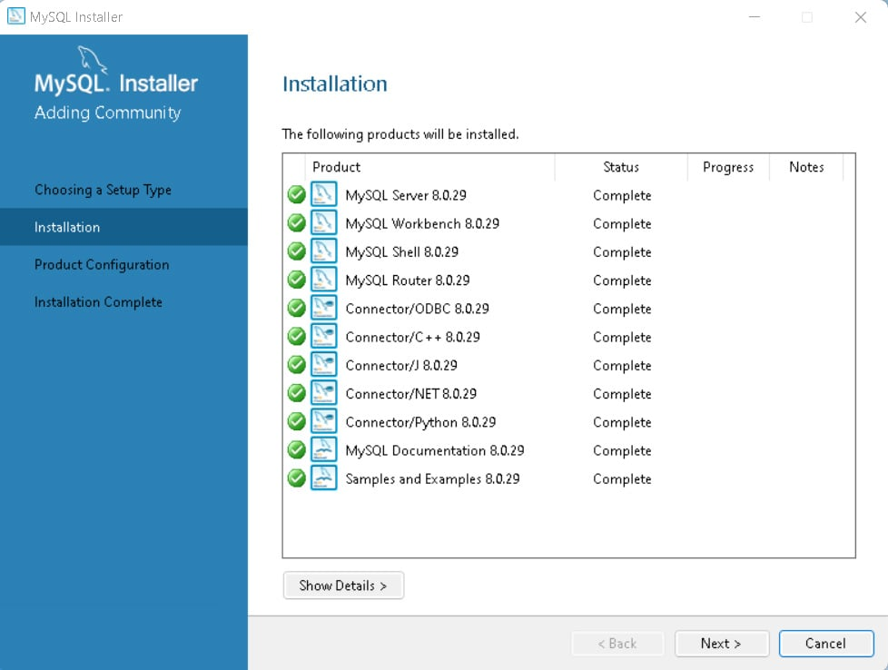

Step 7: Configuration

The next step is to configure the server. You'll see the following screen. Click Next.

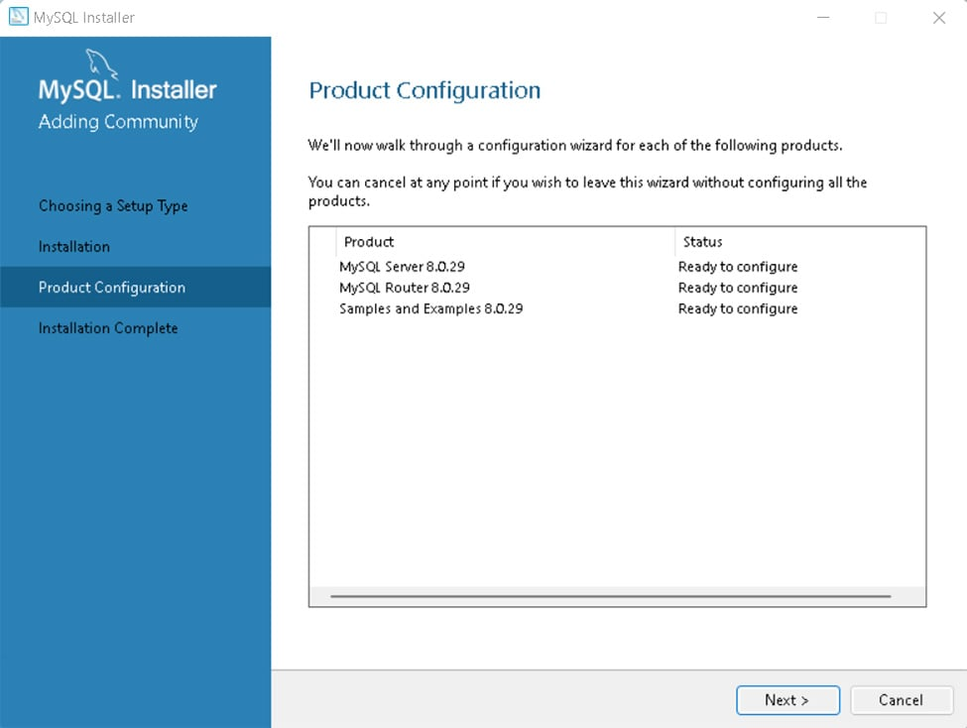  
First, the installer will ask you to configure the network:

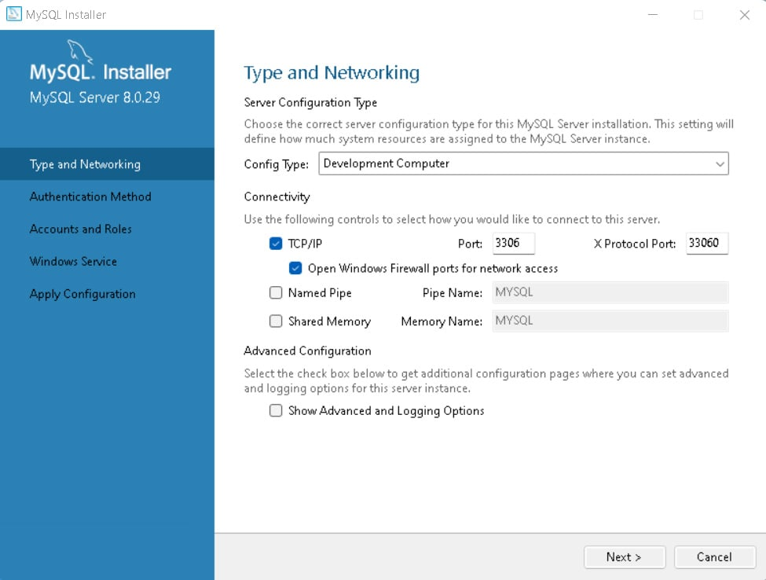  
Choose the port, but the default will work just fine. Click Next.

For the authentication method, choose the recommended option and Click Next:

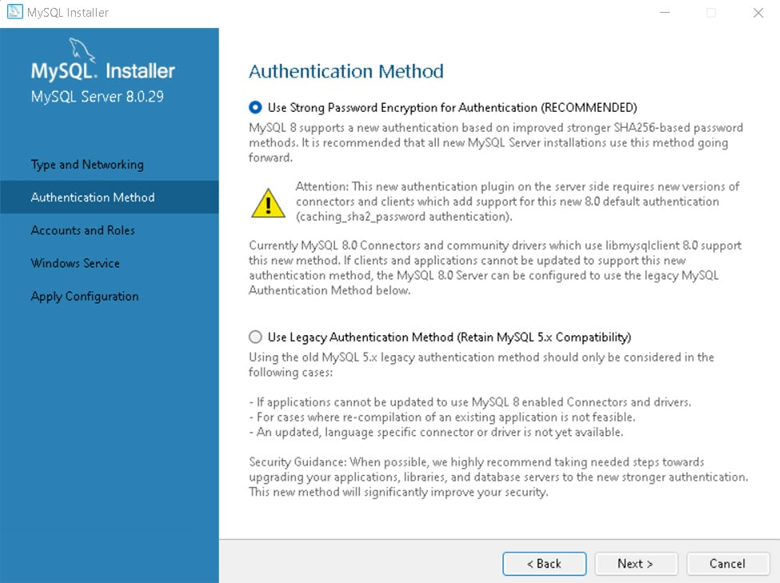  
Create the root account, set a password. Click Add User and fill in the blanks. Then, Click Next.

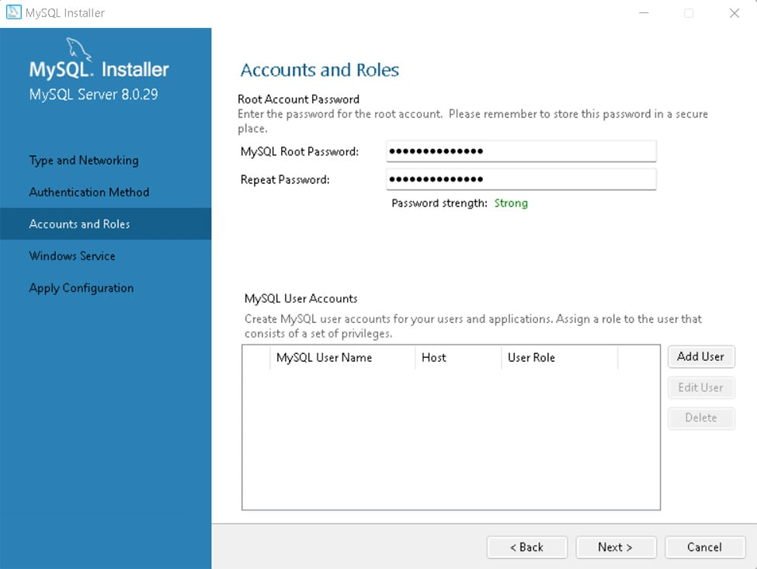  
Choose the Windows service details, such as the service name, account type, and if you want to start MySQL when you turn on your computer. 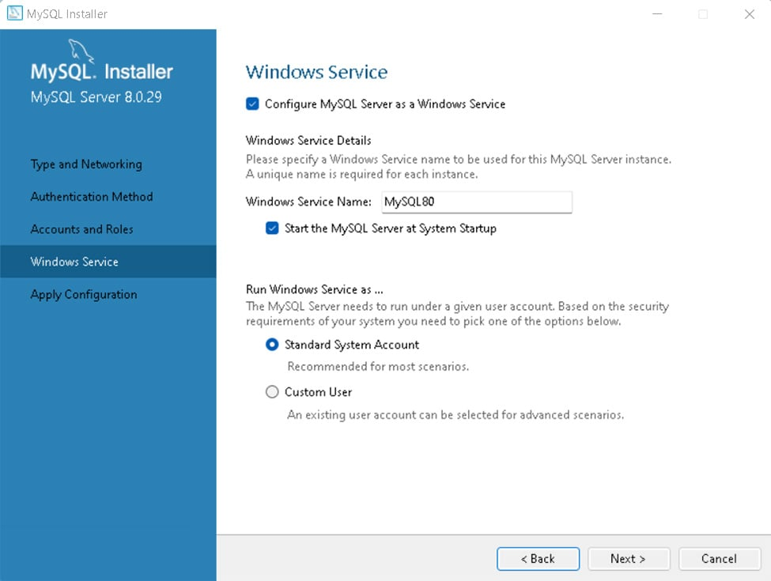  
The next screen applies the configuration. Execute it. This step also takes a while to be concluded.

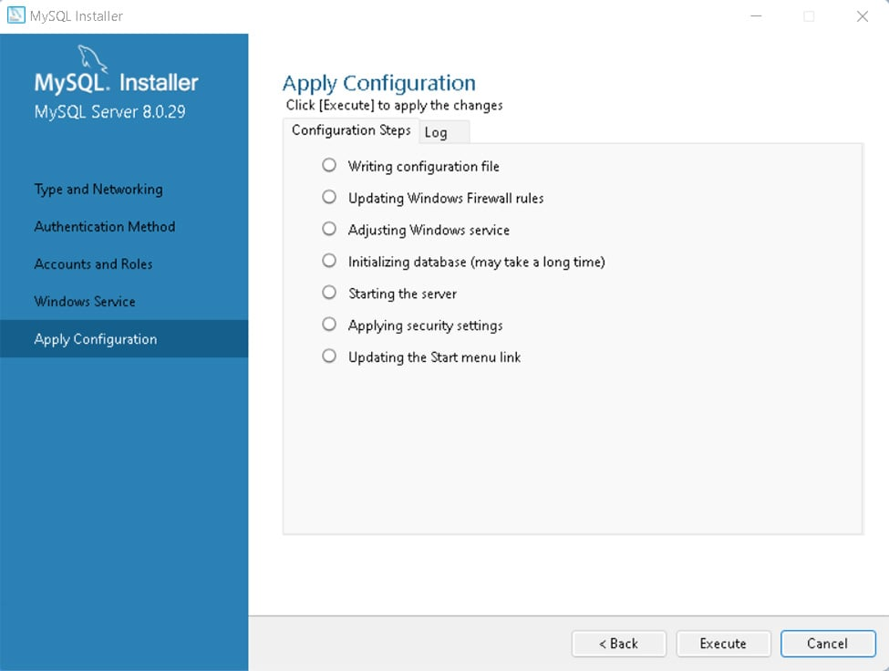  
After it ends, just finish the process.

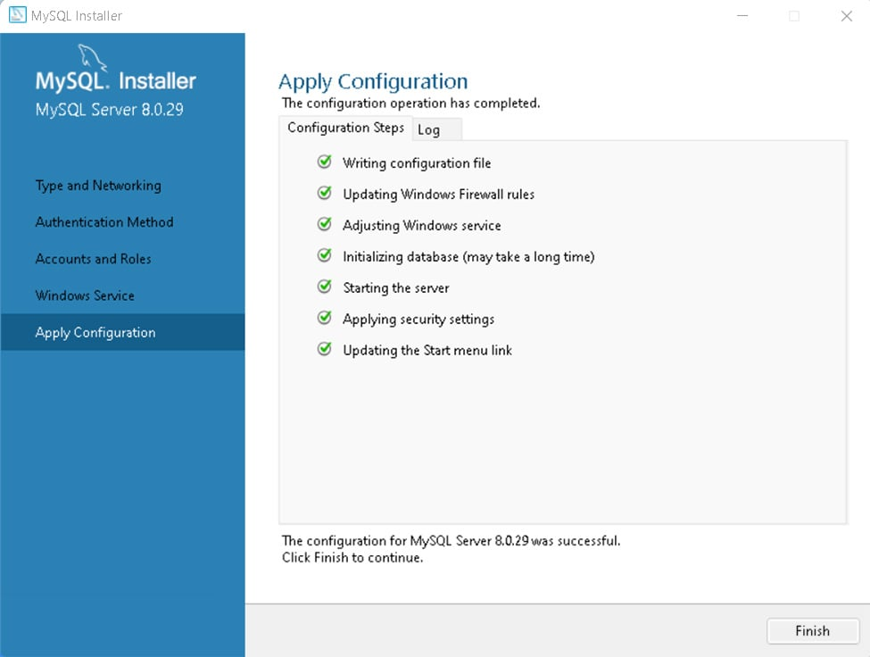

Step 8: Set up account to connect to the server

The next step is to connect to the server. Type the root account's password and click **Check**:

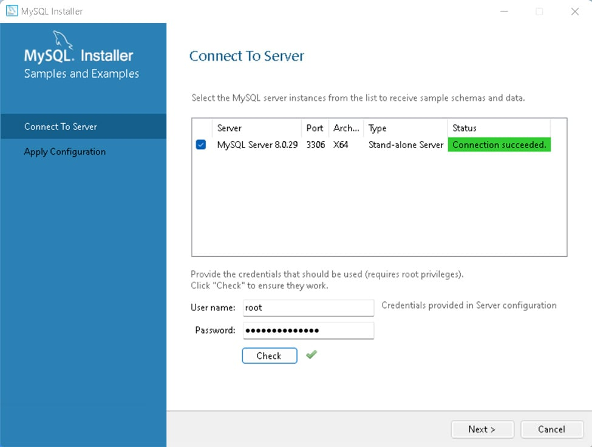  
Step 8: Apply the configuration. Just execute it and click Finish

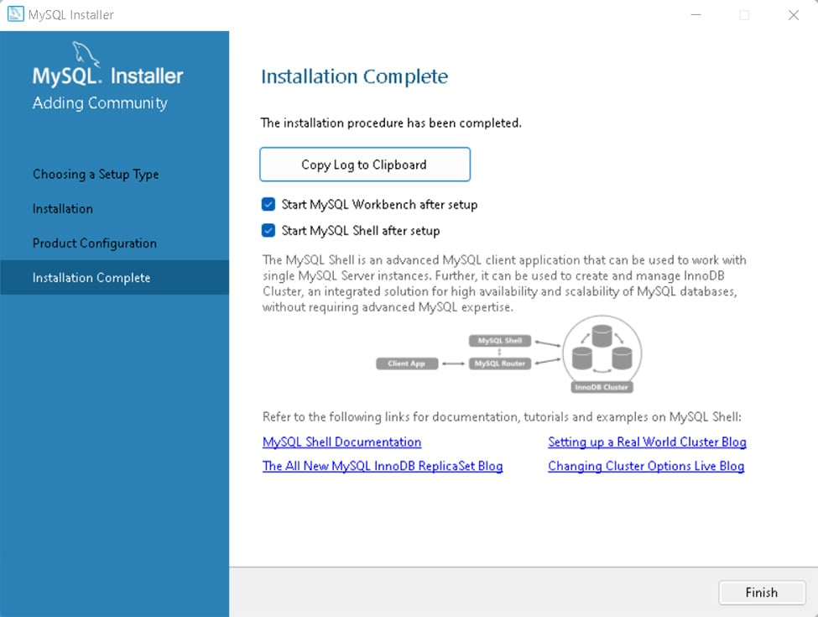

1. **Explore Extensions and Plugins**

Syntax Highlighting:

Python - Provides syntax highlighting, IntelliSense, and more for Python.

[JavaScript (ES6) code snippets](https://marketplace.visualstudio.com/items?itemName=xabikos.JavaScriptSnippets) - Snippets for JavaScript in ES6 syntax.

[HTML Snippets](https://marketplace.visualstudio.com/items?itemName=abusaidm.html-snippets) - Code snippets for HTML.

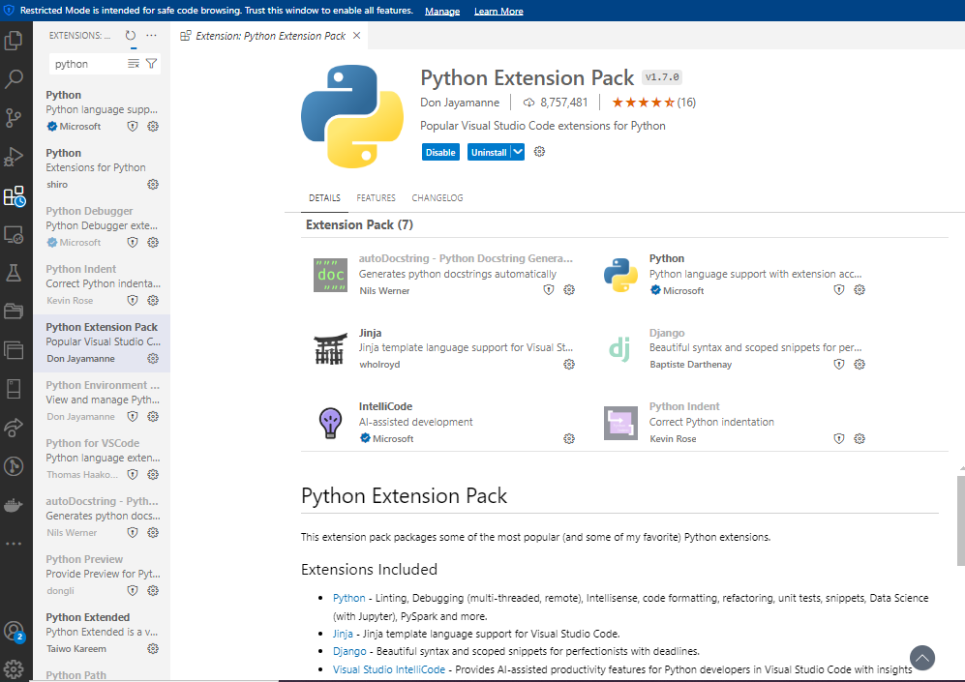

Linting:

[ESLint](https://marketplace.visualstudio.com/items?itemName=dbaeumer.vscode-eslint) - Integrates ESLint into VS Code for JavaScript linting.

[Pylint](https://marketplace.visualstudio.com/items?itemName=ms-python.python) - Integrates Pylint for Python linting.

Code Formatting:

[Prettier - Code Formatter](https://marketplace.visualstudio.com/items?itemName=esbenp.prettier-vscode) - A code formatter for various languages.

Beautify - Another popular code formatter.

Version Control Integration:

[GitLens](https://marketplace.visualstudio.com/items?itemName=eamodio.gitlens) - Supercharges the built-in Git capabilities in VS Code.

[Git History](https://marketplace.visualstudio.com/items?itemName=donjayamanne.githistory) - Provides Git history, search, and visualization.

Additional Functionalities:

[Live Server](https://marketplace.visualstudio.com/items?itemName=ritwickdey.LiveServer) - Launch a local development server with live reload feature.

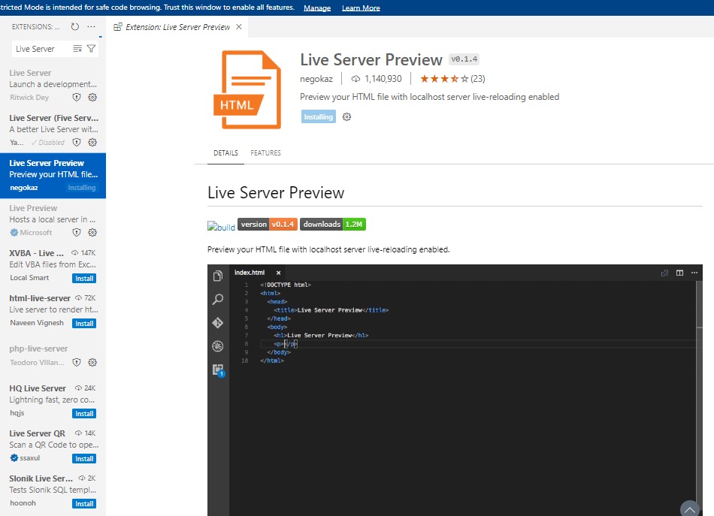

[Docker](https://marketplace.visualstudio.com/items?itemName=ms-azuretools.vscode-docker) - Makes it easy to manage Docker containers and images

1. **A reflection on the challenges faced during setup**

Managing conflicts between different extensions or plugins that offer overlapping functionalities.

Installing too many extensions that could slow down the text editor or IDE.

Ensuring that the version of MySQL being installed is compatible with the operating system.

**Solutions**

Starting with essential extensions and gradually adding more as needed to avoid performance degradation.

Checking for compatibility and installing dependencies