Hi guys,

I found two available code online for our EC project. Both of them use Deep Q Network to train the model and the both of them use the screen model

In order to get both of them running, I installed TensorFlow and Keras as follow(I spend several hours on the set up, since there are always some errors when using different version of TensorFlow and Keras when I run the program).

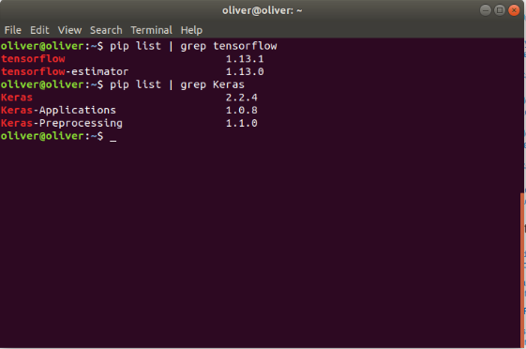

This is a way to fix a potential TensorFlow module error:
AttributeError: module 'tensorflow' has no attribute 'get_default_graph'

http://danlec.com/st4k#questions/55236063

There are maybe some other errors if you are not using the correct version of TensorFlow and Keras for the code

Where I found the code:

1. The first one:
github:
https://github.com/ms0448711/DQN-Breakout

The “105502040_code.py” file is the main code, for this one, you only need to run this file.
But the problem for this code is that when the generation is at around 85-88. The program just pauses and at some point it just stops forever according to my observation.

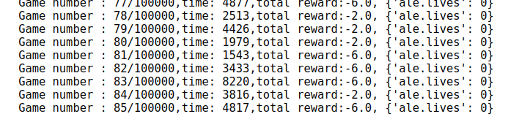

2. The second one I found was in a blog of a Chinese guy.
Here is the link:
https://blog.csdn.net/superCally/article/details/54784103

There are some basic description like DQN algorithm description written in English.
For this one, you also need to install cv2 in python if there is no cv2 in your python.
The command is “pip install opencv-python”

The code is in the file “EC_project_v2.py” as I attached.
To run this code, you have to type “sudo python3 EC_project_v2.py” in your terminal(I think Windows or Mac have the corresponding command )

This code runs quite good but it also takes a long time, the overall generation is 100000, right now is at around 600 generation after I first run it.

My questions is that do we stick to the SGA version by Magnus or do we use the DQN method by others and then make some modifications and changes. I do not understand too much about DQN and how it works now, I only get the code running. But if we decide to use DQN, I think we can study and discuss about it.

11.4
Oliver

