Azure Data Pipeline Project Submission
- Set up an Azure Storage account and upload the student.csv file. (Screenshots of each major step (Azure portal setups, Storage account/Container creation, File Upload results, etc.): Points: 2
- Set up an Azure SQL Database and create the Students table.(Screenshots of each major step (SQL Server setups, SQL Database creation, Firewall rules, Table creation, etc.): Points: 2
- Build a Data Pipeline in Azure Data Factory (Provide screenshots of each major steps): Points: 2
Photos of key Steps for 1-3 (labeled based on actual step in guide):
1.1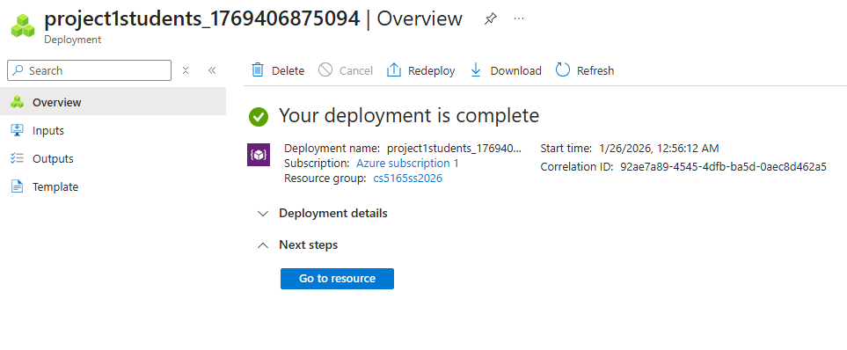
---

1.2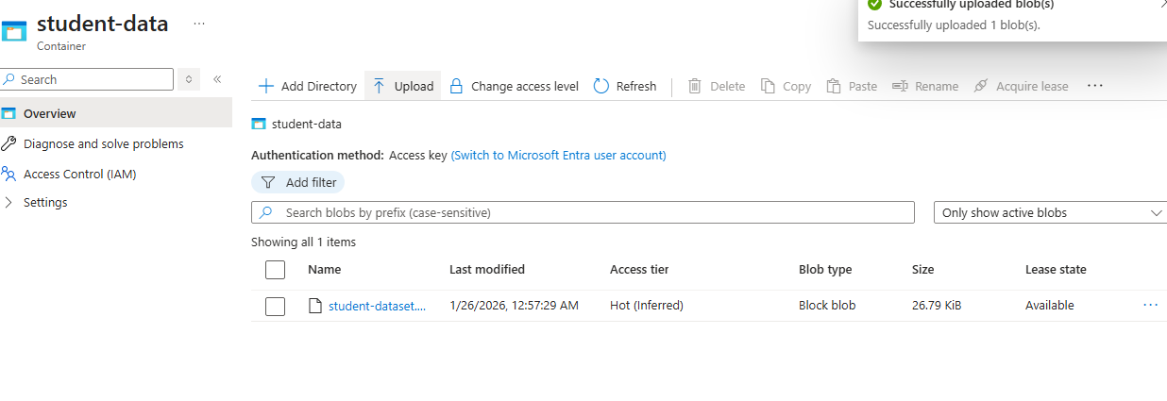
----
2.2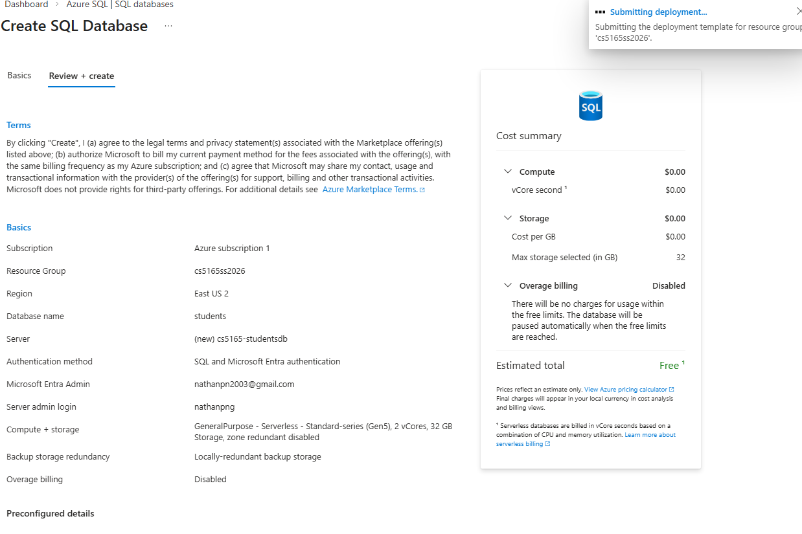
----

2.3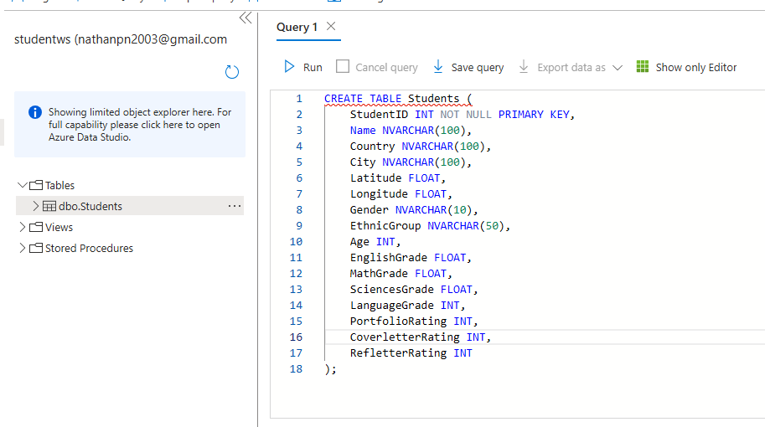----
3.1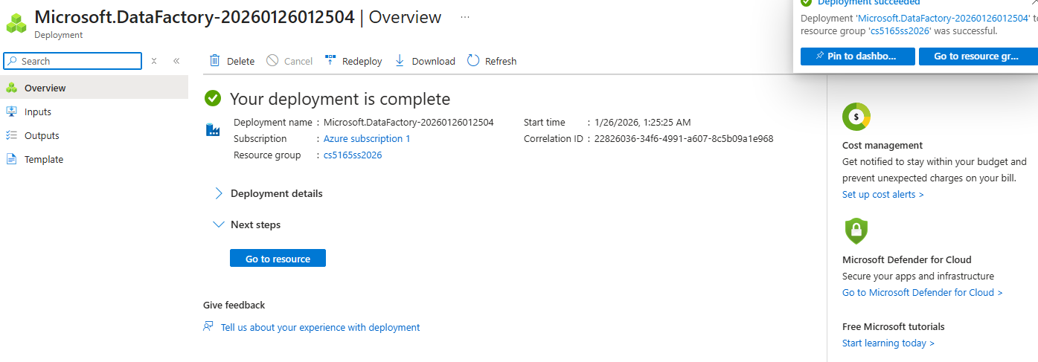
-----

4.2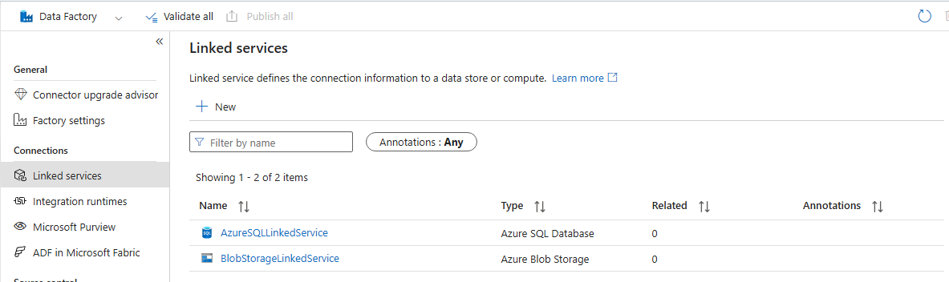
-----

5.1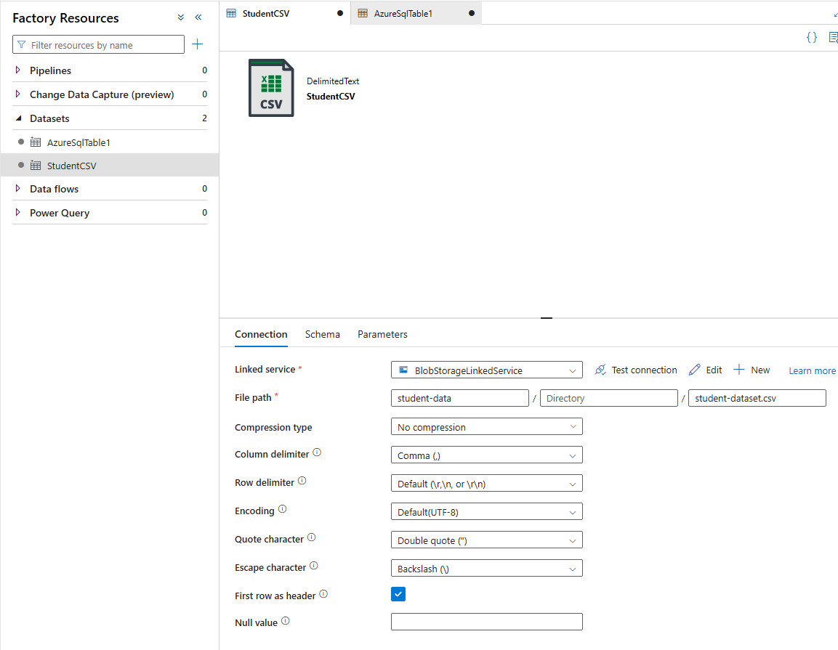
----
5.2
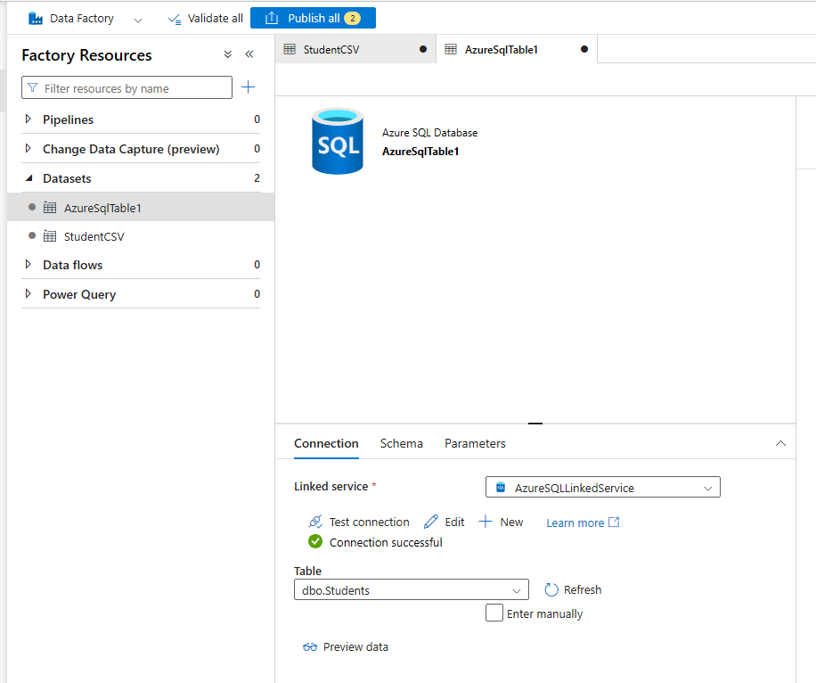
----
6.4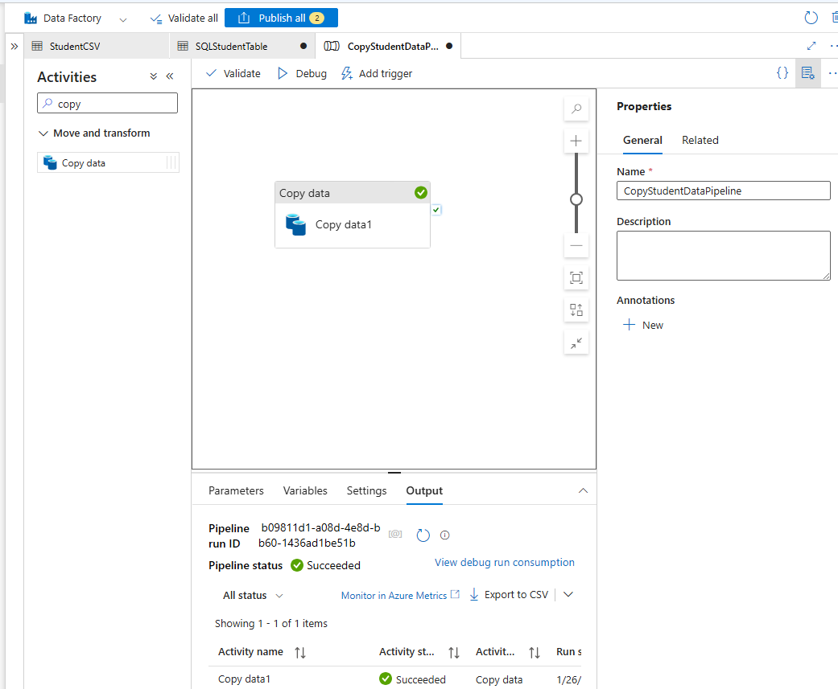
----
6.5
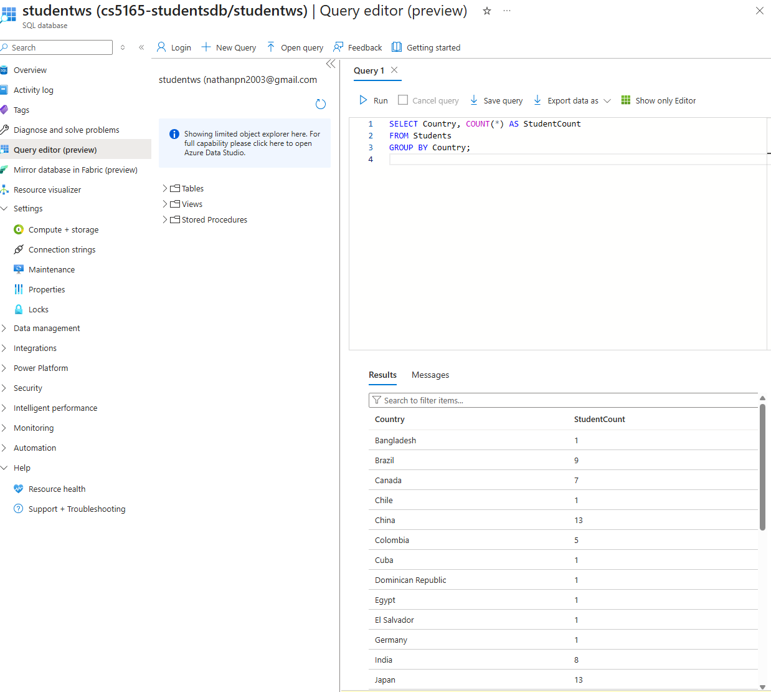
- Provide the Connection information in a text format for me to remotely connect to your Azure database from SQL Server Management Studio (SSMS) in my machine and run the Query: Points: 2
  - Authentication: SQL Server Authentication
  - Server name: cs5165-studentsdb.database.windows.net
  - Database name: studentws
  - Login: nathanpng
  - Password: January2026
  - Ensure the firewall settings and credentials are correct.
    - Firewall settings:
- Public network access enabled
- Allow Azure services and resources to access this server
- External firewall rules configured for SSMS access\
- High-level pricing estimate for the Azure Services used in the project per month: Point: 1
  - *** Cost needs to be broken down by Azure Services, with a short explanation on how you are projecting the final cost
Azure Services used & Estimated Cost:
  - Azure SQL Database
The project uses an Azure SQL Database deployed on the Free or Basic DTU-based tier, which is suitable for small datasets and low query volume. Since the database stores a single table populated from a CSV file and is accessed infrequently for testing and demonstration, the estimated cost is $0–$5 per month.
  - Azure Data Factory
Azure Data Factory is used to run a single pipeline containing a Copy Data activity to ingest the CSV file from Azure Blob Storage into Azure SQL Database. Costs are based on the number of pipeline and activity runs. Because the pipeline was executed only a small number of times during development and testing, the estimated monthly cost is less than $2.
  - Azure Blob Storage
Azure Blob Storage (Locally Redundant Storage) is used to store a single CSV file containing student data. The file size is very small, resulting in negligible storage and transaction costs. The estimated monthly cost is less than $1.
  - Azure Functions (Extra Credit)
An Azure Function running on the Consumption plan is used to query the Azure SQL Database and expose the results as a REST API. Since the function is invoked only a limited number of times and remains well within the free execution grant, the estimated cost is $0 per month.
  - Azure Static Web Apps (Extra Credit)
The frontend is hosted using Azure Static Web Apps on the Free tier. This tier supports static content hosting at no cost for small projects. The estimated monthly cost is $0.
  - Estimated Total Monthly Cost
The overall estimated cost of the project is approximately $0–$8 per month, depending on database tier usage and pipeline executions.

- Provide a short explanation of your project, including objectives, tools used, implementation steps, and "Student Count by Country" results: Points: 1
  - The objective of this project was to design and implement an end-to-end data pipeline using Microsoft Azure that ingests student data from a CSV file, stores it in a relational database, and enables analysis through both SQL queries and a web interface.
The project utilizes several Azure services. Azure Blob Storage is used to store the source CSV file containing student information. Azure Data Factory is responsible for orchestrating the data movement by copying the data from Blob Storage into an Azure SQL Database. The student data is stored in a Students table, which allows structured querying and aggregation.
After the data was loaded, a SQL query was executed to calculate the number of students grouped by country. For the extra credit component, an Azure Function was implemented to query the database and expose the results as a REST API. An Azure Static Web App consumes this API and dynamically displays the results in a web-based table.
The final “Student Count by Country” results show that the United States of America has the highest number of students (193), followed by Mexico (24), China (13), and Japan (13), with several other countries represented by smaller counts. This confirms that the data pipeline successfully ingested, stored, and processed the dataset end-to-end.
  - Student Count by Country Results:
United States of America: 193
Mexico: 24
China: 13
Japan: 13
Brazil: 9
India: 8
Canada: 7
Russian Federation: 6
Colombia: 5
Pakistan: 3
Korea (Republic of): 3
Turkey: 2
Spain: 2
United Kingdom: 2
Thailand: 1
Tunisia: 1
Ukraine: 1
Peru: 1
Philippines: 1
Poland: 1
Morocco: 1
Myanmar: 1
Netherlands: 1
Nicaragua: 1
Cuba: 1
Dominican Republic: 1
Egypt: 1
El Salvador: 1
Germany: 1
Chile: 1
Bangladesh: 1
- Extra Credit: (Points: 1) Some students have expressed interest in exploring cutting-edge cloud technologies, and Azure Functions is one of them. This serverless solution is widely used in the industry for building event-driven applications with minimal code and infrastructure, making it ideal for web APIs, data processing, and IoT integration. This extra credit assignment will guide you through creating a simple web app to visualize student data by country.
  - Provide the URL to the Static Web App, ensure it is accessible, and confirm that it correctly fetches and displays the "Student Count by Country": Points: 1
    - https://proud-pond-03afc530f.1.azurestaticapps.net/
NOTE: It might take 60-90 seconds before the table populates, seems like one of my runners sometimes drains randomly, not sure why
