AWS Project Submission
- Launch an EC2 instance (any platform accepted, but it should be accessible through the internet). (Points: 1)
  - (Screenshots of each major step: AWS portal setups, EC2 creation, Amazon Machine Image (AMI), key pair (login), network settings, etc.)
- Configure a web server and SQLite3 database table (any variation, but help is available for limited variations). (Points: 1)
  - (Screenshots of Flask application setup in the EC2 instance, installation of mod_wsgi for Apache, installation of Python, Pip, and Flask, SQLite3 database table, etc.)
Photos of key Steps for 1-2:
Step 1:
Creating EC2 Instance
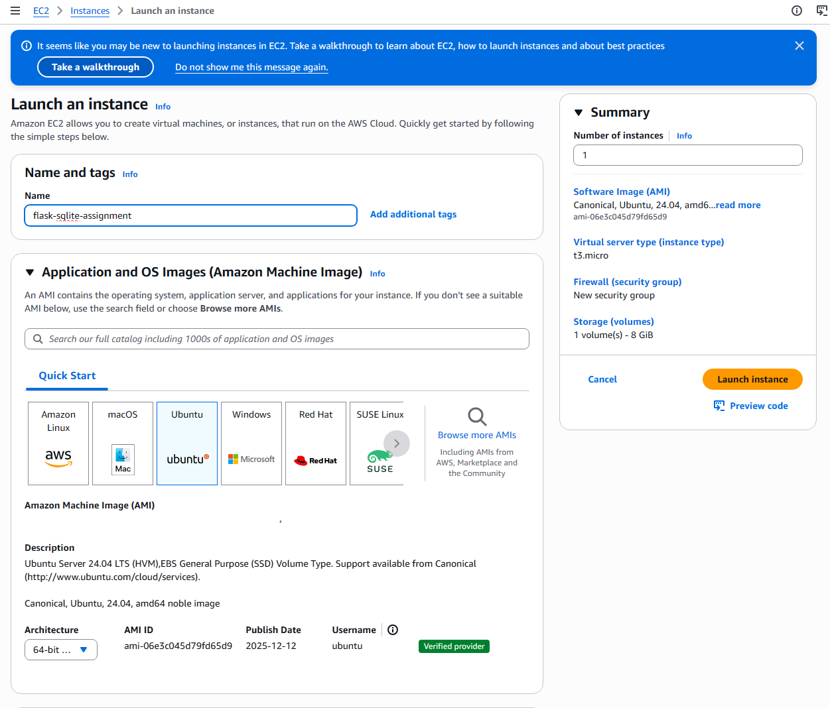

EC2 instance network settings
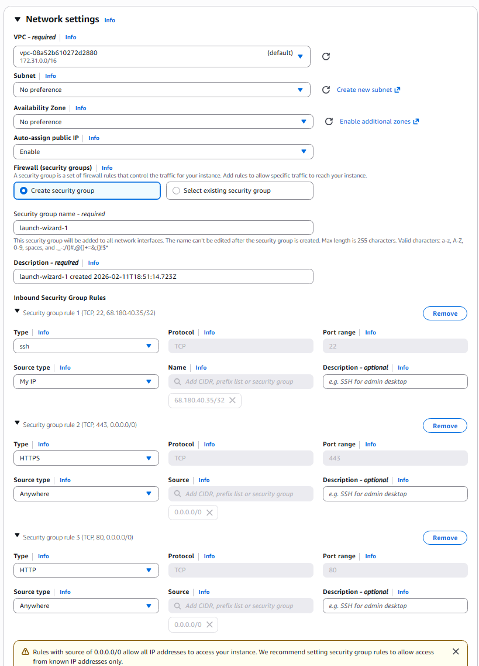

EC2 & AMI creation
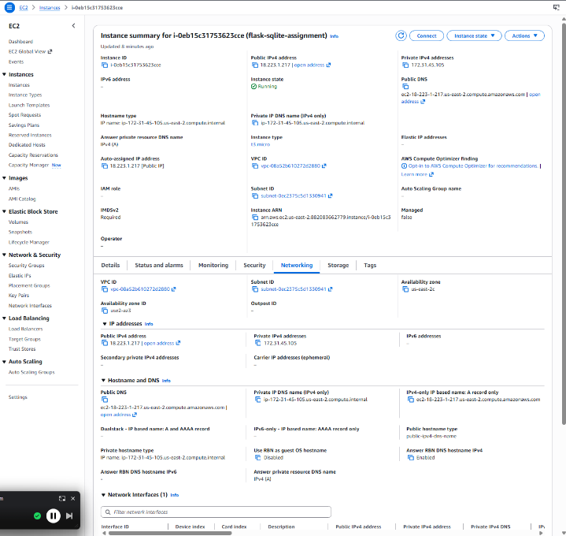
Key pair login test success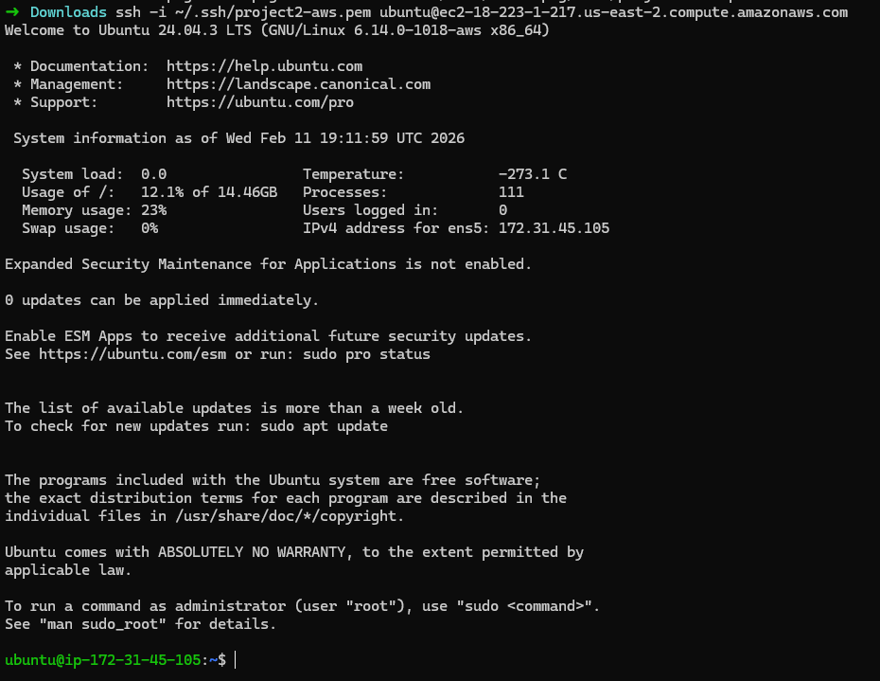
Step2:
Installation setup for EC2 instance
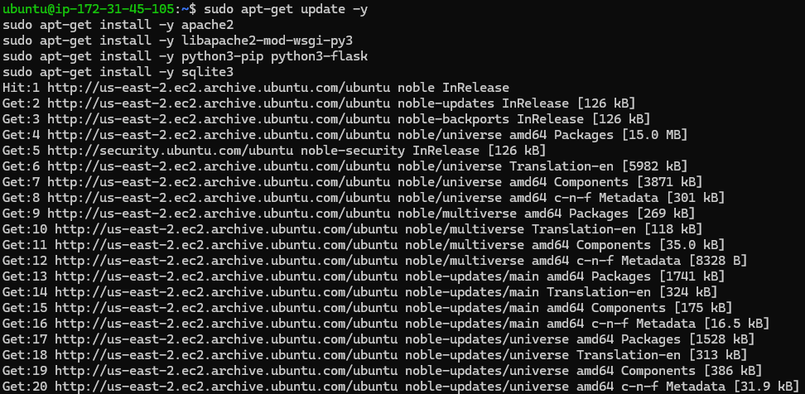
Checking if installed correctly
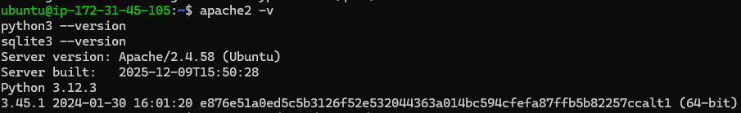
SQLLite3 database table setup + flask app
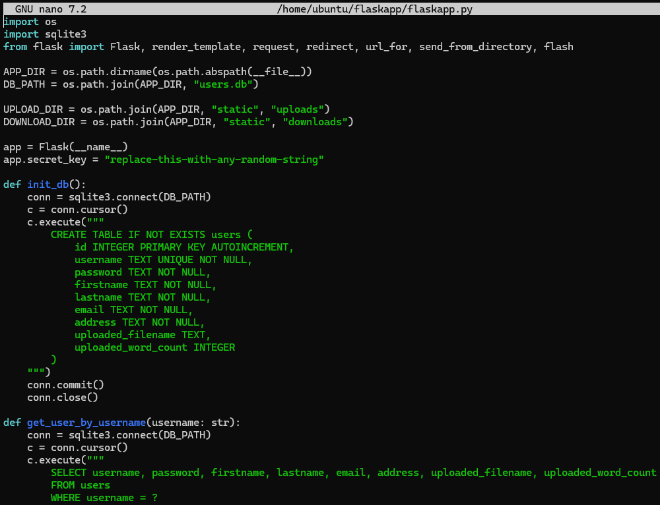
Check for table is correct
- Share the code on GitHub or as an attachment. (Example: https://github.com/UserNameLinks to an external site.) (Points: 1)
  - Link to code: https://github.com/Nathann03/CS5165-Cloud_computing/tree/main/project2/code
  - Link to AWS URL: http://ec2-18-223-1-217.us-east-2.compute.amazonaws.com/
