Biofilm vs. Planktonic Growth in S. aureus
Overview based on BaSSSh-seq single-cell RNA sequencing research

What is the difference?
Planktonic bacteria
Freely floating, individual cells in a liquid medium. They are relatively homogeneous in their gene expression and behave more or less the same way.
Biofilm
An organized, multicellular community in which bacteria attach to a surface and encase themselves in a self-produced matrix (EPS: extracellular polymeric substances). A classic example is dental plaque.

Comparison Table
Feature | Planktonic | Biofilm
Growth mode | Freely floating in liquid | Attached to surface (matrix)
Cell organization | Individual cells | Multicellular community
Transcriptional diversity | Low (homogeneous) | High (heterogeneous)
Antibiotic resistance | Relatively susceptible | Up to 1000× increased
Immune evasion | Limited | Strongly increased
Metabolism | Active & uniform | Varied per subpopulation
Stress response | Basal | Extensively activated

What do we expect to see more of in biofilm?
BaSSSh-seq reveals the following features that are unique to biofilm:
- Transcriptional heterogeneity — subpopulations each with their own gene expression profile
- Stress response genes — activated by nutrient limitation, oxygen gradients, and immune pressure
- Virulence genes — differentially regulated compared to planktonic growth
- Metabolic diversity — including persister cells (metabolically inactive, antibiotic-resistant)
- Complex transcriptional regulation — networks driving the planktonic → biofilm transition

Clinical relevance
In chronic infections (e.g. prosthetics, heart valves, lung infections in CF patients), S. aureus almost always grows as a biofilm. These biofilms are up to 1000× more resistant to antibiotics than planktonic cells. BaSSSh-seq allows this heterogeneity to be studied at single-cell resolution, potentially revealing new therapeutic targets.
Source: BaSSSh-seq study — single-cell RNA sequencing of S. aureus biofilm and planktonic growth under immune pressure.

General information
BaSSSh: Bacterial Single-cell Small-molecule Sensitive Selective Hydrolysisµ
Main question: How does individual vacteria within a bio film differ from those living a plaktonic life?

What most people think is that the bacterial colony is a group of identical clones, but by performing BaSSSh seq we prove that they are highly diverse cities with specialized roles.

Researchers of Nebraska found 3 specific links:

- The trajectory of the Growth
identification of the exact genetic pathway a bact takes as it transforms from free floating to a biofilm
- Turns off growth promoting genes > 1st question: what are the growth promoting genes
- Turns on stress respons and metabolic shift genes: > what are those?

- Hidden diversity: (see below)
You have sleepers (not detectible for antibiotics)
You have “warriors” fighting with the immune system

- Immune Pressure response;
The diff layers of the biofilm change their metabolism differently to survive specific type of immune cells

BaSSSh-seq: Step-by-Step Overview
Step A — Barcoding
The bacteria are first fixed and permeabilized (using formaldehyde + lysostaphin), so they stay intact but the cell wall is opened up to allow reagents to enter.
Then, split-pool barcoding happens in 3 rounds:
- Round I — Reverse transcription: RNA is converted to cDNA, and the first barcode is attached using random hexamers
- Round II — Ligation: a second barcode is added, cells are pooled and mixed
- Round III — Ligation: a third barcode + UMI (unique molecular identifier) + PCR handle + biotin tag are added
The result: every individual cell gets a unique combination of 3 barcodes, so you can later trace every RNA transcript back to its cell of origin.

Step B — Second Strand Synthesis
After lysis (breaking open the cells):
- Streptavidin magnetic beads grab the biotin-tagged transcripts to purify them
- A second DNA strand is synthesized using random primers, creating double-stranded cDNA
- The cDNA is then amplified by PCR

Step C — rRNA Depletion
This is a critical problem: >90% of all RNA in bacteria is ribosomal RNA (rRNA), which is not informative for gene expression analysis.
To remove it, they use dual-strand subtractive hybridization:
- Biotin-tagged oligos specifically targeting rRNA are annealed to the cDNA
- Streptavidin beads magnetically pull out all rRNA fragments
- This is done for both DNA strands
- Result: rRNA is reduced from >90% to <50%, meaning far more useful reads remain

Step D — Library Prep & Sequencing
The cleaned cDNA is prepared for Illumina sequencing through:
- Fragmentation — cutting cDNA into smaller pieces
- Ligation — adding sequencing adaptors
- Amplification — adding i5/i7 index combinations (sample identifiers) and P5/P7 ends
The final library is then run on an Illumina sequencer, and the barcodes allow you to reconstruct which transcript came from which individual cell.

Subpopulations of an S aureus Biofilm:
- The Metabolically Active (Surface Cells): These are the cells on the outer edge of the biofilm. They have high access to oxygen and nutrients, so they are actively dividing. They are the most "planktonic-like" but are also the first to be hit by the immune system.

- The Dormant/Persisters (Core Cells): Deep inside the biofilm, oxygen is scarce. These cells turn off most of their metabolic "engines." This makes them naturally resistant to antibiotics, which usually target active processes like cell wall synthesis.

- The Stress-Responders: A subpopulation that specifically activates "SOS" genes and heat-shock proteins. These cells act as a buffer, helping the community survive fluctuations in pH or temperature.

- The Virulence Specialists: Some clusters show high expression of toxins (like alpha-hemolysin). These are the "soldiers" that actively damage host tissues and fight off white blood cells.

Leiden clustering:
- Social network (graph construction)
- Looks at bacterium who will express similar genes + draw a line between them
- Community Detection
- Looks for communities in the massive network
- Optimization
- Math quality function (modularity) to ensure these groups are as distinct as possible

You only have to give your dataset, and a resolution value, which is 0.5 by default.
The lower the resolution value, the bigger the clusters you get.

Code for Leiding clustering:
- Deviding cells in clustering:
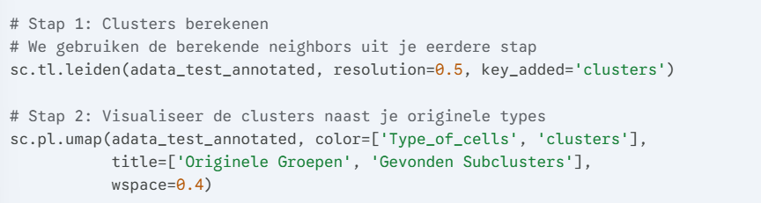
What does wspace do??

- Identifying the succlusters, (Marker genes)
You know which specific genes are in each cluster.

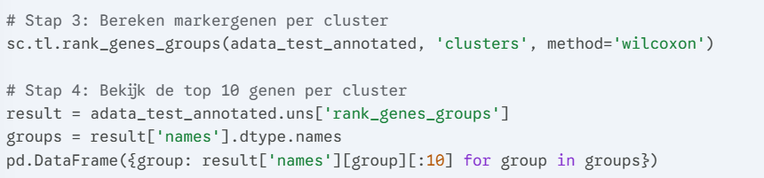

- Sub analysis: Zoomin on only the Biofilm Cells
If we only want to know the cells inside the Biofilm, we can make a subset from these without any influence of the plaktonic cells:
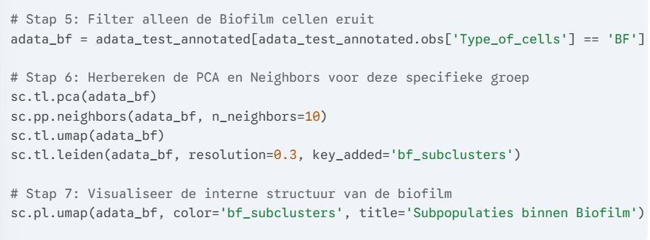

- Where do we have to pay attention to?
Further subdivision is based on
Growh velocity
Virulentie
Metabolism
Subpopulations and Marker Genes
In the biofilm condition, 7 transcriptional subpopulations were identified, each characterized by specific marker genes:

- Cluster 0 (~50% of cells) — Dormant/persister population: characterized by surface proteins (sasA, ebh) and RNA degradation (pnpA)
- Cluster 1 — Active population: TCA cycle (citB), lipoteichoic acid synthesis (ltas), iron acquisition (isdH), and elastin binding (ebpS)

- Cluster 3 — Virulence & amino acid metabolism: clumping factor (clfB), fibronectin binding (fnbB), cold-shock protein (cspB), and arginine metabolism (arcA, rocA)

- Cluster 4 — Respiration: terminal oxidase (qoxA)

- Cluster 5 — Alternative metabolism/stress: glycolytic enzymes (gpmA, fdaB), DNA repair (polX), and acid stress response (ureA)

- Cluster 6 — Nucleotide metabolism: (nrdE)
The same 7 clusters were also recovered in the integrated dataset (biofilm + planktonic)

Extra information
BaSSSh-seq moves bacterial single-cell RNA sequencing beyond proof-of-concept by applying it to a real biological problem: how S. aureus biofilms respond to immune pressure.

First, they validated the method by comparing biofilm to planktonic growth, confirming it could capture the transcriptional diversity between individual cells. Then, the key experiment: they exposed biofilms to three types of immune cells (macrophages, neutrophils, and G-MDSCs) and showed that different bacterial subpopulations each respond in their own unique way.
To make sense of the data, they used two computational tools — iModulon analysis to map entire regulatory networks, and trajectory analysis to track how bacteria shift their gene expression under immune attack.

The bottom line: BaSSSh-seq gives us an unprecedented view of how individual bacteria behave and adapt during infection, which could ultimately guide the design of new treatments against biofilm-associated infections.

