## Lab04

Nan Zhou

z5111593

Exercise 1:

Q1. IP address of gaia.cs.umass.edu is 128.119.245.12

Client IP address is 192.168.1.102

Port 80 is used to send and receiving TCP segment.

Port 1161 is used by client computer.

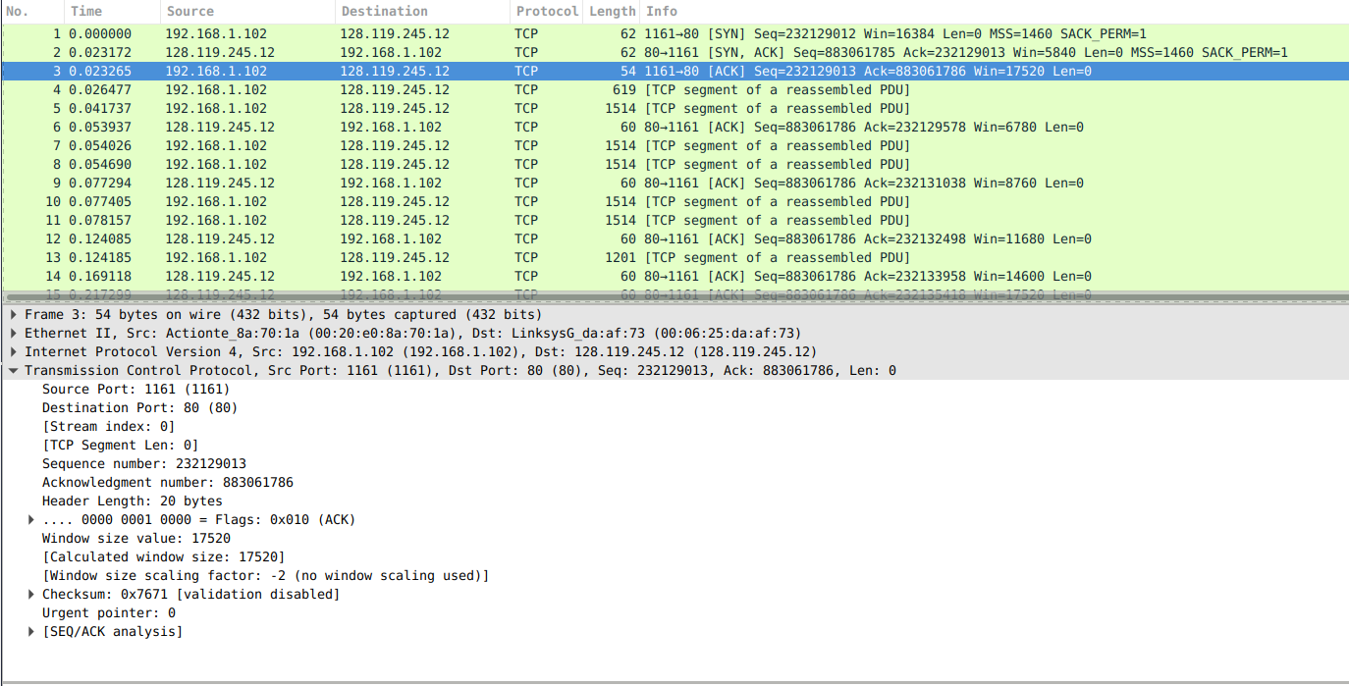

Q2. Sequence number is 232293053

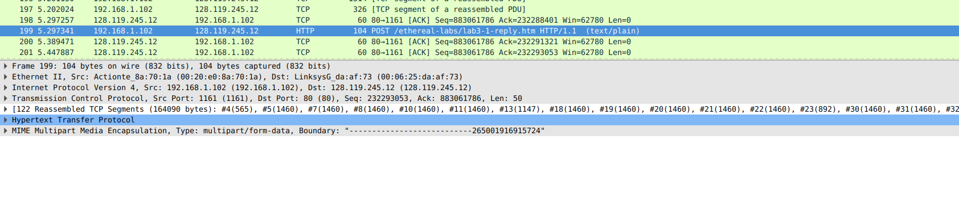

Q3.

|  |  |  |  |
| --- | --- | --- | --- |
| Sequence | Length | Sample RTT | Estimated RTT |
| 232129013 | 565 | 0.02746 | 0.02746 |
| 232129578 | 1460 | 0.035557 | 0.0284742 |
| 232131038 | 1460 | 0.070059 | 0.03367 |
| 232132498 | 1460 | 0.114428 | 0.043765 |
| 232133958 | 1460 | 0.139894 | 0.055781 |
| 232135418 | 1460 | 0.189645 | 0.072514 |

Q4. The first one I 545 bytes. Others are 1440 bytes.

Q5. The minimum advertised window is 5840 and this is advertised in the SYNACK segment.

The receiver window does not seem to throttle the sender.

Q6. There are no retransmitted segments in the trace file. Repeat entry, it will appear if a packet is retransmitted.

Exercise 2

Q1. Seq 295

Q2. Seq 296 is server reply SYNACK. Acknowledgement field: 2818463619

Q3. Seq 297 is the sequence send back from client to SYNACK. Acknowledgement field: 1274095791.

No

Q4. Both client and server close the connection.

Check segments transmission can help to find this. First it is not a 3 or 4 segment closed. And seq 304 and seq 305 indicate that client sends the fin flag while server send the flag same time. It should be a simultaneous close.

Q5. From client to server: 2818463652 – 2818463619 = 33 bytes

From server to client: 1247095831 – 1247095791 = 40 bytes