Lab05

Nan Zhou z5111593

Exercise 1.

Q1. 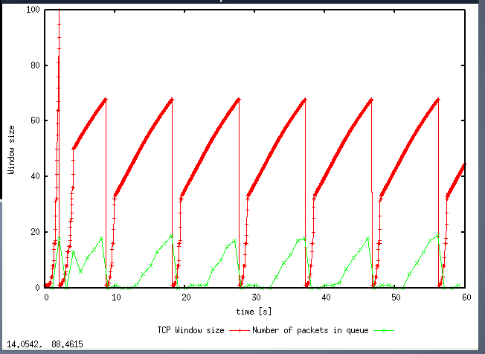

The packet size should be 61.67 When TCP flow reach the ssthresh, congestion window increase by 1 + 1/CWND in order to avoid congestion. After that, if a time out happen, congestion window will decrease by 1/2 of previous one.

Q2. 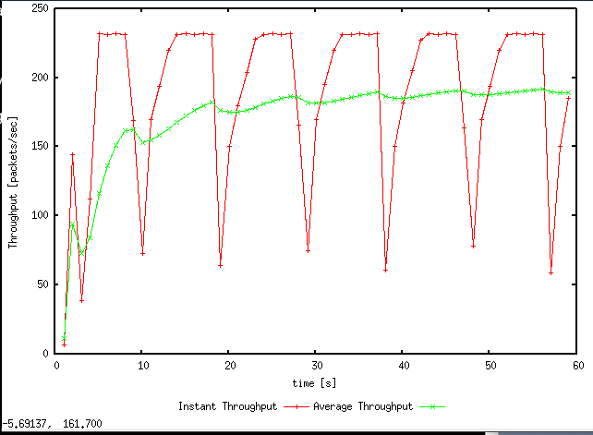

187.75 packet per second.

Q3. Congestion window size do not increase if I allocated a large parameter to script(more than 66). The maximum congestion window is 66

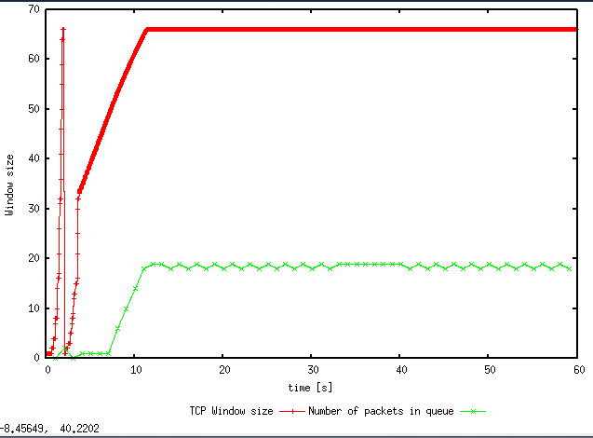

At this point, the average throughput is 220 packet per second. Which is 321200 bytes/sec. This throughput is much larger than real than link capacity because it include the size of header.

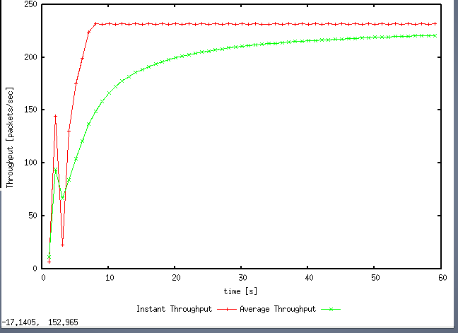

Q4, Graph for TCP Reno. Congestion window.

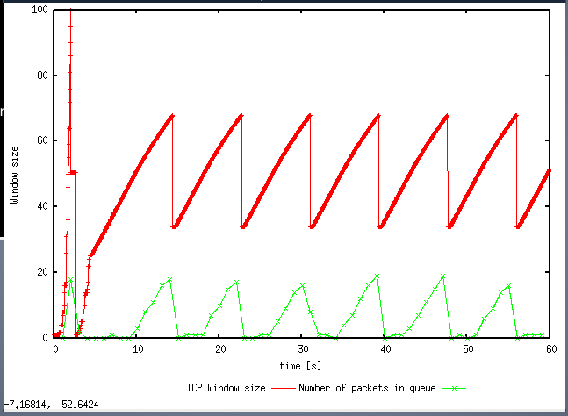

And for Throughput

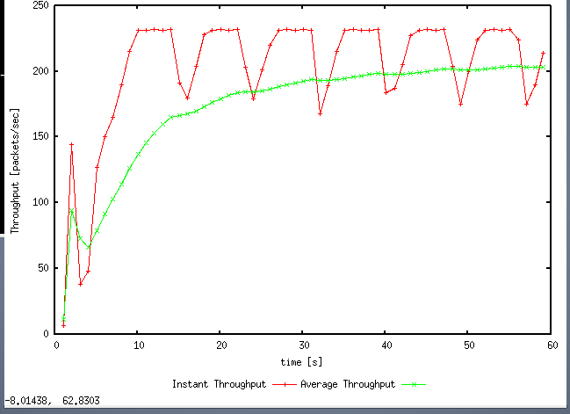

Since TCP Reno skip slow start stage, congestion window does not go back to zero. In TCP Reno, congestion will be reduced into half of max congestion window size when time out. Throughout of TCP Reno is slightly bigger than TCP Tahoe. And the variance of throughout under TCP Reno is more stable than TCP Tahoe.

EX2

Q1. 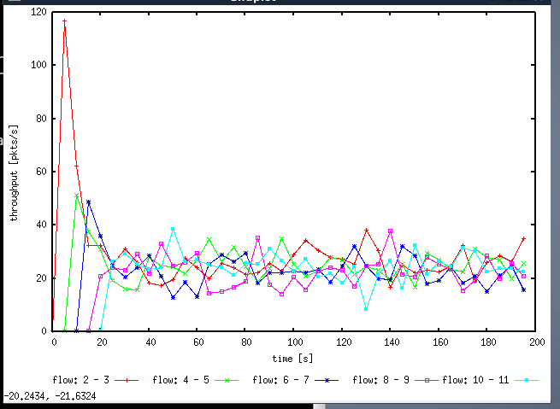

By observation, each flow gets equal share of the capacity of the common link. For every flow in graph, it shows their throughput fluctuate around a number.

Q2. Every time a new flow is created, throughout of pre-existing flow decrease.

Ex3.

Q1. UDP should have larger Throughput than TCP. But UDP should get more packet loss.

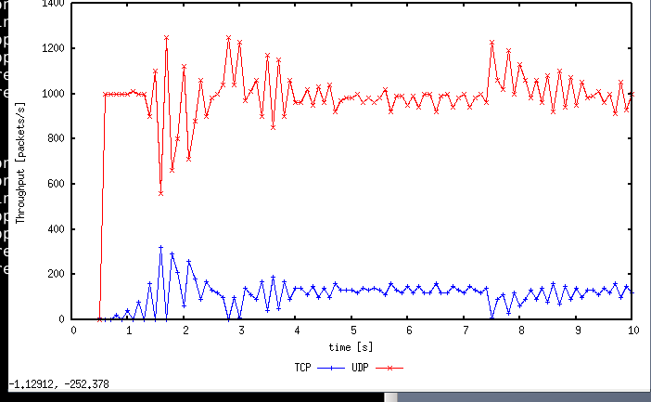

Q2. Since UDP do not have congestion control. It also does not maintain a reliable connection. UDP will send a lot package to client side without knowing if client receive it. So we can find a large throughput in UDP. Another point is slow start, which is for TCP only. UDP can increase its transport speed immediately which TCP is limited by congestion window. All of these difference result in the difference of throughput.

Q3. Adv:

1.Header of UDP is 8 bytes which is much less than 20 bytes of TCP. UDP has less transmission cost.

2.Throughput will not limited by congestion algorithm.

3. Since UDP don’t maintain a reliable a connection. Server do not need to maintain connection state table.

Disadv:

1.Unreliable. Without guarantee of mechanisms, packet loss usually appear.