Engineering Applications of AI and Machine Learning
Project 1
Due: Feb. 24
Part 1: Image Compression & Denoising
Read two reference papers, implement the image compression for ‘For_Img_Compression.JPG”, and denoising for ‘For_Img_Denosing.JPG’, two images are located under the dataset folder.
Two main functions with input and output (in Matlab) are provided, you need to add the code with the PCA/SVD method.
Project1_SVD_Compression.m and Project1_SVD_Denoising.m
The key parameter k: the number of the eigenvectors, should be explored by yourself. The objective

Part 2: Gradient Descent

Using the gradient descent method to optimize the following functions in the range of x,y [-2, 2] with the initial point x₀ = [1.5 1.5].
Choose the stop criteria as
where f_{t+1} and f_{t} represent the values at t +1 and t steps.
Using the AdaDelta method (refer the paper: “AdaDelta: an Adaptive Learning Rate Method”)
Choose the initial learning rate: η = 0.1, the proper decay parameter ρ in the rage of [0.9,0.99] to calculate the RMS value
where g is the gradient, η' is the effective learning rate (or step size)
- Get the final solution (x_{f}) which is the coordinate [x,y] when the algorithm stop. Plot the trajectory of x (all x from x0 to x_{f}) together with the f(x,y) in the same figure which is similar as follows
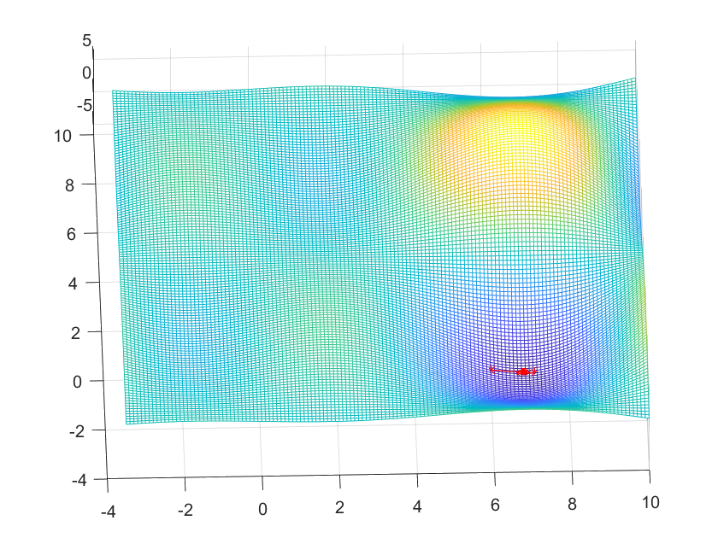
- Plot the figure of η' vs iteration to show its ‘dynamic’ or ‘adaptive’ characteristics

Report needs to include some introduction, method (some key formula), intermediate and final results; conclusions; and Appendix: code

Policy: If no code is added or your code does not support your result, there will be 30% penalty. Same code/result in two different teams, will receive ½.

References:
[1] https://iopscience.iop.org/article/10.1088/1757-899X/263/4/042082/pdf
[2] https://informatika.stei.itb.ac.id/~rinaldi.munir/AljabarGeometri/2024-2025/Makalah/Makalah-IF2123-Algeo-2024%20(85).pdf
[3] https://arxiv.org/pdf/1212.5701

