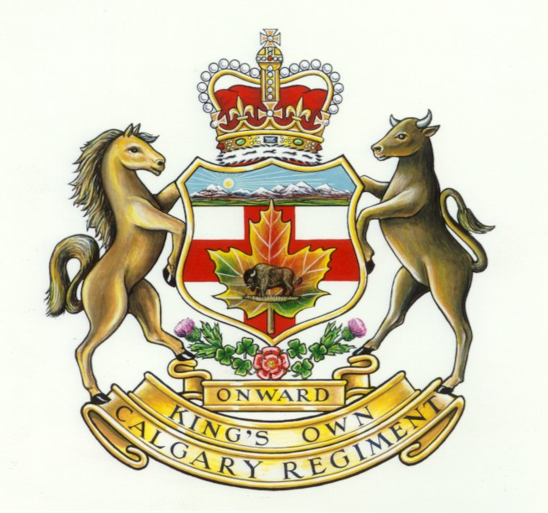

You are invited to

THE KING’S OWN CALGARY REGIMENT

(50 CEF/14 CTR) ASSOCIATION

Annual **67TH** REUNION

**June 1,2,3**

At the **Olds, Alberta** Royal Canadian Legion

To celebrate the 70th Anniversary of Dieppe

and the

End of Combat in Afghanistan

Special Guests: Dieppe Veteran Ray Gilbert and Afghanistan Veteran TBA

**Friday Afternoon/Night**: Meet & Greet at the Olds Legion

**Saturday:** Registration, Parade, Ceremony at Cenotaph, AGM, Banquet

**Sunday:** Memorial Service, Sherman Tank Dedication

*Times TBA at Registration

**…………………………………………Please detach and send REGISTRATION FORM with remuneration…………........................................**

THE KING’S OWN CALGARY REGIMENT

(50 CEF/14 CTR)

ASSOCIATION

4520 Crowchild Trail SW

Calgary, AB, T2T 5J4 Tel: 403 974-2856

Membership Dues Renewal 2012 and Reunion 2012, Olds Legion…..Attendance

Name……………………………………D**ues are still $1.00 (Donations keep us alive)**

Address………………………………………………………………Amount……………

Please **RSVP** whether attending Reunion **dinner** banquet **Will Attend Yes… No… Total attending……….**

**Cost: $20.00** (pay at registration)

Or **email RSVP** info to**:** [markent@shaw.ca](mailto:market@shaw.ca)

**…………………………………………………………………………………………………………………………………**

Please join the Association for all three days of the Reunion or any other combination of days. Motel/Hotel space is limited so book accordingly. Possibilities are listed below.

**OLDS**

Siesta Motel 5218 – 46 Street, Olds 1-403-556-3376

Sportsman Inn 5266 – 46 Street, Olds 1-403-556-3315

Circle Five Motel #17 – 4513 – 52nd Ave., Olds 1-403-556-7755

Best Western Highway 27 East, Olds 1-888-908-5900

**DIDSBURY**

Super 8 1714 – 20th Ave., Didsbury 1-403-335-8088

Didsbury Motel 1414 – 20th Ave., Didsbury 1-403-335-3159

Didsbury Inn 2014 – 19th Ave., Didsbury 1-403-335-3022

The Olds Legion is hosting a weekend program in conjunction with the KOCR reunion.

Please join us for the following festivities:

*Friday*: **2 pm:** ‘Kathrene’ Sherman Tank,‘Support the Troops Trailer’ and Vintage Military Vehicles

arrive. Show & Shine. **4 pm:** Outdoor BBQ sponsored by Legion.

*Saturday*: **8:00-9:30am:** Pancake Breakfast sponsored by Legion. **10 am:** Parade/March/Ceremony at Olds

Cenotaph. **Noon:** Outdoor BBQ Lunch. **1 pm:** AGM **5 pm:** Cocktails/Dinner Banquet

Candlelight Tank Ceremony after Banquet.

*Sunday*: **8:30-9:30 am:** Breakfast **9:45 am:** Service and Olds Legion Tank Dedication Ceremony

***Times and events are subject to change. Please pick up a schedule when you arrive***