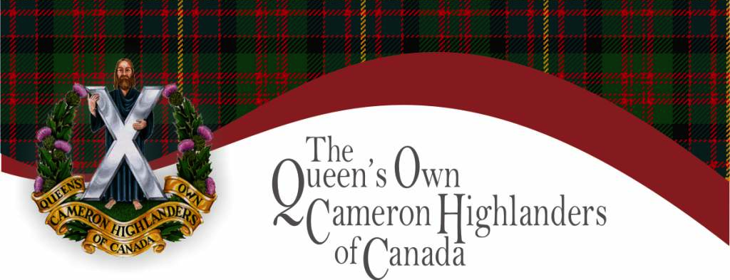

YOU ARE INVITED

We are honored to invite you to the Centenary of the 407 Queen’s Own Cameron Highlanders of Canada Royal Canadian Army Cadets. The Cameron Cadets have had a long and very proud history, and we would be honored to have your presence at our celebration.

We will holding our celebrations on 20 April 2013. Details below;

1300hrs- City Hall Exercising our right to Freedom of the City
1600hrs- Cocktails at the Greenwood Inn
1700hrs- Gala Dinner at the Greenwood Inn
2000hrs- Live band and DJ service for all

We would encourage all members wishing to attend the parade to please do so.

Tickets for the dinner are available now. If you wish to attend the Dinner you must RSVP with cheque maid payable to 407 Queen’s Own Cameron Cadets. Tickets are $35.00ea
RSVP deadline is 5 April 2013.

Please mail your RSVP with check to the following;

407 Cameron Cadets
Attn: 100th Committee
969 St.Matthews Ave
Winnipeg, Manitoba
R3G 0J7
204-786-1130

