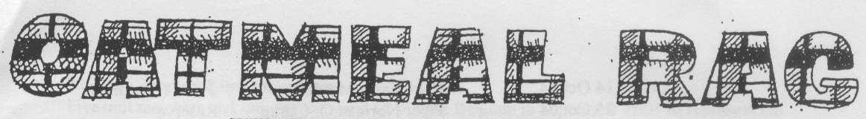
THE QUEEN’S OWN CAMERON HIGHLANDERS OF CANADA
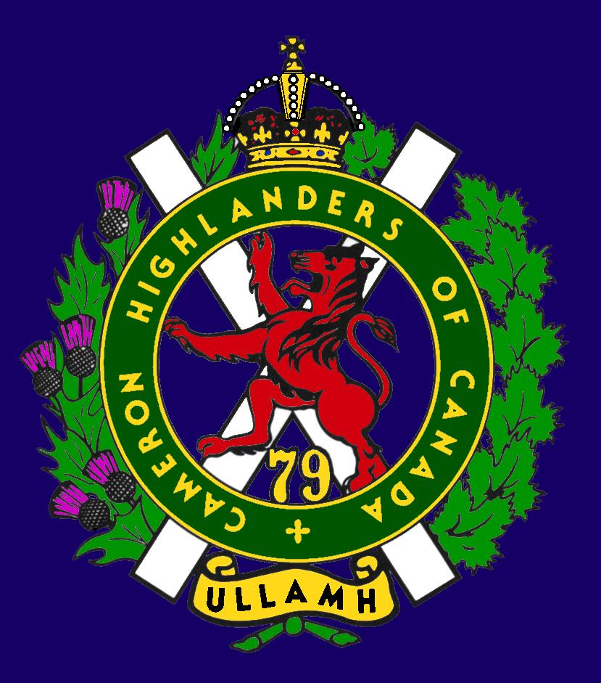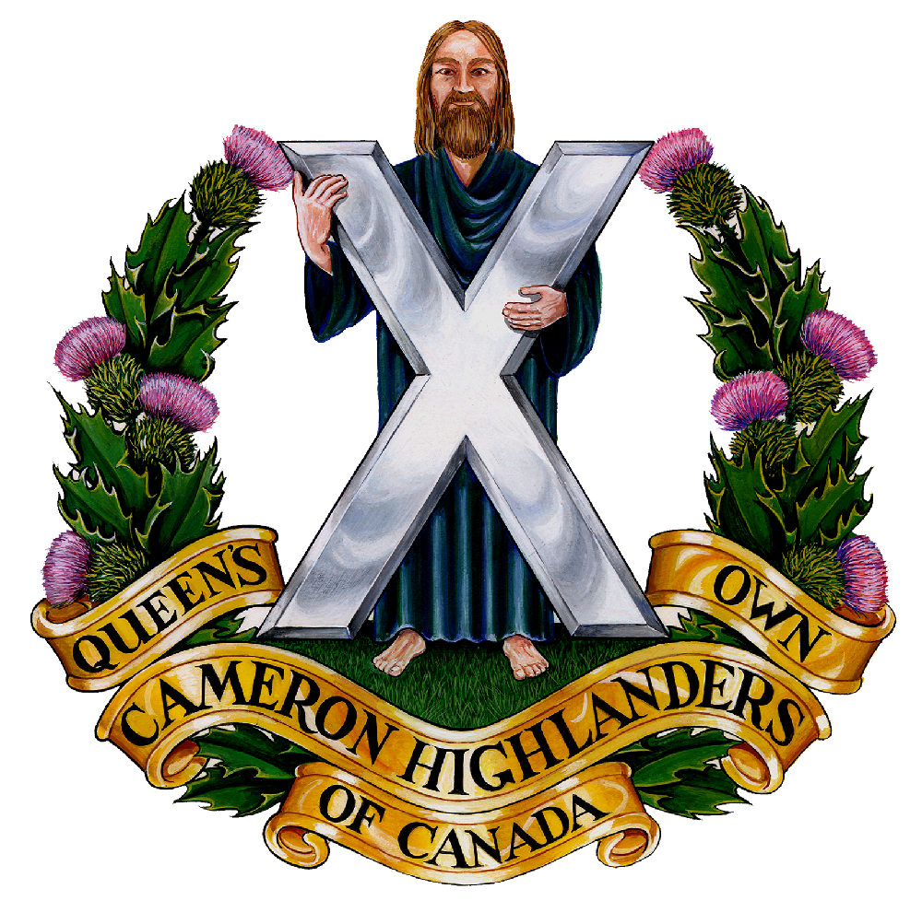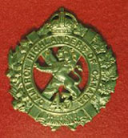
CAMERON ASSOCIATION IN CANADA
THE QUEEN’S OWN CAMERON HIGHLANDERS OF CANADA
MINTO ARMOURY, 969 ST. MATTHEWS AVE
WPG, MB R3G 0J7

2009/2010 OFFICERS

PRESIDENT | DOUG HLADY | 2 – 1014 CORYDON AVE  d_hlady@excite.com | R3M 0Y7 | 287-8113
VICE-PRES | HUGH O’DONNELL | 713 CAMBRIDGE ST  hodonnell@shaw.ca | R3M 3G2 | 285-7222
SECRETARY | HUGH O’DONNELL | “ “ “ | “ “ | “ “
TREASURER | DAVE GIBSON | 104 WILLIAM GIBSON BAY  dwgibson@mts.net | R3C 5L7 | 222-9509

Executive Board

Past Pres | Bill Worden | 47 FLETT AVE | R2K 3N3 | 669 -9888
 | Len Johnson | N/A | N/A | 757 - 2053
 | Don Collins | 17-120 SCOTSWOOD DR | R3R 2X9 | 895-1956
 | Taffy Gray | 194 SEEKINGS ST | R4J 1B1 | 889-5655
 | Marc Gautron | 312-15 ARDEN AVE | R2M 2J8 | 296-7656
 | Mitch Prudhomme
Welcome to the new electronic version of the Oatmeal Rag !

This new format will basically try to mirror the print version so that you won’t miss anything important because you didn’t get the fancy new version or something.

So why call it the Oatmeal Rag?

The Oatmeal Rag masthead has special meaning for Camerons. For many years the late Russ Miller produced Cameron newsletters under that banner. Douglas Ludlow tells me that prior to Russ Miller, Chief Clerks, Eugene (Jimmy) Fatsock and Harry Simms; each produced Oatmeal Rags during their tenure in the BOR.

Oatmeal relates to the Regiment’s Scottish origins and traditions. For many Scots, oatmeal porridge and ‘brose’ were the staple diet. Also dry coarse or steel cut oatmeal is a main ingredient of haggis which served with neeps makes a substantial Scottish repast.

Rag is a slang term for newspaper, especially one specializing in sensationalism or gossip. Russ used the Rag to keep the Regiment informed and entertained. It had to be a good read and Russ was always looking for a ‘wee’ joke to include with the stories about the Cameron family here in Manitoba and throughout the world.

Oatmeal Rag is a good name because it's catchy and shows the newsletter is about us. The name has always had a big effect on readership, so it's essential we explain it to Sassenachs and others who may not yet understand the meaning.

The Oatmeal Rag began in the pre-computer era. Russ typed his lengthy newsletters on a manual typewriter, cranked the copies off on the orderly room Gestetner, addressed and posted them himself. Russ sprinkled his writing with Scots words (wee drammie comes to mind) giving highland flavour to the message. Whenever Russ was stuck for a word, a non-Scots placeholder name like whatchamacallit worked just fine.

Russ understood the Regiment from many perspectives: a Cameron soldier in Northwestern Europe in WWII, a post war RSM, a CO of 407 RCACC and laterally regimental secretary. To the end he remained active with the battalion; all the while collecting news and announcing coming events. At the same time stories from afar flowed to Russ as a result of his voluminous correspondence with Cameron comrades. He never lacked for things to write about in his own colourful style. Regarding our up-coming centenary celebration, Russ would have called on Camerons to gather for the great lash-up coming in 2010. He would have billed it as a hootenanny to remember.

Today the Rag is published by the Cameron Association in Canada. Editors Hugh O’Donnell and Art Sutton are asking Camerons everywhere to contribute to future issues of the Rag. While it is true that email makes it easier to submit news, stories and pictures, the question has to be asked...Is the motivation and demand sufficient to continue publishing The Oatmeal Rag?

There’s no denying that Association numbers have dwindled as we lamented the passing of old guard stalwarts. At the same time the Association has failed to attract many from succeeding generations of Camerons. Will the 2010 anniversary celebrations be the catalyst to propel the Association to a renewed mission? Well, we are going to give it a try. This is another call to arms for Camerons. The Oatmeal Rag will serve to keep you posted and you have to keep us posted.
Art Sutton

* Last Post *
New Entries:
Pipe Major Emeritus THOMAS SMITH (published on November 24, 2009)
THOMAS SMITH (1916 - 2009) It is with great sadness that we share the news of the passing of our father Thomas Smith at the Deer Lodge Centre in Winnipeg on Friday, November 20, 2009 at the age of 93. He was born and raised in Winnipeg and was predeceased by his loving wife of 57 years, Jean in 2004 and his sisters Iris (Harry) and Ruby (John) of Winnipeg, and Margaret (Bill) of Nanaimo. He is survived by his caring and loving children, John and Gloria (Jordan) of Calgary, Janice of Chicago and Tom (Carole) of Winnipeg. He was adored and loved by his grandchildren Jocelyn (Rae), Andrew (Stephanie), Bonnie (Rod), Sean (Kara), Stephanie, Elizabeth (Andy), and his great-grandchildren Russell, Justine and Kiyomi. Also, he was adored by his many loving nieces and nephews. Tom, like his father, was a piper. Tom started piping as a young cadet in the Queen's Own Cameron Highlanders in Winnipeg. As his piping progressed, his father, a member of the Winnipeg Police Pipe Band, allowed Tom to play in the band whenever a substitute was required. As war broke out in Europe, he enlisted fully with the Camerons and went overseas in 1939 and saw action at the Battle of Dieppe where as a piper played his pipes into battle. After Dieppe, Tom saw further action in France, Holland, Belgium and Germany and returned to Winnipeg once the war was over in 1945. Tom was honoured to be a returning veteran to Dieppe in 1992 for the commemoration of the 50th Anniversary, where upon he piped his fellow veterans to the Memorial Service. After the Second World War, Tom became a member of the Winnipeg Police Department and became a member of their Pipe Band. Upon his retirement, Tom joined the Winnipeg Khartum Shrine Pipe Band and he served two terms as their Pipe Major and honorably received the designation of Pipe Major Emeritus. He was also the Honorary Piper of the West Kildonan Legion. Tom was a respected and noted piper and like all fine pipers he could easily bring a tear to anyone's eye. Tom was also a dedicated volunteer for the cancer society and he received a number of certificates of recognition for his contributions. The family wishes to extend their heartfelt thanks to all of the members of the staff on the 2nd and 4th floors at Deer Lodge Centre involved in Tom's care. A funeral service will be held at Thomson Funeral Home on Saturday, November 28, 2009 at 2:00 p.m. In lieu of flowers, donations can be made in Tom's memory to the Canadian Cancer Society, Manitoba Division, 193 Sherbrook St. Winnipeg, MB., R3C 2B7, or Khartum Shrine Centre, 1155 Wilkes Avenue, Winnipeg, MB. R3P 1B9 THOMSON FUNERAL HOME 669 BROADWAY, WINNIPEG, MB R3C OX4 783-7211 Condolences may be sent to www.thomsonfuneralchapel.com

Drummer LESLIE ALFRED (LES) THORNE (published on November 21, 2009)
LESLIE ALFRED (LES) THORNE Leslie Alfred Thorne passed away peacefully at Carewest Signal Pointe, Calgary, after a happy family life. Survived by his wife of 65 years, Helen Jean Morrow. Lovingly remembered by six children, seven grandchildren and two great-granddaughters. He is also survived by a sister-in-law, Helen (Cherrie)

Thorne. Predeceased by parents Georgina and Alfred Hartman Thorne, sister Eileen and brother-in-law Norm McLean and brother Gordon. Les was born and raised in Winnipeg (Elmwood). Les was a teenage cadet and side drummer with the Queens Own Cameron Highlanders of Winnipeg. He was a member of the Cameron Highlanders from September 1939 until discharge September 1945. Les was wounded at 21 years of age at the Dieppe raid, August 19, 1942 and was fortunately evacuated back to England, and subsequently returned to Canada for Officer's training until discharge. The family moved to Calgary in 1954, but we never forgot family and friends in Winnipeg. A private family graveside service and interment took place in Calgary November 7, 2009.

Previously mentioned at Cameron Association Meetings:
07 Dec 2008 |  | Raphiel J. Toms |  | 39/45
13 Dec 2008 |  | Pte Norman H. Clark |  | 39/45
02 Feb 2009 |  | Pte William J. Thompson |  | 39/45
08 Feb 2009 |  | Richard (Dave) Weldon |  | 39/45 & Reserve
20 March 2009 |  | Lawrence M. LaLiberte |  | 39/45
11 June 2009 |  | Pte Robert W. Pilgrim |  | 39/45
30 July 2009 |  | Sgt Wilf Kirk |  | 39/45
21 May 2009 |  | Capt. Charles E. Whitten |  | 39/45

* Sick & Visiting *
Piper Roy Taylor
From Capt B. Smorang FGH, Saturday, November 28, 2009 12:55 PM
Roy Taylor is doing well. He actually looked pretty good and was in great spirits. He is at Riverview Health care Center room 3rd Floor room 17 West and welcomes visitors.
He is allowed out on weekend passes and had gone home on 28th Nov 09 when CWO O’Donnell went by to say hello.

From CWO Hugh O’Donnell Cams of C, 11 Jan 2010

Roy & Louise are coming to the Robbie Burn’s !!! Roy is able to walk short distances but has told me he will refrain from break dancing for the present. Maybe a few bars of The Gay Gordon’s though if he’s really spry come the nicht.

UPDATE ON CENTENARY BOOK PROJECT
Sad to report, we've run into design and printing delays. That's why you haven't got your book. We do apologize.
We expect to have the delays remedied by early next month. So the book should be in our hands sometime in March and we can begin distribution.
We think the wait will be worth it.
Art Sutton
For your book committee
* President's Message *
Election notes & thanks to all who came out
I was very pleased to see the good turnout of our members at the Cameron Association AGM. Thank you for the honour to lead you into our regiment's centenary and Manitoba's Homecoming year. I speak for the executive when I encourage all Camerons to fully participate in the coming year's events.
I need all members of the association to update their contact information with us. This will allow us to inform you of news in a timely manner. Please be sure to include an e-mail address with your mailing address and telephone number.
Burns Supper tickets are now available for $75 each from our new Treasurer Dave Gibson. This is a great opportunity to reunite and rekindle old friendships. Let's have a great year !

Reconnect with Former Camerons

This is an important thing to do for the 100th Anniversary of the Camerons. There are lots of former Camerons out there that we don’t know about for various reasons. For example, we found out about Lloyd McDougall (39/45) through his son contacting us at the web site. Look how happy he is to meet Bill Worden !
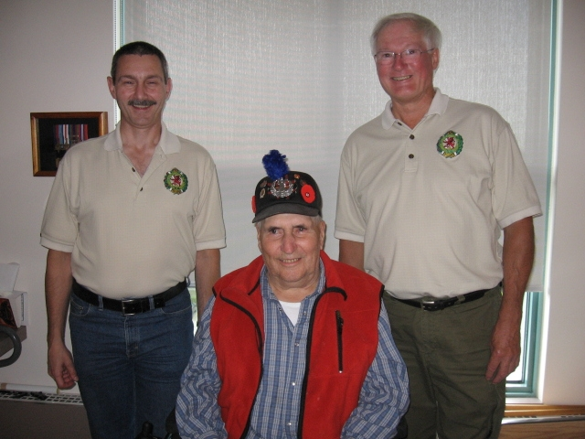
Hugh O'Donnell, Lloyd McDougall, Bill Worden August 2007

Our former Camerons are also out there on Facebook and many other places. Do your bit and try to get them out for the 100th – just think of how much better the party will be if your pals from back when are there too !

Unit Web Site
The Unit web site is up and running at:
http://thequeensowncameronhighlandersofcanada.net/
You will also find some interesting items on the downloads page at:
The Queen's Own Cameron Highlanders of Canada downloads page

Family Requests for Information:
We got a few of these every month at the web site. If you have any information regarding a request you can pass it directly to the person doing the search or through editor The Oatmeal Rag – either version. Here are some of our current requests:
CSM Nestor Orlesky
Good day,
My name is MWO Pat Monsigneur. I am a Div. Sgt Maj. at CFLRS in Saint-Jean Quebec. Nestor Orlesky was a CSM in your Rgt. during the raid on Dieppe. He was also the father of my mother. I am searching for any information I can find on his career with your Rgt. and any images or anything of interest concerning him.
Any help you could provide would be greatly value to our family!
Cheers,
Monsigneur P.A.
MWO DSM Spec Div
CFLRS Saint-Jean QC
Pte Ronald William CHAMBERS H20964
of the Queens Own Cameron Highlanders of Canada
Dear Sir/Madam,
I am writing to enquire if there is any way you can help me identify a soldier from WW2. His name was Pte Ronald William CHAMBERS and I believe his service number to be H20964. Just after WW1 he married Jessie Crichton Slorach and they returned to Toronto where Ronald was born. It was at this point our families lost contact. I enclose a copy of their wedding photograph. Was Ronald a member of the Queens Own Cameron Highlanders of Canada? All I have to go off was his service number and uniform, so any help is greatly appreciated. I have enclosed the wedding photograph for your perusal.
Kind Regards,
Ms. Tracey Rammell

Sgt Laurens Klaas Pals
I am searching for a needle in a haystack. In other words I am trying to trace the family of a Canadian Second World War hero called Sgt Laurens Klaas Pals of the 2nd Canadian Division, army number H16444. Sgt Pals was captured in the abortive Dieppe landings on 19 August 1942 and spent the rest of the war in a prisoner of war camp called Stalag VIIIB/344 in a Silesian village called Lamsdorf. While he was there, he played a prominent role in the RAF escape committee and, I believe, helped my late father, Rifleman Alec Jay of the Queen Victoria’s Rifles, to escape on one occasion alongside an RAF front gunner called Bob Hawthorn. I am researching my father’s wartime experiences from his role in the siege of Calais and subsequent capture through to May 1945 and this is why I am trying to contact Sgt Pals’s family.. From records in the National Archives in London, I have discovered that Sgt Pals’s date of birth was 29 December 1902 and that his peacetime address was 410 Spence Street, Winnipeg, Manitoba. This suggests that he was in the Queen’s Own Cameron Highlanders of Canada. May I ask, in such circumstances, if Sgt Pals appears in your records? If he does and you have any information relating to his family, I would be most keen to learn more. I am contactable at this email address as well as on 00 44 20 7045 0639 during London working hours as well as on my mobile phone, 0044 7836 621930.
He was known to all and sundry as “Larry”. In addition, in a letter he wrote in 1946 commending the sabotage activities of a fellow British POW in Stalag VIIIB/Stalag 344, he described himself as from Canadian Field Security as well as the officer commanding the Canadian Section of the Missing Persons Search Bureau in London. My I ask, on this front, whether there is a veterans association for Canadian Field Security in World War Two?
Ed’s Note: A/ Sgt Pals wasn't actually with the Camerons. He was in Dieppe with the 2nd Canadian Field Security Section, his original Unit was the PPCLI. # 16444. His POW # was 25935. He was Taken On Strength 27/11/39 with the PPCLI and Struck Off Strength 29/05/1940. Never the less, we may be able to help out with this one.

Pte. (?) Theodore Tarasiuk
Hello Sir,
I am contacting you on behalf of my wife regarding her father's involvement with the Cameron Highlanders. He was one of several Ukrainian men who apparently had joined the regiment in the 40"s, but we have little knowledge of his involvement. There were two brothers who joined the same day. they were in the 2nd Bn. - Harry Tarasiuk H433878 TOS 12/01/1944 SOS 13/03/1946 and Theodore Tarasiuk H433881 TOS 12/01/1944 - SOS 15/07/1947. Is there a resource that we can contact to get any possible information?
His name was Theodore Tarasiuk.
Thanks,
Brian Lukie

The Beaver Magazine Article: The feature story in the Oct/Nov 2009 issue of The Beaver Magazine (www.BeaverMagazine.ca ) is about the Shankland medal sale as well as other military history articles. Well worth the read. Then again I would say that – my picture is in it.

Robbie Burn’s 2010: 1900 hrs 23 Jan 2010.
Tickets are only $75 for one of THE best Burn’s Dinners in town. They are available from Sgt Dave Gibson at (204) 222-9509 or dwgibson@mts.net
Tickets are also available now from many of the Cameron WO’s & Sgt’s Club mbrs.

Kirk Parade: 1020 hrs 07 Feb 2010.
It will be held at the 1st Presbyterian on Canora St. The Service starts at 1030 hrs so if you’re not on parade be sure to be seated NLT 1020 hrs as directed by the Ushers.
Dress: Regimental Blazer & Tie or your Churchgoing clothes.

Cameron Reunion: 1930 hrs 20 & 21August 2010
As usual at Minto Armouries on the Friday night with golf the Sat. More to follow next issue !

Cameron 100th Anniversary: 22- 24 Oct 2010
To be held in downtown Winnipeg this coming year. Come on out and join the old guys After all, you know you’re one of them now (and have been for years too) ! Bring a friend or two as well, especially the guys that you did a course or an overseas tour with.

More details will come with the next issue of the Oatmeal Rag and will also be posted on the Cameron web site in case you misplace your copy of the Oatmeal Rag in your personal library. Also, many cities (Winnipeg included) have free internet available at the local libraries and staff who can help you find what you need.

So Online or Printed version for you?

We look forward to hearing from you as to which version you prefer to receive. If we don’t hear from you we’ll assume that you prefer the printed version. If you don’t have a computer or the internet by all means drop us a line at the Association and please let us know which one you like better.
Also, any updates regarding your contact information or perhaps outstanding Association Dues are welcome ! We’ll be happy to add them to the kitty to pay for the free round for members in attendance at the Cameron Reunion in August or perhaps the 100th in Oct this year.

Cheers for now,

Art Sutton & Hugh O’Donnell

