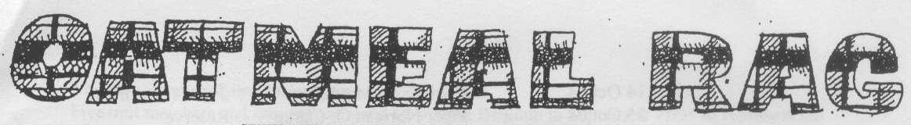
THE QUEEN’S OWN CAMERON HIGHLANDERS OF CANADA
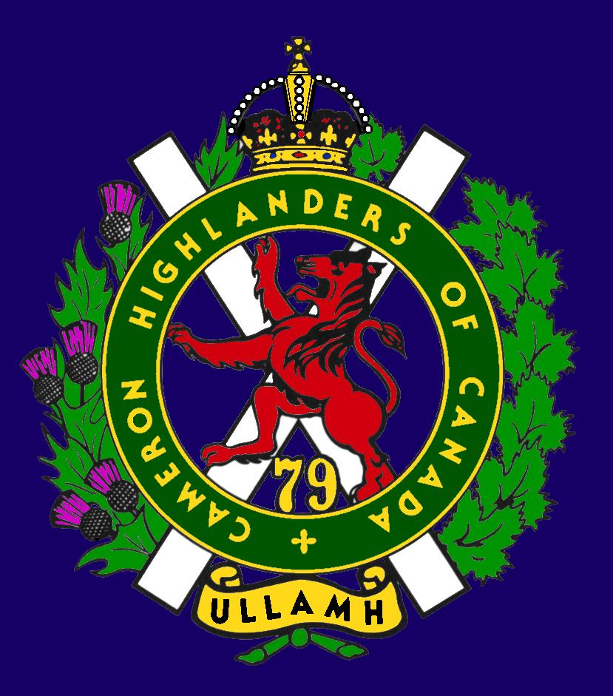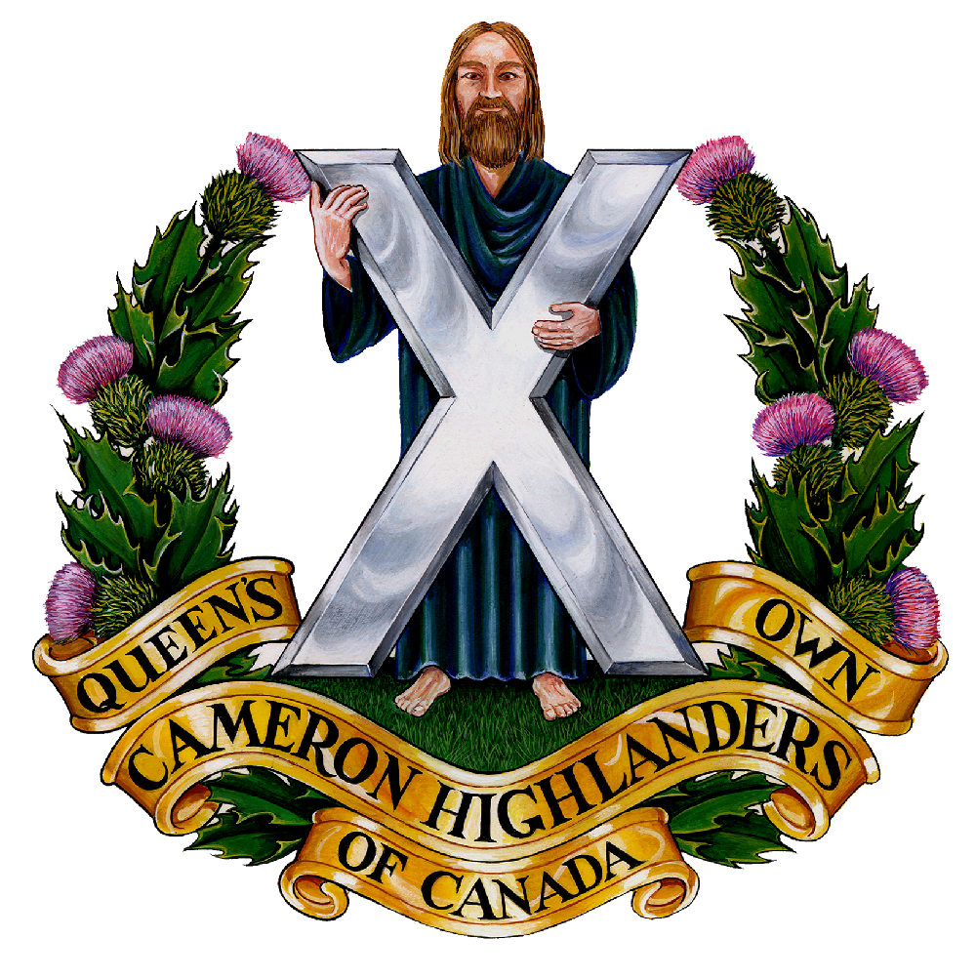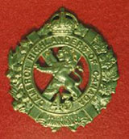
CAMERON ASSOCIATION IN CANADA
THE QUEEN’S OWN CAMERON HIGHLANDERS OF CANADA
MINTO ARMOURY, 969 ST. MATTHEWS AVE
WPG, MB R3G 0J7

2009/2010 OFFICERS

PRESIDENT | Doug Hlady | 2 – 1014 Corydon Ave  d_hlady@excite.com | R3M 0Y7 | 287-8113
VICE-PRES | Hugh O’Donnell | 713 Cambridge St  hodonnell@shaw.ca | R3M 3G2 | 285-7222
SECRETARY | Hugh O’Donnell | “ “ “ | “ “ | “ “
TREASURER | Dave Gibson | 104 William Gibson Bay  dwgibson@mts.net | R3C 5L7 | 222-9509

Executive Board

Past Pres | Bill Worden | 47 Flett Ave | R2K 3N3 | 669 -9888
 | Len Johnson | Not avail | Not avail | 757 - 2023
 | Don Collins | 17-120 Scotswood Dr | R3R 2X9 | 895-1956
 | Taffy Gray | 198 Seekings St Headingly, MB | R4J 1B1 | 889-5655
 | Marc Gautron | 312-15 Arden Ave. | R2M 2J8 | 296-7656
 | Mitch Prudhomme | 790 Parkhill St | R2Y 0V5 | 837-5778
 | Gary Hollingshead | 928 Queenston Bay | R3N 0Y2 | 489-2367
Auditor | Tom Russell | 376 Oak St | R3M 3R5 | 488-0088

* Last Post *
New Entries:
Catherine Jean Kulchycky 2007
(Wife of Adam Kulchycky, Brandon, MB WW 2 Cameron)

MAFALDA MATIAS MACINTYRE (nee Vieira) Mafalda MacIntyre, 36, of Lorrette, MB, passed away on Sunday, January 3, 2010, at the St. Boniface General Hospital. She leaves to mourn her loving husband Capt. Paul MacIntyre, father Jose Oliveira Vieira, mother Maria Emilia Matias, brothers Jose Matias Vieira and Nelson Matias Vieira. Prayers will be held Thursday, January 7, 2010 at 7:30 p.m. from Holy Rosary Roman Catholic Church, 510 River Ave. Mass of the Resurrection will be held Friday, January 8, 2010 at 10:00 a.m. at Holy Rosary Roman Catholic Church. Rev. Fr. Sam Argenziano officiating. Interment in Assumption Cemetery, Garden Chapel Mausoleum, 3990 Portage Ave. In lieu of flowers, donations may be made to the Canadian Diabetes Association, 200-310 Broadway, Winnipeg, MB, R3C 0S6 or the Kidney Foundation of Manitoba, 1-452 Dovercourt, Winnipeg, MB, R3Y 1G4 For online condolences or to light a memorial candle please log onto www.mosaicfunerals.ca 1839 Inkster Blvd. 275-5555

Ben Phillips, WW 2, 20 Feb 2010
Ben Phillips born May 10, 1919, passed away February 20, 2010. He will be dearly missed by his wife of almost 64 years, Edith, their six children Abbie, Bert, Nancy, Ben, Georgina, Jack and grandchildren and great-grandchildren. He also leaves behind his wonderful sister Kaye and many nieces, nephews and in-laws. He was predeceased by his brother Russ and Russ’ son, Billy – the saddest times of his life. Ben was a totally devoted son, husband, brother, father, grandfather, uncle and friend. He will be happily remembered for the man he was and his devotion to life!
A Legion Poppy Service was held at 11:00 a.m. on Friday, February 26th at the Dauphin Royal Canadian Legion.

* Sick & Visiting *
Ed Abraham WW2 Cameron had a stroke near Easter. Ms. Leona Stilling tells me that he's recovering OK but is currently paralyzed on his right side. His vital signs are good but he can't speak.

Maj (Ret’d) Gord Coutts is recovering well at home after a recent hospital stay.

Bill Douglas is out of the hospital now and getting back into shape for the Cameron 100th.

Capt (Ret’d) Taffy Gray is doing well enough after his recent illness that kept him from the Robbie Burn’s. He still has some ongoing health issues but has his fighting spirit from his RSM days and can still find his cup.

Cameron Assn Pres. Doug Hlady is still in the Victoria Hospital. He’s doing OK but is often resting. The nurse tells our S&V guys to wake him up if you go by – he hates to miss anyone due to drowsiness.

Former RSM Archie Moore is doing OK.

Piper Roy Taylor is doing very well and has confounded his doctor not only by surviving his fall of the ladder and subsequent injuries, but by eating loads of haggis at the Robbie Burn’s. Good on you Roy !

Mr. Neil Wither is doing well.

Col (Ret’d) Doug Ludlow wants his “military family” to know that he is now a resident at St. Norbert Personal Care Home. Doug says that he does not expect to be able to attend Anniversary events but welcomes visits at his new LHQ.

* President's Message *
I had a new experience in attending the Winnipeg Infantry Tactical Group (WITG) Christmas Dinner made up of Camerons and RWR’s. Eating on the parade square with such a large group, I think they should have used a sound system because the voices from the head table did not carry well enough for the Old Guard. I felt it lacked the intimacy of our old regimental dinners. It was great seeing our own Bill Douglas, Dieppe POW, able to be there.
It was a good turnout at the New Year's Levy with the new Lt. Governor General, Phillip Lee, being presented with our regimental tie. Retired CDS General Ray Henault was there and it was good to see that Mike Nickerson was his jovial self.
The Robbie Burns Dinner was top notch this year. All the ladies received rose corsages and there was a Cameron Cap Badge Lapel Pin included with the dinner programs. We certainly got our money's worth. I performed the toast to our fallen comrades without the
lament. Our own Hugh O'Donnell gave a brief history of the regiment that was entertaining. Roy Taylor just out of Riverview attended both the dinner and the Kirk parade. Colonel Steve Anema was in town and made it to the church as well.
The Centenary is in full swing and there should be a registration package available for distribution at the end of March.
Dave Gibson is heading a committee reviewing our Association constitution and bylaws. When the committee makes its recommendations we will need to hold a general meeting to approve any changes.
The August Reunion is scheduled for the weekend of August 20th. Meet and Greet on the Friday and Golf Tournament on the Saturday. Prize donations for the golf would be greatly appreciated.
I have found our new Executive to be dedicated and hard working. I would like to thank them on your behalf and encourage them to keep up the good work.
Doug Hlady

Reconnect with Former Camerons

This is an important thing to do for the 100th Anniversary of the Camerons. There are lots of former Camerons out there that we don’t know about for various reasons. Some of the stuff going on out there:

Daniel Goertzen is getting old - "Thanks! The big 4-0 is sure bearing down on me now!"
About April 08, 2010

Don Steenson celebrated his 50th recently. How recently is his to tell. Buy him a beer if you want to know.
1959/63 members
My name is Neil Cameron Walker Wood. My Father was an MO attached to the Imperial Cameron’s during World War one. I was a junior officer during my early Winnipeg days probably 1959 to 63. I was wondering, if any of my peers were still around? I recall it was a great period in my life. Thanks.
NEIL C W WOOD
CAMWOOD PROPERTIES LTD
200 ADELAIDE ST WEST
TORONTO ONTARIO
M5H1W7
www.camwoodproperties.com
p 416-5983345
Our former Camerons are also out there on Facebook and many other places. Do your bit and try to get them out for the 100th – just think of how much better the party will be if your pals from back when are there too !

Unit Web Site
The Unit web site is up and running at:
http://thequeensowncameronhighlandersofcanada.net/

You will also find some interesting items on the downloads page at:
The Queen's Own Cameron Highlanders of Canada downloads page

Family requests for information: We normally get a few of these every month at the web site. If you have any information regarding a request you can pass it directly to the person doing the search or through editor The Oatmeal Rag – either version.
Regimental Events

Rounds Completed
Robbie Burn’s 2010: 1900 hrs 23 Jan 2010.
The 50th Annual Cameron Robbie Burn’s Dinner was a great success. About 154 sat down for a bit of haggis and history.

Kirk Parade: 1020 hrs 07 Feb 2010.
Was held at the 1st Presbyterian on Canora St. This will be the same kirk for the Kirk Parade at the end of the 100th.

Manitoba Tartan Day 06 April 2010
Strictly speaking this wasn’t a Cameron Regimental event – but this WAS the day we showcased our new Regimental Scarlets ! See the picture below and judge for yourself if they look sharp.

Incoming Rounds
Cameron Association Reunion & Golf: 20-21 August 2010
To be held on Friday night at Minto armouries and Saturday afternoon at the Assiniboine Golf Club. Come on out and join the old guys for a beer and a tall tale or twa to get primed for the Centennial in October !
Friday Night details:
Date: 20 August
Time: 6:30 p.m. – Late
Place: Minto Armouries Officers Mess
Price: Cameron Association Dues – $10

Golf Details:
Date: Saturday, August, 21, 2010
Time: 2:00 p.m. tee off
Place: Assiniboine Golf Club
Price: 9 holes of golf and steak BBQ -- $40.00 Just the steak BBQ -- $25.00
[These are the same prices as last year]

Contact: Don MacDonald: (204) 771-3825 or dmacdona@mts.net

Cameron 100th Anniversary: 22- 24 Oct 2010

To be held in downtown Winnipeg this coming year. Come on out and join the old guys After all, you know you’re one of them now (and have been for years too) ! Bring a friend or two as well, especially the guys that you did a course or an overseas tour with.

THE QUEEN’S OWN CAMERON HIGHLANDERS OF CANADA CENTENNIAL WEEKEND

October 22 – 24, 2010
Winnipeg, Manitoba

Please join us in celebrating 100 years of service to Manitoba and Canada by The Queen’s Own Cameron Highlanders of Canada.

Key Events

Friday, October 22 – Welcome “Meet and Greet” Evening
Saturday, October 23 – Freedom of the City Parade, Presentation of Commemorative Plaque to the Province of Manitoba and Gala Dinner
Sunday, October 24 – Church Parade followed by Farewell Luncheon

There will be a number of other events associated with the Centennial Weekend.

Many of the events will be held at the historic and beautiful Hotel Fort Garry and we have arranged a special Centennial Weekend pricing package for attendees who wish to stay at the Hotel. Please contact the Hotel at (204) 942-8251 (www.fortgarryhotel.com) by May 20, 2010 to take advantage of the special rates.

The cost for attending all of the events is $100.00 per person. We are able to offer this low cost due to various sponsorships and through the support of the Regimental Foundation.

Please return your reply to the addressed below to advise how many tickets you would like for this very special event as we begin the next 100 years of service. In order to assist in planning for the event, we request that you indicate your intention to join us for the Centennial Weekend by June 15,

2010. REPLY FORM FOLLOWS:

THE QUEEN’S OWN CAMERON HIGHLANDERS OF CANADA
CENTENNIAL WEEKEND REPLY CARD

Please reserve ___ ticket(s) for the Centennial Weekend at $100.00 per ticket

Name: _____________________

Address: _____________________________________

Telephone:___________________

E-Mail: _____________________

Mail your order to:
The Queen’s Own Cameron Highlanders Centenary Inc.
Suite 85, PO Box 17000 Stn. Forces
Winnipeg, Manitoba
R3J 3Y5

UPDATE ON CENTENARY BOOK PROJECT
The book is in the final stages of layout and proofing and will be in the hands of the printer soon. We are looking forward to presenting HRH Prince Philip with his copy during the Royal visit to Manitoba. Following presentation of the first copy to the Colonel-in-Chief, general distribution will begin in July.

Although initially the book was scheduled to be launched much earlier, author Murray Burt has taken the extra time to include up-to-date accounts of our Cameron soldiers in Afghanistan

The committee wants to thank the many contributors and supporters of this opus. Your financial support has ensured a deficit free book launch.

Art Sutton, Chairman

Manitoba Tartan Day 06 April 2010

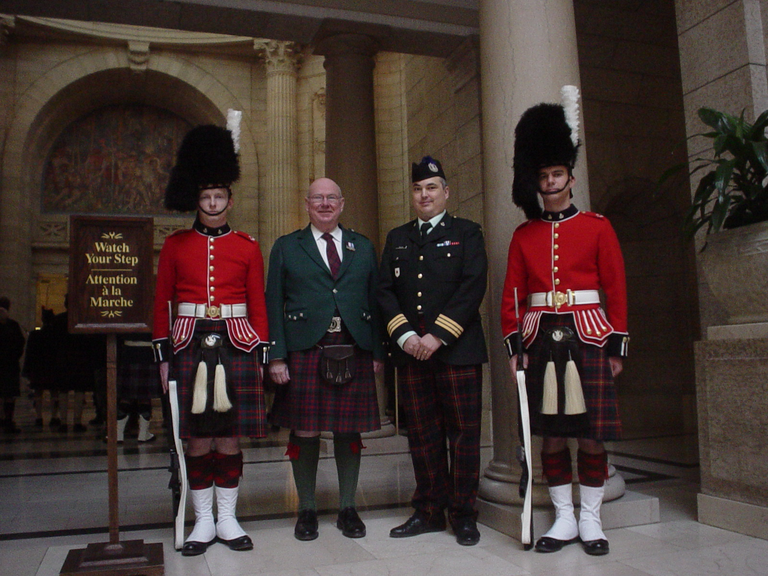

Other Events

The next few items are not run by the Cameron Association but we do support them. They are worthy causes or events in their own right. The first of these is the Normandy Day Dinner. Some time ago it was realized that with the WW 2 Vets passing the knowledge of these events may become lost. The Normandy Day Dinner is meant to keep the memory of those days when the Camerons and Garrys took on Hitler’s best and beat them.

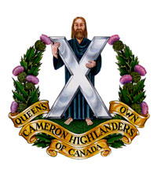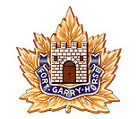

The Normandy Day Committee
Requests the pleasure of Your Company
at a
MIXED NORMANDY DAY DINNER
in
THE LODGE ROOM ‘A’
VISCOUNT GORT MOTOR HOTEL
1670 PORTAGE AVE, Winnipeg
On
JUNE 04, 2010

1830 for 1915 Subvention: $35.00 per
Cash bar

Dress: RSVP By Friday, May 28th to unit:
Men - Blazer (no medals) FGH: Gordon Askew– 885-5897
Ladies –dress or pant suit QOCH of c: Neil Wither – 269-7290

Other Events (cont)

These other events pretty much explain themselves.

30 May 2010 Winnipeg Police Service Scotch & Cigars Night
- Contact Sgt M. Lumsden through at Unit or through the
web site for details & tickets, $50/head.
05 June 2010 Cameron Highland Games
- open to all Camerons & former Camerons & their
guests.
- $10/head to Sgt M. Lumsden or clean WO B's barn for
a week
- Location is near Kleefeld MB @ WO B Breustedt's
farm, maps avail from Sgt M. Lumsden, Sgt J. Clark, or
by email request to the webmaster CWO H. O'Donnell

So… online or printed version for you?

We look forward to hearing from you as to which version you prefer to receive. If we don’t hear from you we’ll assume that you prefer the printed version. If you don’t have a computer or the internet by all means drop us a line at the Association and please let us know which one you like better.
Also, any updates regarding your contact information or perhaps outstanding Association Dues are welcome ! We’ll be happy to add them to the kitty to pay for the free round for members in attendance at the Cameron Reunion in August or perhaps the 100th in Oct this year.

Cheers for now,

Art Sutton & Hugh O’Donnell

