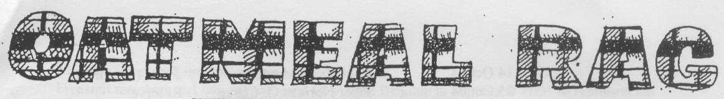
THE QUEEN’S OWN CAMERON HIGHLANDERS OF CANADA
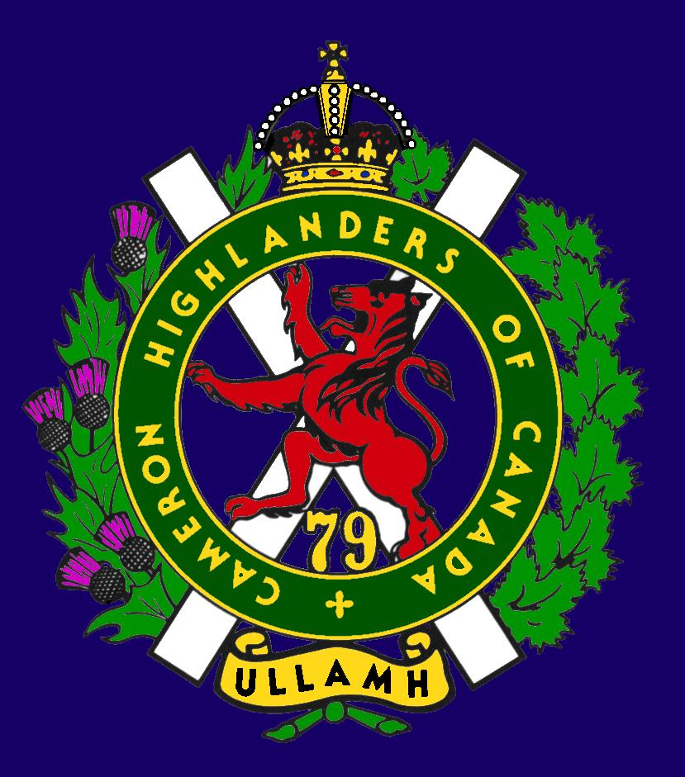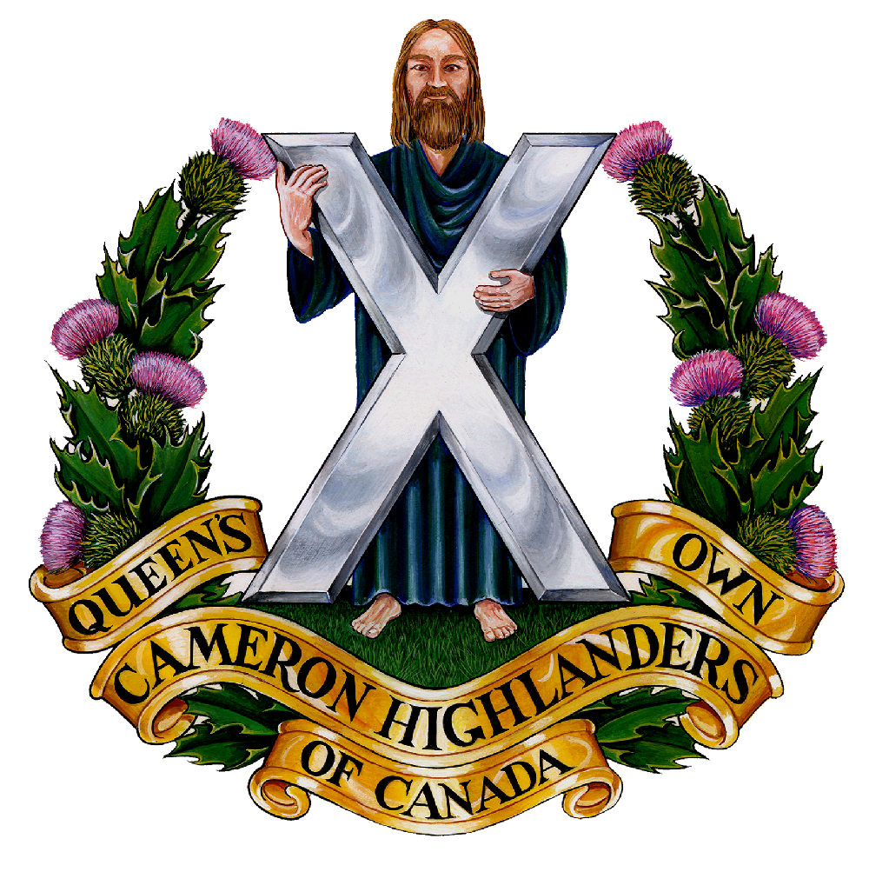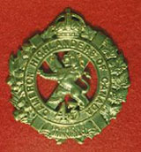
CAMERON ASSOCIATION IN CANADA
THE QUEEN’S OWN CAMERON HIGHLANDERS OF CANADA
MINTO ARMOURY, 969 ST. MATTHEWS AVE
WPG, MB R3G 0J7

2009/2010 OFFICERS

PRESIDENT | Doug Hlady | 2 – 1014 Corydon Ave  d_hlady@excite.com | R3M 0Y7 | 287-8113
VICE-PRES | Hugh O’Donnell | 713 Cambridge St  hodonnell@shaw.ca | R3M 3G2 | 285-7222
SECRETARY | Hugh O’Donnell | “ “ “ | “ “ | “ “
TREASURER | Dave Gibson | 104 William Gibson Bay  dwgibson@mts.net | R3C 5L7 | 222-9509

Executive Board

Past Pres | Bill Worden | 47 Flett Ave | R2K 3N3 | 669 -9888
 | Len Johnson | Not avail | Not avail | 757 - 2023
 | Don Collins | 17-120 Scotswood Dr | R3R 2X9 | 895-1956
 | Taffy Gray | 198 Seekings St Headingly, MB | R4J 1B1 | 889-5655
 | Marc Gautron | 312-15 Arden Ave. | R2M 2J8 | 296-7656
 | Mitch Prudhomme | 790 Parkhill St | R2Y 0V5 | 837-5778
 | Gary Hollingshead | 928 Queenston Bay | R3N 0Y2 | 489-2367
Auditor | Tom Russell | 376 Oak St | R3M 3R5 | 488-0088

* Last Post *
New Entries:
NEIL CHURCHWARD 1958 - 2010 (WFP published on May 01, 2010)
Sadly, on Sunday, April 25, 2010 Neil passed away at Riverview Health Centre surrounded by family, following a two year battle with cancer. Son of LCol Reg and Jo Churchward. In lieu of flowers, friends should they so desire, may make a donation to a charity of their choice. NEIL BARDAL INC. (204) 949 2200 nbardal.mb.ca
http://www.passagesmb.com/obituary_details.cfm?ObitID=163807

JAMES WALTER VICK April 24, 1925 - March 1, 2010 (published on March 13, 2010)
In Lloydminster, SK on March 1, 2010. He is survived by his loving wife Glenadean, children. Born in Winnipeg he was a Second World War veteran, drove streetcar for Winnipeg Electric, joined Canada Post in 1953 and retired after 30 years. Jim was an accomplished pipe band drummer and teacher. He played lead drum for the Cameron and Henderson Highlanders and the Mass Pipes and Drums of Winnipeg, was Drum Major for the Calgary Highlanders and played with the Lloydminster and Battleford bands before retiring his drum in 2008. Jim returned annually to Winnipeg for the Cameron Highlanders Reunion and was happily anticipating the 2010 gathering. Donations may be made in his name to the Canadian Cancer Society.
http://www.passagesmb.com/obituary_details.cfm?ObitID=161939

FRANCIS (FRANK) E. SPEARING (published on April 17, 2010)
Francis (Frank) E. Spearing passed away on April 12, 2010 in Concordia Hospital. Frank, who was predeceased by his first wife Freda, leaves behind wife Dorothy, his son David and other family. Born in 1917, Frank lived in England from 1945 to 1970 before returning to Canada (Ontario) and then to Winnipeg in 1999. In lieu of flowers donations can be made to: New Directions for Children, Youth, Adults and Families Bridges Program, c/o The Winnipeg Foundation, 1350 - One Lombard, Winnipeg, MB, R3B 0X3. Arrangements entrusted to: KLASSEN FUNERAL HOME 1897 Henderson Hwy. 338-0331 Send expressions of sympathy at www.klassenfuneralhome.com
Frank was a WW 2 Cameron. He served with “C” Coy according to his nephew, Sgt Wayne Brown, FGH.

ISABEL EDITH (GILLESPIE) WYATT (published on March 06, 2010)
Born February 16, 1911, Isabel Edith Wyatt peacefully passed away in the comfort of her home on February 28, 2010. She was the eldest in a family of six children of Robert and Anne (Munroe) Gillespie. Born and raised in Winnipeg, Canada, She earned her nursing degree from the Royal Victoria Hospital in Montreal and was assistant head nurse at the Montreal Neurological Institution. During the Second World War, she worked with Dr. William Penfield at the Canadian Neurosurgical center near Basingstoke England. Promoted to Captain, she was sent into action on the continent. In late 1944 prior to an imminent major battle, she established the largest tent hospital in Bayeau France. She spoke of the challenges in moving this field hospital due to its size and needing to restore utilities as the retreating German army devastated everything in their wake. She married Major John P. Wyatt of Winnipeg, pathologist-in-chief of the 10th General Hospital and consultant in neuropathology to the 21st Army Group. After the war, King George awarded her the Order First Class of the Red Cross for her bravery and courage during the Battle of the Bulge. After the war, John and Isabel settled in Boston, Massachusetts where John completed graduate studies in pathology at the Harvard Medical School under his second Banting Fellowship. His first fellowship was interrupted when he volunteered to serve with the Canadian pathological unit during the war. In 1964, John, Isabel, and their children returned to Winnipeg when John accepted a position as Head of Pathology at the University of Manitoba. In 1974, John and Isabel moved to Lexington, Kentucky where John worked as Director of the new Tobacco and Health Institute. On John's passing, Isabel retired to Toronto. Her husband, son Gordon, and her four siblings preceded Isabel in death. She is survived by a sister, Kay Gillespie, three children. In lieu of flowers, donations may be given to the John P. Wyatt M.D. Travelling Foundation, University of Kentucky, which provides fellowships to UK scientists for the purpose of studying and disseminating information related to environmentally caused diseases. Edith’s family included at least one of the Gillespie CO’s and many other fine members of the Camerons.
http://www.passagesmb.com/obituary_details.cfm?ObitID=161690
MALCOLM (SCOTTY) MACPHAIL (published on January 06, 2010)
On January 2 2010, peacefully at home. Malcolm was born on January 17 1934 in Rothesay, The Isle of Bute, Scotland. He moved to Canada in 1951 at the age of 17, where he met his wife Joy Blake in Transcona and they were married in 1954. He leaves to mourn his wife of 55 years, Joy and their children. Dad spent most of his working years as a CNR Police Constable, Retiring in 1990 after 38 years of service. He was a member of the Masonic Lodge and consequently became a member of the Khartoum Temple Shriners Pipe Band as a drummer. In his early years he was a member of the Cameron Highlanders Pipe Band as well as the 402 Fighter Squadron Airforce Pipe Band. If friends so desire donations may be made in Dad's memory to Cancer Care Manitoba, Manitoba Lung Association or a charity of one's choice.
http://www.passagesmb.com/obituary_details.cfm?ObitID=159315

GEORGE THOMSON (published on June 10, 2010)
At the St. Boniface Hospital at the age of 59 years. George was with the Cameron Pipes & Drums in the 1960’s & 70’s. He attended the Edinburgh Tattoo when the band went in 1970. In lieu of flowers donations may be made to the Heart and Stroke Foundation, 6 Donald Street, Winnipeg, MB R3L 0K6. The Coutu family in care of arrangements: E. J. COUTU CO. FUNERAL DIRECTORS 680 Archibald St. 253-5086
http://www.passagesmb.com/obituary_details.cfm?ObitID=165504

* Regimental Reinforcements *

15 June 2010
Lisa and Sgt Dave Gibson now have a baby girl ! 7 lbs 14 oz and everyone is doing well !

Catherine Isabella Gibson was born June 15, 2010 at 0911 hours, 7 lbs 14 oz & 19 ¼ inches (3571 gm & 49 cm).

* Sick & Visiting *
Ed Abraham WW2 Cameron had a stroke near Easter. Ms. Leona Stilling tells me that he's recovering OK but is currently paralyzed on his right side. His vital signs are good and he is able to speak, eat regular meals, and is working very hard to regain mobility.

Cameron Assn Pres. Doug Hlady is recovering well but it will still be a bit. He’s not at the Victoria Hospital but more on that shortly.

Col (Ret’d) Doug Ludlow wants his “military family” to know that he is now a resident at St. Norbert Personal Care Home. Doug says that he does not expect to be able to attend Anniversary events but welcomes visits at his new LHQ.

* President's Message *
I have been out of commission for over three months with a septic infection
in my right knee. I spent nearly three months in the Victoria General Hospital and
am now in the Rehabilitation Hospital of the H.S.C. They have me working out with
the physiotherapist and working with the occupational therapist to get me back home.
I am hoping to return home by the beginning of August.
I had the pleasure of congratulating Dave Gibson on the birth of his daughter.
I was thrilled to see the television. and newspaper coverage of the Royal Visit. Camerons were included numerous times. Colonel Will was spotted at the reception at Government
House and the Honour Guard in their new scarlet tunics on the west side of the Esplanade Riel when HRH Prince Phillip was presented with his copy of "Winnipeg's Ladies from Hell". I was also happy to see our Vice President Hugh O'Donnell there representing us.
Plan on coming to our August Reunion – it’ll be a good one. The Meet and Greet on Friday August 20th at 2000 hrs is in the Officer’s Mess at Minto Armoury. Start planning for the Golf Tournament on the Saturday. The information is available in this copy of the Oatmeal Rag and on the Cameron web site.
Get your golf prize donations in to Hugh. Also get your registrations forms and payment in for the 100th anniversary weekend.

* Vice-President's Message *
While the president is stuck in hospital I have been trying to show the flag at the various events that the Camerons have been connected to.

On the 4th of June 2010 Maj. (Ret’d) Bill Worden and a table’s worth of worthies, Sgt (Ret’d) G. Hollingshead, and I attended the Fort Garry Horse Normandy Dinner. It was held at the Viscount Gort and was quite a nice little evening. There were 2 veterans of the Normandy fighting (Stan Butterworth and Bill Gale) present to add tone to the event, as well as a video and wartime Karaoke. This event used to be a 6th of June ’44 D-Day FGH only event, but with the rapid decline in numbers of veterans it was felt that including all of the units who fought in the Normandy campaign might be a good idea to help preserve the memory of all of our Fallen Comrades.
On the 5th of June 2010 I attended the superb Cameron Highland Games near Kleefield, MB. The weather was most unusual in that it was fantastic, just as Sgt Lumsden had ordered from the RQ for the event. More on that below.
I also attended the Manitoba Highland Dance Association “Mid-Canada Open Sunday Competition” on June 13, 2010 to present the Cameron Association trophy. It is awarded to the winner of the 19yrs and over group and the winner is usually our featured highland dancer for the Robbie Burn’s Dinner. This year’s winner was once again Stacie Nixon and she has agreed to be at the 2011 Cameron Robbie Burn’s Dinner. For more information on the standings and so on here’s the web link:

http://www.mbhighlanddance.com/Results.html

Lastly, I got to stunt double for WITG RSM B. Boyd who was busy saving Wpg motorists from themselves at the Royal Visit where we presented HRH Prince Philip with his copy of “Winnipeg’s Ladies from Hell”. You could tell he’d rather have hung out with us than listen to speeches but the event handlers were having none of that. Nice !

http://www.army.gc.ca/lfwa/feature_prince_philip.asp

* Reconnect with Former Camerons *

This is an important thing to do for the 100th Anniversary of the Camerons. There are lots of former Camerons out there that we don’t know about for various reasons.

There are at least 50 people registered for the 100th, some of whom are paid up too. Join them now by sending your registration and payment to the address listed below describing the events.

From some of our Wandering Highlanders:

Subject: Golf & 100th Anniversary
Hi Hugh,
Sandro Foainesi & I will be attending the 100th Anniversary. I will chat with him this June if he is interested in golfing as well. I will probably be there to golf as well.
Cheers and see you soon !
Eman Turner

Former MCpl Brian Lowe: Unfortunately I won’t be in Winnipeg for the 100th. I fondly recall most of the events of the 75th and I am sure the attendees will no doubt out do that weekend on the upcoming Centennial gathering. I have enclosed a pic for those former & serving members I worked with back in the day of the Robin Hood Hat and Velcro Web Gear:

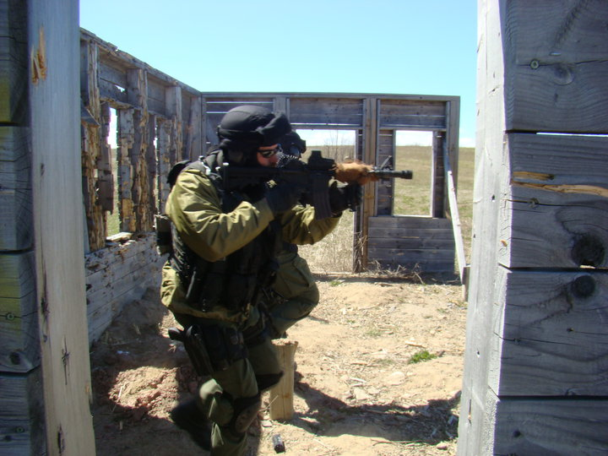

Our former Camerons are also out there on Facebook and many other places. Do your bit and try to get them out for the 100th – just think of how much better the party will be if your pals from back when are there too !

* Unit Web Site *
The Unit web site is up and running at:
http://thequeensowncameronhighlandersofcanada.net/
You will also find some interesting items on the downloads page at:
The Queen's Own Cameron Highlanders of Canada downloads page
Family requests for information: We normally get a few of these every month at the web site. If you have any information regarding a request you can pass it directly to the person doing the search or through editor The Oatmeal Rag – either version.
From: "T. de Wilde-Rinsma" <t.rinsma01@hetnet.nl>
To: <hodonnell@draega.net>
Date: Sat, 8 May 2010 00:00:35 +0200
Subject: veteran N. W. Grantham
Hallo,
After visiting the cemetery in Holten, Netherlands, we visited a farm nearby, that my mother knew from then. They showed us an almost new (but 1945!) German rucksack with written on it; Q.O.C.H. of C. N.W. Grantham P22266 Winnipeg. I promised them to see on the internet for more information.
So I did, but I can`t find N.W. Grantham. Can you? What is the story. Does he (still alive?) want the rucksack back?

Greetings, Erik de Wilde.
We are also in touch with Cec Law, formerly a South Saskatchewan officer. He’s doing Ok and still quite sharp. More of his story will be found in the next Sgian Dhu for those who are interested.

* Regimental Events *
Rounds Completed
30 May 2010 Winnipeg Police Service Scotch & Cigars Night
Despite the tickets being $50/head Sgt M. Lumsden headed up a small Cameron contingent to visit our old comrades like Sgt D. Roxburgh (formerly Cameron P&D’s now WPS P&D’s). It was a fine evening, just like the Scotch !
05 June 2010 Cameron Highland Games
At long last the Camerons have gotten back to basics and held a Highland Games weekend. The event was open to all Camerons, former Camerons & their guests. It was most superbly hosted by WO B. Breustedt and his wife Tracy. The rest of the family pitched in too, helping with the cameras and hosting other Cameron wee ones. Thanks once again to the WO’s & Sgt’s Mess for organizing this (hopefully) annual event and to the HLCol for the Free Issue. Your Association helped out by doing the manful thing and helping pay for the porta-potties. Nothing but glory work for us in the Association !
03 July 2010 Royal Visit
The Royal couple were in Wpg to dedicate the cornerstone for the new Human Rights Museum. We were able to get a small spot near the Esplanade Riel and have the CO present the Col-in-Chief of the Regt a copy of our new regimental history. Sweltering in the heat were the HLCol, CO, DCO, Sgt’s Clark & Lumsden, Cpl’s Blackmore, Curry, Toews, Rivas, Brooker, Robinson, LCol (Ret’d) Ken McCuaig, and Mr. Murray Burt the author of the new history.

Incoming Rounds
Cameron Association Reunion & Golf: 20-21 August 2010
To be held on Friday night at Minto armouries and Saturday afternoon at the Assiniboine Golf Club. Come on out and join the old guys for a beer and a tall tale or two to get primed for the Centennial in October !
Friday Night details: Date: 20 August Time: 6:30 p.m. – Late
Place: Minto Armouries Officers Mess Price: Cameron Association Dues – $10

Golf Details: Date: Saturday, August, 21, 2010
Time: 2:00 p.m. tee off Place: Assiniboine Golf Club
Price: 9 holes of golf and steak BBQ -- $40.00 Just the steak BBQ -- $25.00
[These are the same prices as last year]

Contact: Don MacDonald: (204) 771-3825 or dmacdona@mts.net

Cameron 100th Anniversary: 22- 24 Oct 2010
To be held in downtown Winnipeg this coming year. Come on out and join the old guys After all, you know you’re one of them now (and have been for years too) ! Bring a friend or two as well, especially the guys that you did a course or an overseas tour with. Here are the basics.

CAMERON CENTENNIAL WEEKEND
October 22 – 24, 2010 Winnipeg, Manitoba

Please join us in celebrating 100 years of service to Manitoba and Canada by The Queen’s Own Cameron Highlanders of Canada.

Key Events

Friday, October 22 – Welcome “Meet and Greet” Evening
Saturday, October 23 – Freedom of the City Parade, Laying of Wreaths at the Cenotaph, Presentation of Commemorative Plaque to the Province of Manitoba and Gala Dinner
Sunday, October 24 – Church Parade followed by Farewell Luncheon

There will be a number of other events associated with the Centennial Weekend.

Many of the events will be held at the historic and beautiful Hotel Fort Garry and we have arranged a special Centennial Weekend pricing package for attendees who wish to stay at the Hotel. Please contact the Hotel at (204) 942-8251 (www.fortgarryhotel.com).

The cost for attending all of the events is $100.00 per person. We are able to offer this low cost due to various sponsorships and through the support of the Regimental Foundation.

Please return your reply to the address below to advise how many tickets you would like for this very special event as we begin the next 100 years of service.

THE QUEEN’S OWN CAMERON HIGHLANDERS OF CANADA
CENTENNIAL WEEKEND REPLY CARD

Please reserve ___ ticket(s) for the Centennial Weekend at $100.00 per ticket
My cheque in the amount of $_______ is enclosed. (Please make your cheque payable to The Queen’s Own Cameron Highlanders of Canada.)

Name: _____________________

Address: _____________________________________

Telephone:___________________

E-Mail: _____________________

Mail your ticket request to: Centennial Committee
The Queen’s Own Cameron Highlanders of Canada
Suite 85, PO Box 17000 Station Forces
Wpg, MB R3J 3Y5

Or: Sgt D. Gibson (Centennial weekend Treasurer)
104 William Gibson Bay
Wpg, MB R3C 5L7

* UPDATE ON CENTENARY BOOK PROJECT *
Winnipeg’s Ladies from Hell is here ! Pre-ordered books are being delivered now. If you haven’t received your order by August 1st, send an email to cameron100@mts.net and we check for you.

Haven’t ordered yet… Books may be ordered at $50/copy (delivery included) from
QOCH Centenary Inc
Suite 85, PO Box 17000 Station Forces
Winnipeg, MB R3J 3Y5
Include your name and address with payment.
Please make cheque payable to QOCH Centenary Inc.

You should be able also to purchase a book at Foklorama
Glenwood Community Centre
27 Overton Crescent in St Boniface - 8 Aug until 14 Aug

(Serving members should apply to regimental kit shop to place an order.)

So… online or printed version for you?

We look forward to hearing from you as to which version you prefer to receive. If we don’t hear from you we’ll assume that you prefer the printed version. If you don’t have a computer or the internet by all means drop us a line at the Association and please let us know which one you like better.
Also, any updates regarding your contact information or perhaps outstanding Association Dues are welcome ! We’ll be happy to add them to the kitty to pay for the free round for members in attendance at the Cameron Reunion in August or perhaps the 100th in Oct this year.

Cheers for now,

Art Sutton & Hugh O’Donnell

