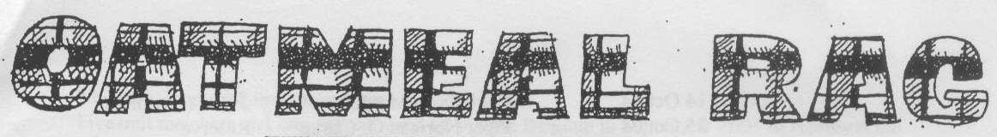
THE QUEEN’S OWN CAMERON HIGHLANDERS OF CANADA
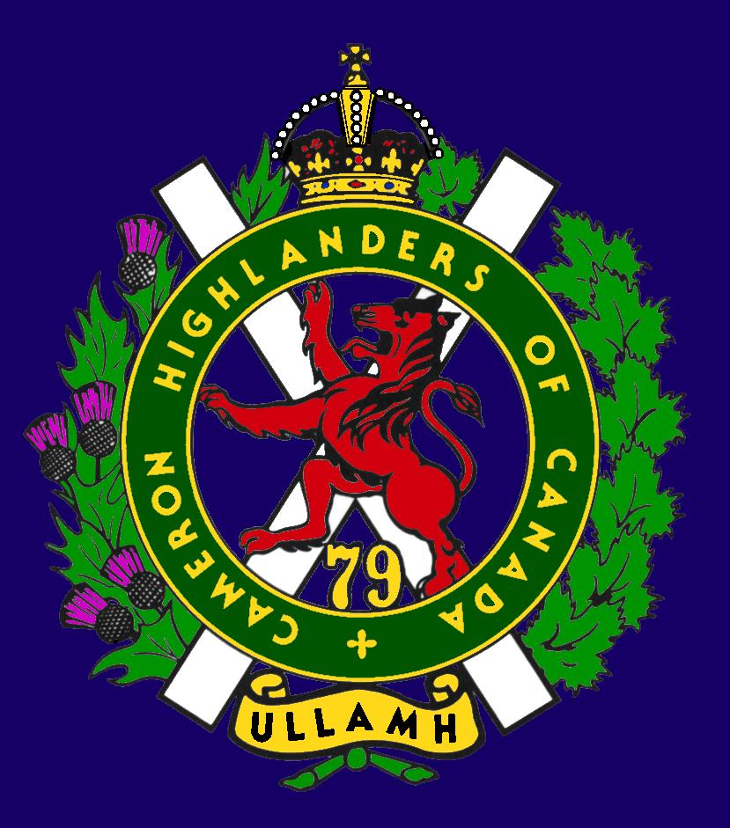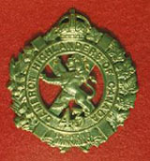
CAMERON ASSOCIATION IN CANADA
THE QUEEN’S OWN CAMERON HIGHLANDERS OF CANADA
MINTO ARMOURY, 969 ST. MATTHEWS AVE
WPG, MB R3G 0J7

2009/2010 OFFICERS

PRESIDENT | Vacant – death | RIP Doug, you are missed.
VICE-PRES | Hugh O’Donnell | 713 Cambridge St  hodonnell@shaw.ca | R3M 3G2 | 285-7222
SECRETARY | Hugh O’Donnell | “ “ “ | “ “ | “ “
TREASURER | Dave Gibson | 104 William Gibson Bay  dwgibson@mts.net | R3C 5L7 | 222-9509

Executive Board

Past Pres | Bill Worden | 47 Flett Ave | R2K 3N3 | 669 -9888
 | Len Johnson | Not avail | Not avail | 757 - 2023
 | Don Collins | 17-120 Scotswood Dr | R3R 2X9 | 895-1956
 | Taffy Gray | 198 Seekings St Headingly, MB | R4J 1B1 | 889-5655
 | Marc Gautron | 312-15 Arden Ave. | R2M 2J8 | 296-7656
 | Mitch Prudhomme | 790 Parkhill St | R2Y 0V5 | 837-5778
 | Gary Hollingshead | 928 Queenston Bay | R3N 0Y2 | 489-2367
Auditor | Tom Russell | 376 Oak St | R3M 3R5 | 488-0088

It’s time to pay your 2010-2011 Cameron Association Dues.

If you are not paid up this is your last Oatmeal Rag.

* Last Post *
I need a piper for a Cameron Association member’s funeral ? ? ?
For those of you who are trying to plan ahead or suddenly need to book a piper for one of our Comrades and don’t know how it is done here you go:
1. Contact the President of the Cameron Association or the Editor of the Oatmeal Rag at a reasonable hour; and
2. We’ll pass you the contact information of the current Cameron Pipe-Major (because the appointment does actually change from century to century or so and otherwise you may call the wrong guy); and
3. The PM will help you to make the appropriate arrangements.
Mr. Doug Hlady, President 2009-2010 Cameron Association
http://www.passagesmb.com/obituary_details.cfm?ObitID=169533
DOUGLAS M. HLADY Suddenly, at home, on September 26, 2010, after a devastating six month illness, Douglas passed, aged 54. He will be lovingly missed by mother, Ora; sisters, Jeanne (John), Valerie; brothers, Mark, Greg (Marlene), Charles (Shigeko), Christopher, and Stephen. As well, many aunts, uncles, nephews, nieces, great-nieces/nephews, cousins, and friends. He was predeceased by father, Walter, and grandparents, Marya, Lucile, Oscar and Maxim. Very important to Douglas, was special friend, Judy Stangeland. Douglas participated in the 1977 Queen's Jubilee Commonwealth Expedition, a bus trip across Europe and Asia to India and back. Benefits included Douglas sponsoring a five year old boy's education. Douglas spent time up north, in Churchill, MB, or Resolute Bay, NWT, as a flight service specialist/coast guard radio operator. He moved back home, to work with The Canadian Corps of Commissionaires. A dedicated member of Our Saviour’s Lutheran Church, 600 Minto St., Doug's booming voice will be sorely missed. The Funeral Service was held Friday, October 1, 2010, with Pastor Nancy Walker, presiding. Douglas helped others, and was honoured by the Canadian Red Cross, with a Rescuer Award. He contributed to the Circus Mom/Daddy Club, and to the Annual MS Walk. When Douglas fell ill, he was rescued by Winnipeg Fire and Paramedic Services, and their Major Incident Response Vehicle. The staffs of Victoria General Hospital Fifth Floor were very good at looking after him. The family appreciates their effort. Douglas eagerly anticipated The 100th Anniversary Weekend, of the Cameron Highlander Association, where he served as President, on October 22 to 24, 2010. Consider donating to The Cameron's Regimental Foundation, c/o 452 Moray Street, Winnipeg, MB R3J 3A8; West Kildonan Legion; Heart and Stroke Foundation. Funeral arrangements through Korban Funeral Chapel, 956-2193.

Maj. Eric N. Mainwaring - 5th Bn QOCH. Also a mbr of the Cameron Association in Canada
http://www.keep-em-moving.co.uk/page9.html
* Sick & Visiting *
Ed Abraham WW2 Cameron had a stroke near Easter. Ms. Leona Stilling tells me that he's recovering OK but is currently paralyzed on his right side. His vital signs are good and he is able to speak, eat regular meals, and is working very hard to regain mobility.

Sgt Ed Chaze 21 Sept 2010
He is presently at the St. Boniface 6th Floor, a semi-private room in E Ward, 6039 Bed 2 by the window. This is good news in that at least they haven't "written him off" - which is what the private rooms are for on that floor! We had him at Seven Oaks a few nights ago (BIG mistake) and they did not do the CAT scan that they said they would and released him the next morning. He collapsed again and had bleeding in his brain plus two earlier subdural hematomas.
I took him to St. B. later and the bottom line is that with suspected heart or stroke problems, go to St. B. and with trauma injuries, go to Health Science Centre.
He is doing much better; however, I think he will be in there for quite some time. He didn't have a stroke, but there are still blood vessels bleeding into the brain which manifest like stroke symptoms. He is slurring his words a little, but is fully cognitive.
Linda Kohut (Daughter)

Lloyd McDougall (39/45 – and still ticking !) 19 Sept 2010
Tanya Rideout (formerly a clerk with 38 CBG) did us the very great service of dropping in to Deer Lodge to visit with Lloyd and bring him the latest Oatmeal Rag. She tells me that he’s as sharp as can be and was seriously considering trying to come for the 100th. It may not come to pass as Lloyd has trouble with long commutes. She also tells me that his room is a Cameron shrine – so maybe we can get the P/M to send a piper or twa around Deer Lodge come 11 Nov or something ?
For those who can drop by he’s Lloyd McDougall and he’s in Tower 5 or
T5 – 531, DEER LODGE CENTER, 2109 PORTAGE AVE.

* President's Message *
Doug is praying for us to have a great time at the 100th.

Be there - because unless you’re Excused Duties he’ll haunt you for all time !
* Vice-President's Message *
Things are definitely kicking into high gear for the 100th as these final weeks seem to melt away. The plaques for the presentations are in and ready to go, the dignitaries are being briefed up for their parts, the speeches are being written (with strong hints that brevity is next to Godliness or some other such word) and the Hotel et al will soon be asking for money – so pay up soonest please !

Extra special thanks are due to Mrs. Maureen Johnson, wife of the Association Exec’s Len Johnson. She writes the newsletter for Royal Canadian Legion’s Branch, the “#215 Times”. Their July – Oct 2010 Issue features the Camerons, our 100th Anniversary celebrations, a bit of #215 Branch history that is connected to us and especially our Dieppe veterans, and to top it all off she’s put in a nice spread about the latest Cameron history book, Winnipeg’s Ladies From Hell. Thanks Very Much Maureen !

* Reconnect with Former Camerons *

This is an important thing to do for the 100th Anniversary of the Camerons. There are lots of former Camerons out there that we don’t know about for various reasons.

There are at least 150 people registered for the 100th, some of whom are even paid up too ! Join them now by sending your registration and payment to the address listed below describing the events.

From some of our Wandering Highlanders:

Former Pipe-Major John Dawson will be joining us for the event. He seems to have been missing his bagpipes and good Scotch for the past few months – or at least the fine company of fellow Camerons. His FB page is a very good thing for those of us who have no lives of our own.

Sgt Tim Seeley will be in town briefly. Hopefully he can grace us with his presence and stories of bad food and other such tales.

Former Sgt Dave Taggart is an RCMP Corporal and is working in Lynn Lake again. He sends his best wishes but that special Lynn Lake extra cold weather can stay up there with him on the morning of the 23rd Oct while we go for a stroll “With Bayonets Fixed and Colours Flying”.

19 August 2010.

Sir:

I've been through the various Regimental web-sites, and have been unable to find anything where-by I can contact the Unit directly to give them my best wishes on this 68th anniversary of the Dieppe Raid. I found your e-mail address, and devotedly hope that, as a former Cameron, you can pass on my best wishes to:

(a) The veterans of the Dieppe Raid (God Bless them!); and
(b) The Regiment on its Centennial.

Please say Hi to Frederick and George Carstead; Steve Anema; Jack McQuaig, Sandy Will; Tim Paryniuk (spelling? He was my first Platoon Sergeant ... ended up as the Area RSM ... and may be long-dead by now). I can remember a lot of other names ... Louis Ayotte (RQMS); Nick O'Shanski (RSM), Dick Huggard (OC A. Coy), Dan Aymont (Cpl A Coy), Rod Kuehn (Pte/Cpl A Coy), but I doubt if they are still around.

With Respects:

Gordon D. Fonstad, CD, M.Sc., P.Eng. (Retired)
Private (Cams of C) 1969 through Lieutenant (Cams of C) 1974
Lieutenant through Major (Retired 1991) Canadian Corps of Military Engineers.

More of our former Camerons are also out there on Facebook and many other places. Do your bit and try to get them out for the 100th – just think of how much better the party will be if your pals from back when are there too !

* Unit Web Site *
The Unit web site is up and running at:
http://thequeensowncameronhighlandersofcanada.net/
You will also find some interesting items on the downloads page at:
The Queen's Own Cameron Highlanders of Canada downloads page
Also of interest on that side of the pond is a newly available Regimental Scottish whiskey:
http://www.cuidichnrigh.com/

* Regimental Events *
Rounds Completed
Cameron Association Reunion & Golf: 20-21 August 2010
It was the usual good deal, the Officer’s Mess hosted us on Friday pm and the Saturday golf and BBQ were held at the Assiniboine Golf Club on Ness.
Thanks are due in no small part to Don MacDonald and HLCol Bob Vandewater of the Cameron Advisory Board in getting us back into that course. Many thanks are also due to Steve MacMillan’s boss for that kick ass drill set and all of the other folks who responded to our call for prizes. Maj Ken Smith reminded us of the days gone by when it was 6 prizes all told for many more golfers. Job well done !!!

Incoming Rounds
Cameron 100th Anniversary: 22- 24 Oct 2010
Come on out and join the old guys After all, you know you’re one of them now (and have been for years too) !
Bring a friend or two as well, especially the guys that you did a course or an overseas tour with. Here are the basics:
22 Oct - 1900 hrs Friday Night Meet & Greet
- MINTO ARMOURY
This is a change as of 16 Sept 2010, please pass the word !
23 Oct - 1000 hrs Freedom of the City Parade Steps Off
Scottish Monument near The Forks to City Hall
- 1020 hrs Presentation of Centennial Plaque
to City Hall
- 1050 hrs Wreath Laying at Cenotaph
- 1130 hrs Parade to Legislature &
1140 hrs Presentation of Centennial Plaque
to the LG of MB for the Legislature. It will eventually hang in the
Hall of Honour outside the LG’s office.

- Free time – Suggestions include more beer, whiskey tasting, or maybe get
REALLY wild and go to see the Cameron’s own Lt. Robert
Shankland’s Victoria Cross at the MB Museum, 190 Rupert Ave.
- 1830 for 1910 hrs Gala Dinner - Fort Garry Hotel
24 Oct - 1030 hrs Kirk Parade - First Presbyterian Kirk, 61 Picardy Place
&
1230 hrs Farewell Luncheon - Fort Garry Hotel

Cameron WO’s & Sgt’s Robbie Burn’s 2011: 22 Jan 2011
We’re at a new grid for this one – the Winnipeg Convention center ! Seems we got a bit of a deal on the price and we’ll be passing that deal on to our loyal friends. It’s a one time shot so be sure not to skip it ! Ms. Stacie Nixon will be the Highland Dancer again as the Winner of the Cameron Association Trophy at the Highland Dance competitions this year. Our very own Pipes & Drums will be providing some entertainment and for once they won’t need to worry about the descent from the stage. Get your Haggis here !

THE QUEEN’S OWN CAMERON HIGHLANDERS OF CANADA
CENTENNIAL WEEKEND REPLY CARD

Please reserve ___ ticket(s) for the Centennial Weekend at $100.00 per ticket
My cheque in the amount of $_______ is enclosed. (Please make your cheque payable to The Queen’s Own Cameron Highlanders of Canada.)

Name: _____________________

Address: _____________________________________

Telephone:___________________

E-Mail: _____________________

Sgt D. Gibson (Centennial weekend Treasurer)
104 William Gibson Bay
Wpg, MB R3C 5L7

* WINNIPEG’S LADIE’S FROM HELL BOOK PROJECT *
Winnipeg’s Ladies from Hell is here ! Serving members should apply to regimental kit shop to place an order. Books may also be ordered at $50/copy (delivery included) from:
QOCH Centenary Inc
Suite 85, PO Box 17000 Station Forces
Winnipeg, MB R3J 3Y5
Please make your cheque payable to QOCH Centenary Inc. Please include your name and address with your payment. You shall also be able to purchase your copy of the book at the 100th of course !

See you at the 100th !!!
Cheers for now,

Art Sutton & Hugh O’Donnell
