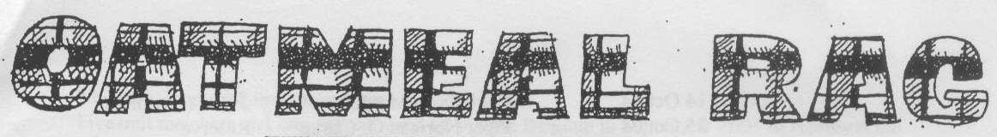
THE QUEEN’S OWN CAMERON HIGHLANDERS OF CANADA
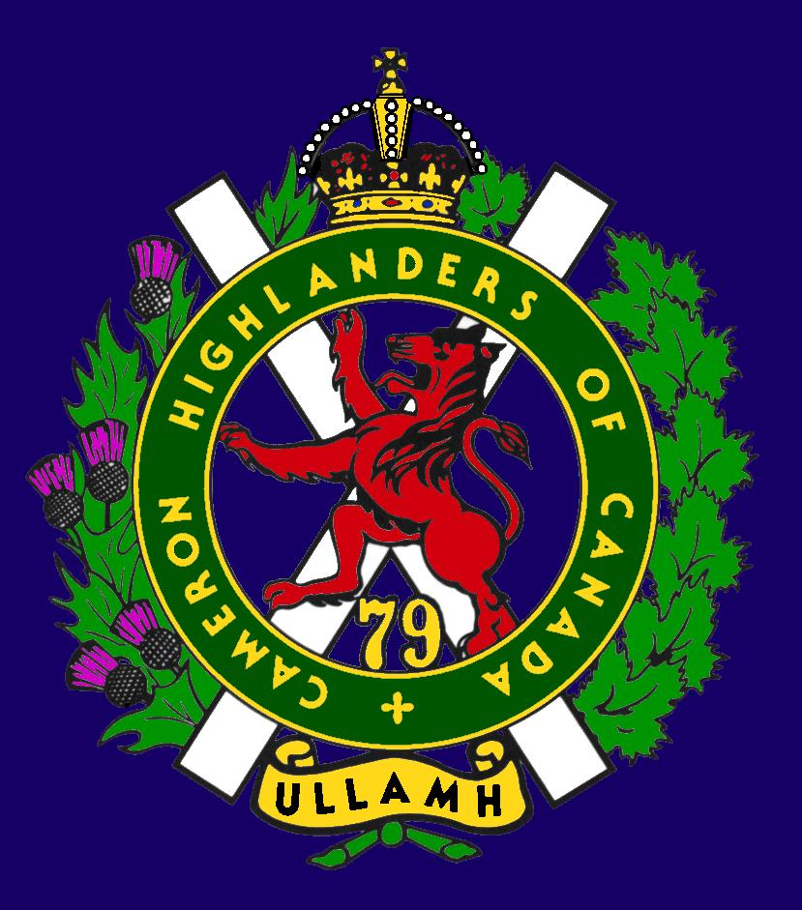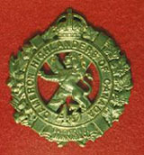
CAMERON ASSOCIATION IN CANADA
THE QUEEN’S OWN CAMERON HIGHLANDERS OF CANADA
MINTO ARMOURY, 969 ST. MATTHEWS AVE
WPG, MB R3G 0J7

2010/2011 OFFICERS

PRESIDENT | Taffy Gray | 198 Seekings St  Headingly, MB | R4J 1B1 | 889-5655
VICE-PRES | Steve MacMillan | 351 Ainslie St  Wpg, MB  sdmacmillan@shaw.ca | R3J 2Z7 | 831-0542
SECRETARY | Hugh O’Donnell | 713 Cambridge St  Wpg, MB  hodonnell@shaw.ca | R3M 3G2 | 285-7222
TREASURER | Dave Gibson | 104 William Gibson Bay  Wpg, MB  dwgibson@mts.net | R3C 5L7 | 222-9509

Executive Board

Past Pres | Bill Worden | 47 Flett Ave | R2K 3N3 | 669 -9888
 | Frederick Carsted | 91 Redview Dr | R2N 3C3 | 254-7533
 | Marc Gautron | 312-15 Arden Ave. | R2M 2J8 | 296-7656
 | Len Johnson | 1094 Bat Rd | R1A 3L1 | 757 - 2023
 | Mitch Prudhomme | 790 Parkhill St | R2Y 0V5 | 837-5778
 | Karen Tyler | 255 Aldine St  Wpg, MB | R3J 2A9 | 414-0973
Foundation Trustee | Don Steenson | Not avail | Not avail | Not avail
Auditor | Tom Russell | 376 Oak St | R3M 3R5 | 488-0088

* Last Post *
PETRO DANYLIUK (published on December 04, 2010) http://www.passagesmb.com/obituary_details.cfm?ObitID=171980
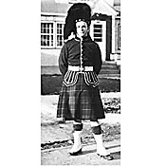 |  | 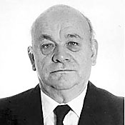

PETRO DANYLIUK It is with profound sadness that we announce the passing of Petro Danyliuk on November 30, 2010. He lost the valiant fight for his life at the age of 87 years. Petro Danyliuk was born on March 31, 1923 in Seliatyn, a village in Bukovyna, Ukraine, (then under Romanian control) the eldest of 11 children. Petro was the loving husband of Halyna; father to Victor and Boris (Kirsten); grandsons, Alexander, Nicholas and Andrew. He finished his secondary education in Seliatyn and post-secondary education in the Czech town of Podebrady. He immigrated to Canada in 1947 and met mom at a Christmas play at the UNF club in Winnipeg, in 1949. He was editor of Ukrainian Voice, Holos Molodi, and a distributor of the journal Bukovyna.
Petro also trained with the Queen's Own Cameron Highlanders. Petro was a member of the executive board of many Ukrainian organizations including Kalyna Ukrainian Cooperative, Carpathia Credit Union and Ukrainian Fraternal Society. Dad also leaves to mourn his sisters in Bukovina, Ukraine and their respective families and a brother in Kyiv. Donations may be made to The Heart and Stroke Foundation, Canadian Cancer Society or to a Ukrainian charity of your choice. Vichnaya Pamyat KORBAN FUNERAL CHAPEL 956-2193
Joseph George Gendre
http://www.beechwoodcemetery.com/index.php/en/upcoming-services
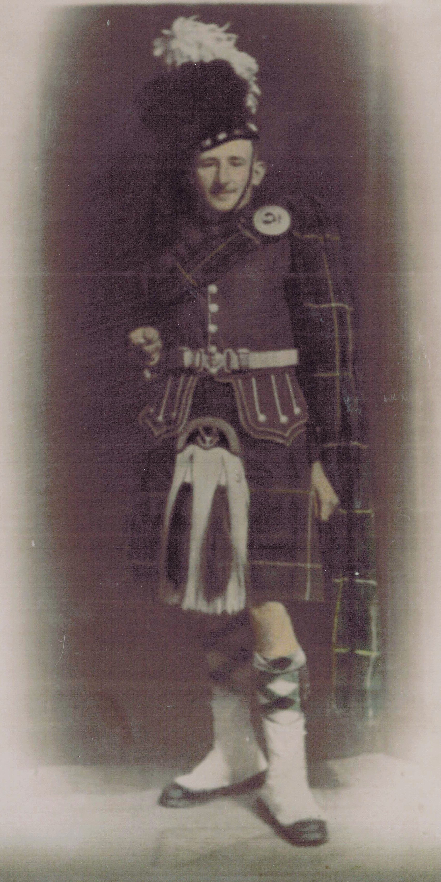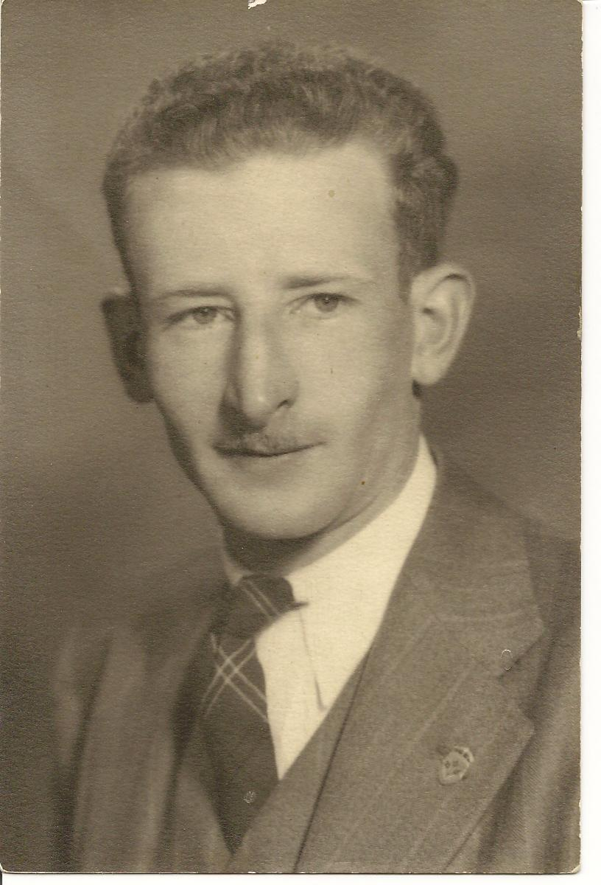

Many years ago, La Gazette published an article on six Gendre brothers who went off and fought in WWII. I wanted to advise you that the last brother who fought in the war has died. Joe passed away at the age of 92 in Ottawa. Joe was a survivor of Dieppe in 1942 as a Queen’s Own Cameron Highlander. Joe was born in St.Claude and when he returned from the war he moved to BC where he took up carpentry. He moved to Ottawa in 2005 to be close to family. Joe will be buried in Ottawa at the National Military Cemetery in Beechwood on 02 May 2011.
Joe is survived by his brother Leonard and sisters, Lea, Marie-Therese, Rose, Angelina and Celine. He was predeceased by his parents Ulysse and Rosanna Gendre nee Lambert, his brothers and sisters: Edmond, Louis, Albert, Alphonse, Jean, Alice, Marie-Angele, Noe and Georges (my Dad).
I have included an image of Joe in his regimental uniform. He was a L/Sgt in rank. Joe never married nor had children.
Rick Gendre, Nephew of Joe
Ottawa

Pte James J. Lawrence H18018 24 Sept 2010
http://www.legionmagazine.com/en/lastpost/details.asp?alpha=L&offset=3150&LastPostData_ID=300859

Pte Arnold Poole H19441 15 Nov 2010
http://www.legionmagazine.com/en/lastpost/details.asp?alpha=P&offset=6050&LastPostData_ID=301286

GEORGE EDMUND RINN (published on December 31, 2010)
http://www.passagesmb.com/obituary_details.cfm?ObitID=173058

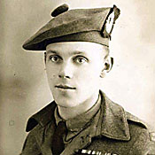 |  | 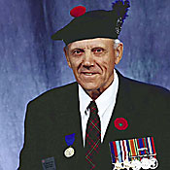

GEORGE EDMUND RINN George passed away peacefully on December 25, 2010 at the Grace Hospital following a long illness. He leaves to mourn Elaine, his wife of 54 years, twin sons Bradley (Susan) and Brian (Sandra), daughter Heather (Mike) Mounsteven; four grandchildren, Joe Mohos, Pauline and Mark Rinn, and Brenden Smith; sister Doreen Anderson; brother Neil. George was born in Snowflake, Manitoba on April 26, 1921 to Myrrha and Leslie Rinn. In 1941 he enlisted in the Queen's Own Cameron Highlanders. He was wounded while serving in France. When the war ended he worked for the CPR as a welder for 38 years, retiring in 1984.
He was honoured to be chosen in 1999 to represent the Cameron Highlanders for the pilgrimage to France commemorating the 55th anniversary of D-Day.
Chapel Lawn 885-9715

DESMOND JOHN ROSS (published on December 07, 2010)
http://www.passagesmb.com/obituary_details.cfm?ObitID=172101

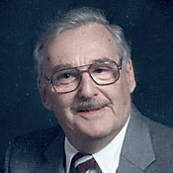

DESMOND JOHN ROSS Peacefully on December 1, 2010 Des passed away at Bethesda Hospital at 90 years of age. Des is survived by Reta, his wife of 24 years; daughter Mary Jane (Jim), stepdaughter Linda (Arnie), stepson Allan, 14 grandchildren, 11 great-grandchildren. Des was born in Gloucester, England and immigrated to Canada in 1921. He joined the Queens Own Cameron Highlanders and participated in the Dieppe Raid, where he was taken prisoner and remained a prisoner until the end of the war. After his release from the military, Des became a Diamond Driller and worked at various mines throughout Western Canada. Des retired from mining in 1979 and in his retirement he met and married Reta. A celebration of Des' life was held Friday, December 10, 2010, at the Henderson Highway Legion, East St. Paul In lieu of flowers, donations may be made in Des' name to CancerCare Manitoba.

JAMES B. WEBSTER (published on November 27, 2010)
http://www.passagesmb.com/obituary_details.cfm?ObitID=171700

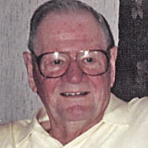

JAMES B. WEBSTER 1921 - 2010 It is with great sadness the family of Jim Webster, beloved husband to Evelyn for 68 years, announces his passing on November 25, 2010 at the Selkirk General Hospital at the age of 89 years after a long, hard battle of cancer. Jim is survived by his wife Evelyn, brother Andy, sister-in-law Joan, many nieces, nephews and friends. Jim served with the Queen's Own Cameron Highlanders of Canada. He was manager of Globe Envelopes until his retirement. A member of the Selkirk Legion, he loved to travel, most of all to his favourite place Hawaii. Donations may be made in Jim's memory to War Amputations of Canada, Manitoba Branch, or to CancerCare Manitoba. Jim was laid to rest in the Peace Niche at Chapel Lawn Memorial Gardens.

HUME BLAKE YOUNG (published on December 13, 2010)
http://www.passagesmb.com/obituary_details.cfm?ObitID=172351

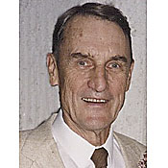

HUME BLAKE YOUNG May 30, 1919 -December 7, 2010 On Tuesday, December 7, Hume passed away peacefully at Riverview Health Centre at the age of 91 years. He is survived by his wife of 68 years, Elinor (née Hopper); his children, Donald (Robin), David (Nancy), Jane, Doug (Marian), Andy (Vicki), Nancy (Mike), 16 grandchildren and eight great-grandchildren. Hume grew up in Winnipeg with loving parents Walter and Frances. He graduated from the University of Manitoba with a Civil Engineering degree (Senior Stick) and primarily worked for the City of Winnipeg. Hume served in the RCAF in the Second World War.
Hume was an accomplished bagpiper who played with the Queen's Own Cameron Highlanders, Winnipeg Police Pipe Band and the ANAVETS Rockwood 303 Pipe Band where he accumulated many friends and fond memories. In lieu of flowers, please send donations to Cancer Care Manitoba. Chapel Lawn 885-9715

* Sick & Visiting *
Ed Abraham WW2 Cameron had a stroke near Easter. Ms. Leona Stilling tells me that he's recovering OK but is currently paralyzed on his right side. His vital signs are good and he is able to speak, eat regular meals, and is working very hard to regain mobility.

Doug Ludlow (Post WW2 Cameron) Is still in the St Norbert Personal Care Home at 50 St Pierre St. Any and all visitors are advised strongly to call ahead before visiting. The number to call is 269 – 4538.
http://members.winnipegdirect.info/p/st-norbert-personal-winnipeg-50-st-pierre/

Lloyd McDougall (39/45 – and still ticking !) 19 Sept 2010
Tanya Rideout (formerly a clerk with 38 CBG) still does us the very great service of dropping in to Deer Lodge to visit with Lloyd and bring him the latest Oatmeal Rag.
For those who can drop by he’s Lloyd McDougall and he’s in Tower 5 or
T5 – 531, DEER LODGE CENTER, 2109 PORTAGE AVE.

Roy Taylor (WW2 RAF, Post WW2 Cameron) Roy is at home and comfortable. He enjoys short visits and does get tired quickly.
Len DeCosse (WW 2 Cameron Mortar PL, Post WW2 Sigs)
Hi to All:
Operation Whittle Whittle now over by a skilled Vascular surgeon but still licking up pain killers. My old army legs should last a little longer. Just cleared Royal Jubilee yesterday and now back to work. I found 83 messages on my tube arriving home and now will get my old ass in gear and clean up. I fully intend to keep in touch.
Thanks,
Len

* President's Message *

Just a few notes and thoughts to share this month. First of all, thanks to the Cameron WO’s & Sgt’s Club, and in particular Sgt. Dave Gibson for the wonderful job they did with the Robbie Burn’s Dinner – yet again. Thanks also to Sgt (Ret’d) Ian McGregor, Sgt Grant Tyler, and CWO Hugh O’Donnell for the support to families of our former members through the Cameron web page. Now that so many of our veterans have gone to their well earned rest the task of assisting families with requests for information is becoming more challenging than ever.
We have a few things in the works for you. The first is that we are going to try to do more to help people doing family research by providing more information on the Cameron web page in terms of links and forms from Library and Archives Canada. The second is that we are going to set up a Mess Dinner which we hope will become an annual event. We still have some details to work out so more to follow on that one.
I have not forgotten that this is your Association and we of the Association Executive are here to serve you the member. Don’t be afraid to write or email us to share your opinions and views, or even tell us a war (or peacetime) story. Once a Cameron, always a Cameron !
Ullamh
Taffy Gray
* Vice-President's Message *
These are Steve’s last few weeks with the Army and then he’ll have some time to share a few thoughts with us.

* Reconnect with Former Camerons *

This is an important thing to do for the health of the Association. There are still lots of former Camerons out there that we don’t know about for various reasons. Just because you or they weren’t WW 2 or Korea veterans doesn’t make them any less important to the Cameron Association.
Please help us locate them and bring them back into the fold. The ranks of the WW 2 guys are terribly thin now and the torch must pass to the following generations of Camerons that we may continue to serve our fellow Camerons.

Pte Adam Kulchky would like to contact Lt Dunbar or his family. Lt Dunbar was in Adam’s WW2 Company. If anybody is able to help please contact the staff at the Oatmeal Rag for Adam’s information.
Thomas William Dunbar & Jack Dunbar
From: "Gary & Kathy Pawson" <abbey2@shaw.ca>
To: The Queen’s Own Cameron Highlanders of Canada
Date: Wed, 9 Mar 2011 20:02:47 -0800
Subject: Family questions
Dear Sir,
My mother was born in Winnipeg, so the family connection with your city. During the First World War my grandfather served with your regiment. His name was Thomas William Dunbar. He joined the Regiment in January 1917 I believe. The number on his attestation Paper is 524289. I'm not sure if this would be his Regimental number or not. After being wounded, and recovered he rejoined the Regiment as a stretcher bearer. (I'm lucky that I have one of his collar dogs, as well as the Red Cross flash he wore on his battle dress. His son, my uncle Jack (Dunbar) also served with your Regiment during the Second World War. He was amongst the members who landed on Green Beach at Pourville during the Dieppe Raid, and was wounded during what was called the withdrawal. After 6 months in hospital in England I believe he re-joined the Regiment and stayed with the unit until the end of the Northwestern European Campaign. The family verbal history say's that grandpa and Uncle Jack's war history were very similar experiences. Both wounded and returned to the Regiment, etc.
I have also been to Dieppe a couple of times. One of the local tour company's here takes me along to act as historian for the fellows on their pilgrimages back to Europe. Each time I go to the Dieppe Cemetery I leave poppies on the graves of the Unknown as well as on the grave of Lt. Col. Gostling. Last time I also left a small Canadian Red Ensign at the foot of his headstone. (I also gave the local private museum a couple of 3’ X 5’ Canadian Red Ensigns to them, and they were thrilled to receive them. They seemed to know more about the colours than most people here)!
Dieppe, still boggles my mind how anybody in their right mind could ask a force to land in front of Dieppe. Thank God, the Regiment followed the SSR onto Green Beach at Pourville. You must surely be proud of your Regiment for the advancements the unit made through Pourville and up the Scie river valley that terrible day!
Is there any way that I can obtain whatever information you might have regarding these two soldiers? My daughter is attempting to build a family military history. It will be a rather large job she has taken on. My father was in the RCOC in England, and in the cadre which formed the RCEME. His cousin served with the Argyll & Sutherland Highlanders of Canada and was killed in action on Aug. 5th 1944 at a place called Tilly de Champaign I think. Two of my mother's brother's served in the RCN, one on a frigate (HMCS Charlottetown), & one on a corvette (HMCS Owen Sound). Her other brother served with the PPCLI, then the Provost Corps.
So as you can see, she really does have a bit of work in front of her, and any help you may be able to supply regarding these two men would be very helpful and most appreciated.
Best wishes and regards from the west coast.
Gary Pawson
Private Edwin John Strachan
From: "dave strachan" <dstracha@telus.net>
To: The Queen’s Own Cameron Highlanders of Canada
Date: Mon, 10 Jan 2011 16:28:37 -0800
Subject: RE: WW II vet searching
Hello,
I am the youngest son of a QOCHofC WW II vet. For the past few years (since 1998), I have been researching and working with my father on piecing together his story. At one point, I had contacted the QOCHofC museum in Winnipeg and corresponded with Captain Russ Miller who was very helpful in a number of ways. He was with the regiment at the same time as dad though they did not know each other. I seem to recall he may have been a sergeant with “C” company in March 1945 while dad was a private with “D” company. If so they were both involved in the battle of Netterden where dad was wounded on March 30th, 1945.
Using regimental diaries, Capt. Miller, contact with Major Dennis Sweeting and Major Samson, I was able to recreate most of dad’s movements with the regiment during the month leading up to his being wounded. I put together a book of dad’s story which I sent to Capt. Miller for forwarding to Dennis Sweeting. This was in 1999 I believe. I was later advised by Miller that the book stayed at the QOCH museum. If so, confirmation of its status would be appreciated.
There are still a few pieces missing from dad’s story (he just turned 85 and is doing well). It would be great if there were still a few vets out there that served with the QOCH at that time and had remembrances of the last week of March 1945. On March 30 th D and C companies attacked Veldhunten from the south and NE. The battle lasted 7 hours and in the end 9 QOCHofC were killed. It was fierce fighting against these determined elite Paratroops.
This is a thorough, but not quite complete, description of dad’s experience following the crossing of the Rhine on the 28th of March 1945. Prior to the crossing, he had spent a little over 3 weeks with the QOCH mainly clearing houses/towns and searching for snipers. He would have been in the battle for Xanten as they were in their starting positions that morning but after fierce resistance was met by the first 2 companies, the attack was called off and the regiment moved to a resting area.
Details for Private Edwin John Strachan: 2nd Canadian Infantry Division,
6th Canadian Infantry Brigade, Queen's Own Cameron Highlanders of Canada
"D" Company, 17th Platoon
Commanding Officer “D” Coy- Dennis Sweeting
17 Platoon Comd - Lieutenant Garbut
17 Platoon Sergeant – “Blackie” Grantham
Section Corporal - Abbot Fraser
Pvte St. Boniface (lost leg on March 30th)
Pvte John MacFie KIA March 30th
Pvte Glaser
Pvte Faulkner
Pvte Stewardson
Pvte LaPerre
Private Edwin John Strachan
Born January 7th 1926 - Virden Manitoba, Canada
June 6 1945 Enlisted - in Winnipeg Manitoba
January 11th 1945 Sailed to England on the Mauritania
January 17th Arrived in Portsmouth, England
February 26th Arrived - Calais
March 4th Joined QOCH in Hochwald Forest as replacement for casualties suffered in battle of Hochwald Gap
March 30 Wounded (hands shot up) in battle for Netterden and area
March 31 Hospital in Brugge Belgium
June 2nd Re-entered active service - signed up to fight in the Asian theatre
June 20th Transferred to Royal Winnipeg Rifles
June 30th to March 1946 Served in occupation force stationed in Aurich Germany.
April 1946 Returned to Canada on Ile De France
June 4th 1946 Discharged from Canadian army
For the week prior to crossing the Rhine, the QOCH were stationed in the Reischwald forest. They had suffered heavy casualties in the battle to take the Rhine (Xanten, Kleve etc) and were training, re-fitting and resting).
On March 28th the QOCH crossed the Rhine at Blackfriar's bridge (pontoon bridge) near Rees, Germany. They saw no action that day (except for being shelled by artillery) and spent the night in a building resembling a barracks that the Germans had used east of Emmerich near Praest.
The next day (March 29th) they were ordered to carry double ammunition and prepare to attack a major German stronghold northwest of Emmerich. We are pretty sure this was the Hoch Elten. They marched for a number of hours before being told their orders had changed and there would be no such attack. They crossed the Dutch border at Meghelen and settled that evening around a farmhouse named de Schriek (the de Smit family). Headquarters was set up here.
Dad remembers the farmer putting out fresh straw in the barn for them to sleep on. Unfortunately, they did not get to rest long. Late on the 29th or early on the 30th, Major Sweeting took "D" company west to investigate the town of Netterden.
Upon approaching the town, dad's section/platoon was tasked with clearing a house on the outskirts...we believe this would have been east or south east end of town. WE have since learned this was likely a farmhouse approximately 500 yards from the eastern edge of town owned by the Daniels family. Dad was left alone to guard the back door of the house, so as to shoot any Germans trying to exit that way while the rest of the section, entered from the front and cleared the house. Dad remembers it being pitch black with very poor visibility. He was scared to death. Not only was he afraid of being overrun by Germans but worse, of mistakenly shooting one of his own soldiers because visibility was so bad.
It turned out there were no Germans in the house, only a very happy Dutch family. It was clear they wanted to give something to the soldiers in gratitude but had almost nothing. What they did have was fresh milk and lots of it. Dad remembers all the guys being thrilled with such a treat as it was something they never had while in the battle zone.
The bulk of dad's company remained around the farm while a small group moved off towards Netterden to investigate. After a half hour or so dad remembers the group returning at full speed to the farmhouse. Between them and the house was a pond which they ran straight through with the PIAT gun on Sergeant Grantham's back leaving a wake like that of a motorboat as he scrambled through the water. They were all laughing about it afterward.
Netterden was indeed occupied and by a company of elite German Paratroops of the 17th Fallschirmjager Regiment of 6th Fallschirmjager Division. Major Sweeting decided it would be best to wait until first light to attack and that they would need the support of "C" company. Col. Kennedy decided it would be best to have C company attack from the NE so as to encircle the town and prevent escape (the area west of Netterden was flooded so the Germans had their back to the wall).
At 4:00am, the QOCH attacked Netterden. "D" company from the South and East and "C" company circled around to the NE (to prevent the Germans escaping). Dad's platoon was held in reserve on the edge of town where he and his section watched and listened to the battle from the loft of a barn. From time to time they could see German soldiers which they fired at but they were not in "the thick of things".
The battle was intense and raged on for about 7 hours with a cease fire agreed to at approx 11:00am on the 30th. Dad and his platoon were ordered into the village where they witnessed the wounded and a cart full of Canadian dead being removed. The battle diaries and most history books claim 4 Canadians were killed in Netterden. Dad remembers seeing at least 8, mostly from “C” company who prevented the Germans from escaping to the north. In fact, 11 QOCH died that day; 1 at headquarters from mortar fire, 4 in the initial attack, 5 died of wounds, 1 who was found later and buried by the townspeople. The 6th Brigade diary refers to this battle as the stiffest resistance that side of the Rhine.
Major Sweeting had convinced the commanding officer of the Germans and 20 of his men to surrender and so the battle ended. During the heat of the battle, Major Sweeting realized that having the 2 Canadian companies divided could leave them vulnerable to being overtaken by the strong German resistance. He ran across approx 300 yards of open, bullet swept ground to make contact with “C” Company and managed to get the two companies joined up. This joint force was able to defeat the German strong hold in Netterden and shortly thereafter the Germans surrendered. For his actions, Major Sweeting was awarded the Distinguished Service Order.
While the Germans were surrendering and the Canadians re-grouping, my dad's platoon (approx. 20 - having been left out of battle and therefore being fresh) was ordered out on patrol to consolidate the area. This may have been towards Veldhunten but we are not sure. As regular soldiers, they really had no idea where they were or where they were going. They may have headed straight for Veldhunten but then again, they could have gone just about anywhere to the north or east of Netterden. They crossed large fields on their way and at one point a large group of German soldiers stood up and surrounded them. Luckily this group, numbering around 70+, while outnumbering dad's under-strength platoon had no more stomach for war and surrendered. They were sent back to the containment area with a single guard.
Further on, the platoon was walking along a dirt road with the sections spread out on both sides. They were approaching a small town or group of buildings when suddenly they came under heavy fire. They jumped into the ditches on either side of the road to avoid the machine gun and sniper fire. Dad was the second from the front on the right hand side of the road with only Pvt. John Graham MacFie between him and the Germans.
Suddenly, MacFie jumped up and ran towards a small shed on the right hand side of the road (looking towards the village/buildings). Dad without thinking, followed as did two others of dad's section. The rest of the platoon, took refuge in a house/barn on the left side of the road.
Upon arriving behind the shed, dad was told that MacFie had been shot through the throat by a sniper. It was a terrible thing to watch him choking and unable to breath. There was nothing they could do for him and he soon died of his wound. Dad has never forgotten how it was the actions of MacFie that saved his life that day. Had he stayed in that ditch, he would surely have been killed. He did not know MacFie well but remembers him fondly as an older fellow with a large family (7 children) back in Canada.
Lieutenant Garbut ordered the remainder of dad's group to cross the road to their building one at a time. This they did successfully under constant fire from the Germans.
Sergeant Grantham was inside the house near a window while Lt. Garbut was outside behind a hedge. They were trying to locate the German machine gun. Dad remembers how the Sergeant would stick his head out the window to draw the German's fire, while LT Garbut would try to see where the fire was coming from. They did this a number of times.
Luckily, neither was hit.
The entire platoon then took up positions within and around the building returning fire. Dad was stationed at a double window facing the road next to the Bren Gunner. They were firing at anything that moved in the Village/cluster of buildings. He remembers resting his rifle on fancy metal curl of the framework in the window.
They were trapped in the building without enough men to fight their way out. The battle was intensifying when suddenly, dad felt a sharp pain in his left hand and his gun dropped to the ground. He looked down and his hands were covered in blood. Apparently, a bullet had struck the window or his rifle and sprayed both hands with shrapnel. One of his section, put sulpha powder on his wounds and bandaged him up.
Not long after that, the Germans brought in a self-propelled artillery piece and began shelling them. Dad was asked by Corporal Fraser if he would be willing to run back to headquarters with a message that they were pinned down by and under fire from a self-propelled gun. Dad agreed. He was given directions and a message and sent on his way.
For a short distance he was protected from fire by buildings and a hedge. Then he had to turn and cross a road under direct fire from the Germans (who always try to kill the messenger). He remembers there being a fence and a thin line of small trees lining the road. He had to cross a field and began running as he put it "faster than I had ever run in my life". Half way across the field he felt a tug at his waist and soon his gas cape was flapping loosely. Apparently the strap had been shot off during his run. He was still under fire but stopped to remove the loose equipment before carrying on. In hind-sight, he can't believe he was stupid enough to stop at that time. He arrived at HQ and was so short of breath he could hardly get the message out.
He was placed in an area with other wounded QOCHofC and soon after ordered back to the regimental aid post. They started on their way but soon got lost. They had no weapons and no idea where the Germans might be, so scared, they took refuge in a barn and waited until dark. Somehow they eventually found their way back to the regiment. While they were hiding out, the regiment had been able to extract his platoon though one of the guys (St Boniface) lost a leg when the roof of the building they were in was shelled and a roof beam crushed his leg.
Dad's hands were badly swollen and though he had asked to stay with the regiment, the doctors insisted he had to be evacuated to a medical center for surgery. By the time dad recovered from his wounds, the war was over in Europe. He signed up to go fight the Japanese but by the time he was to disembark, the war was over. He had not been in action long enough to earn the points to go home with the regiment so was transferred to the Royal Winnipeg Rifles and spent a year in occupation in Northern Germany at Aurich.
If you can find anyone with memories or stories from this time, dad would be absolutely thrilled (as would I). We continue to piece together his activities and have managed to fill in almost all the blanks.
Also, if the museum has any photos of the QOCH from March 1945, I would be interested in somehow viewing them, if possible. Dad remembers a photographer taking some shots of him and his section at some point during March and it is possible some of those are still around.
Thanks for any help you can provide.
Regards,
Dave Strachan
Lt. Donald James Lyons
From: Dave Leary
To: The Queen’s Own Cameron Highlanders of Canada
Date: Fri, 7 Jan 2011 10:03:51 -0800
Subject: Re: Grandfather
I am researching both my grandfathers. Here is the info I have on Lt. Donald James Lyons:
Donald James Lyons, Born March 3, 1919
Joined Canadian Armed Forces June 26, 1940. Not sure if this would be his Regimental # H20351 Queen's Own Cameron Highlanders of Canada (Little Black Devils ??? )
Chosen for officer training
Promoted through the ranks to Lieutenant.
Went overseas, did some training with the Winnipeg Rifles, then back to Queen's Own Cameron Highlanders. Fought in Caen and Falaise, France. Fought in Belgium and Holland to the border of Germany (Black Forest). Lead a platoon of 15 - 32 men. Back to Ghent, was then hospitalized due to fatigue, hitchhiked back to Queen's Own Cameron Highlanders, went to Graesvech, Germany. Then back to Belgium, back to London and then back home. 5 years total service???
Regards,
Dave Leary, Grandson of Donald James Lyons
Pte Antone Ciocia

Good afternoon
I'm interested in any info you may have on my uncle, he was KIA on 23 Oct 1944 and is interned at the Bergen Op Zoom war cemetery.
http://www.cwgc.org/search/cemetery_reports.aspx?cemetery=2061700&mode=1
Thanks in advance for any assistance.
MWO Antone Collins
CSM Sup Coy
1 SVC BN
Antone.Collins@forces.gc.ca

* Cameron Constitution Amendment Motion *

Introduction
The current Cameron Constitution is a very good one but I feel that we have inadvertently missed offering some category of membership to some very important people who belong to our Regimental Family.
The Honorary Membership category which enjoys voting rights and the right to serve on the Executive is in my opinion rightly capped at 20%. This is intended to limit the impact of well meaning people who have never served in the Regiment and may not understand some of the factors which are of vital importance to those who have seen such service.

Our numbers are very likely to shrink over time and the 20% cap may limit us to only a few new such Honorary Members every 5 years or so and may completely exclude widows, sons, and daughters of former Regular Members who wish to stay in touch and/or help to promote interest in the Regiment and Cameron Association.

To correct this unintentional oversight I propose that we amend the current Cameron Constitution of 15 Jan 2011 at our 2011 AGM as proposed below.

The current Paragraph 5 reads:

5. The Association may admit to Honorary Membership in The Association any person of good character who is not eligible as a Regular member as herein provided but who is in sympathy with the aim and objects of The Association and who would assist in the advancement of same. Honorary Membership within The Association shall be limited to twenty percent (20%) of the total membership of The Association. Each application for Honorary Membership shall be considered by the Executive Board as to its worthiness for acceptance or rejection.

I respectfully recommend that we amend our 15 Jan 2011 Constitution by creating a new membership category paragraph to read:

- The Association may admit to Associate Membership in the Association any person of good character who is not eligible as a Regular Member as herein provided but who is in sympathy with the aim and objects of The Association and who would assist in the advancement of same. The Associate Membership category is non-voting and Associate Members cannot hold office, but are encouraged to support Association functions. Its intent is to allow families of past or current serving members of the Regiment and former Cameron Cadets of adult age to become members of The Association. The annual subscription fee will be one-half (1/2) that of Regular and Honorary membership categories.

I further recommend that if the new membership category is created that we renumber the existing paragraphs starting with Paragraph 6 and onwards sequentially.

Hugh O’Donnell

* Unit Web Site *
The Unit web site is up and running at:
http://thequeensowncameronhighlandersofcanada.net/
You will also find quite a few pictures from the 100th on the Picasa web page at:
http://picasaweb.google.com/camsofc
Also of interest is this month’s featured web site link: “Military Personnel Records” on the Cameron Links page will take you to the Library and Archives Canada Canadian Genealogy Centre. This page is very useful and has several links to help out the newcomer to the family research quest. One of the best places to start on this site is the appropriately titled link: “How to Begin”. Here’s the link to it in case you just want to go straight there:
http://www.collectionscanada.gc.ca/genealogy/022-600-e.html

* Regimental Events *

Reinforcements:
Callum William Flook was born 04 April 2011 to Andrew & Julie Flook. Congrats !

Rounds Completed
100th Notes: Here are the Coles notes to some of the events which happened at the 100th that would easily have been missed even by most present.
First up was the presentation by the CO of the 85th Anniversary plaque to Mrs. Allison Darling of the 1st Presbyterian Kirk, where she is the Clerk of Session. This plaque was originally intended to have hung in the MB Legislature but we weren’t old enough at that point. You need to be 100 years old to hang a plaque at the Legislature. It is to be mounted sometime soon in the Regimental Chapel amongst our other artifacts located there.
Second was the very kind donation of time and kit on display by Mr. Dirk Derrin. Dirk has quite a collection of militaria which included the Universal (aka “Bren”) Carrier on display at Minto on the Friday night and on our big parade. He painted it up in our WW 2 marking scheme – with a little help from a certain Len DeCosse. For those who don’t know him Len was a Sgt with the Cameron 3” Mortar Platoon during WW 2.

Men’s Christmas Dinner: 11 Dec Minto The program included the usual dinner on the parade square followed by drinks up in the JR’s Mess. Some of the awards for good work done during the year were presented but alas I wasn’t there to record who got what. Sorry guys !

Cameron WO’s & Sgt’s Robbie Burn’s 2011: 22 Jan 2011
We were at a new grid for this one – the Winnipeg Convention center. Seems we got a bit of a deal on the price and we passed that deal on to our loyal friends. It was a one time shot. Our very own Pipes & Drums provided some entertainment and for once they won’t need to worry about the descent from the stage.
Incoming Rounds
Cameron Highland Games Weekend: 25- 26 June 2011. The plans are coming along from the Trenchard Brothers and most parts are coming along as smoothly as we can make them happen. Keep watching the web site for details.

Metis Memorial at Batoche
You may have received this through other means but it wouldn't hurt to pass this on to any members of the association who qualify, or if you wanted to pass on any names of eligible Camerons who have passed on - George Gobeil comes to mind although there are others – Sandy Will

From: Eleanor Creighton [mailto:ecreighton@mnbc.ca]
Sent: Saturday, 18, December, 2010 21:51 PM
Subject: FW: Metis issues
Hi,
If there any members who served in the Canadian Forces or in either the Army, Navy or Airforce prior to unification, they qualify to become a Metis Veteran. Membership costs nothing.
If that is the case I will send you the paperwork to forward to DAAG (Defence Aboriginal Advisory Group) members. Also they are planning to dedicate a memorial at Batoche next summer for all Metis veterans past and present. If you know of Metis Veterans who are deceased let me know and I will send the information to have their name added to the memorial wall.
Eleanor Creighton, BMASC, BAJS
Director of Justice
Metis Nation British Columbia
Work: (250) 597-4412
Mobile: (250) 361-6638
ecreighton@mnbc.ca

Annual ReunionWeekend:
19 - 20 August 2011
Friday: Minto Armouries 1900 hrs
Saturday Golf & Dinner: Assiniboine Golf Club, register Friday pm please !

* Links *

Yeoman of The Guard Tower of London
http://www.youtube.com/watch?v=wTNfdPxtfek&feature=related

Afghanistan photo essays:
http://www.boston.com/bigpicture/2011/03/afghanistan_february_2011.html

From Sgt Nenad M.
http://www.ted.com/talks/sharmeen_obaid_chinoy_inside_a_school_for_suicide_bombers.html

From Sgt James Clark
http://www.vagabondish.com/haggis-potato-chips/

I need a piper for a Cameron Association member’s funeral ? ? ?
For those of you who are trying to plan ahead or suddenly need to book a piper for one of our Comrades and don’t know how it is done here you go:
1. Contact the President of the Cameron Association or the Editor of the Oatmeal Rag at a reasonable hour; and
2. We’ll pass you the contact information of the current Cameron Pipe-Major (because the appointment does actually change from century to century or so and otherwise you may call the wrong guy); and
3. The PM will help you to make the appropriate arrangements.

Cheers for now,

Hugh O’Donnell

